Advertising Competitive Insights 2021

Weekly Updates

DL: [DL-eBay-Competitive-Insights-Ads@ebay.com](mailto:DL-eBay-Competitive-Insights-Ads@ebay.com)

# Calendar Week 52 (Dec 31)

## **Where Big Tech Advertising Businesses Stand At The End Of A Crazy 2021**

The biggest US tech companies – Alphabet, Meta, Amazon, Apple and Microsoft – are often lumped together. But their ad platform businesses have distinct dynamics, and each was affected by the trials and tribulations of 2021 in very different ways.

* **Google**
  + Google’s data and privacy policy changes continued to keep the entire industry hopping on hot coals. But Google’s own ambition to test and launch third-party cookies alternatives in its Privacy Sandbox fizzled this year.
  + One major change came in September when **Google abandoned last-click attribution as its default measurement standard.** The new conversion default, called “data-driven attribution,” uses modeled data rather than attributing direct clicks to purchases.
  + A New York judge unsealed information from an antitrust lawsuit exposing a secret deal between Google and Facebook, whereby Facebook got unique identity data and ad volume guarantees from Google in exchange for shifting its ad network spend to Google rather than header bidding vendors.
* **Facebook**
  + **Facebook Analytics, the free tool used by advertiser and business accounts on the platform, shut down in June.** Scrapping the product was perhaps easier than overhauling it to meet new data privacy standards.
  + **Facebook’s new go-to measurement methodology is geo-testing.** Although Facebook no longer has reliable user-level data, it can collect enough data market or region to model conversions.
  + Facebook is scaling down its ad product capabilities as a way to consolidate data. Last week, Facebook [announced](https://developers.facebook.com/blog/post/2021/12/21/simplifying-campaign-objectives-outcome-driven-ad-experiences/) it will consolidate outcome-based campaigns from 11 to six metrics. Awareness, traffic, engagement, leads, app promotion and sales made the cut, while reach, video views and messages were among the discards.
  + **Facebook Shops, an on-platform service integrated with Shopify,** now offers discounts to advertisers that traffic customers back to Facebook rather than to Amazon or their own sites.
* **Amazon**
  + Amazon’s ad platform wasn’t caught up in data privacy drama because Amazon is a first-party data machine. Amazon already owns its own conversion data (i.e., sales on Amazon) and only needs to track users on its properties – across an increasing number of surfaces.
  + Amazon expanded its inventory pool this year. **New sponsored video units sometimes now appear in search feeds alongside high-performing or brand-name products.** Big brands pay well to distinguish their items from lower-quality lookalike.
  + **Amazon also tested Twitch ads bundled into its DSP for general programmatic video** in 2021 and closed the door to third parties.

<https://www.adexchanger.com/online-advertising/where-big-tech-advertising-businesses-stand-at-the-end-of-a-crazy-2021/>

## **Digital Trust in Social Commerce 2021**

About half of US adult social media users have made a purchase via social media in the past year. eMarketer’s report surveyed 1,730 US social media users on the factors that most affect their trust in social platforms. The report reveals which social platforms users feel most comfortable making a purchase on and how trust (or lack thereof) relates to their willingness to buy on social media.

* **About half of US social media users** made a purchase on a social platform in the 12 months prior to our survey, either directly on the social platform or by clicking an external link to an immediate purchase opportunity.
* Facebook was the most common place where users engaged in social commerce, followed by Instagram and YouTube.

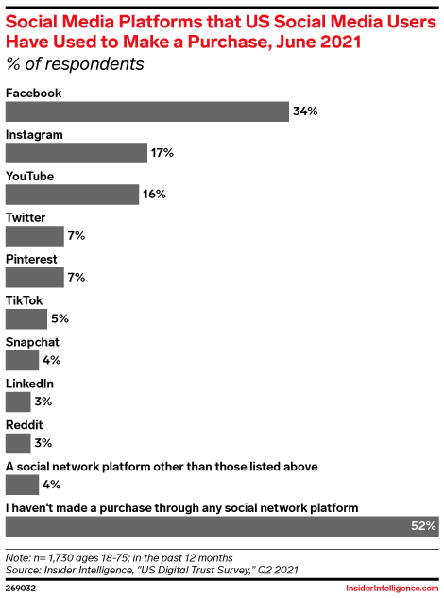

* The top two reasons **why users haven’t purchased on social media** are: they want to interact directly with a retailer, or they don’t want to share payment information with a social platform.

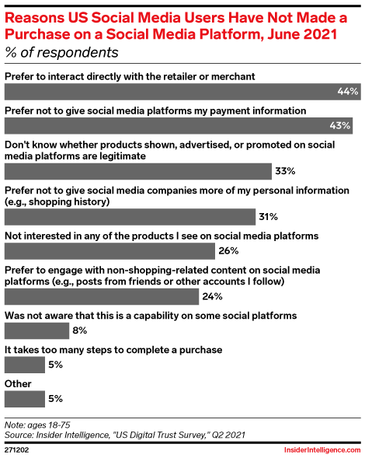

* **Social users aren’t very confident in purchasing on social platforms.** There is a strong correlation between social commerce usage and trust.

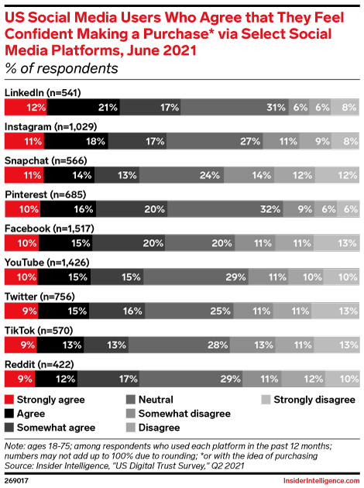

* **Relevant ads are a strong motivator for social commerce buyers.** This group was as much as twice as likely as nonbuyers to say that seeing relevant ads on a given platform affected their decision to interact with ads or sponsored content there.

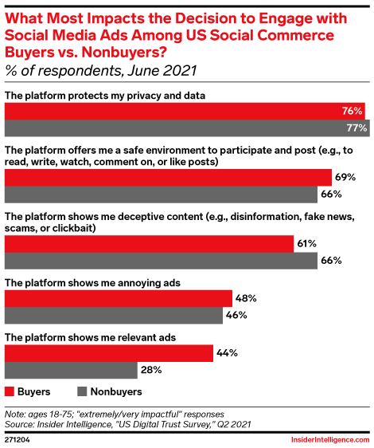

* **Social buyers visit social platforms more often and spend more time there than nonbuyers.** They are highly engaged, active users of their chosen platforms.

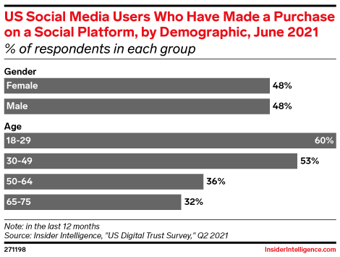

<https://content-na1.emarketer.com/digital-trust-social-commerce-2021>

## **Google Search Console testing announcement bar**

Google is testing a new announcement bar or tab at the top of the Google Search Console interface.

* The bar does not yet seem to function properly but has three levels of announcements depending on the urgency of the information.
* Google Search Console shows these three types of announcements bars:
  + Informational announcement
  + Minor issue announcement
  + Major issue announcement

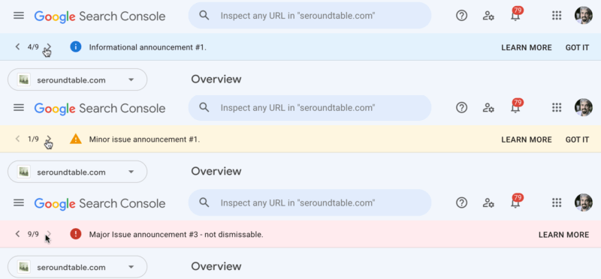

<https://searchengineland.com/google-search-console-testing-announcement-bar-378064>

## **Google Merchant Center allows retailers to save product filters**

The ability to save product filters has been spotted in Google Merchant Center.

* Save-able product filters can enable marketers to more quickly zoom into the product category they want to analyze.

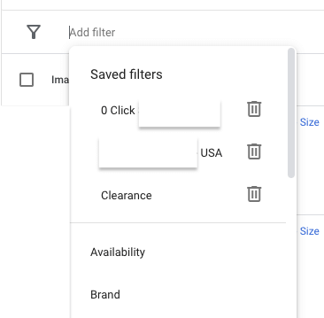

* Being able to save product filters enables marketers to more quickly analyze different product categories, such as clearance items, for example.

<https://searchengineland.com/google-merchant-center-allows-retailers-to-save-product-filters-378069>

# Calendar Week 51 (Dec 24)

## **PPC 2021 in review: Privacy and automation force advertisers to adapt**

In 2021, PPC professionals navigated changes in keyword match types and automated bidding, scratched their heads at the prospect of a future without third-party cookies and navigated their role in an increasingly automated industry.

* In Q1 2021, **Google** announced a significant change to how it treats phrase match keywords by expanding it to include [broad match modifier traffic (BMM](https://searchengineland.com/google-expands-phrase-match-to-include-broad-match-modifier-traffic-345874)).

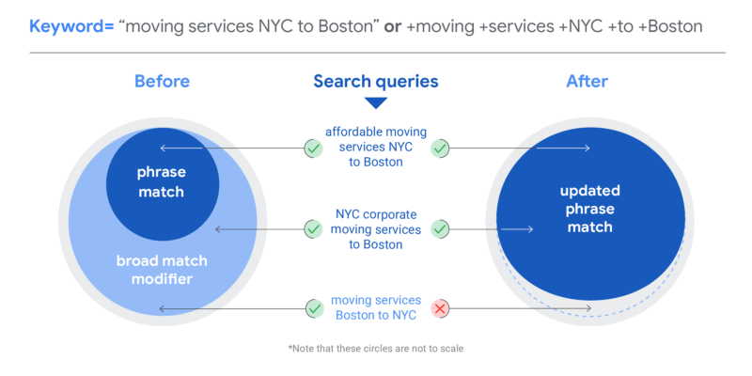

* **Google** updated its Smart Bidding in April 2021, bundling the **Target CPA (tCPA) and Target ROAS (tROAS) strategies with the Maximize Conversions and Maximize Conversion Value bid strategies.**
  + Three months later, the company [removed standalone Maximize conversions and Maximize conversion value bid strategies for search campaigns](https://searchengineland.com/google-removes-standalone-maximize-conversions-and-maximize-conversion-value-strategies-350712).

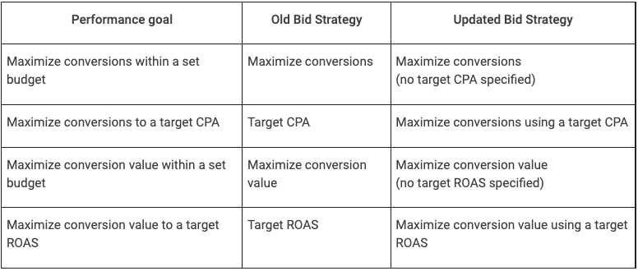

* **Microsoft Advertising** made an important change in this area as well: Beginning in March 2021, it migrated all search, shopping and Dynamic Search Ads campaigns without an automated bidding strategy in place over to [Enhanced CPC.](https://searchengineland.com/microsoft-ads-to-replace-manual-cpc-with-enhanced-cpc-by-end-of-april-345917)
* **Google** announced a sunset date for [expanded text ads (ETAs)](https://searchengineland.com/google-to-sunset-expanded-text-ads-etas-in-june-2022-374153), which will become unavailable beginning in July 2022. As it did with the phrase match change, **Microsoft Advertising** also [announced that it would be deprecating ETAs](https://searchengineland.com/microsoft-advertising-eta-deprecation-auto-generated-remarketing-lists-and-audience-network-updates-374937) starting on June 30, 2022.
* This was also the year that **Performance Max campaigns**, an automated campaign type that runs across all Google ad inventory, became [available to all advertisers](https://searchengineland.com/performance-max-campaigns-are-now-widely-available-and-will-include-smart-shopping-and-local-campaigns-in-2022-375702).
* **Microsoft Advertising** released features specifically for [automotive](https://searchengineland.com/microsoft-advertising-announces-automotive-ads-open-beta-in-the-us-and-uk-347367), tour and leisure, credit card and health insurance businesses.
* **Google** rolled out Shopping integrations for [Shopify](https://searchengineland.com/google-unveils-its-shopping-graph-an-expanded-shopify-integration-and-more-shopping-features-at-i-o-348735), PrestaShop, BigCommerce, WooCommerce, GoDaddy and Square. **Microsoft Bing** also launched an integration for retailers on [Shopify](https://searchengineland.com/microsoft-bings-shopify-integration-now-live-with-buy-now-377804).
* **YouTube** **ad** creation became simpler for SMBs this year — in June, the company announced a [new workflow](https://searchengineland.com/google-simplifies-youtube-ad-creation-for-smbs-349736), enabling advertisers to launch a campaign by adding a video, selecting the audiences they want to reach and designating a budget.

<https://searchengineland.com/ppc-2021-in-review-privacy-and-automation-force-advertisers-to-adapt-377960>

## **Microsoft Bing’s Shopify integration now live with buy now**

The Microsoft Bing and Shopify integration that was previously announced in October is now live in the Bing Shopping and Bing Search results, the company [announced](https://blogs.bing.com/search/december-2021/Microsoft-Bing-Shopify-integration-is-now-live)

* .You can click the **“Buy Now”** link directly in the Bing search results and be taken directly to the **shopping cart page on that Shopify website**. Here is a screenshot of this:

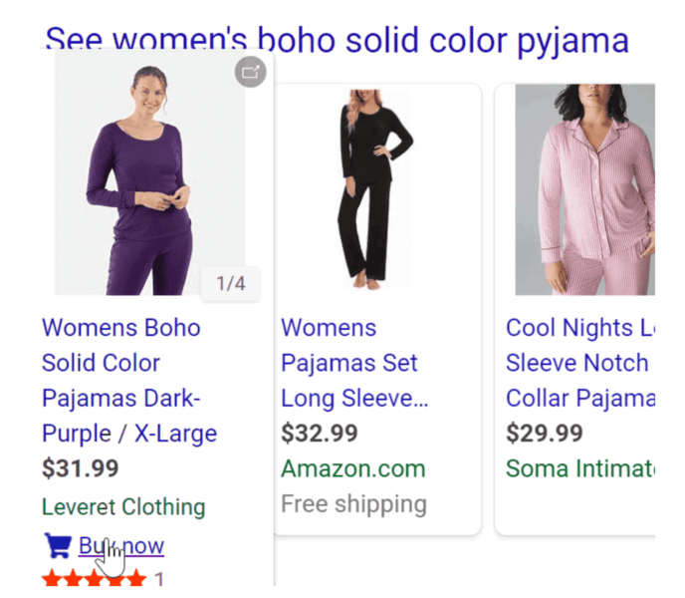

* “Merchants can quickly connect through the Microsoft Channel using their Microsoft Advertising account or sign-up for a new one in few simple steps.” Under Sales Channels, click Microsoft, and sign in.

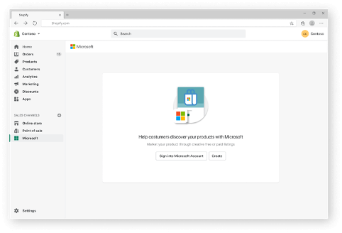

* This integration and updates to the Microsoft Channel app are just another way to help small businesses, retail, and e-commerce find visibility online.

<https://searchengineland.com/microsoft-bings-shopify-integration-now-live-with-buy-now-377804>

## **Amazon launched localized keywords for Sponsored Products and Sponsored Brands campaigns**

Advertisers creating or optimizing Sponsored Products and Sponsored Brands campaigns using targeted keywords can now input these keywords in their preferred language, instead of the language of the Amazon site they are advertising in.

* Advertisers can use the **new keyword localization feature to translate these keywords with the click of a button to best-matching keywords in the Amazon site’s default language.**
* The translated keywords are then used to match ads with search terms (in the Amazon site’s language) that shoppers are using to find products.
* Advertisers can make use of this feature to expand their reach and run campaigns across geographies where they may be unfamiliar with the local language.
* For example, an English-speaking advertiser from UK can use this feature to localize their trusted English keywords to run campaigns in Spain (Spanish) and France (French).
* This feature is available today for both **Sponsored Products and Sponsored Brands**.
* The localization feature is available to all advertisers who are adding keywords in a list or via an uploaded file, as long as they have selected a supported secondary language.
* Advertisers unfamiliar with the local marketplace language can make use of this feature to launch effective keyword targeted campaigns, using existing trusted keywords in a known language.

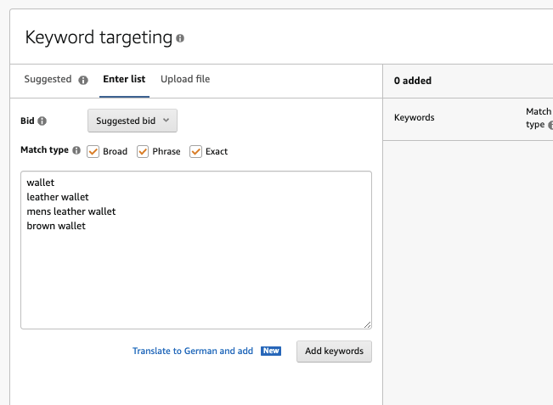

<https://advertising.amazon.com/en-us/resources/whats-new/optimize-campaigns-localized-keywords/?ref_=a20m_us_wn_gw>

## **Amazon Sponsored ads are now available in Poland**

**Sponsored ads and Stores** are now available in Poland. Eligible sellers and vendors selling on Amazon.pl can start using Sponsored Products, Sponsored Brands, and Stores.

* **Sponsored ads** can help boost sales, scale a new product launch, increase visibility on deals, or introduce products and brands to new customers in Poland.
* **Sponsored ads** can help accelerate your sales with Sponsored Products by using keyword-targeted ads, driving traffic to product detail pages. Ads can appear in shopping results and on product pages as shoppers are looking for products like yours on Amazon.pl.
* **Sponsored Brands** can help elevate your brand presence in Poland by featuring customized ads and up to three of your products. You can further establish your brand’s identity through Stores to inspire, educate, and help customers discover your expanded product selection.
* With [a manager account](https://advertising.amazon.com/en-us/blog/manage-multiple-advertising-accounts-in-one-dashboard?ref_=a20m_us_wn_pl_121621_blg), you can easily manage multiple country accounts under a consolidated dashboard by linking your accounts together.

<https://advertising.amazon.com/en-us/resources/whats-new/sponsored-ads-launches-in-poland/?ref_=a20m_us_wn_gw>

## **Microsoft to acquire Xandr to accelerate delivery of digital advertising and retail media solutions**

**Microsoft** is announcing that we have entered an agreement to acquire Xandr from AT&T.

* [Xandr](https://www.xandr.com/about/) provides a data-enabled technology platform with tools that help power a diverse ecosystem connecting marketers and media owners through first-party, data-led advertising solutions across its network.
* **With Xandr, Microsoft** can accelerate the delivery of digital advertising solutions for the open web by combining Microsoft’s audience understanding, technology and global advertising customer base with Xandr’s large-scale, data-driven platforms for advertising. These include:
  + Improved activation and advertising results with Xandr’s cross-screen, first-party data-centered buying platform, [Xandr Invest.](https://www.xandr.com/solutions/invest/)
  + Strengthened monetization for publishers through larger first-party data access and a full funnel marketing offering with [Xandr Monetize](https://www.xandr.com/solutions/monetize/), which includes a leading video solution, empowering content and media owners to unlock the full value of their inventory.
  + Increased advertiser and publisher value with Microsoft’s global native ad buying solution, the [Microsoft Audience Network](https://about.ads.microsoft.com/en-us/solutions/microsoft-audience-network?s_int=en-us-gct-web-src_msaweb-sub_blog-flx_xandracq), by helping improve ad performance..
  + Enhanced retail media solutions with [PromoteIQ](https://www.promoteiq.com/) for reaching audiences across the open web and improving the economic engine for retailers while enabling them to own their data and customer relationships.
  + Accelerated [Microsoft Customer Experience Platform](https://cloudblogs.microsoft.com/dynamics365/bdm/2021/11/02/introducing-microsoft-customer-experience-platform-a-solution-for-connected-customer-experiences/) capabilities by enabling marketers to reach high-value prospects across the open web.

<https://about.ads.microsoft.com/en-us/blog/post/december-2021/microsoft-to-acquire-xandr-to-accelerate-its-digital-advertising-and-retail-media-solutions>

Calendar Week 50 (Dec 17)

## **YouTube to automatically link to places mentioned in videos**

YouTube is launching a new link format within **the video description box** that provides “an easy and visual way for viewers to learn about **locations** mentioned” in the video, the company announced via its Creator Insider channel.

* Named **“Places Mentioned**,” this feature will be visible on the mobile app for iOS and Android for food and drinks videos where YouTube can detect places.
* The company has not released a timeline for the rollout or stated whether Places Mentioned will expand to more video categories.
* Automatic detection and link creation for places that are mentioned will decrease some of the legwork for content creators in the food and restaurant vertical.
* YouTube said that **Places Mentioned** will give viewers an engaging way to learn more about places in the video.

<https://searchengineland.com/youtube-to-automatically-link-to-places-mentioned-in-videos-377358>

## **Sell on TikTok with BigCommerce $1,000 advertising boost**

BigCommerce are expanding their recent TikTok For Business offering to support merchants in France, the Netherlands, Italy, and New Zealand to sell on TikTok.

* With the TikTok partnership and app, currently available in the U.S., Canada, the U.K. and Australia, BigCommerce merchants will be able to showcase their brand personality to enrich their connections with current customers, reach new shoppers and drive traffic to their storefronts.
* According to TikTok, 57% of users in Europe agreed that the social media platform inspired them to shop even when they weren’t looking to do so.
* **Through January 31, 2022, eligible merchants who spend $300 on ads will receive $1,000 in advertising from TikTok and BigCommerce.**
* The TikTok For Business app is available to merchants via the BigCommerce Channel Manager and equips partners with a new approach to strengthen their omnichannel sales strategies and assist with content, optimization and other services.

<https://tamebay.com/2021/12/sell-on-tiktok-with-bigcommerce-1000-advertising-boost.html>

## **Alibaba.com Announces 50 Small Businesses Receiving US$10,000 Grants to Catalyze Entrepreneur Economy**

Alibaba.com today announced the 50 entrepreneurs each receiving $10,000 grants from the first-ever Alibaba.com [Grants Program.](https://alibaba.helloalice.com/)

* A total of $500,000 in grant support will fuel new participants in the Entrepreneur Economy. Recipients were selected from a pool of more than 12,000 applicants who submitted their product idea or go-to-market strategy for consideration by Alibaba.com’s panel of [expert judges](https://buyer.alibaba.com/buyer/detail/pxr01002-1507002-who-is-the-new-digital-entrepreneur.html?tracelog=icbumkt20_B2BT_1109LI_B2BTuesdayArticle).
* The Alibaba.com Grants Program, created in partnership with Hello Alice, the largest community of underrepresented entrepreneurs in the U.S., aims to support today’s Entrepreneur Economy by providing much-needed capital and resources to New Digital Entrepreneurs who are starting businesses online.
* 44% of these New Digital Entrepreneurs say they needed $5,000 or less in the first six months of launching their business and program applicants underscored this need in their applications, citing raising capital as their top business challenge of 2021.
* In addition to the opportunity for grants, the thousands of applicants all have access to the Alibaba.com [Digitization Sprint for Retailers](https://buyer.alibaba.com/buyer/detail/pxax60f8-1507002-digitization-sprint-for-retailers.html?spm=a2700.bc-blog-list.0.0.1a2b37d0SzCt5n), gaining valuable insight into ecommerce basics like sourcing, digital advertising and supply chain management.

<https://www.businesswire.com/news/home/20211214005187/en/Alibaba.com-Announces-50-Small-Businesses-Receiving-US10000-Grants-to-Catalyze-Entrepreneur-Economy/?feedref=JjAwJuNHiystnCoBq_hl-fLcmYSZsqlD_XPbplM8Ta6D8R-QU5o2AvY8bhI9uvWSD8DYIYv4TIC1g1u0AKcacnnViVjtb72bOP4-4nHK5iej_DoWrIhfD31cAxcB60aE>

## **Top NFT marketplaces in 2021: OpenSea, Axie make the cut**

NFT’s are non-fungible tokens, a non-interchangeable unit of data stored on a digital ledger. It can be associated with items such as photos, videos, 3D models, audio, and other types of digital files as unique items. NFTs use blockchain technology to provide public proof of ownership. According to market tracker DappRadar, from a monthly sales volume of USD 400 million at the start of 2021, the market cap of NFT now stands at more than USD 13 billion. Growth in the NFT market has caught attention from Amitabh Bachchan to legacy auction houses like Sotheby’s and Christie's and have both launched their own NFT marketplaces to get in on the action.

* **OpenSea:** OpenSea is the leader in NFT sales. It is the world’s largest market place for Crypto collectibles. OpenSea has all sorts of digital assets available on its platform, and it's free to sign up and browse the extensive offerings. It also supports artists and creators and has an easy-to-use process if you want to mint your own NFT The marketplace supports more than 150 different payment tokens.
* **Axie Marketplace:** Axie Marketplace is the online shop for the video game Axie Infinity. Axies are mythical creatures that can be bought and trained and then pitted against other players' Axies to earn rewards. On Axie Marketplace, players can buy new Axies, as well as entire lands and other items, as NFTs for use within the game.
* **Rarible**: Rarible is another large marketplace for all sorts of NFTs, similar to OpenSea. All kinds of art, videos, collectibles, and music can be bought, sold, or created on the platform. However, unlike OpenSea, you will need to use the marketplace's own token Rarible to buy and sell on the marketplace. Rarible is built on the Ethereum blockchain.
* **Foundation.app:** Foundation.app was designed as a simple, no-frills way to bid on digital art. Sales are made using Ethereum. Since the marketplace's launch in early 2021, it has sold more than USD 100 million of NFTs. Artists are invited to the platform by the Foundation community, and buyers simply need a crypto wallet funded with Ethereum to start making purchases.
* **Nifty Gateway:** Nifty Gateway has facilitated the sale of some of the most popular digital artists such as Beeple and singer/musician Grimes. It's an art curation platform powered by the crypto exchange Gemini controlled by tWinklevoss Twins. The NFTs, known as Nifties, are built on Ethereum. Besides being a curated platform, Nifty Gateway also hosts any NFTs purchased -- meaning the NFTs aren't stored in your own wallet but are actually stored for you by Nifty Gateway and Gemini. Nifty purchases and sales also can be made in fiat currency e.g. USD without making a cryptocurrency purchase first.
* **Mintable**: Mintable is backed by Mark Cuban, aims to be an open marketplace similar to OpenSea. To participate in buying and selling NFTs on Mintable, you'll need Ethereum. The platform also supports minting of NFTs for creators of all types from photographers to musicians who want to sell their work as a digital asset.
* **Theta Drop:** Theta Drop is a blockchain platform built for the decentralized distribution of video and TV on the internet. It made its debut in 2021. Theta utilizes its own blockchain technology. To participate in the Theta Drop NFT marketplace, you'll need to purchase Theta Token Various crypto exchanges such as Binance support Theta, and the tokens and NFTs purchased with them can be stored in a crypto wallet, as well as in Theta's own crypto wallet app.
* **Cardingo**: Cardingo is a NFT marketplace built on the Cardano blockchain offering a Curated Designer NFT platform that connects talented artists with Cardano fans worldwide. IT has sell option at the full functional marketplace. NFT competition, 5 curated designer NFTs launch, marketing efforts expand, NFT game launch, Cardingo Smash Club NFTs, Token listings on native Cardano Dex, and partnerships.

<https://www.cnbctv18.com/cryptocurrency/crypto-ban-outright-prohibition-ineffective-and-difficult-to-execute-says-gita-gopinath-11834762.htm>

## **RAKUTEN DELIVERS SUCCESS WITH FIRST-EVER OPPORTUNITY TO TARGET SHOPPERS WITH PERSONALIZED CASH BACK OFFERS**

Rakuten has reached a milestone in the quest to make affiliate and Cash Back marketing more flexible, strategic and efficient channels for driving revenue from new and existing customers. **Rakuten's Personalized Rewards capability allows brands – for the first time ever – to segment Cash Back offers on a 1:1 basis with automated audience targeting and it's driving results.** Initial campaigns show an average 128 percent lift in new shoppers and a 125 percent lift in sales.

* Personalized Rewards brings together the affiliate marketing leadership and automated technology of Rakuten Advertising with Rakuten Rewards' unparalleled reach and influence. Rather than relying on cookies, **Personalized Rewards allows brands to use proprietary data from their customer relationship databases and anonymized Rakuten Rewards' first-party data to recognize consumers in real-time.**
* Upon identifying a customer and its attributes, Personalized Rewards automatically delivers an optimized Cash Back offer to incentivize a first-time or repeat purchase or to focus their attention on high-margin products.
* Personalized Rewards gives marketers more control over their consumer rewards strategies by enabling them deeply optimize outcomes, improve campaign performance and better understand the efficacy of their spending. By allowing greater control over audience segmentation than affiliate marketing's traditional dynamic commissioning, marketers can target individual consumers with products and unique offers based on their customer status and product and category preferences.
* Several customers are already benefitting from this new offering – including leading luxury retailer Saks Fifth Avenue and innovative footwear company FitFlop. FitFlop turned to Personalized Rewards to attract new customers to its full line of comfortable and fashionable footwear. Rakuten delivered targeted offers – with varying levels of Cash Back rewards – to select customers to incentivize purchase and conversion. The campaign was highly successful in helping FitFlop achieve its strategic month-over-month goals. The company saw a 149% increase in new-to-file buyers 83% of which were net-new to FitFlop. This improvement in new-to-file buyers helped FitFlop achieve an overall increase in shopping trips by 195%.

[https://finance.yahoo.com/news/rakuten-delivers-success-first-ever-140000289.html?](https://finance.yahoo.com/news/rakuten-delivers-success-first-ever-140000289.html?guccounter=1&guce_referrer=aHR0cHM6Ly93d3cuZ29vZ2xlLmNvbS8&guce_referrer_sig=AQAAACCT6fptUicGZ0A-wcZrKnpBozCljgPD1SkDJmmq5lkDUnTXJP6oWQESmFFBcqdDC7_IUYRuNRnaqUZ0W9v0oWUOqQ5Ho161L3A5mQOTw4LQzqW1wP9j2MRdNQF0Y3IXFX9i5R8MlUsynhFRn_pvrdHdiqfrVIpI5AvhwHHdqUX3)

# Calendar Week 49 (Dec 10)

## **Microsoft Advertising adds Asian-, Latin-, Women-owned and Diabetic-friendly business attributes**

Microsoft Advertising has added **Asian-owned, Latin-owned, Women-owned and Diabetic-friendly business attributes**, enabling advertisers to showcase more of their selling points and values, the company [announced](https://about.ads.microsoft.com/en-us/blog/post/december-2021/new-marketing-with-purpose-business-attributes-showcase-brand-values) Thursday.



* **These inclusive business attributes are text additions that can be added to search ads.** Including these attributes enables you to quickly communicate and showcase the **mutual values between your brand and your customers** that help **build trust, brand love, and loyalty through inclusivity.**
* These four new attributes join the [32 Marketing with Purpose business attributes](https://about.ads.microsoft.com/en-us/blog/post/december-2021/new-marketing-with-purpose-business-attributes-showcase-brand-values) that Microsoft introduced in September.
* These attributes can be set at the account level and used to decorate text ads and product ads. Advertisers can add attributes to their accounts in four easy steps:

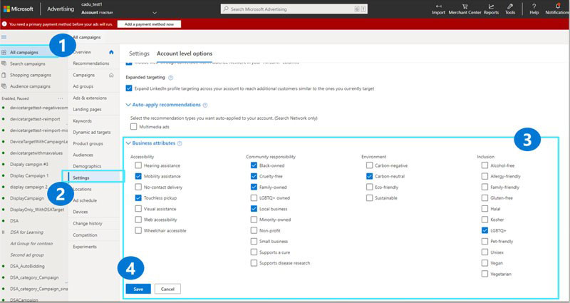

* Highlighting unique attributes **helps differentiate your brand, demonstrates responsibility, and shows how your brand values align with those of your customers.**

<https://searchengineland.com/microsoft-advertising-adds-asian-latin-women-owned-and-diabetic-friendly-business-attributes-377156>

## **Google News performance report updated for accuracy, expect impression reductions**

Google, on December 9th, has updated the news performance report in Google Search Console “to make it more accurate,” the [company said](https://support.google.com/webmasters/answer/6211453?hl=en#zippy=%2Cperformance-reports-search-results-discover-google-news).

* This update may **result in a drop in the number of impressions** you’d normally expect to see in this report.
* **Google wrote** “Google has recently updated its logging system for Google News to make it more accurate. You may notice a reduction in the number of impressions for your site in the **performance report for Google News**. These improvements are to ensure you receive the most accurate report impressions from Google News via Search Console and don’t reflect any changes in user behavior on the Google News app or news.google.com.”
* **The Google News performance report** in Google Search Console shows you clicks, impressions and click-through-rates for your performance on Google News from news.google.com, and from the Google News app on Android and iOS.

<https://searchengineland.com/google-news-performance-report-updated-for-accuracy-expect-impression-reductions-377166>

## **TikTok Users Can Make Money Through Tips & Gifts**

TikTok is adding **a new tipping feature, and the ability to send digital “gifts,”** which will allow users to earn money from creating content.

* These additions to TikTok are part of a suite of monetization tools called **Creator Next,** which includes five ways to get paid.
* **TikTok’s new tipping feature** lets users send money to other users to show gratitude for the content they create.
  + When you receive a tip on TikTok you’ll keep 100% of the tip value.
  + Payments are facilitated by Stripe. If you haven’t signed up with Stripe you’ll have to create an account in order to receive tips.
  + **A processing fee will apply when sending tips**, **which is how TikTok earns revenue** since it doesn’t take a cut from the recipient.
  + Users who are eligible to receive tips will have a new icon displayed on their profile. After tapping on the icon, users can choose to send either $5, $10, $15, or custom tip amount.

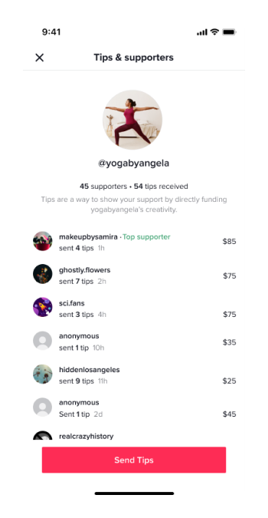

* **TikTok’s new gifting feature** allows users to send virtual gifts for specific videos. They’re kind of like Reddit awards, except the recipient can trade them in for real money.

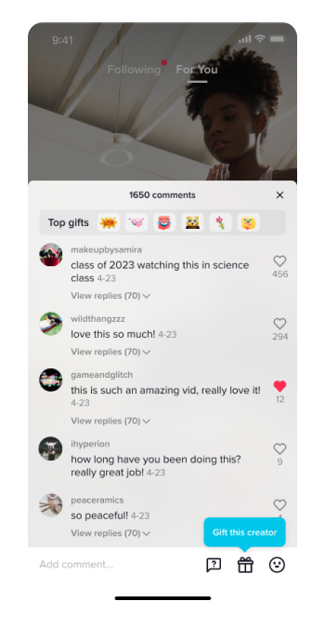

<https://www.searchenginejournal.com/tiktok-users-can-make-money-through-tips-gifts/429223/#close>

## **Amazon Advertising 2021**

As the top US digital advertising company after Google and Facebook, Amazon is finally gaining attention as a formidable player in the space. Its remarkable ascendance has other retailers following its lead, adding fuel to the growing retail media market.

* **How big is Amazon’s US digital advertising business, and how fast is it growing?:** Amazon’s US digital ad revenues will reach $24.47 billion in 2021, rising 55.5% over the prior year and representing 11.6% of the digital advertising market. We expect it to account for 14.6% of the market in 2023 as it narrows the gap with Google and Facebook.
* **What is Amazon’s role in the retail media advertising trend?:**It is the dominant player in retail media and will account for 77.7% of the market in 2021. The ecommerce giant’s realization of this high-margin incremental revenue stream has driven other retailers to follow suit. Differentiated offerings from Walmart, Instacart, and others will keep Amazon on its toes.
* **How will brands invest in Amazon advertising over the next year?:** Amazon’s base of advertisers will expand beyond its core of small and medium-sized businesses (SMBs) on its marketplace. Large multinational brands will invest more in sponsored search and brand-building ads, while advertiser categories nonendemic to Amazon, such as financial services, will focus on offerings through Amazon DSP and streaming TV ads.
* **How will Amazon continue to attract advertiser spending?:** Amazon will attract more brand investment through product innovation, improved metrics for brand and sales performance, and expansion into other ad formats. It will also need to build out its brick-and-mortar footprint—particularly in the grocery and department store segments—to maintain its leadership in first-party data.

​​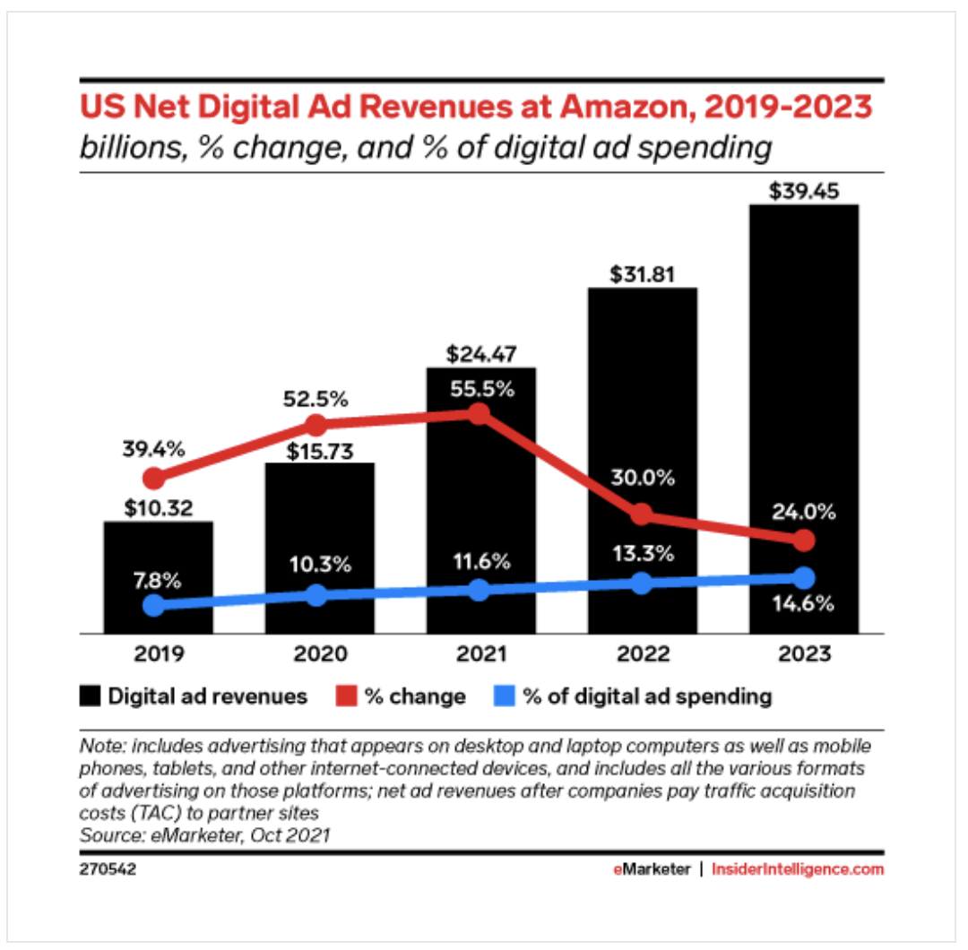

<https://viewcontent2.emarketer.com/Content/amazon-advertising-2021?ecid=dfda7bcd4b86471fba0d362c1f4a962e>

## **Snapchat Shares New Data on the Marketing Benefits of Immersive AR Experiences**

**Snapchat has** [**shared some new insights**](https://forbusiness.snapchat.com/blog/augmented-reality-is-here-and-it's-more-immersive-than-traditional-advertising) **into the value of AR for advertising**, by underlining just how immersive and engaging AR experiences can be, and how Snap’s AR tools, in particular, can drive better response.

* Snapchat commissioned market research firm [Alter Agents](https://alteragents.com/) to conduct a study of AR immersion, which measured heart rate variability when viewing different types of social content experiences.
* *“When we talk about “immersion,” we’re referring to a neurological state based on a person’s relative level of attention and emotional connection. When people are highly immersed, they are paying attention, emotionally engaged, and actively committing information to memory. To put it differently, they are “in the zone,” and the experience is resonating with them on a fundamental level - to the point it can predict future behavior.”*
* Based on this study, Snapchat found that AR experiences are indeed more immersive, with AR process on Snapchat, TikTok, Facebook and Instagram all generating higher immersion scores above the general entertainment mean.
* Some of these measures are variable, based on the methodology and process. Is heart rate variability really the best measure of such, or would eye-tracking and neurological response data provide more indicative measures of actual engagement and mental response
* In addition to this, Snapchat also found that AR advertising generated improved consumer response across various elements.

<https://www.socialmediatoday.com/news/snapchat-shares-new-data-on-the-marketing-benefits-of-immersive-ar-experien/611291/>

## **Amazon invests in Dibbs for fractional sports collectibles as NFTs**

Amazon has entered the sports collectibles space through an investment in [Dibbs](https://dibbs.io/), a startup that created a marketplace for fractional interests in physical sports trading cards. The card is represented by non-fungible tokens (NFTs), which is fractionalized. Details of the investment were not disclosed, but Dibbs raised a $13 million Series A investment in July.

* As the market for sports collectibles evolves, the prices of many coveted cards are beyond the reach of the average collector. Dibbs is attempting to solve this through a platform that holds the physical cards in storage and sells fractions of NFTs that can be traded in its marketplace.
* *The platform recently launched a new feature in the marketplace, “Sell with Dibbs”, which enables card owners to sell fractions directly to other users. They have to submit the physical card to Dibbs, which stores it in a vault.*
* Dibbs uses the Ethereum, Flow and WAX blockchains to conduct transactions.

<https://www.ledgerinsights.com/amazon-invests-in-dibbs-for-fractional-sports-collectibles-as-nfts/>

# Calendar Week 48 (Dec 03)

## **LinkedIn Adds Live Video & Newsletters To Creator Mode**

LinkedIn is rolling out access to live video and newsletters to users that have creator mode enabled on their personal profiles.

* This update is launching gradually throughout the month to users who don’t already have access to live video and newsletters.
* **The creator mode** is a free upgrade to user profiles designed for users who specialize in content creation.
* The creator mode grants access to **LinkedIn Live Video and LinkedIn Newsletters** if you meet the access criteria.
* Criteria that needs to be met to utilize LinkedIn’s live video and newsletter features is as follows:
  + An audience of more than 150 followers and/or connections.
  + Recent shares on LinkedIn of any type of original content (For example creating posts with text, images or videos, publishing articles etc.).
  + A profile that’s in good standing with a history of abiding by LinkedIn’s Professional Community Policies.
* Should you decide that creator mode isn’t a good fit for your profile you can turn it off at any time.

<https://www.searchenginejournal.com/linkedin-adds-live-video-newsletters-to-creator-mode/428867/#close>

## **Google Performance Planner adds support for ineligible campaigns, secondary metrics, ‘Suggested changes,’ specific time ranges**

Google has added four new features to its **Performance Planner forecasting tool**, including options for previously ineligible campaigns, “**suggested changes**,” and more, the company [announced](https://support.google.com/google-ads/answer/11394472) Tuesday.

* **Performance Planner’s new features.** The updates include:
  + The ability to add previously ineligible campaigns by using past performance or adding manual forecasts to plan across your entire account.
  + The “**Suggested changes**” column, which displays **budget and bid recommendations** for a specific campaign.
  + The ability to add **secondary metrics to a performance plan**, which may help advertisers understand impacts on performance beyond their most important metrics.
  + The ability to **select a specific time range for historical conversion rate**. This enables advertisers to use a historical conversion rate that may be closer to what they’re expecting for their plan’s date range.
* **These new features expand Performance Planner’s flexibility**, making it potentially more useful for advertisers in more situations.

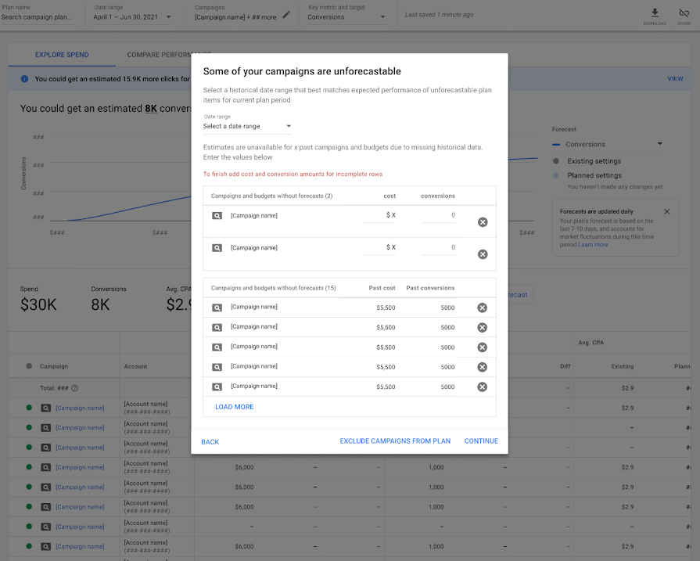

<https://searchengineland.com/google-performance-planner-adds-support-for-ineligible-campaigns-secondary-metrics-suggested-changes-and-specific-time-ranges-376625>

## **YouTube’s experimental tool for creators simplifies keyword research and identifies content gaps**

**Search Insights** was announced on YouTube’s [Creator Insider channel](https://www.youtube.com/watch?v=jbkC3jaflww) on Thursday, November 25, 2021; the company has not provided a timeline for the rollout.

* **YouTube Search Insights** is an experimental feature that shows creators search data such as the queries that led viewers to their videos or query data across YouTube’s entire audience. It can also identify content gaps (when viewers can’t find the exact content they’re looking for).
* The new features are spread across two tabs within YouTube Insights: “**Your viewers’ searches**” and “**Searches across YouTube**.”
* The **“Your viewers’ searches”** tab (shown below) displays the top searches from your viewers or from channels similar to yours.
  + YouTube-wide search volume for the term is also available, although it is described generically as low, medium or high.
  + Creators can also see the number of views their channel received for a given query (this data is only available for the previous 28-day period).
* **Searches across YouTube** tab goes beyond a channel’s own audience and allows creators to explore searches across YouTube’s entire audience.
  + Similar to the Your viewers’ searches tab, search volume is described as high, medium or low and data for views your channel received from these terms is only available for the previous 28-day period.
* Youtube is also testing a new concept called **content gaps. Content gaps** can include instances when users can’t find any results for a particular query or the content they found is low quality.

<https://searchengineland.com/youtubes-experimental-tool-for-creators-simplifies-keyword-research-and-identifies-content-gaps-376596>

## **Shopify’s Almost-Marketplace**

Shopify insists that they won’t build a marketplace, but the Shop app has recently become one. The app now allows discovering merchants, adding their items to a shopping cart, and checking out - all without leaving the app.

* **Shopify is slowly adding functionality that is bringing the app closer to a marketplace.** When the app launched in April 2020, it didn’t have a shopping cart or in-app checkout. Clicking on items would bring up a pop-up window with the shop’s website page. **All of those are now integrated features, allowing shopping without ever leaving the app.** The app satisfies the definition of a marketplace.
* The missing piece is the ability to search for items rather than merchants. That is, the app doesn’t allow finding sweaters across all Shopify merchants. It shows merchants with “sweaters” in the title instead. **But Shopify is piloting a feature that solves this. “Shopify is quietly testing a new search feature that allows customers to search for items across Shopify merchants — meaning products from competing brands would show up alongside one another,”** wrote Madeline Stone for Business Insider.
* However, not everyone at Shopify agrees that search functionality should exist. Even if participating in the universal search is an opt-in for merchants. “An internal debate continues about whether the feature would hurt merchants,” wrote Madeline Stone. **A universal search means a ranking algorithm and deciding what metrics influence higher ranking. Eventually, universal search also means an advertising platform for merchants who want to pay to rank higher.**
* Marketplace functionality is not enough to make Shop a shopping destination. Shopify might have all of it in place, but it doesn’t have a value proposition to shoppers. Millions of Shopify merchants wrapped in universal search is not it. The app wouldn’t be able to replace Amazon or other retailers because its selection is spotty. Nor could it focus on just a few categories because that is already done well by a new wave of DTC brand discovery marketplaces like The Fascination, Thingtesting, or Etsy.

<https://www.marketplacepulse.com/articles/shopifys-almost-marketplace>

## **Blockchain.com is launching an NFT marketplace and has opened a waitlist for users as the digital collectibles market booms**

Users of the crypto-trading app can now sign up for the waiting list, the company said in a Thursday blog post. In the coming weeks, people will be able to buy, sell and store NFTs in their Blockchain.com wallet, the company said.

* "We want to make accessing the NFT market as easy as accessing the crypto market," the statement said, adding that while users wait for the new feature, they can explore NFTs on the site.
* With its upcoming offering, Blockchain.com is following other crypto exchanges, like Binance and FTX.US, which already have NFT marketplaces of their own.
* Coinbase is expected to launch its version by the end of the year and received 2.5 million emails from users wanting to sign up within a month after making the announcement, according to Bloomberg.
* While demand for NFTs — blockchain-enabled digital collectibles — has soared this year, cryptocurrencies remain a much larger market. Total NFT sales in 2021 are expected to hit $17.7 billion, according to a [research report](https://cointelegraph.com/news/nft-sales-aim-for-a-17-7b-record-in-2021-report-by-cointelegraph-research) from Cointelegraph. Meanwhile, the total cryptocurrency market cap has hit $3 trillion in 2021.

[blockchaincom-nft-marketplace-waitlist-crypto-trading-2021-12](https://markets.businessinsider.com/news/currencies/blockchaincom-nft-marketplace-waitlist-crypto-trading-2021-12)

# Calendar Week 47 (Nov 26)

## **LinkedIn: Gen Z Is Our Fastest Growing Audience**

LinkedIn shares tips to help marketers reach the **Gen Z demographic**, which is currently its fastest growing audience segment.

* **Gen Z, also referred to as “Zoomers**,” is comprised of individuals ages 9 to 24.
* Gen Z engagement on LinkedIn – as defined by total number of engagements – is 2.7x higher than at the start of 2020.
* Zoomers have eclipsed Millennials to become the most mobile segment of the workforce.
* A particularly interesting finding in LinkedIn’s report is that Gen Z has an interest in **SEO**.
* In the chart below you’ll see three of the top ten courses are related to HTML, Python, and SEO — all of which can be used together to create a formidable online marketing skillset.

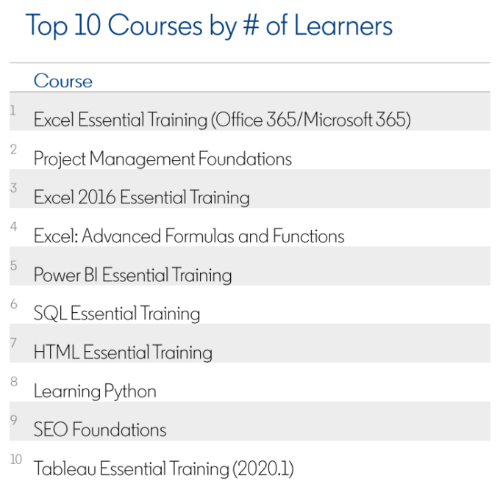

* LinkedIn recommends the **following strategies for moving brand development and content creation** in a direction that appeals to **Gen Z**.
  + **Know what their skills are:** “Easily adaptable,” “creativity skills,” and “presentations skills” are Gen Z’s top current and fastest growing skills.
  + **Prioritize mobile:** Gen Z vastly prefers mobile devices over others.
  + **Create interactive content:** Gen Z likes controlling the content they consume. Over half would like to control the plot of what they’re streaming.
  + **Collaborate rather than control:** Gen Z’s ideal leader is a collaborator, not a controller, commander, or director.

<https://www.searchenginejournal.com/linkedin-gen-z-is-our-fastest-growing-audience/428187/>

## **Microsoft Bing launched Page insights**

Microsoft Bing Page insights is now live in the Bing search results for search results snippets, the company [announced](https://blogs.bing.com/search/2021-11/Save-time-online-with-Page-insights-from-Microsoft-Bing) Tuesday.

* Users will see a **lightbulb icon on the right-hand side of the search results** that provides more details about the search result.
* Here is a screenshot of this new feature, which you can see yourself for a Bing search on [mars mission nasa]:

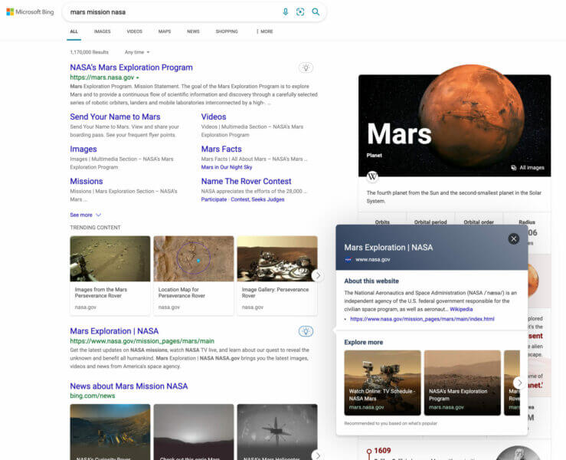

* **Page insights** “helps you verify that the source is relevant to your needs, helps you get caught up to speed at a glance on top factoids you didn’t know about, and lets you jump straight to the relevant section of the page when you click ‘Read more’ for a specific question”.
* This feature is only available on desktop search results because of the “screen size required to properly display the results.”

<https://searchengineland.com/microsoft-bing-launched-page-insights-376361>

## **Amazon Sponsored Display audiences expands custom lookback windows**

Amazon has expanded customizable “lookback windows” for both views and purchases remarketing audiences for Sponsored Display.

* Now, advertisers can **specify time period past 30 days for their Sponsored Display custom audiences campaigns to include those who performed the relevant shopping action** (ie. visited a detail page or purchased a product).
* Vendors and registered sellers can now better bring their insights when creating and managing their Sponsored Display audiences campaigns.
  + **For views remarketing**, you can select 7, 14, 30, 60, and 90 days for your custom lookback window.
  + **For purchases remarketing**, you can select 7, 14, and 30, 60, 90, 180, and 365 days.
* This feature is available in the United States, Canada, Mexico, Brazil, Germany, Spain, France, Italy, Netherlands, United Kingdom, UAE, Australia, India, Japan.
* Vendors and sellers who use Sponsored Display can use it.
* Available on both Advertising console and Amazon Advertising API.

<https://advertising.amazon.com/en-us/resources/whats-new/sponsored-display-audiences-expands-custom-lookback-windows/?ref_=a20m_us_wn_gw>

## **Google Ads App Updated With 3 New Features**

Google Ads updates its mobile app with new features to help marketers monitor campaign performance and make changes from their mobile device. With the Google Ads app, marketers will be able to:

* + **See more explanations for campaign changes** The Google Ads app now gives you more context about campaign insights, such as explanations for performance fluctuations.

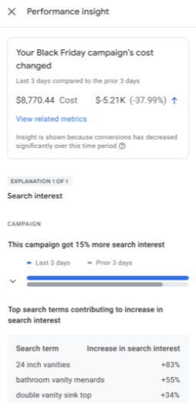

* + **Monitor real-time search trends** Keep up with consumer demand with a new report on search trends, which is updated in real-time.
    - Tapping on an individual search trend will show you popular queries associated with it.

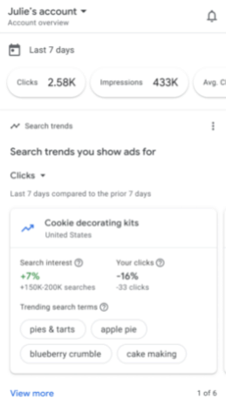

* + **Create entire campaigns on their smartphone** Using the Google Ads mobile app, you can now create a search campaign while untethered from your desktop computer.
    - This process can be completed in a few steps. Start by tapping on the plus-sign button on the bottom right side of the screen.

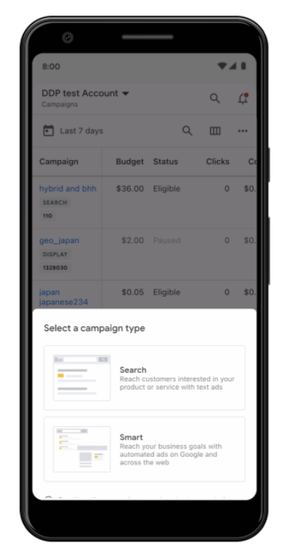

<https://www.searchenginejournal.com/google-ads-app-updated-with-3-new-features/428292/>

# Calendar Week 46 (Nov 19)

## **Google Ads Insights Page Updated With 4 New Features**

Google Ads is giving businesses access to more data on the Insights page that should help with maximizing sales during the holiday season. The following features are rolling out in beta to all advertisers worldwide.

* **Demand Forecasts:** Predicts six months of search trends with forward-looking insights that combining machine learning technology with past seasonal search data. Insights are personalized to your business.
* **Consumer Interest Insights:** Collects the top-performing search query themes that drive performance in your campaigns. Includes the number of people who searched for each theme, its growth, and how it performed in your account.
* **Audience Insights:** Learn the interests and affinities of your customers, such as what creative resonates the most with them.
* **Change History Insights & Auction Insights:** Find both change history insights and auction insights spread throughout the Insights page. Learn how shifts in auction competition or account changes impacted your campaign performance.

<https://www.searchenginejournal.com/google-ads-insights-page-updated-with-4-new-features/427482/#close>

## **The Microsoft Audience Network expands to 18 new markets**

[**Microsoft Audience Ads**](https://help.ads.microsoft.com/apex/index/3/en-us/56674#!)are now available to all customers in **Argentina, Austria, Belgium, Brazil, Chile, Colombia, Denmark, Finland, Ireland, Italy, Mexico, Netherlands, Norway, Peru, Spain, Sweden, Switzerland and Venezuela,** the company announced Tuesday.

* Prior to this update, this native ad product was only available in the U.S., Australia, Canada, France, Germany, New Zealand and the UK.
* **Microsoft Audience Ads** is a native advertising solution optimized for search advertisers. This feature enables advertisers to get additional high-quality traffic from non-search placements.
* **Microsoft Audience Ads** appear on the **Microsoft Audience Network**. These ad placements are cross-device and include premium sites like MSN, Outlook.com, Microsoft Edge, and other partners (with more to come).
* **Microsoft Audience Ads** are unique because they’re targeted to users based on our understanding of their interests. We use consumer intent signals, which include **search history, browse history, page content, and demographic information.**
* Users exposed to **Microsoft Audience Ads engage with Brands at a higher rate.**

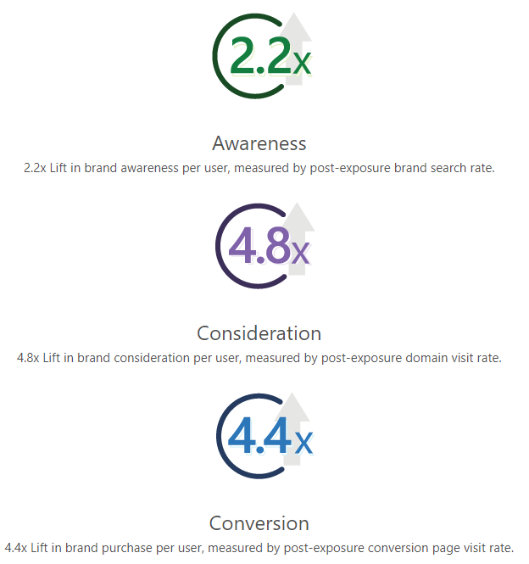

<https://about.ads.microsoft.com/en-us/blog/post/november-2021/reach-new-audiences-with-the-microsoft-audience-network>

## **Yelp’s new ad types aim to connect national advertisers to local users**

Yelp is launching two new ad units that will appear on its iOS app homepage, the company announced Tuesday.

* **Sponsored Collections** can enable brands to promote local businesses that may be selling or serving their products.
  + This feature enables brands, with or without a physical storefront, to highlight local businesses based on a common theme.

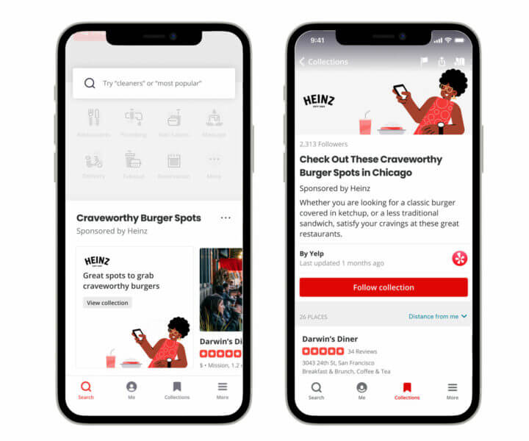

* **Seasonal Spotlight Ads** are designed to drive in-store traffic for multi-location brands by highlighting seasonal deals, promotions and new products.
  + Seasonal Spotlight Ads are carousels of posts from brands with details about the brand’s seasonal campaigns.

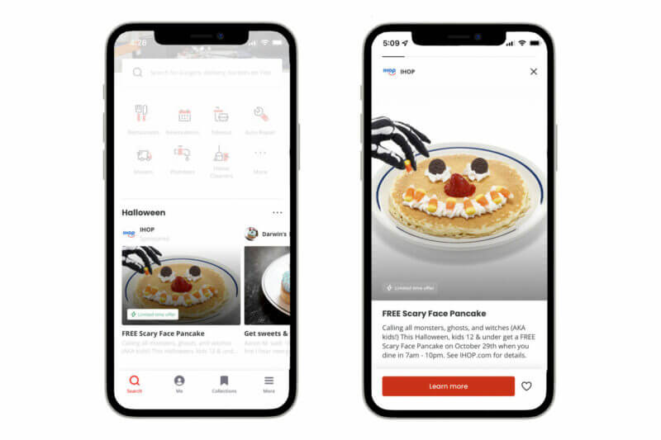

* These ads are available to multi-location brands on the Yelp mobile app and must be accompanied by another Yelp advertising campaign (either on-platform with Yelp Ads or off-platform with [Yelp Audiences](https://searchengineland.com/yelp-audiences-allows-advertisers-to-reach-yelp-users-off-the-platform-350437)).

## **Facebook’s topic exclusion controls test rolls out to more advertisers**

Facebook will soon expand its test of topic exclusion controls for ads in the News Feed to a limited number of advertisers that run ads in English, the company announced Thursday. First announced as a test in January 2021, topic exclusion controls allow advertisers to exclude ad delivery to users who have engaged with any of the following topics: “News and Politics,” “Social Issues” and “Crime & Tragedy.”

* In its early tests, advertisers were able to avoid appearing next to exclusion categories 94-99% of the time.
* If these controls roll out more widely, advertisers might feel more confident about brand safety on Facebook.
* Creating a more brand-safe environment may help Facebook maintain revenue from ads. But, if it’s not able to modernize itself and compete with newer platforms, like TikTok, advertisers may eventually move to whichever social media platforms their audiences migrate to.
* xBy the end of the year, the company also plans to work with third-party brand safety partners to develop a solution to verify whether content adjacent to an ad in News Feed aligns with a brand’s suitability preferences.

<https://searchengineland.com/facebooks-topic-exclusion-controls-test-rolls-out-to-more-advertisers-376250>

## **Amazon Ads Wants to Help Travel Outfits by Sharing Its Customers’ Buying Habits**

Very quietly over the last year-and-a-half, Amazon has been scaling up its Amazon Ads business to target the travel and hospitality sector. Brands including Avis and Disney, as well as destination management organizations, including TravelTexas.com, are among the travel and hospitality organizations that Amazon Ads touts in case studies or other marketing materials for its fledgling travel advertising business.

* The idea behind the new ad program is to use Amazon first-party data about its customers’ buying habits to enable travel and hospitality companies to better target travelers through display and video ads, for example, mostly across Amazon platforms and devices.
* The promotional materials for Amazon Ads for travel and hospitality state that 78 percent of the U.S. population that Amazon reaches spent more than $500 on travel during the past six months. And travelers visit Amazon outlets 85 times on average in the month prior to a trip, the company says.
* “By leveraging Amazon Ads’ audience-based marketing solutions, advertisers can focus on reaching the right travel audiences, with the right message, at the right time on and off Amazon,” goes the pitch.
* Although Amazon may in theory help advertisers reach travelers on other platforms, the emphasis appears to be on reaching target audiences in the U.S., Canada and Europe across Amazon’s own platforms and devices, whether it is on Amazon.com for shopping, the Alexa voice assistant at home, or Twitch video game live streaming.

<https://skift.com/2021/11/17/amazon-ads-wants-to-help-travel-outfits-by-sharing-its-customers-buying-habits/>

# Calendar Week 45 (Nov 12)

## **Meta Is Removing Some ‘Sensitive’ Detailed Ad Targeting Options**

Meta (formerly known as Facebook) announced it will **remove specific detailed targeting options that relate to topics people may perceive as sensitive.** In addition, the company will also be expanding the level of control users can have over the ads they see about specific types of content.

* Examples of detailed targeting options are **health causes** such as “Lung cancer awareness” and “World Diabetes Day,” targeting options related to **sexual orientation, religious groups and festivities, political beliefs, social issues, causes, organizations, and figures.**
* The decision to remove these detailed targeting options was not met positively by some advertising partners using the options to help generate positive societal change. To appease all sides, Meta has offered suggestions on how organizations relying on those options can find viable alternatives to maintain a successful outcome for their campaigns.
* These suggestions include [engaging with custom audiences](https://www.facebook.com/business/help/1090330204367211?id=2469097953376494) to reach people who have liked their Page or previously interacted with their content in News Feed.
* Meta is also expanding the level of control users can have over the ads they see about specific types of content – such as ads related to politics, parenting, alcohol, and pets.
* Early next year, Meta will also add more types of content to this list, allowing users to opt-out of being served ads about topics like gambling and weight loss, among others.

<https://wersm.com/meta-facebook-removing-sensitive-detailed-ad-targeting-options/>

## **Freelancers can now offer their services on LinkedIn’s new gig marketplace**

LinkedIn has officially launched a marketplace that competes with platforms like Fiverr and Upwork, giving freelance SEO and PPC professionals a new place to market their services.

* Professionals can set up a service page from their LinkedIn profile. Your service page will show an overview of the services you provide, ratings and reviews from previous clients and whether you have mutual connections with a prospective client.

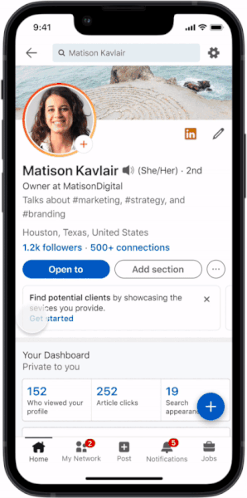

* The service page also has a dashboard that can be used to manage requests, messages, reviews and client lists.
* Potential clients can search for freelance service providers through LinkedIn’s search functionality, using the “Services” filter. They can also submit a request for a proposal or message a provider without having to connect with or follow them first.
* For LinkedIn, the marketplace may attract new users, which adds to its value as a recruiting platform for businesses.

<https://searchengineland.com/freelancers-can-now-market-their-services-on-linkedin-375970>

## **Yelp’s new home feed looks like a certain popular social media app**

Yelp is introducing a new home feed experience, consisting of a vertical feed of visual content from local restaurants, for its mobile app, the company announced Tuesday.

* The Instagram-like feature is now rolling out to iOS users in nearly 150 metropolitan areas across the United States.
* Photos of Popular Dishes, which are determined by Yelp’s machine learning systems based on user-submitted photos and reviews, and Yelp Connect posts can appear in the new home feed.

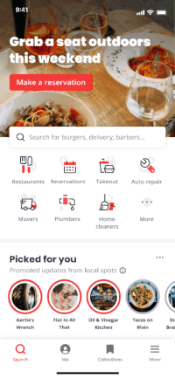

* When a user taps on a Popular Dish in the home feed, they’re redirected to more photos and reviews mentioning the dish.
* Subscribers of Yelp’s paid Connect feature will also gain more visibility in the new home feed. **Connect posts are distinguished by the “Sponsored” label.**

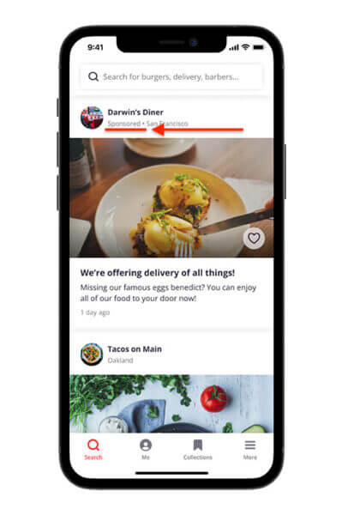

* Home feed content is personalized to users based on various factors, including their physical proximity to the business, the popularity of a dish in reviews and the recency of the content.

<https://searchengineland.com/yelps-new-home-feed-looks-like-a-certain-popular-social-media-app-375823>

## **BigCommerce launches TikTok advertising coupon programme**

BigCommerce has announced [a new advertising coupon programme with TikTok](https://www.bigcommerce.com/press/releases/bigcommerce-launches-tiktok-advertising-coupon-program-to-help-merchants-drive-growth-unlock-more-revenue/) to give matching ad credits to qualified merchants.

* The programme encourages them to explore TikTok’s suite of ad solutions to expand audience reach and drive business growth.
* Qualified merchants of all sizes based in the US, UK, Australia and Canada that spend $300 on ads will receive $1,000 in advertising credits from TikTok and BigCommerce.
* Merchants can directly access the TikTok For Business app via the BigCommerce Channel Manager. This creates a one-click experience to place the TikTok pixel, sync their catalogues, and ultimately begin producing ad campaigns.
* With TikTok For Business, BigCommerce merchants will be able to highlight their brand personality to connect with current customers. Reach new shoppers and drive traffic to their storefront on TikTok, powered by BigCommerce.
* TikTok Shopping is currently in beta in select countries. BigCommerce will be expanding the programme into additional markets in 2022.

<https://www.enterprisetimes.co.uk/2021/11/08/bigcommerce-launches-tiktok-advertising-coupon-programme/>

## **Twitter launches Blue subscription service in U.S., offers ad-free access to 300 news sites**

Twitter on Tuesday launched its Blue subscription services for users in the U.S. and New Zealand. The social media company has been testing the subscription product with Australian and Canadian users since June, but Tuesday marks the first time the feature is available to U.S. users.

* Twitter Blue costs $2.99 a month for iOS, Android and web users, the company said.
* The subscription product includes special features reserved for Twitter power users, such as the ability to undo a tweet or customize the Twitter app icon. But the U.S. launch of Twitter Blue also comes with one major addition: access to ad-free articles from more than 300 U.S.-based news sites like The Washington Post, Rolling Stone, The Atlantic and Insider.
* With Twitter Blue, the company is making an attempt to diversify its revenue streams. Advertising makes up more than 89% of Twitter’s revenue, according to its third-quarter earnings report. The social media company set goals earlier this year to reach 315 million monetizable daily active users by the end of 2023 and double its annual revenue to $7.5 billion by the end of 2023.
* Twitter will pay a portion of its users’ subscriptions to participating news sites based on what users read. Twitter Blue subscribers can see the impact of their reading habits through a transparency feature that shows how much money went to the news sites they visited.
* “Our goal is that each site makes 50% more per person than they would make serving ads to that person,” Twitter’s senior director of product, Tony Haile, said in a briefing Monday.

<https://www.cnbc.com/2021/11/09/twitter-blue-subscription-service-launches-for-us-users.html>

# Calendar Week 44 (Nov 05)

## **Google adds Smart Bidding for store sales to optimize bids for offline transactions**

Google announced that advertisers can **add Smart Bidder for store sales to help increase those in-person visits from customers who are ready to buy.**

* Advertisers can upload their first-party, transaction data in a privacy-safe way to optimize for store sales conversions for Search and Shopping campaigns—with the goal of driving additional sales in stores.
* Along with the announcement, Google linked [a list of best practices](https://support.google.com/google-ads/answer/6190135) to enhance the use of this feature for advertisers looking to **drive offline sales via online searches**:
  + Build out your [Google Business profile.](https://searchengineland.com/google-my-business-now-known-as-google-business-profile-as-google-migrates-features-to-maps-and-search-375767)
  + Work to measure the offline value of your online ads.
  + Optimize your campaigns for maximum return from both online and offline conversions.
  + Highlight your locations and communicate your store information, business offerings, promotions and more to nearby customers when they search, browse or navigate on Google Search, Maps, YouTube and the Google Display Network.

<https://searchengineland.com/google-adds-smart-bidding-for-store-sales-to-optimize-bids-for-offline-transactions-375812>

## **Microsoft Bing expands Shopping options for users, gives retailers more options to reach shoppers**

Bing Shopping now includes **new customer-focused tabs to help shoppers find exactly what they’re looking for all in one place.**

* The new tabs categorize commerce options under headers like Departments, Deals, Trending products, Price drops, Stores, and more.
* In August of last year, the company opened up an organic shopping listing option to retailers who participated via the Merchant Center. The feed-based system was limited at first but has grown since.
* Along with the upgraded Shopping tabs, Microsoft is moving Shopping up the funnel. The company announced in September that Shopping options will soon be available in Edge.
* **The new direction for Bing Shopping is to become a recommendation engine over just a search engine.** Bing will be able to customize shopping suggestions based on these shopper types and the overall retail landscape trends it’s seeing.
* Trend seekers are **looking for shopping recommendations based on what others are buying at the time.** 
  + Microsoft will have recommended deals based on what the platform is seeing everyone else buying and the best pricing options for buyers.
  + The “highly rated” indicator will also show that many other shoppers have reviewed a trending product for its quality.
  + The deal seekers will be able to look into price history, ratings and reviews, too.
* **Stores have to opt in to make it work.** In order for the model to work for both shoppers and retailers, stores will have to opt-in to providing their “entire corpus of products. Right now, they can do that through the Merchant Center.
* Along with becoming a recommendation engine, Bing Shopping strives to become a shopping destination by integrating [express checkout and shipping directly into Bing Shopping.](https://blogs.windows.com/windowsexperience/2021/09/23/our-top-new-features-are-designed-to-put-your-family-first/)

<https://searchengineland.com/microsoft-bing-expands-shopping-options-for-users-gives-retailers-more-options-to-reach-shoppers-375764>

## **Amazon DSP Line item recommendations in Bulk Sheets launch in open beta**

[Amazon DSP](https://advertising.amazon.com/en-us/solutions/products/amazon-dsp?ref_=a20m_us_wn_dsp_102821_p_dsp) now offers bulk sheets that are pre-populated with recommended line item settings.

* These line item settings are generated based on Amazon Ads’ best practices and are tailored to an order’s goal KPI.
* The recommendations are fully customizable, with line item settings easily editable within the bulk sheet.
* The recommended line items and settings are generated using the newest Amazon DSP features and the latest best practices tailored to your campaign performance goals.
* The feature is available in:
  + North America: United States, Canada
  + Europe: Spain, Italy, France, Germany, United Kingdom
  + Asia Pacific: Australia, Japan
* Self-service advertisers can access and use it on Amazon DSP.

<https://advertising.amazon.com/en-us/resources/whats-new/bulk-sheets-line-item-recommendations-beta/?ref_=a20m_us_wn_gw>

## **Advertisers can now measure brand marketing impact using Amazon Brand Lift (beta) in Amazon DSP**

Advertisers can now design, launch, and view reporting o**f Amazon Brand Lift** studies from within the Amazon DSP console via self-service.

* **Amazon Brand Lift** helps advertisers **quantify how their Amazon Ads campaigns are driving marketing objectives such as awareness, purchase intent, and ad recall.**
* **Amazon Brand Lift** is powered by the [Amazon Shopper Panel,](https://panel.amazon.com/?ref_=a20m_us_wn_unbxd_dsp_102621) an invitation-only, opt-in program where participants can earn monthly rewards by choosing to share receipts from purchases made outside of Amazon.com or complete short surveys from within a standalone mobile app.
* With participation of the sizable, representative, and engaged Amazon Shopper Panel community, Amazon Brand Lift helps provide objective and concrete measurement results.
* **The reporting** provides insights such as **how much an advertiser’s campaign has impacted the percentage of respondents who report being aware of a brand or interested in purchasing from a brand.**
* This feature is available in the United States.
* Both self-service and managed service advertisers can use it.
* Advertisers can access this service in Amazon DSP or Amazon advertising API.

<https://advertising.amazon.com/en-us/resources/whats-new/amazon-dsp-brand-lift/?ref_=a20m_us_wn_gw>

## **Pinterest Announces 'Pinterest TV' Shoppable Live-Stream Series**

Pinterest is looking to lean into the rising live-stream commerce trend, which has already gained huge traction in China, with its own series of live shopping events, via a new initiative called ‘Pinterest TV’.

* *“Today we’re announcing Pinterest TV, a series of live, original and shoppable episodes featuring creators right on Pinterest. Pinterest TV episodes are refreshed each weekday and will be recorded and available for Pinners to view on-demand, and save and rewatch later.”*
* The new series of shopping-focused live-streams, beginning on November 8th, will give Pinners the opportunity to take up exclusive deals in the app, via engaging, immediate live-stream broadcasts.
* Pinterest has been exploring its own live-stream options as a means to maximize its eCommerce push, with the platform recently launching a series of celebrity-led live-streams in the app as part of its ‘Creators Connect’ event.

<https://www.socialmediatoday.com/news/pinterest-announces-pinterest-tv-shoppable-live-stream-series/609202/>

# Calendar Week 43 (Oct 29)

## **TikTok for Business, The New York Times Advertising Team Up on Campaign**

TikTok for Business and The New York Times Advertising joined forces on **“Small Wins,” a campaign to support small and midsize businesses.**

* The New York Times Advertising built a custom ad product, **Vertical Video Flex XL**, to capture the essence of TikTok videos in their signature format.
* The two companies said that by combining the two types of media experiences offered by the media site and the video creation platform, SMBs can benefit from large-scale exposure, as well as resources to help them craft a presence on TikTok, including asset templates, measurement/optimization tools, platform insights and tips for creating effective ads.
* “Small Wins” will run across audio platforms and in a paid post on the Times site through year-end.

<https://www.adweek.com/social-marketing/tiktok-for-business-the-new-york-times-advertising-team-up-on-campaign/>

## **Amazon Advertising Unveils 8 New Tools and Features**

At Amazon Advertising’s annual UnBoxed event on Oct. 26, the ecommerce giant announced **a slew of new features and tools it said will enhance brands’ ability to tell their stories and improve customer relationships.**

* **Interactive video ads** Amazon is adding the ability for viewers to request more information in interactive video ads on the IMDb TV app on Fire TV. Shoppers who request product information will receive an email or a QR code, which will take them to the brand’s landing page on Amazon.
* **Interactive audio ads** In a similar vein, Amazon Music is giving listeners the option to “Remind me,” “Send me more information” or “Add to cart” in its interactive audio ads in a limited beta in the U.S.
* **Brand Follow**
  + Amazon is expanding its Brand Follow feature, which, as the name implies, **allows U.S. shoppers to “follow” brands for notifications when they are about to stream on Amazon Live.**
  + Brand Follow will also display deals from the brands consumers follow on Amazon’s homepage. Moss said this helps brands give their loyal followers special offers.

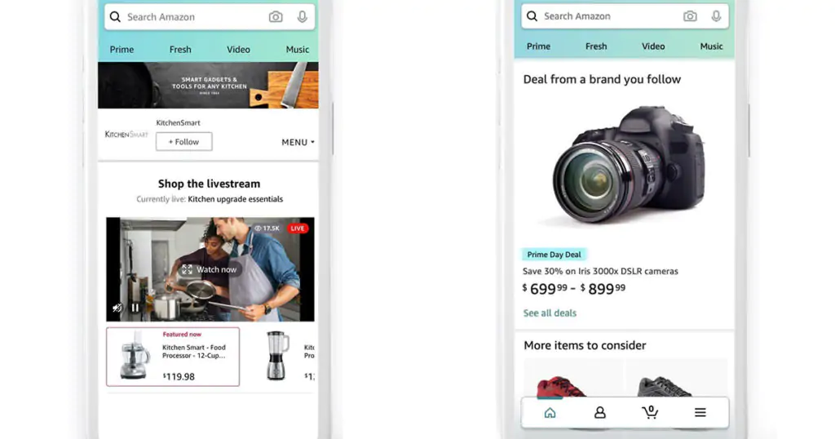

* **Sponsored display ads on Twitch** Amazon is also building on the sponsored display ads on Twitch’s Browse tab and directory pages, which were first introduced in June. Now, these ads will also be integrated into Twitch livestreams in the U.S., U.K., Canada, France, Germany, Italy and Spain.
* **Amazon Marketing Cloud** Amazon Marketing Cloud (AMC), an analytics platform that debuted in January, is now more closely integrated with the ecommerce giant’s demand-side platform.
  + Advertisers can upload their own data and query it alongside data from Amazon ad campaigns. Amazon also recently launched a library with templated queries for a range of measurements.

<https://www.adweek.com/commerce/amazon-advertising-unveils-8-new-tools-and-features/>

## **Facebook is now Meta: Tech giant announces rebrand**

Facebook’s Mark Zuckerberg announced Thursday that the tech company is renaming itself to “Meta” to encompass its expanding technology and role in what it calls, **“the metaverse.”**

* **What’s the metaverse?** The way that Zuckerberg explains it in his founder’s letter today makes it sound like the next level of virtual reality: “You will be able to teleport instantly as a hologram to be at the office without a commute, at a concert with friends, or in your parents’ living room to catch up.”
* **What does this mean for Facebook?** “Starting with our results for the fourth quarter of 2021, we plan to report on two operating segments: Family of Apps and Reality Labs,” said the announcement.
* Meta’s metaverse may offer interesting new opportunities, especially for digital goods. This may be a logical extension for brands, like Asics or Dolce & Gabbana, that are already trying their hand at NFTs. This also begs the question of whether the metaverse will become a new frontier for advertising (especially as the Oculus has been testing [ads in VR](https://searchengineland.com/facebook-testing-virtual-reality-ads-in-oculus-vr-349694)).

<https://about.fb.com/news/2021/10/facebook-company-is-now-meta/>

## **Microsoft Advertising Partners With Shopify & Google Ads Partners With BigCommerce**

Google and Microsoft announced new partnership deals on the ad side. Microsoft Advertising now partnered with Shopify to integrate your products on your Shopify with your ads on Bing Search. Google Ads partnered with BigCommerce to list your products for free on Google, create ad campaigns and review performance metrics directly in their BigCommerce store.

* Microsoft said Shopify merchants will be able to easily reach shoppers on the Microsoft Search Network and Microsoft Audience Network with just a few clicks. The onboarding is simple, allowing merchants to quickly connect with shopping offerings that showcase their products using free and paid listings.
* Google said starting today, we are making it even easier for BigCommerce’s 60,000 merchants to show up across Google.

<https://www.seroundtable.com/google-ads-bigcommerce-microsoft-advertising-shopify-32297.html>

## **AdRoll Becomes a Shopify Plus Partner**

Today AdRoll, a leading marketing automation platform for growing ecommerce brands, announced it has expanded its partnership to become a Shopify Plus Certified App Partner. Shopify Plus supports both hyper-growth and long-standing large ecommerce Shopify merchants by helping them find the apps and solutions they need to build and scale their business, and today AdRoll became the first certified app to provide merchants with advertising technology solutions.

* By integrating AdRoll with their Shopify stores, merchants have access to all of AdRoll’s robust ads, measurement, and email offerings, creating an overall better experience for consumers and stronger results for merchants, including an average 15x return on ad spend (ROAS) .
* In addition to AdRoll’s ecommerce platform capabilities, qualified Shopify Plus merchants will get advanced features including a dedicated account manager to help marketers maximize their Shopify integration – from regular strategy sessions and metric reviews to deep analysis and actionable insights from AdRoll’s Customer Insights and Analytics team, and education and guidance for future-proofing around industry changes like the deprecation of third-party-cookies.
* Shopify Plus customers will also have access to AdRoll’s team of expert designers to produce custom campaign ads in line with merchants’ brand guidelines.
* As a Shopify Plus Partner, AdRoll will be able to build upon its rich dataset, accessing store data from integrated merchants to help fuel better targeting, measurement, and performance for hyper-growth companies. In addition, it allows AdRoll to ingest merchants’ product feed to personalize creative for each user and tracks marketing events on the store to help power our Cross Channel Performance Dashboard, providing insights across every marketing channel a merchant is utilizing.

<https://martechseries.com/mobile/mobile-marketing/e-commerce-and-mobile-commerce/adroll-becomes-a-shopify-plus-partner/>

# Calendar Week 42 (Oct 22)

## **Amazon offers up more data to tell third-party sellers which items will be popular**

Amazon has announced a tool that will give sellers access to information about what shoppers are currently looking for and help make it easier to choose which products to create next. Amazon calls it the Product Opportunity Explorer and says that it’ll give sellers access to data and trends that will help them “identify opportunities to launch new, high-potential products to serve unmet customer demand.”

* With Amazon’s track record of copying popular products and selling them under its Amazon Basics brand, an obvious concern with this tool is where the data is coming from and how granular it is.
* While Amazon quotes a seller saying that they’re excited to get “recommendations specifically relevant” to their business, it’s easy to imagine other sellers being nervous that Amazon’s suggestions could direct businesses to rip off existing products.
* The tool will be giving sellers aggregated data that won’t give out specifics about how other brands are doing. Instead, the company says that the tool will give suggestions for products that perhaps customers are searching for, but not finding.
* **The tool will also give broader category and subcategory metrics, such as what people are searching for, pricing trends, and the like**. In its press release, Amazon says that the tool gives sellers **“rich insights into what customers are searching for, clicking on, and buying, as well as not buying,” along with “detailed data on search volume and growth, sales history, and pricing trends.”**
* There are also other minor concerns — if everyone has access to the same data or gets similar recommendations, could it start more algorithm-directed arms races between sellers to be the first to try to fill a perceived niche? And could Amazon risk damage to its relationship with sellers if the data predicts a product will do well, but it ends up totally flopping? The company may have the opportunity to figure those questions out before they become real problems, though; it will test the Product Opportunity Explorer in beta before releasing it for free to all sellers in 2022.

<https://www.theverge.com/2021/10/20/22736658/amazon-product-opportunity-explorer-tool-sellers-amazon-basics-data>

## **ChannelAdvisor Supports New Amazon Local Selling Program**

ChannelAdvisor launched a solution for sellers who want to offer in-store pickup within the newly released Amazon Local Selling program. The Amazon service was announced at the Amazon Accelerate conference on October 21 and is currently available to select sellers who can deliver products to customers’ homes within local delivery areas or offer Buy Online, Pickup in Store (BOPIS) at their retail stores or warehouses.

* ChannelAdvisor’s new solution helps sellers participating in Amazon Local Selling to manage the in-store pickup experience, including their store setup, store-level inventory, and order status updates (“ready-for-pickup” and “picked up”).
* The in-store pickup service complements the existing solutions ChannelAdvisor provides to sellers who use Amazon services.
* “Online shoppers have grown accustomed to the convenience and speed of in-store pickup. Our solution helps sellers in Amazon Local Selling provide the in-store pick-up options their customers are actively seeking. We’re thrilled to invite sellers to leverage ChannelAdvisor’s expanded support to help grow their businesses.”

<https://www.eseller365.com/channeladvisor-amazon-local-selling/>

## **Microsoft partners with Shopify to help retailers expand their reach**

With the updated Microsoft Channel app “**Shopify merchants can easily connect with shoppers on the Microsoft Search Network and Microsoft Audience Network with just a few clicks**.

* Currently available in the U.S. and Canada, the Microsoft Channel app within Shopify allows businesses to **show up automatically in the Microsoft Bing Shopping tab and the Microsoft Start Shopping tab for free as product listings.**
* Along with an easy way to show up in Bing Product Ads, Product listings on the shopping tab, and Product Listings on the Microsoft Start Shopping tab, Shopify users will soon be able to take advantage of the integration’s new quick checkout option: a **“Buy Now” button on products ads and listings.**

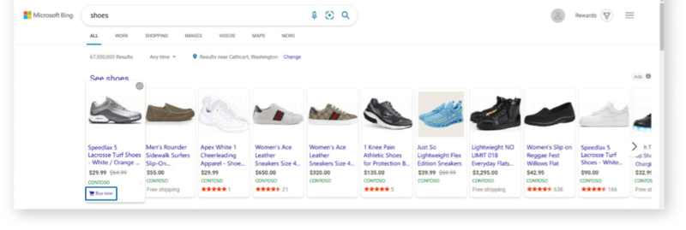

* Website owners and advertisers can easily set up the integration in Shopify.
* This integration and updates to the Microsoft Channel app are just another way to help small businesses, retail, and e-commerce find visibility online.
* The Shopify integration means that these retailers (and even those who are more experienced in selling online) will be reaching online shoppers just in time for the holiday season crunch.

<https://searchengineland.com/microsoft-partners-with-shopify-to-help-retailers-expand-their-reach-375381>

## **Instagram Adds More Demographic Insights For Businesses**

Instagram Insights now provides **key demographic information about a business's engaged** including top cities, top countries, top age ranges, and more.

* Previously, the demographic breakdown in Instagram Insights was limited to users who follow you. Now you can see the demographics of all users you reach, regardless of whether they follow you or have ever engaged with your content.
* The new data is located in Instagram Insights under the sections called **Accounts Engaged** and **Accounts Reached.**
* Instagram is adding **demographic data to audience insights under a section called Accounts Engaged.** The data added includes:
  + Top cities
  + Top countries
  + Top age ranges and gender
* **Accounts Reached** section includes the total number of accounts reached and a demographic breakdown similar to the one in Accounts Engaged.
* Insights is located in the main menu of the Instagram app.

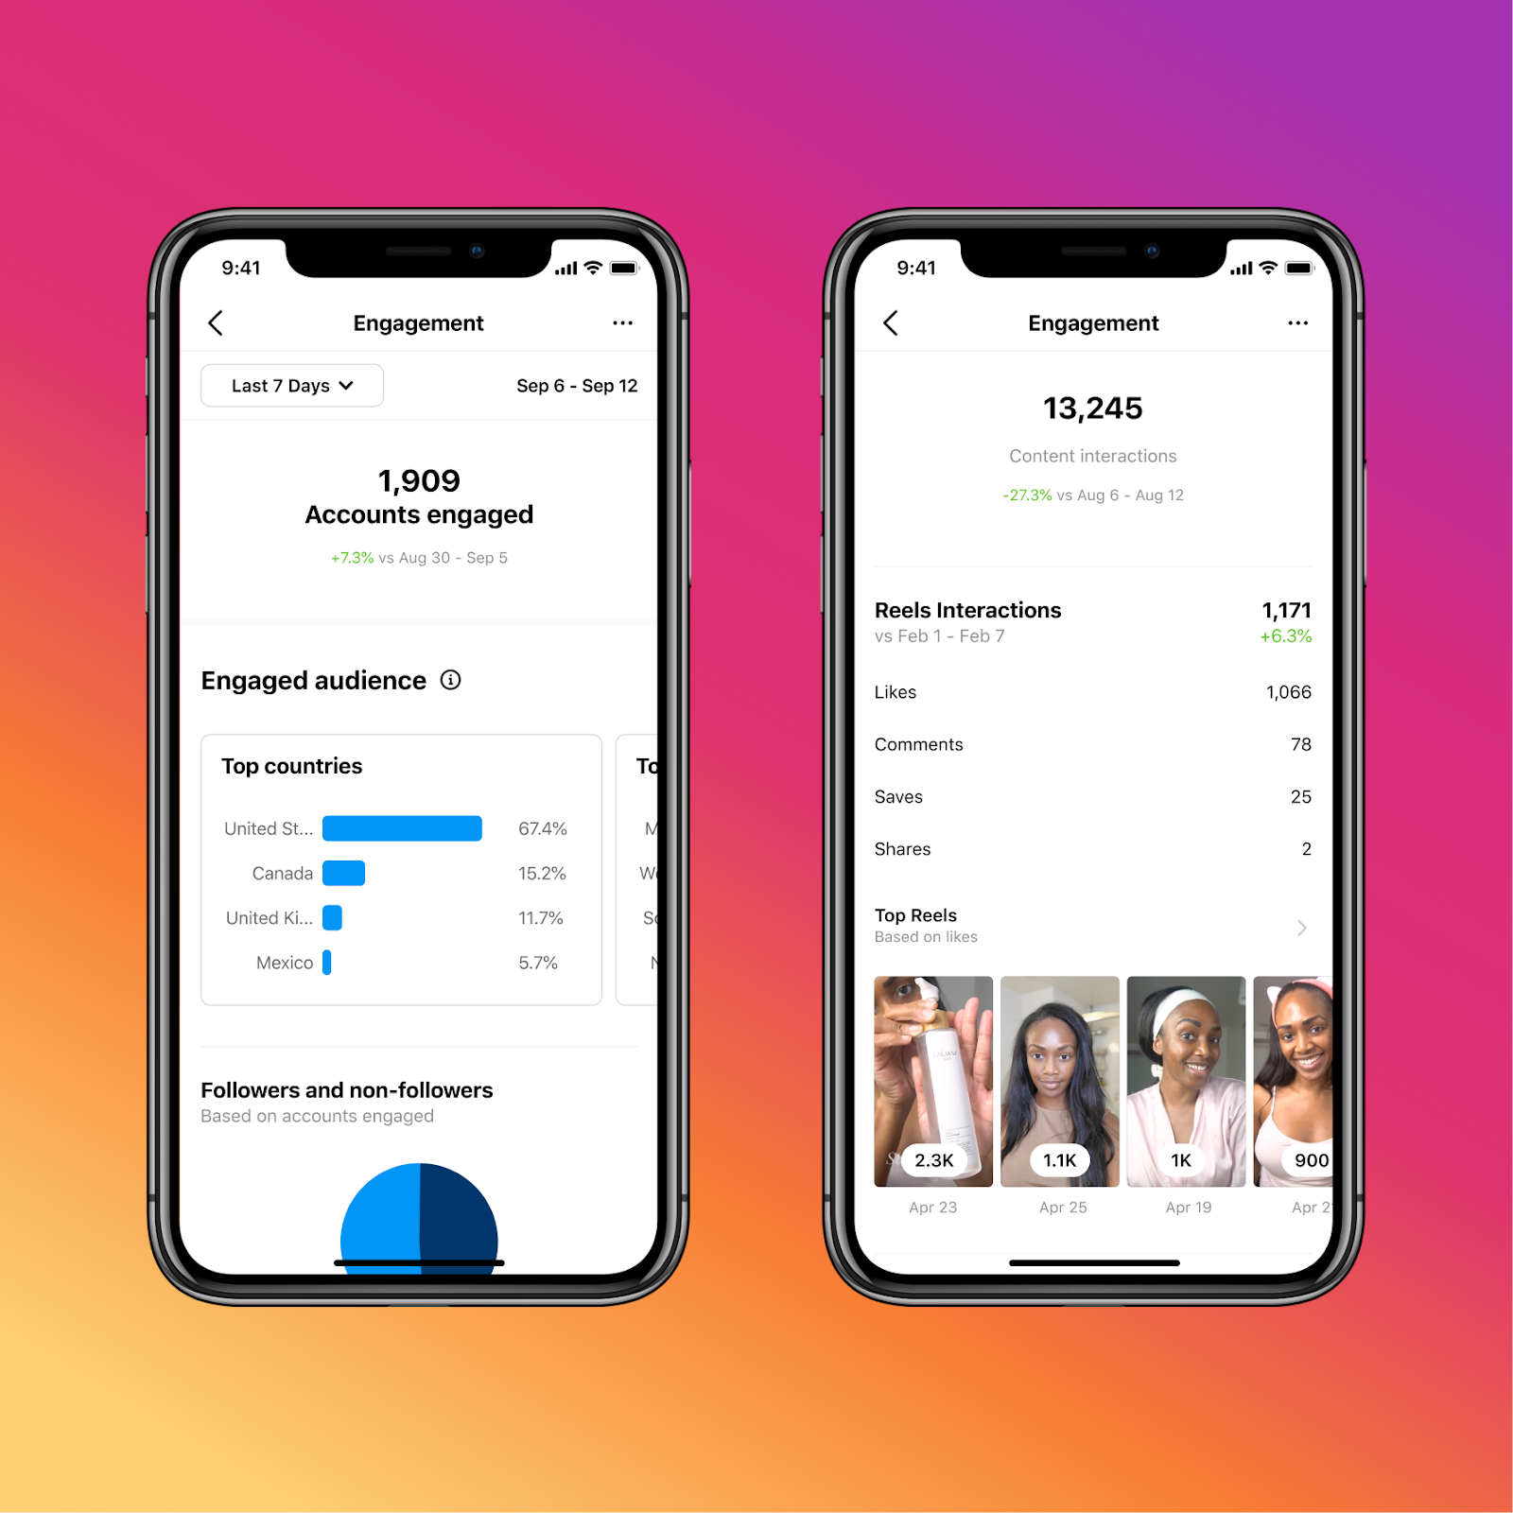

<https://www.searchenginejournal.com/instagram-adds-more-demographic-insights-for-businesses/424088/#close>

## **YouTube Announces Live Shopping and CTV Product Updates**

Google announced the latest live shopping and CTV product updates from YouTube. The announcements provide a clear picture of what’s coming next in streaming and commerce.

* YouTube initially experimented with “shoppable” on-demand videos, and **now the platform is testing “shoppable” livestreams**, as well.
* More recently, YouTube partnered with several top creators to test their new live shopping features, and has also tested shoppable live streams with leading retailers on their channels.
* According to Comscore OTT Intelligence, **40% of all ad-supported streaming watch time is currently taking place on YouTube.**
* **60% of YouTube CTV viewers now watch video content with others.**
* Also new this month, U.S. advertisers can fully measure their YouTube CTV video investments across YouTube and YouTube TV. This provides a more accurate view of true incremental reach and frequency in Comscore Campaign Ratings (CCR).
* YouTube also upgraded Video action campaigns to automatically include CTV inventory recently.

<https://www.searchenginejournal.com/youtube-live-shopping-ctv-updates/424047/>

# Calendar Week 41 (Oct 15)

## **Twitter Rolls Out New Advertising Features, Revamped Algorithm Ahead of E-Commerce Push**

Twitter on Tuesday rolled out new advertisement features and revamped the algorithm that decides which advertisements users see, as part of an effort to lay the groundwork to launch future e-commerce features.

* The new features come as Twitter is pushing to grow its performance advertising business, a strategy that aims to quickly generate sales, and constituted just 15 percent of Twitter's business last year.
* Advertisements promoting downloads for mobile games and other apps, which are a major type of advertisement on social media sites, will now allow users to initiate the download without leaving the Twitter app, the company said in a blog post on Tuesday.
* Twitter added it is working on new tools to let companies run advertisements to find customers who are more likely to make in-app purchases.
* Slide-show advertisements that feature multiple products can now send users to different websites when they click the advertisement, whereas previously brands could only choose one destination.
* Twitter also improved the advertising algorithm, showing the advertisements to a larger pool of people at the beginning of the campaign so it can better gauge user interest.

<https://gadgets.ndtv.com/social-networking/news/twitter-ads-feature-revamped-algorithm-e-commerce-push-advertising-advertisement-in-app-purchase-2573725>

## **Google rolling out continuous scroll on mobile**

Google’s mobile search results now offer infinite scroll, what Google is calling continuous scroll.

* As you scroll, Google will not show you the “more results” button when you reach the bottom of the page, instead, Google will just load the next page of results automatically.

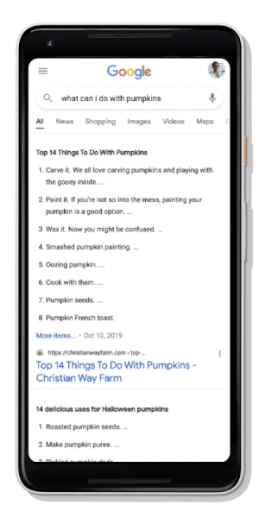

* Google added that while “you can often find what you’re looking for in first few results, sometimes you want to keep looking.” And for those searchers who want to keep on looking, you will be able to continuously scroll “up to four pages of search results” without clicking to load more.
* It is yet to be determined how this might impact your click-through rates and traffic from Google search but keep an eye on it.

<https://searchengineland.com/google-rolling-out-continuous-scroll-on-mobile-375171>

## **Microsoft will shutter LinkedIn in China by the end of the year**

Microsoft will shut down its localized version of LinkedIn in China by the end of the year, the company announced Thursday.

* The company cited a difficult operating environment, enhanced compliance requirements and a lack of success with the social aspects of its platform as reasons for shutting down LinkedIn in China.
* As it sunsets LinkedIn, Microsoft plans to launch InJobs, a new, standalone jobs application for China, later this year as well. Unlike LinkedIn, InJobs will not have a social feed or the ability to share posts or articles.
* Sunsetting LinkedIn in China is likely to hinder B2B businesses that have a partner there or rely on the platform for communication with potential partners. Additionally, LinkedIn advertisers will no longer have access to users in China. However, it is likely that InJobs will offer some of these capabilities.
* With regards to the social media industry, LinkedIn is the last domino to fall as all other major U.S.-based social media platforms — like Facebook, Instagram, Twitter, Twitch, Pinterest and Reddit, to name a few — are blocked in China.

<https://searchengineland.com/microsoft-will-shutter-linkedin-in-china-by-the-end-of-the-year-375189>

## **Pinterest rolls out new shopping features for advertisers**

Pinterest is rolling out [new features](https://business.pinterest.com/blog/new-pinterest-shopping-features-to-help-people-find-what-they-love/) for advertisers and brands to promote their products to users on its site. The launch marks the company’s latest initiative to grow online shopping and advertising on its platform.

* A new “slideshow for collections” feature pulls products from brands’ catalogues and automatically turns them into a “collections ad.
* ” Pinterest notes that this new feature will help advertisers easily produce video-like content tailored to individual users.
* The aim is to encourage shoppers to purchase more items at once, as the company notes that shoppers on Pinterest have 85% bigger baskets than shoppers on other platforms and spend twice as much per month. Since shoppers will be browsing more than one product at a time through the slideshow feature, they’re more likely to purchase additional items.
* Pinterest is launching another new feature called “merchant details” to allow brands to showcase their values on their profile.
* Brands can showcase values such as “responsibly sourced” and “inclusive.” Further, companies can also highlight communities that they are a part of, such as “Women-owned” and “Black-owned.”
* The company is also expanding its Verified Merchant Program, which helps users find vetted brands, to Austria, Brazil, Italy, Mexico, the Netherlands, Spain and Switzerland. Brands who have been vetted get enhanced distribution and a “verified” badge on their profiles.
* Pinterest is also testing a new “Idea Ads with paid partnership” feature that is a joint partnership between creators and advertisers. As part of the feature, the creator makes an Idea Pin and tags a brand partner. The advertiser can then promote the Idea Pin as an Idea Ad. The company notes that this kind of partnership helps businesses and creators reach more users on the platform.

<https://techcrunch.com/2021/10/06/pinterest-rolls-out-new-shopping-features-for-advertisers/>

# Calendar Week 40 (Oct 08)

## **Google AdSense switching to first-price auctions as part of continued simplification**

Google today [informed](https://blog.google/products/adsense/our-move-to-a-first-price-auction/) users and ad buyers alike that AdSense for Content, Video, and Games is switching to first-price auctions in the coming months.

* AdSense previously used a sealed-bid [second-price auction](https://en.wikipedia.org/wiki/Vickrey_auction) for buyers wanting to purchase ad space. It involved the winner — who offered the most — only paying the amount of the second-highest bid.
* AdSense is now following and adopting a first-price auction to “help advertisers by simplifying how they buy online ads.”
* In doing so, Google says it is “aligning our process with other ad selling platforms in the display advertising ecosystem,” including its own Ad Manager and AdMob. However, this upcoming move does not impact AdSense for Search or Shopping.
* End users were emailed today and told they will “likely not see a change in [their] earnings.” There will also be no changes to ad formats. The transition is automatic, and will be completed by the end of this year.

<https://www.adexchanger.com/online-advertising/why-non-advertising-businesses-are-going-into-ads/>

## **Why Non-Advertising Businesses Are Going Into Ads**

One of the most important trends in advertising right now is the rapid growth of ad businesses stood up by non-advertising companies.

* The OG of this category is Amazon. The online retailer has shown ads can be a high-margin addition to the bottom line, boosting profit without heavy upfront investments for any business with valuable data and real estate for potential ads in an app or site.
* It came as no shock when Instacart, the online grocery delivery platform and an Amazon Fresh competitor, launched a self-service ad platform last year. Or this year when buy now pay later (BNPL) services Klarna and Afterpay, which offer installment-style payments for ecommerce, started testing in-house ad networks powered by their financial data.
* Uber is also investing heavily in its ad business, including the [recent hire](https://www.adexchanger.com/ad-exchange-news/friday-03012021/) of Mark Grether from Amazon Advertising.

<https://www.adexchanger.com/online-advertising/why-non-advertising-businesses-are-going-into-ads/>

## **Wavemaker strikes ‘world first’ Amazon Advertising collaboration**

Wavemaker has secured a deal to access Amazon Advertising’s "Overlapping Audiences" API, which provides brands with insights to help understand the relationships between a brand’s audience and other audiences on Amazon.

* The Group M agency claims it is the first globally to integrate the API directly into its "Provocative Planning" platform.
* Wavemaker said this would enable planners to access Amazon’s audience insights directly to integrate into media plans and campaigns, which would “create strong audience strategies and realise clients’ digital maturity plans”.
* Wavemaker global head of ecommerce Mudit Jaju said: “With access to Amazon Advertising’s Overlapping Audiences API we can better optimise our clients’ Amazon campaigns and help them drive growth.”

<https://www.campaignasia.com/article/wavemaker-strikes-world-first-amazon-advertising-collaboration/473051>

## **The Amazon and Shopify Venn Diagram**

The overlap of sellers that sell on both Amazon and Shopify is growing. What used to be separate and distinct groups of entrepreneurs is converging. Amazon marketplace developed years before Shopify would gain momentum. It inspired a type of business built to sell on Amazon. Many of them sold goods bought wholesale from established brands. Over time, competition among resellers and thus the ever-decreasing margins forced the industry to look for other opportunities. That opportunity was private label brands.

* Many of those businesses were built around Amazon and thus tailored their business models around it. For example, most relied on FBA for fulfillment. That made other channels more difficult or expensive to sell on. But since Amazon was (and still is) the largest, they made a calculated risk that building an all-in-on-Amazon business and hence suffering from asset specificity was the right call.
* But e-commerce continues to evolve beyond Amazon. Shopify grew to be [40% as large as the Amazon marketplace](https://www.marketplacepulse.com/articles/shopify-is-40-as-big-as-amazon-marketplace) almost out of nowhere. However, Shopify is just one of many companies. The results of Shopify instead represent the evolution and acceptance of direct-to-consumer commerce. More businesses learned to sell online, and more customers found them there.
* While many Amazon-focused sellers continued to wait for the next marketplace to challenge Amazon and thus allow them to diversify, the next marketplace turned out to be direct-to-consumer. Instead of expecting Walmart, Target, Wish, Google, and many other companies that promised to be challengers to deliver, the option arrived in the form of Shopify.

<https://www.marketplacepulse.com/articles/the-amazon-and-shopify-venn-diagram>

## **Google Search Console Adds More Detail to Error Reports**

Google is updating the rich results error reports in Search Console with additional details that should assist with resolving specific issues.

* *“Today we’re adding more details to some errors on Search Console Rich Results status reports to make them more actionable and help you understand how to solve those issues. Learn more about using the rich result reports and try it out!“*
* In short, it’s designed to identify any errors in your website’s structured data that could prevent pages from being served as rich results in SERPs.
* When it comes to using the rich results report in Search Console to identify and fix errors, nothing has changed there.
* Search Console is not reporting on new of types errors, it’s simply adding more information about errors it already checks for.
* Specifically, more details are being added about the following types of errors:
  + Invalid attribute string length
  + Invalid attribute enum value
  + Invalid object
  + Type conversion failed

<https://www.searchenginejournal.com/microsoft-advertising-launches-open-beta-for-credit-card-ads/419828/>

# Calendar Week 39 (Oct 01)

## **Microsoft Advertising Launches Open Beta for Credit Card Ads**

Microsoft Advertising announced an open beta for a new ad unit, called **credit card ads**. Credit card ads are available to advertisers targeting the United States and Canada.

* **Credit card ads are feed-based, dynamically generated ads.** The ads are created purely from the feeds – and are not triggered by keywords, or site content.
* Feeds for credit card ads include things like the card issuer, cash-back percentages, rewards, annual fees, and sign-up bonuses.
* Credit card ads are available on the right rail of the Bing SERP, alongside text ads.
* While advertisers do not input keywords, Microsoft shared some of the types of queries that credit card ads will show for, including: brand name, card category, credit level, and more.

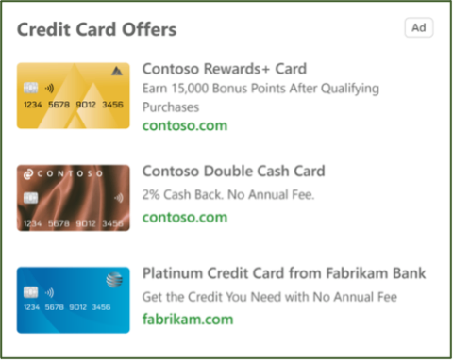

* Microsoft notes that the credit card ads auction is separate from the text ads auction. Advertisers can leverage both the credit card ads auction and also participate in the text ad auction with regular search campaigns。

<https://www.searchenginejournal.com/microsoft-advertising-launches-open-beta-for-credit-card-ads/419828/>

## **Google Ads announces machine learning-based data-driven attribution models in new privacy landscape**

In a move away from last-click, **data-driven attribution** will soon be the default attribution model for all new Google Ads conversion actions.

* **[Data-driven attribution]** uses advanced machine learning to more accurately understand how each marketing touchpoint contributed to a conversion, all while respecting user privacy.
* **Data-driven attribution** looks at all the interactions—including clicks and video engagements—on your Search (including Shopping), YouTube, and Display ads in Google Ads. By comparing the paths of customers who convert to the paths of customers who don’t, the model identifies patterns among those ad interactions that lead to conversions.
* The data-driven attribution model is now available for Search, Shopping, Display and YouTube ads.
* Data-driven attribution provides advertisers and businesses with reporting that better reflects the full marketing journey and higher performing bidding, which adapts to customers’ real journeys to conversion.

<https://searchengineland.com/google-ads-announces-machine-learning-based-data-driven-attribution-models-in-new-privacy-landscape-374727>

## **Etsy embraces virtual shopping with interactive AR show home**

E-commerce firm Etsy, a specialist in vintage and craft items, is spreading its wings in the digital domain with an interactive augmented reality (AR) show home populated entirely by curated products.

* [The Etsy House](https://www.theetsyhouse.com/) permits buyers to wander through the virtual environment at their leisure while perusing the goods in situ around them to get a better feel for how the items fit into a domestic environment.
* Utilizing photorealistic rendering and life-size scale, the interactive experience employs intuitive navigation and 360° environments to transport potential customers for the ultimate in window shopping.
* The fully shoppable experience will reduce transaction friction to the bare minimum, with pop-up product information and purchase links materializing as soon as you hover over an active item.

<https://www.thedrum.com/news/2021/09/28/etsy-embraces-virtual-shopping-with-interactive-ar-show-home>

## **SellerApp releases a new feature for Bulk Operations in Amazon Advertising**

SellerApp sets a milestone for Amazon businesses with its new feature on Bulk Operations. Their PPC Analyzer tool is further enhanced with a new section - Bulk actions, which helps sellers manage multiple campaigns seamlessly, save time and improve operational efficiency.

* This tool is the first of its kind among all other Amazon third-party seller apps. There are multiple ways in which sellers can use the Bulk Actions tool to their advantage. Sellers with multiple campaigns running can easily manage and optimize them by leveraging this AI-powered tool.
* “With Bulk Actions, sellers now won’t need to separately optimize their bids and keywords with the bulk upload feature. Our tool is a spreadsheet-based system that enables optimizing ad campaigns, downloading files, editing metrics, and uploading them to the SellerApp dashboard.
* The Bulk Files can not only help sellers manage their campaigns, but the massive spreadsheet comprises every piece of data required to optimize the PPC ads.

<https://www.einnews.com/pr_news/552699601/sellerapp-releases-a-new-feature-for-bulk-operations-in-amazon-advertising>

## **Google Ads launches new budget report**

Google Ads is launching a new budget report to visualize monthly campaign spend behavior, the company [announced](https://support.google.com/google-ads/answer/11202082) Thursday. The report shows daily spend, monthly spending limit, monthly spend forecast, cost to date and budget changes you’ve made that particular month.

* **What the budget report shows:** The budget report shows daily spend, your campaign’s monthly spending limit (solid grey line), your monthly spend forecast (dotted blue line), cost to date (solid blue line) and any budget changes you’ve made during that particular month.
* The shaded blue area shows the prediction intervals that indicate the upper and lower bound that the actual aggregate spend will likely land for a given day. Changes to your average daily budget are represented by arrow icons on the days the budget changed and you can hover over the arrows to see the budget changes.

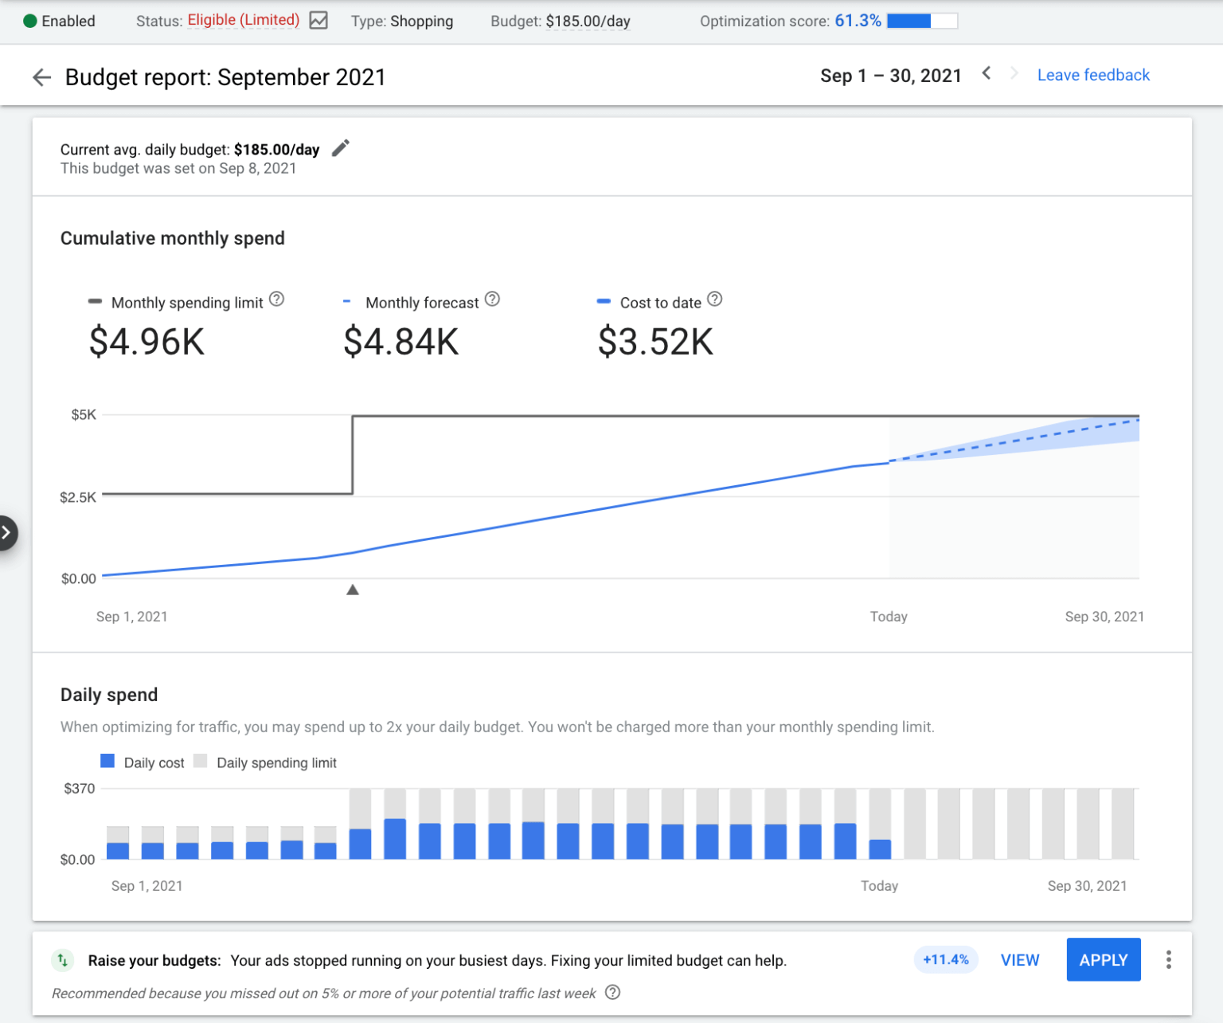

* **How to access the budget report.** To see the budget report, you’ll first need to have a campaign with a date range that includes the current month. The budget report is accessible from the Campaigns page, the shared library and the Ad groups page.
* This new report can help advertisers understand how editing their budget can impact the campaign’s spending limits, how past changes to average daily budget can affect performance and spend limits, and how much they’re projected to pay at the end of month. That information can then be used to improve their planning.

<https://www.einnews.com/pr_news/552699601/sellerapp-releases-a-new-feature-for-bulk-operations-in-amazon-advertising>

# Calendar Week 38 (Sep 24)

## **Google ads to get more transparent by offering access to advertiser’s recent history**

Google today announced a change to its online ads, which will now **display new disclosures that allow web searchers to see** not just who the advertiser is and why the ad was served to you, but also **what other ads the advertiser has run with Google**, starting with the most recent.

* The changes are a part of Google’s broader revamp of its ads business in the face of increased regulatory scrutiny and a broader shift across the tech industry to technologies that promote transparency and consumer privacy.
* Within these new advertiser pages, anyone will be able to click to **learn more about the advertiser and access a menu where they can view all the ads a specific advertiser has run over the past 30 days.**
* Google presents this as a useful tool from a consumer perspective, by noting how a consumer who saw a product for sale, like a coat, could use the tool to learn more about a brand and its other products.

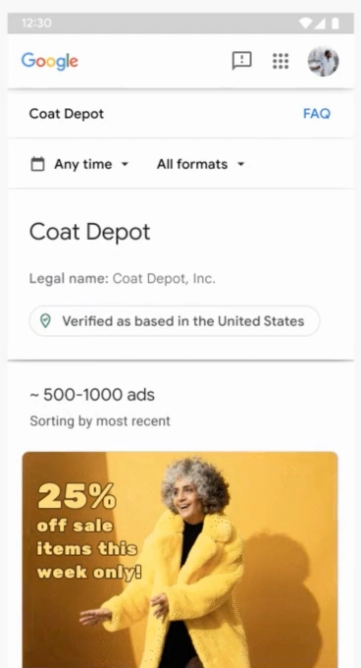

* Google says the new ad disclosures “build on our efforts to create a clear and intuitive experience for users who engage with ads on Google products.”

<https://techcrunch.com/2021/09/22/google-ads-to-get-more-transparent-by-offering-access-to-advertisers-recent-history/>

## **Understanding attention on TikTok: Ads drive strong brand impact across view durations**

A recent study shows that TikTok ads drive strong brand recall and positive sentiment across various view durations. The study was conducted in partnership with MediaScience and shows that **brands on TikTok are more memorable and perceived more positively than brands on competitive platforms.**

* This research study, commissioned by TikTok's Marketing Science team, was conducted in the United States with 343 in-lab respondents between the ages of 18 and 45.
* Overall, ads on TikTok were found to drive higher early user engagement and attention, showed stronger brand recall, and generated more positive brand sentiment than other platforms tested.
* **TikTok ads are engaging and memorable, even at short durations** Brand recall increases the longer an ad is watched, but ads on TikTok see strong brand recall regardless of view duration. An ad on screen 6 seconds or less still delivered 38% of the recall compared to ads viewed 20 seconds or more.

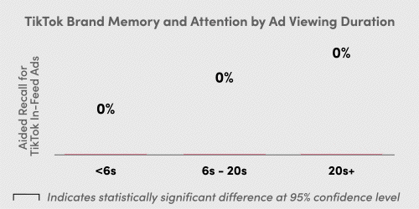

* **Attention and engagement are captured early** Regardless of how long an ad stays on screen, TikTok draws early attention and physiological engagement in the first few seconds.

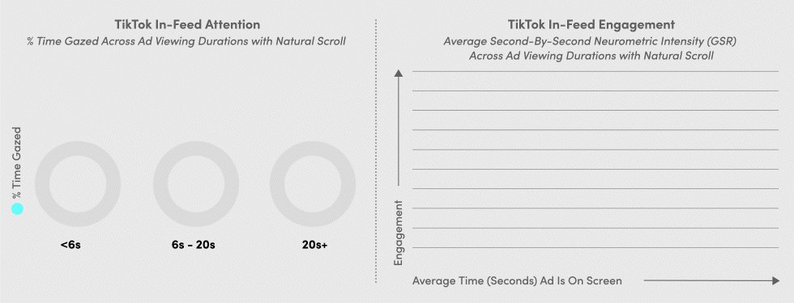

* TikTok drives better brand recall compared to other leading social platforms

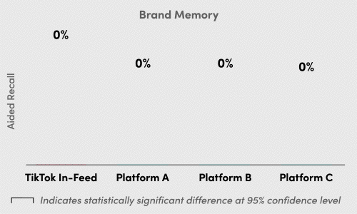

* Ads on TikTok see more positive brand perception

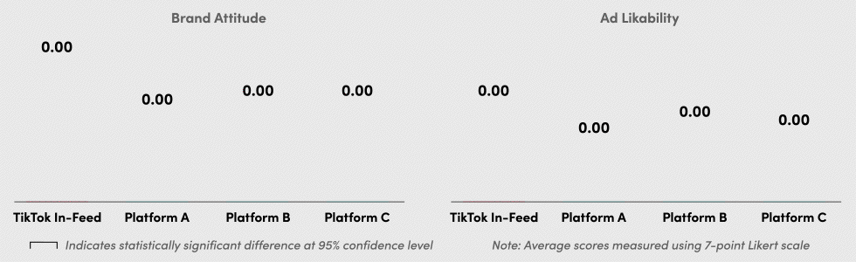

<https://www.tiktok.com/business/en-US/blog/mediascience-study-brands-memorable-tiktok>

## **Amazon is piling ads into search results and top consumer brands are paying up for prominent placement**

Until recently, Amazon put two or three sponsored products at the top of search results. Now, there may be as many as six sponsored products that appear ahead of any organic results, with more promotions elsewhere on the page.

* The number of ads that appear differs depending on the exact search term and other factors such as whether users are shopping on desktop, mobile or in the Amazon app, Amazon says.
* Advertising revenue was the fastest-growing part of Amazon’s overall business in the second quarter, with revenue soaring 87% from a year earlier to more than $7.9 billion.

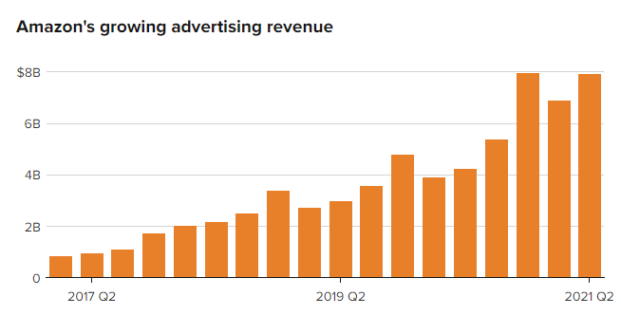

* For brand owners, the price of doing business on Amazon is surging as the company expands its dominance in online commerce. The cost per click for Amazon search advertising was $1.27 in August, up from 86 cents a year ago, according to a survey of more than 300 Amazon sellers.

<https://www.cnbc.com/2021/09/19/amazon-piles-ads-into-search-results-as-big-brands-pay-for-placement.html>

## **Microsoft Advertising launches Marketing with Purpose Business attributes**

New attributes from Microsoft Advertising allow businesses to indicate their dedication to “responsibility, how your brand values align with the values of your customers, and how your brand is being inclusive”.

* “Marketing with Purpose Business Attributes allow you to communicate quickly and easily how your brand is ‘for someone like me.’ They allow you to be authentic, which is the key attribute to building trust with customers,” said the blog.
* The idea behind the initiative is to “build a brand that’s welcomed into people’s lives by earning genuine trust, upholding their values, and inclusively advertising.”
* The attributes advertisers can choose from fall under four main categories: **inclusion, environmental, community/social responsibility, and accessibility.** Within those categories, there are 32 attributes that a business can choose.
* 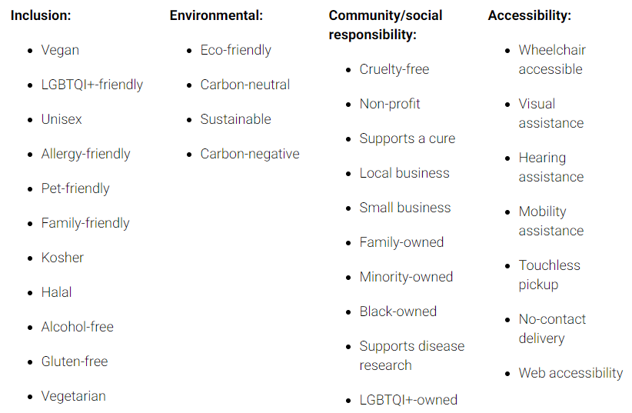

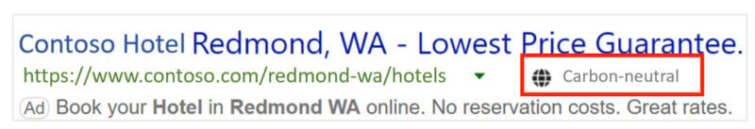

<https://searchengineland.com/microsoft-advertising-launches-marketing-with-purpose-business-attributes-374650>

## **Facebook Has New Ways to Generate Leads & Connect With Customers**

Facebook is rolling out new free and paid business tools designed to help businesses find new customers and connect with them in more ways.

* Facebook is updating its **click-to-message ads,** which encourage people to connect with businesses through Messenger, Instagram Direct, or WhatsApp.
  + Businesses can invite customers to connect through all the messaging platforms where they’re available to chat, whether they’re owned by Facebook or a third party.
* Facebook is flexing its integration capabilities with the launch of a new feature that involves WhatsApp and Instagram.
  + It’s now **possible for businesses to add a WhatsApp click-to-chat button to their Instagram profile.** This may encourage more customers to connect with businesses if they prefer WhatsApp over Instagram DMs.
* A brand new feature from Facebook wil**l allow businesses to invite customers to request a quote.**
  + Businesses can customize their request form by selecting 4-5 questions to ask consumers prior to sending a message.
* Facebook plans to test paid and organic tools to help small businesses find and qualify leads directly within the Instagram app.

<https://www.searchenginejournal.com/facebook-has-new-ways-to-generate-leads-connect-with-customers/420325/>

# Calendar Week 37 (Sep 16)

## **Google Ads will combine Smart and standard Display campaigns**

Google Ads will combine **standard Display campaigns and Smart Display campaigns** into a single option, the company announced on Wednesday. In addition, Google Ads will also be introducing **optimized targeting** to Display campaigns.

* In this **new Display campaign experience**, advertisers will have the ability to choose the level of automation they prefer in bidding, creatives and audiences.
* During the campaign setup process, advertisers can choose what to automate or control manually, and they can change their automation choices at any time without having to create a new campaign.
* Existing Smart & Standard Display campaigns aren’t affected by this change at this time. Once this update is rolled out in the advertiser's account, they’ll see the new Display campaign type option and workflow when you create a new campaign.
* Along with this change, Google Ads will also introduce **optimized targeting,** which treats audience settings as signals to find audience segments that may improve campaign performance, to Display campaigns.

<https://searchengineland.com/google-ads-will-combine-smart-and-standard-display-campaigns-374449>

## **Shopify Makes it Easy to Market to Specific Countries**

Shopify is making it easier to optimize ecommerce stores for **international markets all from a single Shopify site.**

* Up until now, if a business wanted to reach a global market, they’d have to sell on a marketplace or through another retailer.
* A new solution called **Shopify Markets removes the need for a third party** and allows businesses to sell directly to international consumers.
* **With Shopify Markets** merchants can sell outside of their home country without having to worry about complexities like currency conversion, language localization, providing local payment methods, and duty and import taxes.
* Shopify store owners can target single country markets, or create custom markets by grouping multiple countries together.
* Features will vary according to your plan. These are the **features included with all Shopify plans:**
  + Manage how you sell to each market from one place
  + Sell in 133 currencies with Shopify Payments
  + Provide local payment options with Shopify Payments
  + Sell in up to 20 languages
  + Set up custom domains to optimize for search
  + Smart settings that optimize market operations
* Those on **Advanced Shopify and Shopify Plus plans** get these additional features:
  + Estimate and collect duty and import taxes at checkout
  + Set custom pricing per market with Shopify Payments
  + Customize catalogs and storefront per market
  + Manage fulfillment locations per market.
* **Shopify Markets is available in early access globally as of September 14**, and will roll out to all merchants in the coming months.

<https://www.searchenginejournal.com/shopify-markets/419994/>

## **YouTube Adds Traffic & Revenue Data to Mobile Analytics**

YouTube is bringing more analytics reports to mobile that were previously only available on desktop, which includes data about traffic sources and revenue.

* As part of this initiative, creators are getting access to **two new reports under the revenue tab in the Studio Mobile app.**
  + **Monthly Revenue Report** This report shows estimated revenue for the current month, along with historical data so you can compare month over month performance.
  + **Transaction Revenue Report** This report shows where your earning came from which includes channel memberships, Super Chats, Super Stickers, and other things that are paid for by viewers.
  + **Traffic Sources Performance Report** Previously available only in the video overview section of YouTube Studio on desktop, creators will now have access to the traffic sources report on mobile.
* Previously available only in the video overview section of YouTube Studio on desktop, creators will now have access to the traffic sources report on mobile.
* In another update for creators in the YouTube Partner Program — if you get banned from the program you can now submit **an appeal via video.** 
  + When a creator believe’s YouTube’s reviewers made a mistake, they can record a video explaining why their channel doesn’t violate monetization policies.
  + Then YouTube’s policy team will review the video, and the channel as a whole, with that added context in mind.

<https://www.searchenginejournal.com/youtube-mobile-analytics/419837/>

## **Facebook revamps its business tool lineup following threats to its ad targeting business**

Facebook today is announcing the launch of new products and features for business owners, following the threat to its ad targeting business driven by Apple’s new privacy features, which now allow mobile users to opt out of being tracked across their iOS apps. The social networking giant has repeatedly argued that Apple’s changes would impact small businesses that relied on Facebook ads to reach their customers.

* As the ability to track consumers declines — very few consumers are opting into tracking, studies find — **Facebook is rolling out new features that will allow businesses to better position themselves in front of relevant audiences.** This includes updates that will let them reach customers, advertise to customers, chat with customers across Facebook apps, generate leads, acquire customers and more.
* The company earlier this year began testing a way for customers to explore businesses from underneath News Feed posts by tapping on topics they were interested in — like beauty, fitness and clothing, and explore content from other related businesses. The feature allows people to come across new businesses they may also like, and would allow Facebook to create its own data set of users who like certain types of content. **Over time, it could possibly even turn the feature into an ad unit, where businesses could pay for higher placement.**
* Facebook is also making it easier for businesses to chat with customers. They’re already able to buy ads that encourage people to message them on Facebook’s various chat platforms — Messenger, Instagram Direct or WhatsApp. Now, they’ll be able to choose all the messaging platforms where they’re available, and Facebook will default the chat app showcased in the ad based on where the conversation is most likely to happen.
* The company will tie WhatsApp to Instagram, as well, as part of this effort. Facebook explains that many businesses market themselves or run shops across Instagram, but rely on WhatsApp to communicate with customers and answer questions. So, Facebook will now allow businesses to add a WhatsApp click-to-chat button to their Instagram profiles.
* Separately from this news, Facebook announced the launch of a new business directory on WhatsApp, **allowing consumers to find shops and services on the chat platform, as well.**
* Another set of changes being introduced involve an update to Facebook Business Suite. **Businesses will be able to manage emails through Inbox and send remarketing emails**; use a new File Manager for creating, managing and posting content; and access a feature that will allow businesses to test different versions of a post to see which one is most effective.
* **Other new products include tests of paid and organic lead generation tools on Instagram; quote requests on Messenger**, where customers answer a few questions prior to their conversations; and a way for small businesses to access a bundle of tools to get started with Facebook ads, which includes a Facebook ad coupon along with free access to QuickBooks for three months or free access to Canva Pro for three months.

[https://techcrunch.com/2021/09/16/facebook-revamps-its-business-tool-lineup-following-threats-to-its-ad-targeting-business/?](https://techcrunch.com/2021/09/16/facebook-revamps-its-business-tool-lineup-following-threats-to-its-ad-targeting-business/?guccounter=1&guce_referrer=aHR0cHM6Ly93d3cuZ29vZ2xlLmRlLw&guce_referrer_sig=AQAAAJJACsIx2V3pEo2VGcz2XsFplH5MUSnvWAmlyPcyXmu9ZFLlXTVrcT0SWP6QzrHUsTen1kl0XellNSJSW_b4OEf1plbQ4zMs94AGpQzwynRv6xR-7k_x7siiYjSJ4yZ2qoJa42jILOFdQ4G1QOwsdfmUD7iiVJ9kGNBJNlmg596s)

# Calendar Week 36 (Sep 10)

## **Google to Begin Sharing More Search Term Data With Advertisers**

Google Ads announced that **it will begin sharing more search term data with advertisers.**

* Google estimates that **advertisers could see 6.5x more search term data, on average.**
* Search term data will be retroactively populated back to February 1, 2021 for applicable search terms.
* As part of a focus on improving privacy, Google has decided to remove search term data pre-dating September 1, 2020, when the initial privacy restrictions were rolled out to govern search term reporting.
* Google has been working on ways to share data back to advertisers while upholding high privacy standards that are consistent across all areas of the account.
* Google also noted that it plans to share additional data in the **Insights page** in the coming months to **help advertisers understand how customers found them on search.**

<https://www.searchenginejournal.com/google-to-begin-sharing-more-search-term-data-with-advertisers/419065/#close>

## **Video and vertical-based product ads pilots arrive on Microsoft Audience Network**

**Video ads and vertical-based product ads** are now being piloted on the **Microsoft Audience Network**, Microsoft announced on Tuesday .

* **Video ads** are now available on the **Microsoft Audience Network as a pilot program** in the U.S., Australia, Canada, France, Germany, New Zealand and the U.K.
* Videos can be between six seconds and two minutes in length, and video ads on publisher partner placements will also be coming soon.
* The company is also piloting another Microsoft Audience Network feature — **vertical-based product ads,** which use an advertiser’s existing feed to generate ads for auto listings, entertainment events, hotels, tours and activities and vacation rentals in native environments.
* Microsoft Advertising is introducing disclaimers in ads (as shown below). While this feature isn’t specific to regulated industries, it can be particularly useful for advertisers in verticals in which consumers may need to be informed about details related to your business.

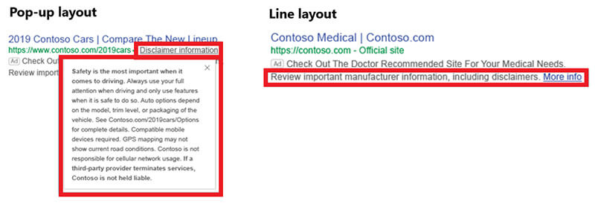

* Microsoft will be adding inline appeals for product ads to Microsoft Merchant Center ahead of the holidays (the company did not specify an exact date). It is designed to give advertisers an overview of policy violations that may be driving editorial rejections for offers.

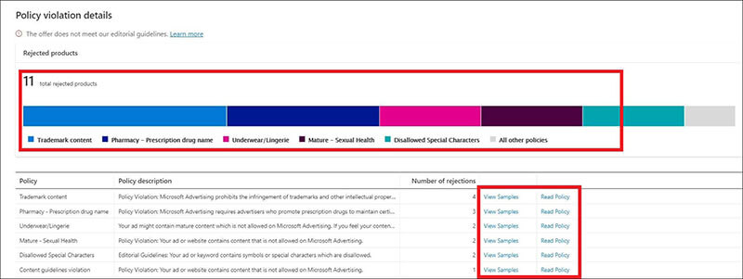

* Microsoft is also launching third-party integrations with Google Tag Manager, Shopify, Squarespace and WordPress.

<https://searchengineland.com/video-and-vertical-based-product-ads-pilots-arrive-on-microsoft-audience-network-374271>

## **TikTok Reveals What Makes A High Performing Ad On Its Platform**

TikTok has published 4 best practice tips that have resulted in increased impressions for their video ads. The social platform also gives advice to eCommerce brands.

* TikTok saw the following best practices improve impressions compared to other video ads that didn’t set them.
  + **Video Resolution Of At Least 720P** 83.19% of the platform’s top-performing videos have a minimum of this resolution.
  + **Vertical Aspect Ratio** Of the top-performing videos on TikTok, 82.13% of them utilized a vertical aspect ratio.
  + **Use Of Audio** 93.02% of the highest-performing videos on TikTok used audio, which led to a 16.05% increase in impressions.
  + **9:16 Aspect Ratio** 98.63% of the highest performing videos had this aspect ratio, which saw a 60.45% lift in impressions.
* TikTok gave three more pieces of advice for **eCommerce Brands** to help increase campaign performance:
  + **Feature An Offer Of Some Sort** Although only 3.21% of TikTok’s highest performing videos showed somebody highlighting an offer of some kind, these saw impressions rise by 67.4%
  + **Include Scene Variations** 99.29% of the best performing videos published on TikTok made use of different angles and shots. This resulted in 40.56% lift in impressions.
  + **Don’t Forget The Closed Captioning** Not only does this help make your videos more accessible, but it can also increase impressions by 55.68%.

<https://www.searchenginejournal.com/tiktok-reveals-what-makes-a-high-performing-ad-on-its-platform/418657/>

## **Chinese Sellers Losing Market Share on Amazon**

Chinese sellers have been losing market share on the Amazon marketplace for most of 2021. This year, after increasing market share for years, the trend has unexpectedly reversed.

* So far, 2021 has been an anomaly compared to the five years preceding it. Previously, Chinese sellers’ market share of the top sellers increased every year: from 16% to 22% in 2017, from 23% to 26% in 2018, from 26% to 33% in 2019, and from 35% to 42% in 2020. The same trend held for the estimated share of GMV too.
* Currently, 38% of the top sellers are based in China, down from 40% at the start of the year.
* In May 2020, Chinese sellers’ market share shrunk because of disruption to manufacturing, freight, and warehousing. By the end of the year, it had recovered. But, since then, it didn’t go back to growing as it did for years prior.

<https://www.marketplacepulse.com/articles/chinese-sellers-losing-market-share-on-amazon>

## **Facebook Tests New Ad Automation Flows to Help Maximize Campaign Performance**

Facebook’s looking to add a new option to help advertisers automate their Facebook ad campaigns, with a process it's calling ‘[Ad Strategies](https://twitter.com/MattNavarra/status/1433120454147969030)’ now being tested with some users.

* Facebook’s new Ad Strategies option looks to help users maximize their Facebook campaigns by automating various elements, which then enables Facebook’s systems to optimize ad spend based on your focus goals.

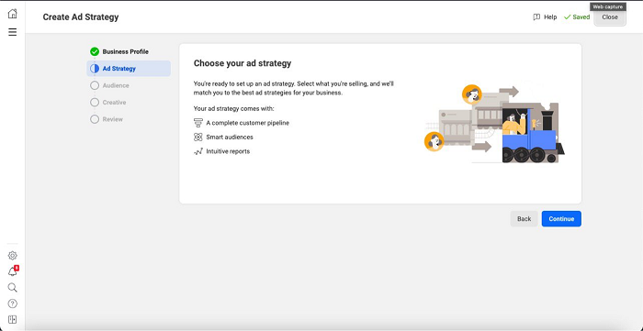

* The process looks to simplify your ad creation process as much as possible, with the walkthrough then asking more questions about what you sell, how often people are likely to purchase from you, and your campaign goals.

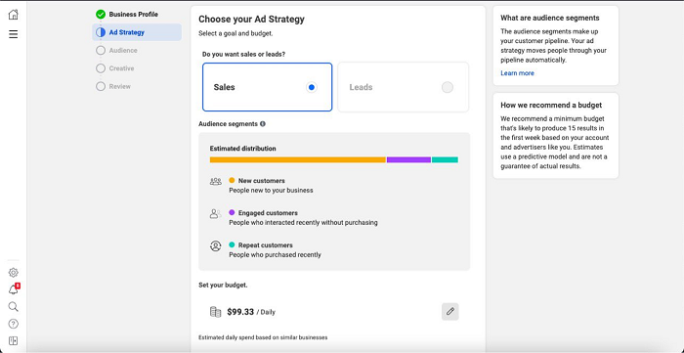

* You then choose your focus region. The process will automatically target people for you based on Facebook’s learned knowledge about how each user is likely to respond, taking into account their past in-app behaviors and noted interests, so you don't need to narrow down your audience with specific parameters as such.
* The system will measure response over time, and optimize your ad spend accordingly, simplifying your Facebook outreach set-up and management.

<https://www.socialmediatoday.com/news/facebook-tests-new-ad-automation-flows-to-help-maximize-campaign-performanc/605983/>

# Calendar Week 35 (Sep 03)

## **Google page experience update is now rolled out**

Google confirmed that it completed the page experience update rollout today. This includes **the updates to the Top Stories carousel on mobile search** but the Google News app changes won’t be done for a week.

* Google began rolling out the page experience update on June 15th and told us it would be completed by the end of August. It technically was not finished before the end of August and has about a week more to go, but it is essentially done.
* This was a slow rollout and Google originally said do not expect drastic changes: “While this update is designed to highlight pages that offer great user experiences, page experience remains one of many factors our systems take into account… Given this, sites generally should not expect drastic changes,” said Google.
* Do not confuse the page experience update with core updates. . The core updates are felt more in terms of ranking fluctuations by sites in Google Search than would this page experience update.

<https://searchengineland.com/google-page-experience-update-is-now-rolled-out-374237>

## **Twitter Super Follows: New Way to Monetize Followers**

Twitter introduced a new program that **allows Twitter creators to monetize their followers with a monthly subscription.** The new way for creators to earn revenue on Twitter is called **Super Follows.**

* **Super Follows** enables approved Twitter creators to charge a subscription to followers who will be able to view exclusive bonus content.
* Twitter users who purchase a subscription, known as **Super Followers,** **will receive a public badge that is highlighted under their name** whenever they interact with the creator who they are paying a subscription to.
* That gives the creator an opportunity to pay more attention to subscribers if they wish.
* Right now the **Super Follows** allows creators to share private tweets that include **polls, links, conversation threads and voice tweets.**

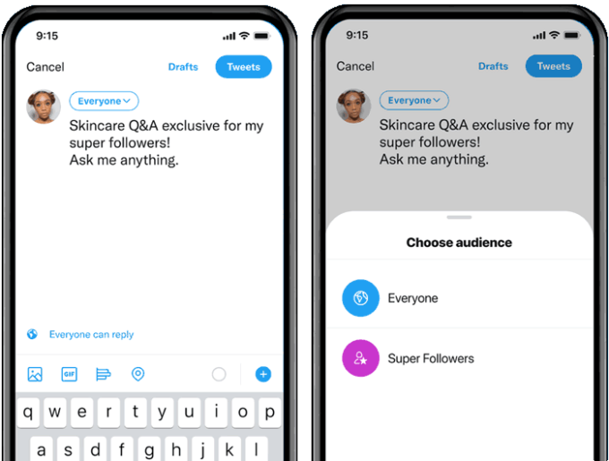

* **Subscription rates on the system are:** $2.99, $4.99 and $9.99 a month.
* The program is currently in testing mode and is temporarily open only to United States creators.
* Right now the **Super Follower program is in testing mode** and is limiting the amount of users who are approved.
* Twitter users in the United States and Canada can subscribe and become super followers but this will change over the coming weeks as it rolls out worldwide.
* The program is currently limited to users on the Apple iOS Twitter app but that will change at some point in the future.

<https://www.searchenginejournal.com/twitter-super-follows/418378/>

## **How Google and Yelp handle fake reviews and policy violations**

Both Google and Yelp have implemented **automated systems** as their first line of defense against fake reviews and bad actors. And, they both use **human moderators** for tasks that the technology isn’t suitable for. However, **their respective policies and approaches, which inform the deployment of their technology and human staff,** are the most important distinctions.

* **Google’s** approach seems to emphasize **prevention at scale via machine learning algorithms** that help to tackle fake reviews and listings.
* **Yelp** focuses heavily on the integrity of its reviews and seems to have more **robust punitive measures** in place for violators.
* **Google’s automated detection system.** Google’s automated systems “use hundreds of cues to detect abusive behavior, such as a shift of review patterns on a business and implausible behavior patterns by reviewers”.
* **Google’s human content moderators.** Teams of human operators and analysts complement Google’s automated detection systems. These analysts help with content evaluations that algorithms may not be able to analyze, such as understanding local slang within a review.
* **Yelp’s automated detection system.** Yelp’s automated recommendation software analyzes data points from all reviews, reviewers and businesses in order to recommend reviews to users, but it also looks for solicited reviews and unfairly biased reviews.
* **Yelp’s human content moderators.** Yelp has been relatively open about how it uses both technology and its human content moderators to combat policy-violating content: “When a community member, a business owner or our automated system alerts our team about potential issues, a real human reviews the issue every single time.”
* **Consumer Alerts.** When Yelp detects abnormal activity on a business profile, which may be an attempt to manipulate a business’s reviews or ratings, it conducts an investigation that may lead to the application of one of its [Consumer Alerts.](https://trust.yelp.com/consumer-alerts/)
* **Consequences for violating** Google and Yelp’s content policies:
  + Both platforms can remove illegitimate reviews.
  + Yelp applies ranking penalties; Google declined to comment.
  + Yelp may remove business listings; Google may revoke profile ownership.
  + Violators can still advertise on Google, but not on Yelp.
  + Yelp continues to monitor listings; Google doesn’t seem to.

<https://searchengineland.com/how-google-and-yelp-handle-fake-reviews-and-policy-violations-374071>

## **TikTok expands Shopify partnership, pilots TikTok Shopping in US, UK and Canada**

TikTok is moving into e-commerce. **The company** [**announced**](https://newsroom.tiktok.com/en-us/new-ways-to-discover-and-shop-on-tiktok) **this morning an expanded partnership with e-commerce platform Shopify**, as well as a pilot test of TikTok Shopping among select Shopify merchants across the U.S., U.K. and Canada in the weeks to come.

* The social video platform first [announced](https://techcrunch.com/2020/10/27/tiktok-invests-in-social-commerce-via-new-shopify-partnership/) its plans to partner with Shopify last October, with the introduction of **new tools that allowed Shopify merchants to create, run and optimize their TikTok marketing campaigns directly from the Shopify dashboard**, as well as new integrations within the TikTok For Business Ads Manager.
* Soon, Shopify merchants with a TikTok For Business account will be able to add a new “Shopping” tab to their TikTok profiles and sync their product catalogs to create mini-storefronts on their profile.
* The pilot is also underway with other Shopify merchants in the U.S. and U.K., and will roll out to merchants in Canada in the weeks ahead. Merchants can request to join the pilot through Shopify’s own TikTok channel, the company notes.
* Another aspect of the new partnership involves bringing to Shopify merchants product links that can be used to tag products in their TikTok videos. This way, TikTok users will be able to click the tagged product to be directed toward the merchant’s storefront for checkout.

<https://techcrunch.com/2021/08/24/tiktok-expands-shopify-partnership-pilots-tiktok-shopping-in-us-uk-and-canada/>

## **TikTok’s new Creator Marketplace API lets influencer marketing companies tap into first-party data**

TikTok is making it easier for brands and agencies to work with the influencers using its service. The company is rolling out a new **“TikTok Creator Marketplace API,”** which allows marketing companies to integrate more directly with TikTok’s Creator Marketplace, the video app’s in-house influencer marketing platform.

* On the [Creator Marketplace website](https://creatormarketplace.tiktok.com/), [launched](https://adage.com/article/digital/tiktok-users-are-surprised-find-themselves-ads-app/2204996) in late 2019, marketers have been able to discover top TikTok personalities for their brand campaigns, then create and manage those campaigns and track their performance.
* The new API, meanwhile, allows partnered marketing companies to access TikTok’s first-party data about audience demographics, growth trends, best-performing videos and real-time campaign reporting (e.g. views, likes, shares, comments, engagement, etc.) for the first time.
* They can then bring this data back into their own platforms, to augment the insights they’re already providing to their own customer base.
* TikTok is not officially announcing the API until later in September, but it is allowing its alpha partners to discuss their early work:
* One such partner is Captiv8, which tested the API with an NRF top 50 retailer on one of their first TikTok campaigns. The retailer wanted to discover a diverse and inclusive group of TikTok creators to partner with on a new collaboration and wanted help with launching its own TikTok channel. Captiv8 says the branded content received nearly 10 million views, and the campaign resulted in a “significant increase” in several key metrics, which performed above the Nielsen average. This included familiarity (+4% above average), affinity (+6%), purchase intent (+7%) and recommendation intent (+9%).

<https://techcrunch.com/2021/08/31/tiktoks-new-creator-marketplace-api-lets-influencer-marketing-companies-tap-into-first-party-data/>

# Calendar Week 34 (Aug 27)

## **Facebook announces new features to level-up your advertising campaigns**

Launched last year, **Facebook's Automated App Ads (AAA)** is designed to help businesses, big and small, get the most out of their app ads. Over the last year, Facebook has launched a series of new features to help AAA operate more effectively.

* **In July 2020 Facebook released App Level Settings** , it's a new tab in Business Manager which allows you to specify settings, requirements or constraints at the app level. Now you can define App Level Settings for:
  + **Minimum age targeting** The default age targeting for AAA is 13+.
  + **Custom Audience exclusion targeting** enables you to upload and apply Custom Audience exclusion lists.
  + **City and state-level targeting** allows you to include or exclude particular cities or states from AAA campaigns.
* **App event optimization with custom events within your app ads** will help to drive meaningful results, allows for easier set-up, and also provides more flexibility to communicate your goals.
* Throughout 2021, Facebook also released a number of features to help improve reporting and managing creatives, such as:
  + The ability to view the creative name for your AAA campaigns within the editing flow for easier management
  + Creative level reporting breakdowns with Mobile Measurement Partner reporting.
  + Restoring asset reporting for offsite conversion events on SKAN campaigns.
* Facebook also expanded the access of Automated App Ads from Ads Manager to the Marketing Ads API.
* Over the next few months, you will be able to **create ads in multiple languages to reach multiple audiences with dynamic language optimization.**

<https://www.gamesindustry.biz/articles/2021-08-26-facebook-announces-new-features-to-level-up-your-advertising-campaigns>

## **How Instagram Ranks Search Results**

Head of Instagram, Adam Mosseri, explains how the app ranks search results and shares a few Instagram SEO best practices.

* The way Instagram ranks search results relies on a user to input text in order to return results.
* Instagram aims to organize search results by **what’s most relevant to the individual user.**
* In addition to text entered by the user, Instagram’s search algorithm uses information from **accounts, hashtags, and places** to rank results.
* Instagram’s top ranking signals in order of importance are:
  + **Your text:** The text you enter in the search bar is Instagram’s most important ranking signal.
  + **Your activity:** This includes accounts you follow, posts you’ve viewed, and how you’ve interacted with accounts in the past.
  + **User engagement:** When there are a lot of potential results, Instagram will look at engagement signals.

<https://www.searchenginejournal.com/how-instagram-ranks-search-results/417449/>

## **Google confirms it changed how it creates titles for search result listings**

Google has confirmed that the search engine has changed how it creates titles for search result listings.

* Previously, Google often used the query the searcher entered into the search box when formulating the title of the search result snippets. But now, Google said, “generally” it “will no longer” use the query when making these titles.
* Google has a new system to generate these titles that the company claims “describe[s] what they are about, regardless of the particular query.”
* Google said for 80% of the results, the HTML title tags are still the primary way it produces titles.
* Google said this “update is designed to produce more readable and accessible titles for pages.
* Google wrote the search company is “already making refinements” to the new title system “based on feedback,” and it promises to “keep working to make it even better over time.”

<https://searchengineland.com/google-confirms-it-changed-how-it-creates-titles-for-search-result-listings-351506>

# Calendar Week 33 (Aug 20)

## **Advertisers can adjust conversion values in Smart Bidding in the coming weeks**

Google Ads announced that advertisers will now have more control over smart bidding with **conversion value rules**.

* **Conversion value rules** will adjust the value of a given conversion, based upon factors that impact lead quality and value.
* **Conversion value rules** allow advertisers to tell Google Ads what factors are most important to them by applying rules.
* **Conversion value rules** allow advertisers to indicate instances when a conversion is worth more or less than the average conversion, based upon various characteristics of the auction.
* Having this control will also allow advertisers and smart-bidding algorithms better data to bid and budget more effectively.
  + For example, if advertisers know certain audiences or people in certain locations are most likely to convert, they can set a rule to multiply the conversion value for the chosen group by two.
* These rules will also be used by Maximize conversion value and Target ROAS to optimize your bids in real time. Conversion value rules will be available for Smart Bidding across Search, Shopping, and Display over the next few weeks.

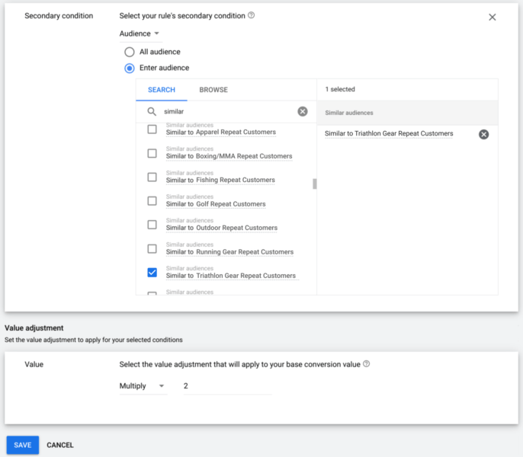

<https://www.searchenginejournal.com/google-ads-new-conversion-value-rules-what-they-are-how-to-use-them/416943/#close>

## **YouTube adds video chapter previews, auto-translates captions in new search functions**

To make searching for videos on YouTube easier, the company announced two new updates on Tuesday to the way its on-site search function operates.

* **Timestamp previews and auto-play snippets added to mobile.** YouTube has previously had a short autoplay with captions when desktop users move their mouse over a video to help them know what they’re about to watch. This option allows you to find exactly what you’re looking for. The quick auto-play will also be available on mobile upon scroll.

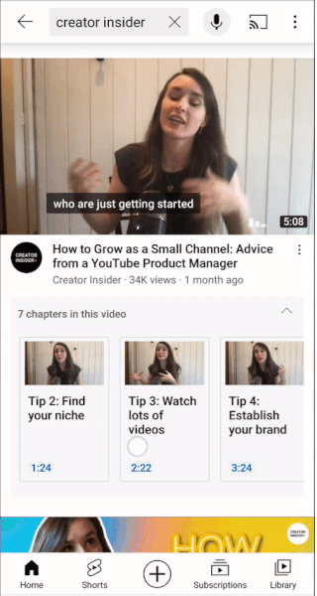

* **Auto-translated captions in different languages**. Youtube is starting to show search results from other languages with automatically translated captions, titles and descriptions when relevant content in the local language isn’t available.

<https://searchengineland.com/youtube-adds-video-chapter-previews-auto-translates-captions-in-new-search-functions-351311>

## **Facebook’s First-Ever Report On Most Viewed Content**

Facebook published a report which offers a first-ever look at what content gets the most views in peoples’ news feeds. Facebook says the goal of this first quarterly report is to provide **clarity around what people see in their news feed.** Here are some general takeaways:

* The content that’s seen by the most people isn’t necessarily the content that also gets the most engagement.
* 57% of posts that people see is from their family and friends.
* Fewer than 13% of content views were on posts with links.
* **Most viewed news domains** account for 0.31% of all content views. Of those domains, mainstream media dominate by views. here’s a look at the top five.
  + youtube.com (181.3M views)
  + amazon.com (134.6M views)
  + unicef.org (134.4M views)
  + gofundme.com (124.8M views)
  + twitter.com (116.1M views)
* **Of posts with links**, around **a quarter of the most viewed domains were news publishers.**

<https://www.searchenginejournal.com/facebooks-first-ever-report-on-most-viewed-content/416808/>

## **x**

x

* x
* x
* x
* **x**
* **x**

<https://www.searchenginejournal.com/facebooks-first-ever-report-on-most-viewed-content/416808/>

## **x**

x

* x
* x
* x
* **x**
* **x**

<https://www.searchenginejournal.com/facebooks-first-ever-report-on-most-viewed-content/416808/>

# Calendar Week 32 (Aug 13)

## **Google Looks to Simplify Custom Bidding, and Provide More Transparency Over its Bidding Algorithms**

Google's looking to help more advertisers utilize Custom Bidding, and provide more transparency over the Custom Bidding process, with [two new updates](https://blog.google/products/marketingplatform/360/whats-new-with-automated-bidding-in-display-video-360/) to its ad campaign options designed to further simplify the process.

* Custom Bidding is Google's automated bidding strategy for Google Ads, which enables advertisers to assign a value to a conversion or purchase, which Google's system can then optimize for within its process.
* It can be a good way to maximize campaign performance, based on Google's ever-evolving machine learning processes - but up till now, Custom Bidding has required a degree of technical expertise to implement, due to coding elements.
* To mitigate this, and lower the barrier to entry, Google's now adding 'Floodlight activities', which are pre-created HTML code snippets that can be used to track conversions, or other information about transactions.

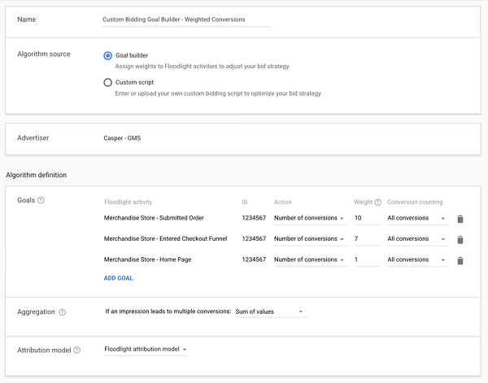

* Through this new process, you'll be able to choose pre-determined goals for your Custom Bid approach, then export the code for insertion on your site. So there is still a level of technical expertise involved - but you won't have to understand all the code parameters and build the relevant HTML yourself.
* As per Google: *"You'll be able to monitor what the average cost-per-thousand impression (CPM) bid is based on the likelihood of an impression to lead to a conversion or a click. This way you’ll see that automated bidding is increasing your bids for impressions that generate better returns for you."*

<https://searchengineland.com/instagram-is-adding-more-e-commerce-support-with-ads-in-the-shop-tab-351151>

## **TikTok Launches 'Creative Solutions' Guide to Building Effective TikTok Campaigns**

As TikTok continues its meteoric rise, many more marketers are now looking the app's way, and considering how they can tap into the platform to boost their brand reach and discovery.

* But TikTok requires a dedicated approach - you have to understand what works with the TikTok community, and align with organic trends. Re-purposing ad campaigns from other platforms won't be effective, while polished, edited, professional-quality ads likely won't gain significant traction either.
* The best way to approach TikTok is to learn from the organic videos posted in the app - which is the key message of TikTok's latest creative guide for brands, which is essentially a 101 of building a business TikTok presence.
* **The guide includes notes on how to build authentic TikTok content, including specific tips on creative approaches and posting frequency.**
* There are also links to relevant resources and tools - including template examples of TikTok 'safe zones' for your video clips (i.e. the areas not obscured by in-app UI elements).
* It also includes links to TikTok's various brand features, including its Creator Marketplace and audio tools.

<https://www.socialmediatoday.com/news/tiktok-launches-creative-solutions-guide-to-building-effective-tiktok-cam/605010/>

## **Instagram is adding more e-commerce support with ads in the Shop tab**

**Instagram is now testing ads in the Shop tab,** TechCrunch first [reported on Monday](https://techcrunch.com/2021/08/09/instagram-tests-ads-in-its-shop-tab/?guccounter=1). The ads can include a single image or a carousel of images, and the test is currently only open to a handful of retailers. The ads are rolling out now to mobile users in the U.S.

* Ads in Instagram Shops will launch with an auction-based model and the company plans to monitor consumer sentiment in order to balance content with ads, according to TechCrunch.
* Away, Boo Oh, Clare Paint, DEUX, Donni Davy, Fenty Beauty and JNJ Gifts are among the retailers participating in the test. The company has not yet released a timeline for when these ads will be available to more advertisers.
* The ads will expand to global markets in the coming months.
* Instagram [launched the **Shop tab**](https://searchengineland.com/social-shorts-googles-shoploop-instagram-shop-overhaul-snapchat-brand-pages-337870) in July 2020.

<https://searchengineland.com/instagram-is-adding-more-e-commerce-support-with-ads-in-the-shop-tab-351151>

## **Facebook Ads Announces Updates to Targeting Minors, Instagram Shop Ads, & More**

Facebook has announced updates to the way that they are **handling privacy for minors, launched new ad placement tests, and developed a new tool for advertisers.**

* Facebook has started to deliver messaging in the UI alerting advertisers to upcoming changes in the way that they will handle targeting of Facebook users under 18.
  + Starting August 23, many targeting options, including detailed targeting and Custom Audiences, will no longer be available to target people under 18 globally, 20 in Thailand or 21 in Indonesia.
* Facebook recently launched a new idea generator, a tool in which is designed to help suggest new campaign ideas.
  + To use the tool, advertisers plug in their vertical and whether the content is seasonal or not. After clicking submit, Facebook surfaces campaign ideas, as well as data and insights, and resources.
* In an article by AdWeek, it was shared that I**nstagram has begun testing ads in the Instagram Shop Tab.**
  + Ads will appear on the homepage for the Instagram Shop tab. Clicking the ads will allow users to view additional images, read product details, and view other products, much the same as the experience when browsing organic shop tab listings on Instagram.
  + For now this ad placement will only be available for advertisers in the U.S.

<https://www.searchenginejournal.com/facebook-ads-updates/416179/>

## **Google Ads Editor Rolls Out New Features: Lead Form Extensions, Hotel Ads & More**

Google Ads released Google Ads Editor 1.7 with new features including easier downloads, audio ads, and more!

* **Easier Downloads** Users can improve download speeds by opting to select only certain parts of campaigns to download.
* **Lead Form Extensions** 
  + Previously only accessible through the UI, lead form extensions were released in 2019 allowing users to append a lead form to their ads so that prospects could complete the form without ever leaving the SERP.
  + Users can now download, edit, and create lead form extensions within Google Ads Editor. Lead Form Extensions.
* **YouTube Audio Ads**, which were released in 2020, were previously only available to set up directly within the UI. Now audio ads can be set up through Google Ads Editor.
* **Hotel Ads** Users can now use Google Ads Editor to manage Hotel Ads, which are feed-based ads that help hotel advertisers promote prices and availabilities of their properties on any given day.
* Google also now supports additional recommendation types, including:
  + Fix Ad destinations
  + Use Target impression share bidding
  + Bid more efficiently with Maximize clicks
  + Use broad match versions of your keywords
  + Bid more efficiently with Maximize conversion value
  + Add image extensions to your ads
  + Set a target ROAS
  + Add call extensions to your ads

<https://www.searchenginejournal.com/google-ads-editor-rolls-out-new-features-lead-form-extensions-hotel-ads-more/416160/#close>

# Calendar Week 31 (Aug 06)

## **Microsoft Ads August Updates: New Bidding Strategy, New Automated Extensions, & More**

Microsoft announced a list of new product updates and releases for Advertisers including **a new bid strategy, manager-account labeling, new automated extensions, extended brand safety protections, and updates to Unified Campaigns.**

* Microsoft Ads announced the release of **Target Impression Share strategy, mirroring that of Google Ads.** 
  + Microsoft Ads will automatically set your bids based upon where you want your ads to appear and your Target Impression Share.
  + Advertisers can choose that they’d like to “show anywhere on the page”, “Top of page” or “Absolute top of the page”.

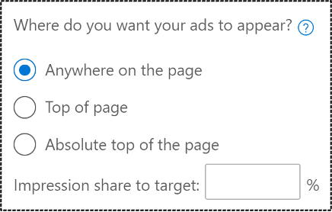

* + Advertisers can set a Max CPC limit but it may restrict volume, depending on the other settings that have been selected.
* Starting in August, Microsoft is launching **new automated extensions,** which will be available to all advertisers.
  + Dynamic Location extensions will pull in location information from advertiser location extensions and Bing Maps
  + Dynamic Multimedia extensions will append multimedia assets, such as images and videos (begins flighting in early 2022)
  + Syndication Decorations are automated buttons or enhancements that partners use to entice clicks
* For advertisers using an MCC, Microsoft Ads is rolling out manager account-level labels.
* Advertisers using Shopping Campaigns or other feed-based campaigns will now be able to create **product conversion goals**.
  + A customer clicks an ad for Product A, navigates away without purchasing, subsequently clicks an ad for Product B, but ends up purchasing Product A. Normally, this conversion would be attributed to the ad for Product B because that was the ad last clicked. However, with the product conversion goal, you can track this as a conversion for the ad for Product A.
  + Alternatively, for retailers participating in product-specific goals, they can also attribute conversions at the brand level.
* Microsoft announced a partnership with Integral Ad Science (IAS) last September.
* Lastly, Microsoft Advertising announced a host of updates for unified campaigns based upon feedback from early adopters.

<https://www.searchenginejournal.com/microsoft-ads-august-updates-new-bidding-strategy-new-automated-extensions-more/415220/#close>

## **Google drops safe browsing as a page experience ranking signal**

Google is removing the safe browsing signal from the Google page experience update, the company announced.

* **New page experience diagram.** Here is the new diagram that removes “safe browsing” from the list of page experience signals:

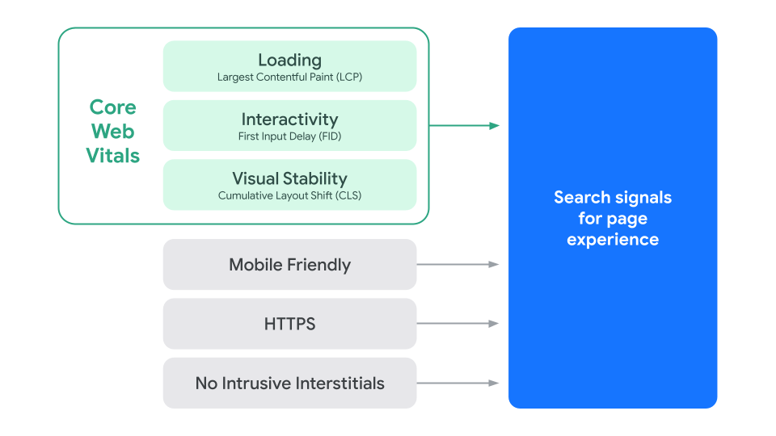

* Google said it is removing this as a signal because these are issues that are not always in the control of site owners.
* Google is also removing the Ad Experience widget, Google said “to avoid surfacing the same information on two parts of Search Console.”
* **More changes to the page experience report.** Google made additional changes to the page experience report including:
  + Added a “No recent data” banner to the Core Web Vitals report and Page Experience report.
  + Fixed a bug that caused the report to show “Failing HTTPS” when Core Web Vitals data was missing.
  + Rephrased the empty state text in the Page Experience report and Core Web Vitals report.

<https://searchengineland.com/google-drops-safe-browsing-as-a-page-experience-ranking-signal-350995>

## **Yelp introduces “Proof of vaccination required” and “Staff fully vaccinated” profile attributes**

Yelp is introducing two new COVID-related profile attributes, the **“Proof of vaccination required”** and **“Staff fully vaccinated”** attributes, the company announced Thursday.

* Users will be able to filter searches using these attributes and the “Proof of vaccination required” attribute will be visible in search results.

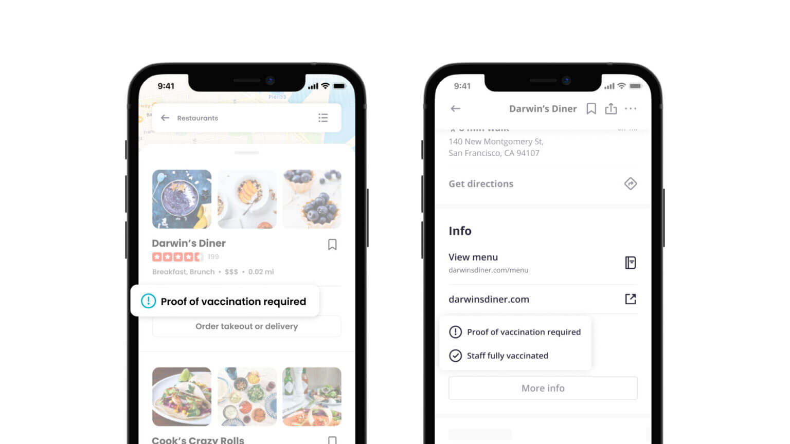

* Given the rapid spread of COVID’s Delta variant, these attributes may help customers feel safer when visiting a local business, which can help businesses continue to operate as more safety-oriented consumers shy away from in-person activities.

<https://searchengineland.com/yelp-introduces-proof-of-vaccination-required-and-staff-fully-vaccinated-profile-attributes-350972>

## **Amazon’s ads business posts 87% growth**

The company’s “Other” unit, which is primarily made up of advertising but also includes sales related to other service offerings, grew revenue by 87% year-over-year in the second quarter to more than $7.9 billion, the company reported Thursday. That’s up from the 41% year-over-year growth the segment saw in the second quarter of 2020 and up from the 77% year-over-year growth it saw last quarter.

* Amazon chief financial officer Brian Olsavsky said Thursday **that new products and functionality helped drive higher demand and higher bid rates.**
* **Amazon Advertising launched “over 40 new features and self-service capabilities” in the quarter**, the [company said](https://www.businesswire.com/news/home/20210729006106/en/) in its earnings release. Amazon said one example is a tool that creates regional sponsored product campaigns.
* Amazon’s cut of the industry grabbed a 10% cut of the U.S. ad market last year and is expected to keep on taking share.
* Amazon also appears well-poised to stomach some of the privacy-related changes impacting the digital ad world given its strong first-party relationship with consumers.

<https://www.cnbc.com/2021/07/29/amazons-ads-business-posts-87percent-growth.html>

## **Where are Amazon advertisers spending most of their ad budgets?**

The cost of advertising on the platform is increasing, however, as brands become more and more competitive. In fact, [62% of Amazon sellers](https://www.junglescout.com/amazon-seller-report/) are concerned about increasing ad costs on Amazon in 2021.

* **Sponsored Products and Sponsored Brands:**
  + Professional sellers and brand-registered sellers can make use of the three PPC ad types on Amazon: [Sponsored Products](https://www.junglescout.com/blog/amazon-sponsored-product-ads/), [Sponsored Brands](https://www.junglescout.com/?p=81357), and [Sponsored Display](https://www.junglescout.com/?p=80111). If you are not enrolled in [Brand Registry](https://www.junglescout.com/blog/amazon-brand-registry/), only Sponsored Products is available to you.

​​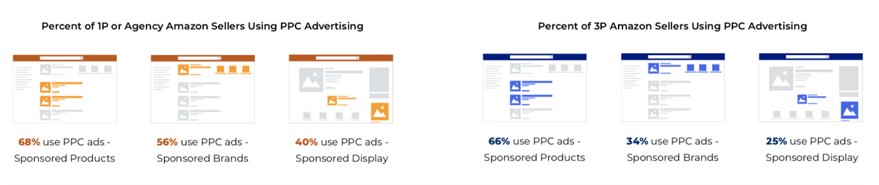

* + According to Jungle Scout’s ecommerce data, Sponsored Products is the most popular ad type amongst sellers and brands. But in the last three years, there has been a noticeable shift in ad spend from Sponsored Products ads towards Sponsored Brands and Sponsored Display ads — a clear indication that sellers find value in investing not just in their products, but also in their brand presence on Amazon.

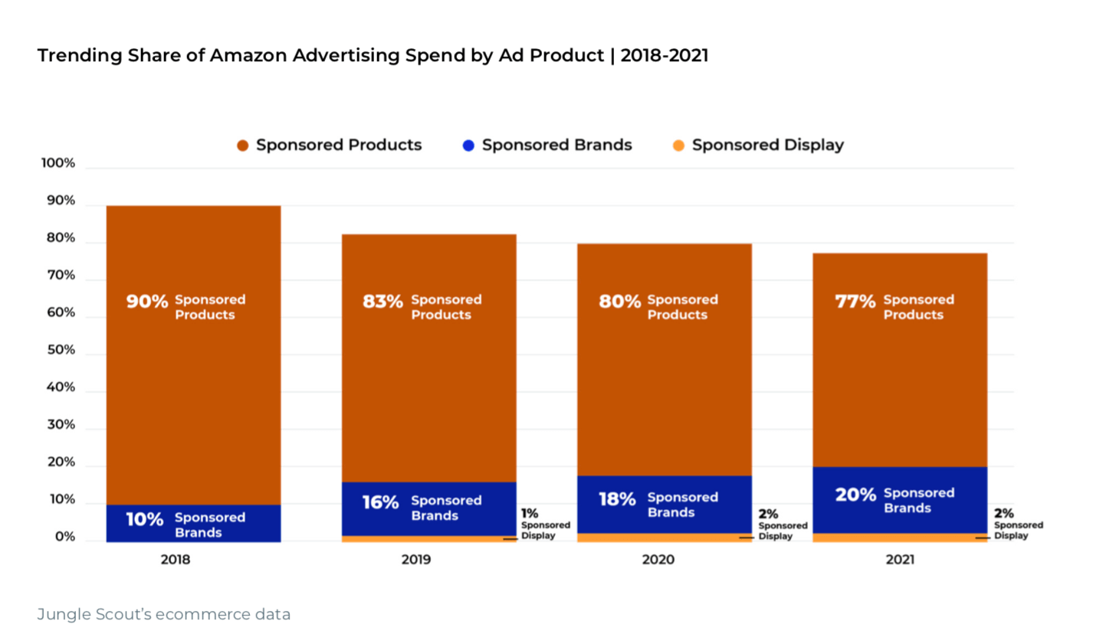

* + Brands are also focusing their budgets on ad products that produce a good return on investment.

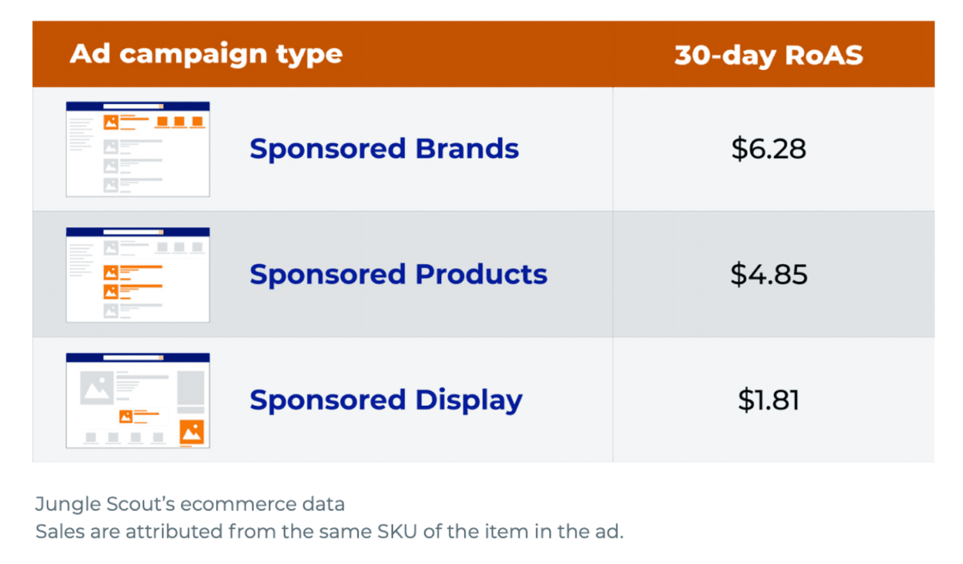

* According to Jungle Scout’s ecommerce data, Sponsored Brands yields the highest return on ad spend (RoAS) compared to Sponsored Products and Sponsored Display.
* Out of all the match types, advertisers are spending the most amount of money on loose match ads as they have the lowest cost per click (CPC) out of all the targeting types — giving advertisers more room to spend on campaigns.
* While loose match has the lowest CPC, close match ads result in the greatest RoAS over a 14- and 30- day period. This is because the more relevant the ad is to a customer, and the more intent the customer has to buy that product, the more likely they are to make a purchase.

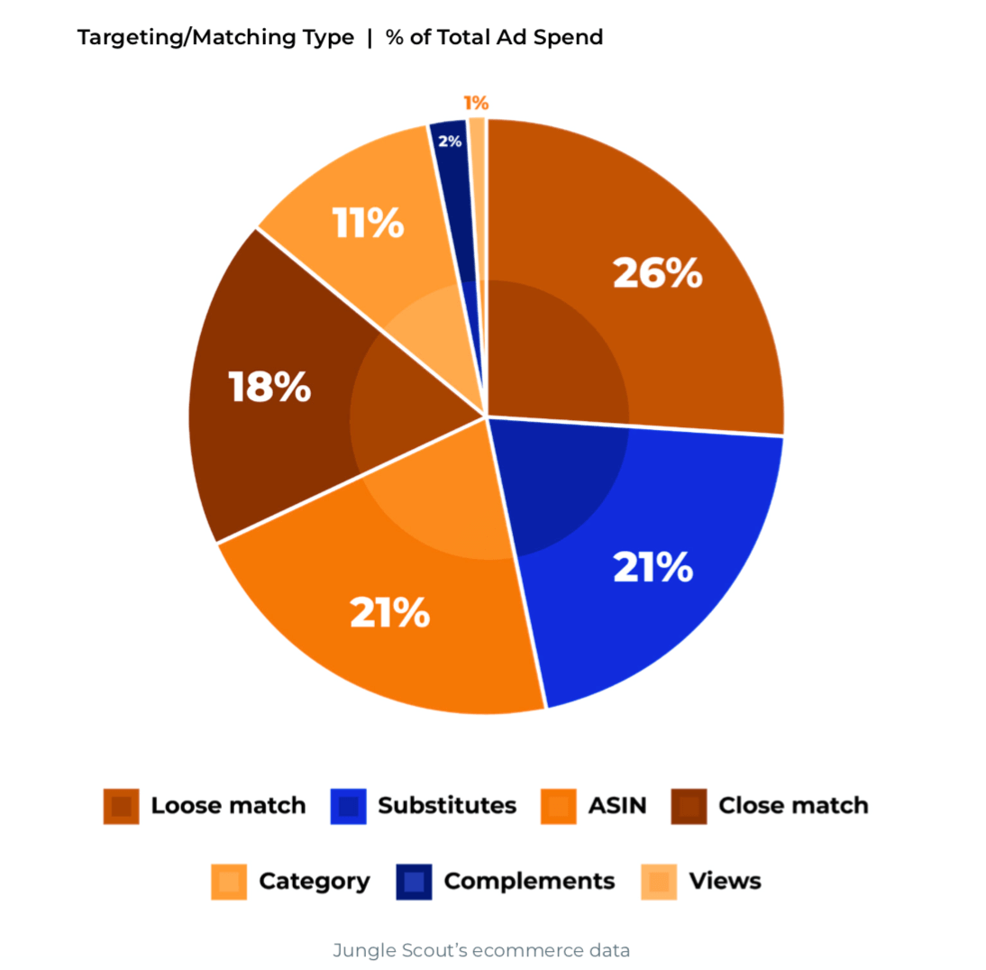

<https://www.junglescout.com/blog/how-much-do-amazon-ads-cost-in-2021/>

## **Facebook Launches New Interview Series Looking at Evolving Shifts in Advertising Approaches**

Facebook has [launched a new series of expert interviews](https://www.facebook.com/business/news/data-creative-and-advertising-excellence#) to help **provide more guidance for advertisers on how to respond to key industry shifts**, and outline what's working right now in building effective Facebook ad campaigns.

* *"Across several chapters, we will explore how the marriage of data and creativity is helping drive best in class advertising and powering better return on investment for brands."*
* The initiative comes at a crucial time, because Facebook, like all digital platforms, is in the midst of a major advertising shift due to the increased focus on data privacy
* That means **less insight for advertisers to go on in mapping out their campaigns, and as a result, marketers are being forced to develop new methods of gathering response insights, and building their ad campaigns based on expanded inputs and considerations.**
* In the first interview of the series, Facebook's ANZ Head of Marketing Science Andy Ford spoke to Jen Rhodes of BMF and James Greaney of CHE Proximity to get their insights into how they're coping with these changes.
* **Both Rhodes and Greaney explore the expanded push to combine data and creativity, and how brands are now evolving their processes on this front.**
* Ford specifically notes that, despite recent shifts, great creative remains the key driver, with recent research conducted by Facebook, in conjunction with Analytic Partners and The Lab, showing that 70% of the potential return on investment for video advertising comes from the creative itself.

​​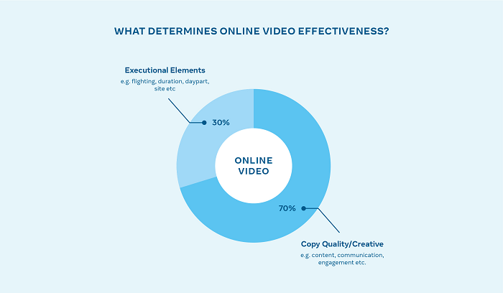

<https://www.socialmediatoday.com/news/facebook-launches-new-interview-series-looking-at-evolving-shifts-in-advert/604561/>

# Calendar Week 30 (Jul 30)

## **Twitter’s Shop Module pilot adds a product carousel to profiles**

**Twitter has launched Shop Modules,** a dedicated section at the top of profiles where brands can showcase their products, as a pilot, the company announced Wednesday.

* The Shop Module pilot is currently rolling out with a handful of brands in the U.S., and only people in the U.S. who use Twitter in English on iOS devices are currently able to see the module.

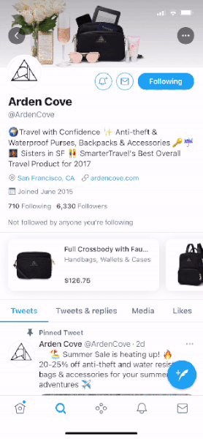

* **The Shop Module is a carousel of products.** Tapping on a product takes the user to the associated product detail page (in an in-app browser, so they aren’t leaving Twitter), where they can learn more and/or complete the purchase.
* The Shop Module pilot is currently not open for businesses to sign-up.
* “We’re creating deeper partnerships with businesses that reflect whom we’re building for with a new Merchant Advisory Board,” the company said in its announcement.
* The board will consist of “best-in-class examples of merchants on Twitter” and the company hopes to utilize this advisory board to address the needs of businesses of various sizes and across verticals in its own product innovation.

<https://searchengineland.com/twitters-shop-module-pilot-adds-a-product-carousel-to-profiles-350828>

## **Instagram is disabling interest and activity-based targeting of underage users**

Instagram announced that beginning in a few weeks, advertisers will only be able to target Instagram, Facebook and Messenger users under the age of 18 (or older in certain territories) based on their age, gender and location.

* This policy change will roll out worldwide and, as mentioned above, apply to Instagram, Facebook and Messenger.
* When a user turns 18, Instagram will inform them about the targeting options that advertisers can now use to reach them and the ads settings at their disposal.
* Alongside this change, Instagram also announced that all users under 16 (or 18 in certain territories) will have their accounts set to private as a default when they join the platform.
* The company is also taking precautions to make it more difficult for potentially suspicious accounts to follow minors.

<https://searchengineland.com/instagram-is-disabling-interest-and-activity-based-targeting-of-underage-users-350810>

## **TikTok Launches 8 New Features For Livestreams**

TikTok is rolling out eight new features for livestreams which includes Q&A, picture-in-picture, the ability to schedule streams in advance, and more.

* **Schedule in Advance** Content creators on TikTok can now schedule, manage, and promote livestreams in advance.
  + Streams scheduled ahead of time, referred to as “TikTok Events,” offer a new way for creators to connect with their audience and build anticipation for future content.

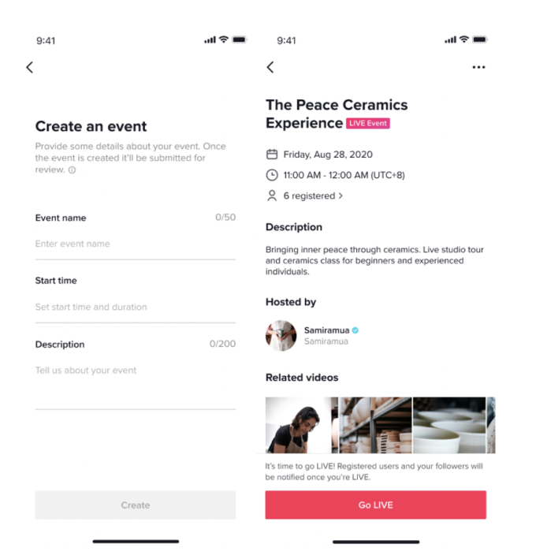

* **Picture-in-Picture** TikTok livestreams can now be viewed in picture-in-picture on iOS and Android.
* **Go Live With a Friend** A new feature called “LIVE Together” allows two users to broadcast live on the same stream.
* Live Q&A A new Q&A feature for livestreams makes it easy for creators to engage with and respond to viewers’ questions in realtime.



* **Top Streams** Livestreams will soon be discoverable through category pages which include Chat (Q&A), Gaming, Talents, Fashion, and Daily Life.
* Assign Moderators Ahead of their livestream, creators can assign a person they trust to help them moderate it by tapping Settings on the right side of the livestream launch screen.
* **Keyword Filters** Creators can now mute any word of their choosing during a livestream. In the settings tab of the LIVE launch screen, creators can turn off comments or add up to 200 terms into the keyword filter to limit those comments in the chat.

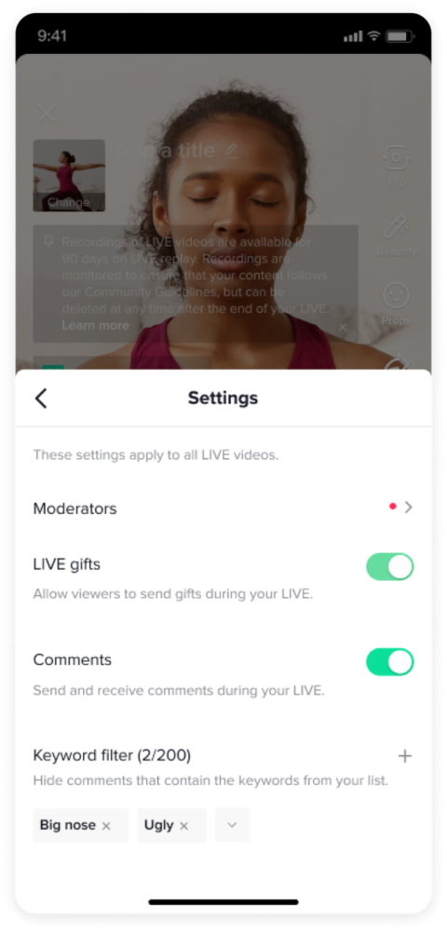

* **Harmful Comment Alerts** Before leaving a comment that TikTok detects as potentially harmful, users will be prompted to reconsider how their words might be received by the streamer.

<https://www.searchenginejournal.com/tiktok-launches-8-new-features-for-livestreams/414788/>

# Calendar Week 29 (Jul 23)

## **Walmart expands Ibotta partnership with new cash-back rewards**

Walmart is using cash rebates to attract shoppers to its e-commerce offerings, including the Walmart+ membership that launched last September, grocery delivery and more. Once the rebates are redeemed, the cash-back hits shoppers' Walmart accounts, helping to retain those who have already signed up for the retailer's loyalty program and encouraging registration for those who haven't.

* **By redirecting the value of the rebates to its account database, Walmart appears to be building its capabilities in digital data collection.**
* To sign up for an account, shoppers must enter personal information, including name and email address, **which lets Walmart track shopping activity and leverage the data to inform targeted advertising.**
* Retailers such as Walmart are investing in their abilities to collect digital data about their customers, a move that could serve as a workaround to needing cookies altogether. **By deepening its knowledge around its digital customers, Walmart can also potentially better help advertisers on its site reach the most effective audiences.**

<https://www.marketingdive.com/news/walmart-expands-ibotta-partnership-with-new-cash-back-rewards/602740/>

## **Walmart Surpasses 100,000 Marketplace Sellers**

Walmart marketplace has doubled in size in twelve months to reach 100,000 third-party sellers. It has doubled for the second year in a row.

* **Having reached 50,000 sellers in July 2020, the marketplace is now adding close to 5,000 new sellers monthly.** Like on other marketplaces, many of those never become active - 35,000 out of 100,000 sellers currently have products listed for sale. Nevertheless, Walmart is growing the number of active sellers faster than sellers are churning.
* **A growing number of sellers are international.** In March, Walmart expanded the marketplace to remove the previous US-only limitation. In July, 15% of new sellers were from China. The figure has been increasing every month - it will soon be adding 1,000 sellers from China monthly. However, most show delivery estimates longer than a week.
* In February, Walmart said to investors, “This year, we’ll significantly increase the number of sellers in our marketplace.” It is doing so by partnering with Shopify and BigCommerce and by expanding to include international sellers. **The increasing seller universe is bringing infrastructure parts like fulfillment and advertising to the forefront.**
* Advertising is starting to be a more critical lever as few niches are now without substantial competition. The marketplace is expanding considerably faster than the number of shoppers on Walmart. That increases the role of advertising to out-rank others in search results. Walmart is catching up with this by offering more ad options.

<https://www.searchenginejournal.com/youtube-rolls-out-3-updates-for-live-streams/413789/#close>

## **Amazon Will Pay Brands To Drive Traffic to Amazon**

Amazon reduced the transaction fee to 5% from the typical 15% for sales originating from brands bringing the shopper to Amazon. Amazon is trying to incentivize brands to invest in marketing on platforms like Facebook and Google but link to Amazon instead of their e-commerce website.

* **The Brand Referral Bonus program, launched last week, “credits brands an average of 10% of sales from traffic you have driven to Amazon.”** The bonus rate varies by category and is not paid out to brands directly but instead gets used to deduct future transaction fees (Amazon calls them referral fees).
* Amazon Attribution, the analytics solution that powers the program by allowing Amazon to attribute sales to off-Amazon clicks, has been around since August 2018.
* Effectively, if a shopper goes to Amazon and finds the product, the brand will pay a 15% fee. But if the brand sends the shopper to Amazon via their newsletter or an ad on their Instagram account, the brand will only pay a 5% fee.
* The program has a singular purpose: stopping brands from investing in direct-to-consumer websites and directing those shoppers to Amazon instead. The transaction fee Amazon charges is significantly more than, for example, Shopify’s 2.9% + 30¢ USD credit card processing fee. The new program reduces Amazon’s fee to be closer to Shopify’s.

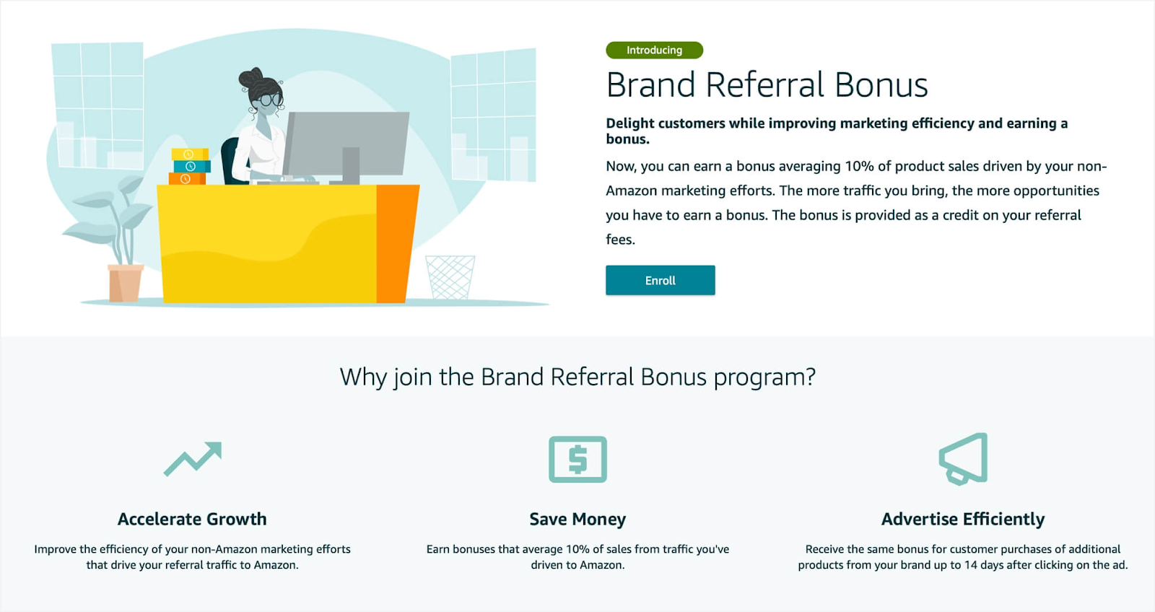

<https://www.marketplacepulse.com/articles/amazon-will-pay-brands-to-drive-traffic-to-amazon>

## **Google Launches Free Deals Listings in Search Results**

Google is rolling out a new way for ecommerce stores to list deals in search results, which is currently free for all merchants.

* **Free Deals Listings in Google Search Results** When searching for a product, the shopping tab will now organize and show product listings that are competitively priced or discounted from retailers across the web.

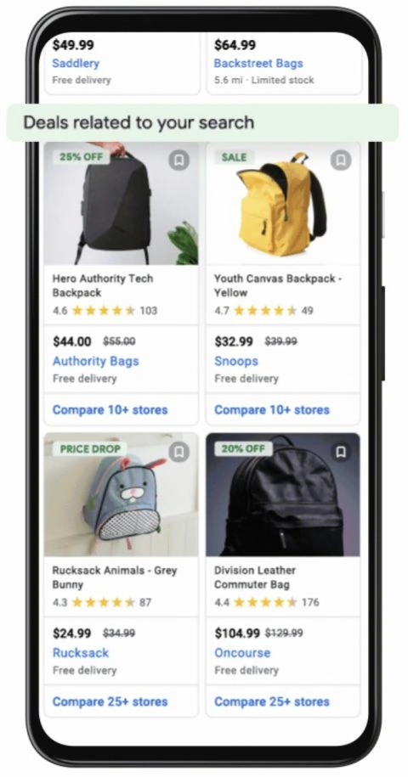

* When people search for deals during major sales events, like “Black Friday deals” or “Cyber Monday sales,” they will see a new section highlighting relevant deals, alongside other related sales information.

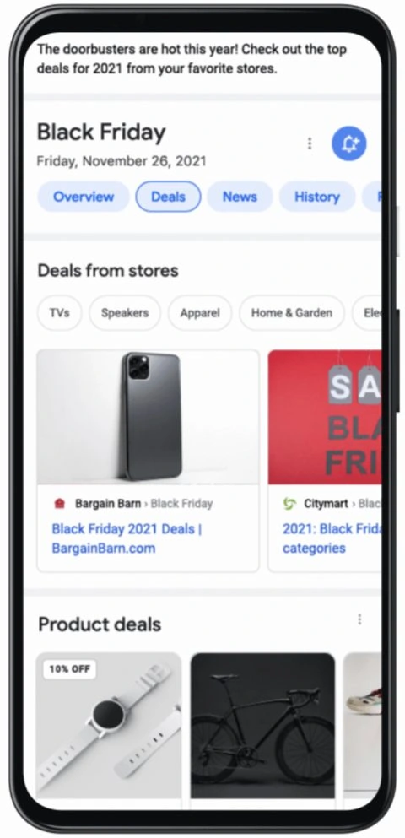

* **Customize Promotions in Google Merchant** Center Another update launched today in Merchant Center allows retailers to customize their promotions. The promotions will be shown to all shoppers, but only those who meet a retailer’s specified criteria will be able to access the promotional price.
* **Better Merchandising Insights** Google is adding two new features to the best sellers report:
  + Historical best seller data: Helps retailers predict sales trends for the upcoming season with insights into popular products from previous shopping events.
  + Relative product demand: Helps retailers gauge the relative demand between products in the same category and country, as well as the potential opportunity when stocking new products.

<https://www.searchenginejournal.com/google-launches-free-deals-listings-in-search-results/414132/#close>

## **YouTube Rolls Out 3 Updates For Live Streams**

YouTube’s path toward feature parity with Twitch continues as the company announces **three updates exclusively for live streams**. These updates expand the availability of an existing feature while bringing two new features to live streams on YouTube. YouTube’s updates to live streams include:

* **Live Polls In Chat** YouTube channels can now create and manage live polls on streams and premieres. Live polls can be used, for example, to ask your audience’s opinion on the current topic of discussion.
* **Subscribers-only chat** A new option to make live chats available only to subscribers can help with moderating the live chat and creating more connections.
* **Expansion of Clips** YouTube is expanding the rollout of Clips, a feature which has been in testing with a limited number of creators.
  + Clips allow viewers to select a 5-60 second segment of content (both video uploads and streams) that can be shared with others on YouTube and across third-party platforms.

<https://www.searchenginejournal.com/youtube-rolls-out-3-updates-for-live-streams/413789/#close>

## **Google Launches New Way to Optimize Videos For Search**

**Google has a new way to optimize videos for search results** when they’re published on a creator’s own website rather than YouTube.

* Previously it was trickier when the video was uploaded to a creator’s website because the site owner had to manually label each segment. Now, all site owners have to do is tell Google the URL pattern for skipping to a specific timestamp within a video.
* Google will use **AI to identify key moments in the video,** and display links directly to those moments in search results.
* This capability, called **SeektoAction**, was announced earlier this year at Google I/O and has been in beta for several months.
* **SeekToAction** markup can be applied to videos like other other type of schema.org structured data.
* Google adds that the **SeekToAction markup** is markup that only applies to videos embedded on one’s own website. This markup is not supported by any other third-party platforms.

<https://www.searchenginejournal.com/google-launches-new-way-to-optimize-videos-for-search/413877/>

# Calendar Week 28 (Jul 16)

## **Google Ads optimized targeting gradually rolling out**

[**Optimized targeting**](https://support.google.com/google-ads/answer/10537509) is gradually rolling out to Google Ads managers. A new “Signal” label under the Demographics tab is for the Optimized targeting.

* **“[Optimized targeting]** uses audience & demo inputs as signals to find more conversions w/in campaign goal, so you’ll see impressions outside of your set targeting signals.

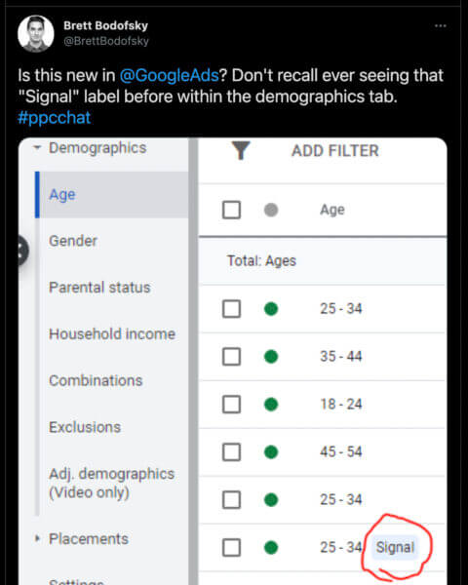

* **Optimized targeting is automatically turned on for all campaigns.** Optimized targeting looks at information like keywords on your landing page or in your creative assets, then finds audiences that can meet your campaign's goals. If you don't want to use optimized targeting, you can turn it off in your ad group settings.
* **You can also add criteria like audience segments or keywords (also known as “targeting signals”) to optimized targeting**. Optimized targeting uses targeting signals to find similar criteria to serve your ads on. If optimized targeting finds better performing traffic, it may reduce or stop serving traffic on your signals.
* Optimized targeting is available for display, discovery, and certain types of video campaigns.
* Optimized targeting works best for advertisers in any of the following situations:
  + You want your campaign to serve to audience segments most likely to convert.
  + You want to acquire new customers beyond your existing segments and still meet your goals.
  + You want to identify new people who perform well for your campaign.
  + You want to increase conversions without increasing bids or the cost per customer.

<https://searchengineland.com/google-ads-optimized-targeting-gradually-rolling-out-350490>

## **Yelp Audiences allows advertisers to reach Yelp users off the platform**

**Yelp is launching Yelp Audiences,** its first offering that enables both location-based and non-location-based advertisers to reach Yelp users across the web, based on their Yelp search activity.

* **Targeting is based on the user’s purchase intent on Yelp and the ads do not have to lead back to Yelp’s platform.**
* Yelp is partnering with demand-side platforms (DSPs) to deliver ads to its users on third-party sites, apps and video streaming services (through CTV).
* The targeting is based on the user’s Yelp activity, “This includes search, delivery and takeout actions, search filters, and category interest.
* With the way Yelp Audiences ads are displayed, clients receive regular updates on performance metrics.
* Yelp also deliver regular reports and insights to clients by either providing raw performance metrics or wrap-up reports that offer a summary of the campaign’s performance.
* Yelp has a similarly named offering, the Yelp Audience Network, which enables advertisers to run ads on third-party sites. The key difference is that clicking on ads shown on the Yelp Audience Network takes users to the advertiser’s Yelp business page.

<https://searchengineland.com/yelp-audiences-allows-advertisers-to-reach-yelp-users-off-the-platform-350437>

## **YouTube Begins Adding Chapters to Videos Automatically**

YouTube is now automatically adding chapters to videos by default — a new feature that can be turned on or off from the settings panel.

* Instead of the creator providing timestamps and titles, YouTube’s machine learning steps in and creates the chapters automatically.
* This feature is now turned on for all channels. Channels can turn it off in YouTube Studio by clicking on Edit Video and toggling the option to ‘allow automatic chapters when eligible and available.’
* If creators prefer to opt out of automatic chapters for all uploads going forward, they can do that as well.
* Three additional things to note about YouTube’s automatic chapters feature；
  + Creators can override YouTube’s automatic chapters by manually entering their own in the video description.
  + Not all videos are eligible for automatic chapters. It's not known what would make a video ineligible.
  + This feature will start rolling out to new uploads only. It will eventually roll out to more videos depending on how recently they were uploaded.

<https://www.searchenginejournal.com/youtube-begins-adding-chapters-to-videos-automatically/413542/#close>

# Calendar Week 27 (Jul 9)

## **TikTok Triples Length of Videos**

TikTok is tripling the maximum length of videos, increasing the time limit from sixty seconds to three minutes.

* This update puts TikTok in a unique spot as far as short-form vertical video on social media goes.
* Facebook and Instagram stories are limited to sixty seconds, as are Instagram feed posts. Instagram Reels can only be 30 seconds.
* Creators can take advantage of the added length and make longer content just for their TikTok audience.
* If that’s the route creators choose to go, users may find themselves with a wider variety of content to enjoy, and a reason to open TikTok versus other apps.
* All of that is to say a small change like increasing video length could lead to larger, indirect changes.
* Longer TikTok videos have been in testing with a limited number of creators, so it’s possible you may have encountered one already.

<https://www.searchenginejournal.com/tiktok-triples-length-of-videos/412601/>

## **Microsoft Advertising Announces New Multimedia Ads For Search**

Microsoft Advertising has announced a new responsive ad format, called **multimedia ads.** The ads will c**ombine advertisers’ images, headlines and descriptions using machine learning to create engaging, attention-grabbing ads.**

* **Multimedia ads** will be delivered on the Bing.com search pages and will be featured prominently in the mainline at the top of the SERP or on the right rail.
* **Multimedia Ads** allow advertisers to showcase their brand with an attractive, rich ad format.
* Here are a few examples of what they can look like.

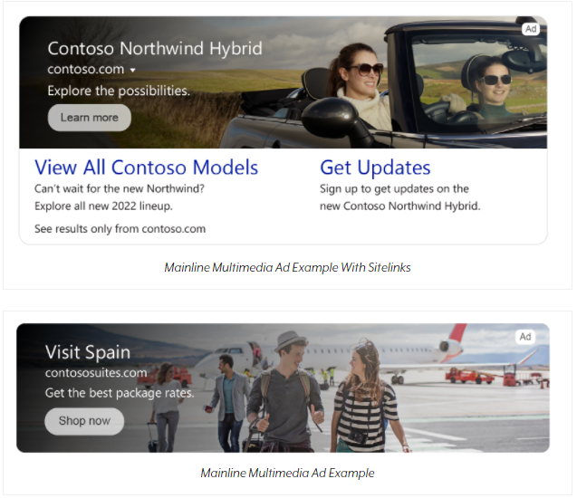



* The setup of Multimedia Ads is similar with Google’s responsive display ad creation. The proves also closely resembles the creation process for Responsive Search Ads, but with the ability to use rich visual assets in combination with text.

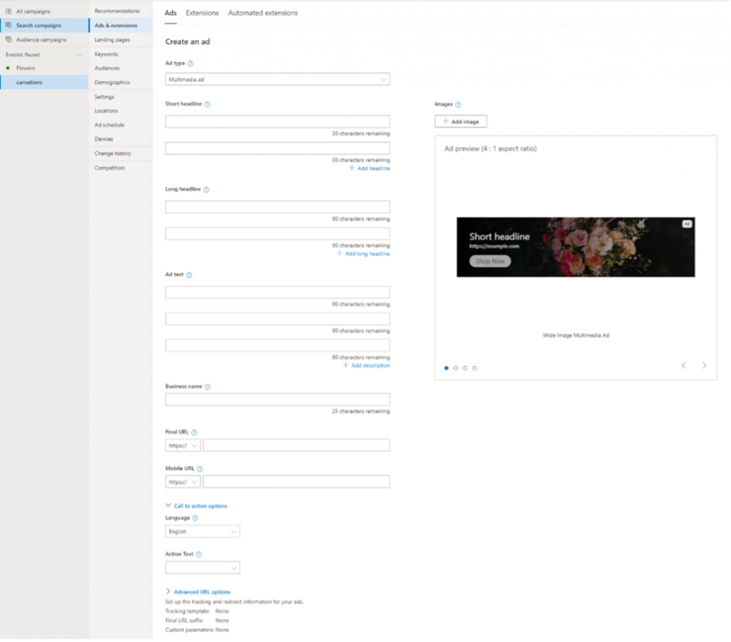

* Because only one multimedia ad can display at a time, Microsoft Ads has rolled out bid adjustment settings. Advertisers can add an additional bid modifier for the multimedia ad placement.

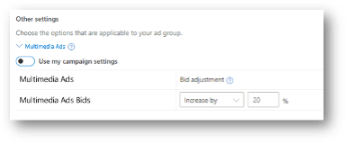

* Microsoft Advertising will create recommendations using advertisers’ existing image assets (such as image extensions) and text ads assets, as well as stock images (coming soon).
* Microsoft Advertising plans to roll out the following enhancements in the near future:
  + Enhanced mainline experiences with additional rich formats, including video.
  + Multimedia Ads for Retail: Combining the power of Multimedia Ads with your product feeds.
  + Additional Bing surfaces and expansion to the Microsoft Audience Network.
  + New CPM-based auto bidding strategies for Multimedia Ads.
  + Additional import opportunities of your rich media assets from other ad platforms.

<https://www.searchenginejournal.com/microsoft-advertising-announces-new-multimedia-ads-for-search/412476/>

## **Five tech companies now earn 46% of global ad revenues as news media left behind**

Google, Facebook, Alibaba, TikTok owner Bytedance and Amazon generated ad sales of $296bn last year – making up 46% of the market.

* **Global ad market 2010: Big five claim 17% of revenues**

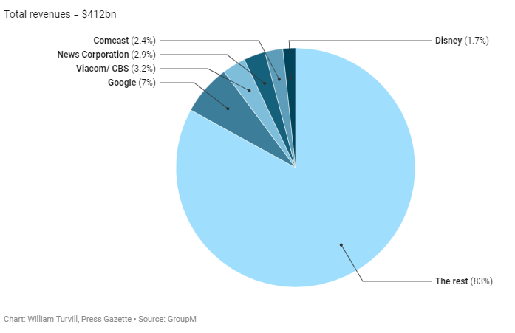

* **Global ad market 2020: Big five claim 46% of revenues**

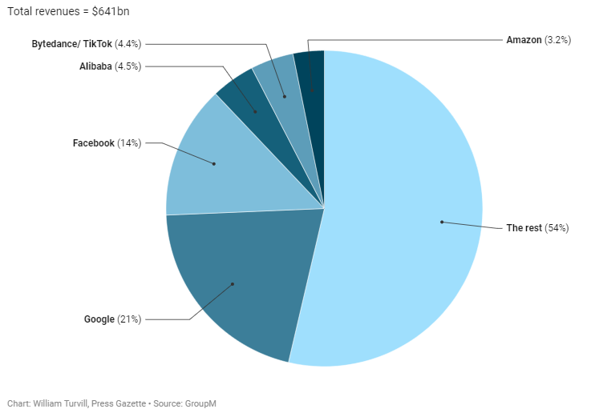

* **Google and Facebook** – known as the Duopoly in media and advertising circles – made combined ad revenues of $219m in 2020, claiming 34% of the total market. Five years before, in 2016, they sold $101bn of ads – or 19% of the global total.
* **2020’s top 20 global ad revenue earners**

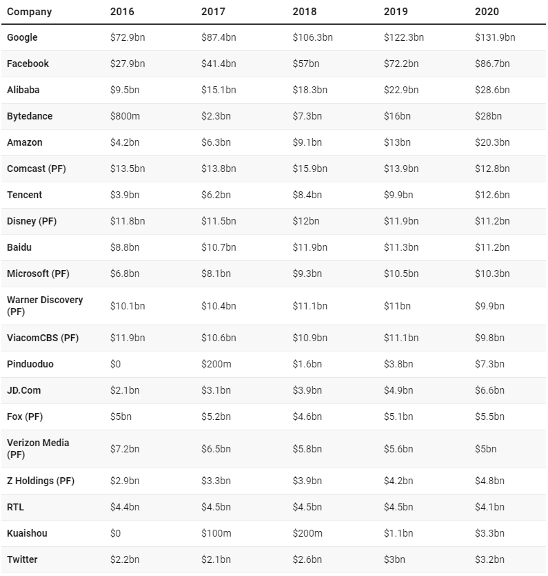

<https://www.pressgazette.co.uk/global-advertising-spend-2020-quintopoly/>

# Calendar Week 26 (Jul 2)

## **Advertisers will lose the ability to create new BMM keywords on Google in late July**

As of late July, **advertisers will no longer be able to create new broad match modifier (BMM) keywords with the +keyword notation,** Google Ads announced Tuesday. Existing BMM keywords will keep serving under the updated phrase match behavior.

* When Google Ads first announced that it was expanding phrase match to include BMM traffic, the company also stated that after the new behavior rolled out worldwide, advertisers would not be able to create new BMM keywords.
* Google recommends **consolidating duplicate keywords and switching your BMM keywords to a different match type** so that it’s easier to manage your account in the future.
* To help identify redundant keywords, **a “Remove redundant keywords” recommendation** may appear on the Recommendations page when a keyword also exists as phrase match in the same ad group.
* Bulk editing tools to convert BMM keywords have also been added to Google Ads and Google Ads Editor.
* When a BMM keyword is converted, it is removed and a new keyword in the designated match type is created.

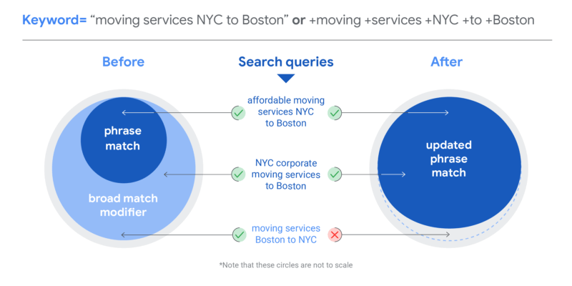

<https://searchengineland.com/advertisers-will-lose-the-ability-to-create-new-bmm-keywords-in-late-july-349971>

## **Instagram: “We’re No Longer A Photo Sharing App”**

Head of Instagram, Adam Mosseri, announces further expansion into video as he states that his company’s app is about more than just photo sharing. Mosseri says Instagram is currently **building out new experiences in four key areas**.

* The company’s first priority is **creators** and helping them earn a living with new monetization features.
* Second in priority is **video**, which is seeing an immense amount of growth online on all major platforms right now.
* A third area Instagram plans to expand on is **shopping.**
* The fourth area Instagram plans to build out is **messaging**, which Mosseri says has become the primary way people connect with their close friends on the app.
* Over the next couple of months, Instagram will experiment more in the space of recommendations. That involves showing users content in their feed from accounts they may not be following yet.
* Instagram will also experiment with how video is used as a content format.
* Lastly, the company expects to be more transparent in its communication of upcoming changes, noting these plans represent an ongoing effort and not an overnight shift.

<https://www.searchenginejournal.com/instagram-were-no-longer-a-photo-sharing-app/412194/#close>

## **Apple extends advertising lead following iOS 14.5**

Apple devices are capturing a larger share of advertising spend following the release of iOS 14.5, but only in markets where iOS has historically been an important player, according to a WARC Data analysis of AppsFlyer data.

* **Among the seven markets where Apple took at least a 40% share of advertising spend** before iOS 14.5, five of them (71%) have seen Apple grow its share since launch.
* **In the eight markets where Apple has historically taken a less than 40% share of advertising spend,** seven of them (88%) have seen Apple's share decline since launch.
* In markets where Apple is less relevant, advertisers have been willing to shift budgets to target more data-rich Android devices.
* In markets where Apple plays a more important role, advertisers have been reluctant to move their investment.
* On a global basis, however, Apple's market share has dipped following iOS 14.5 – it averaged 42.7% of global app advertising spend before and this has since fallen to 41.8%. Android investment has accelerated over this same period.

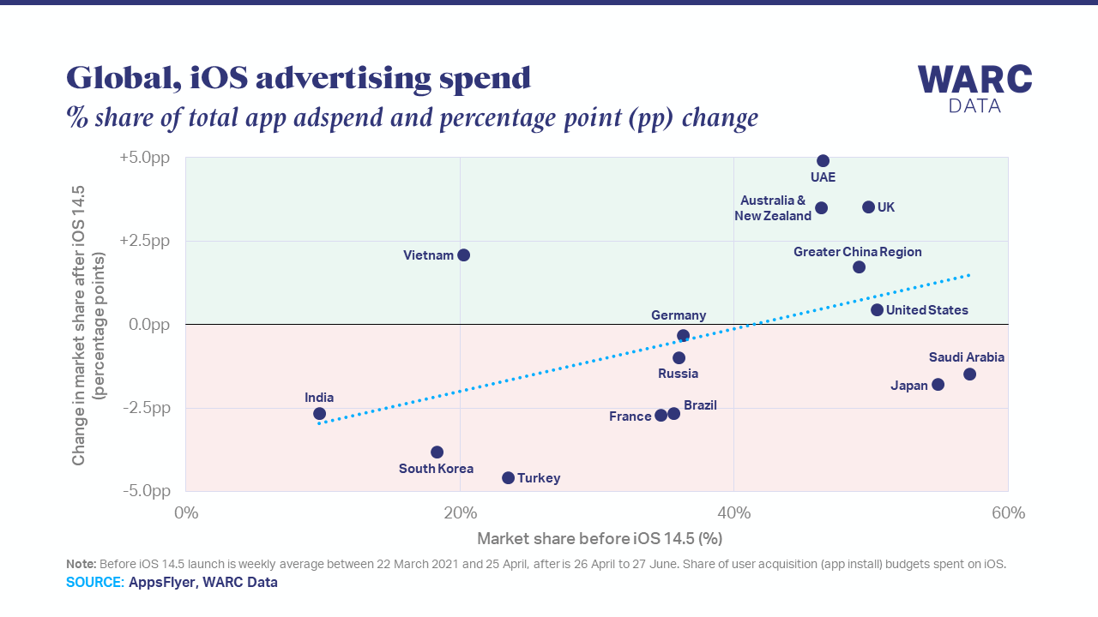

<https://www.warc.com/content/paywall/article/WARC-DATAPOINTS/Apple_extends_advertising_lead_following_iOS_145/137970>

## **The founder of a new ad-free search engine bets people will pay for privacy**

[Neeva](http://www.neeva.com/) is a new search engine, officially launching today, that carries a subscription fee. Though it’s extremely similar to Google in many respects—with a few twists of its own—**it dumps the web giant’s venerable ad-based business model in the interest of avoiding distractions, privacy quandaries, and other compromises.**

* It’s free for three months—long enough for users to grow accustomed to it without obligation—and $4.95 a month thereafter.
* Apps for iPhones and iPads, and browser extensions for Chrome, Firefox, Safari, Edge, and Brave, are part of the deal.
* Neeva may have a certain whiff of improbability about it, but its co founders, [Sridhar Ramaswamy](https://www.fastcompany.com/90616232/googles-former-ad-chief-is-challenging-its-search-engine-monopoly) and Vivek Raghunathan, are the furthest thing from naïfs. Two long-time Google executives with more than a quarter-century of experience at the web giant between them, they have an insider’s understanding of how it operates. Moreover, about 30 percent of the roughly 60-person staff they’ve assembled at Neeva consists of ex-Googlers, including Hall-of-Famers such as Udi Manber (a former head of Google search) and Darin Fisher (one of the inventors of Chrome).
* They’ve also secured $77.5 million in funding, including investments from venture-capital titans Greylock and Sequoia.
* At its highest level, Neeva represents a bet that the way Google monetizes search and other services through advertising—as it’s done for more than two decades to wildly profitable effect—has hampered its user experience, thereby opening up an opportunity.

<https://www.fastcompany.com/90650719/neeva-search-engine-google-alternative-privacy-sridhar-ramaswamy-tech>

## **Amazon acquires podcast distributor, monetization platform Art19 in chase for audio ad dollars**

Amazon is attempting to round out its podcast advertising suite with the Art19 acquisition as the audio advertising category at large grows more competitive. Financial terms of the transaction were not disclosed.

* Founded in 2015, Art19 offers a platform where clients can manage both their content and ad operations in one place. Performance dashboards track how listeners are engaging with campaigns in real-time, measuring impressions and downloads based on standards certified by the IAB Tech Lab.
* The company also operates an Ad Creative Studio to assist with creative strategy and production.
* Art19's goal is to bring the same level of granular marketing capabilities common across digital to the podcast space while sitting at the intersection of publishers and advertisers, according to its website.
* With the acquisition, Amazon continues to ramp up podcast dealmaking, an attempt to close the gap in an area where it's a relative latecomer.
* Advertising revenue for podcasts grew 19% year-on-year to $842 million in 2020, bolstered by a 37% gain in the fourth quarter, [according to a recent analysis](https://www.marketingdive.com/news/podcast-ad-revenue-to-exceed-2b-by-2023-iab-forecasts/600089/) by the Interactive Advertising Bureau and PricewaterhouseCoopers. The category at large is expected to surpass $2 billion in revenue by 2023, the firms found.

<https://www.marketingdive.com/news/amazon-acquires-podcast-distributor-monetization-platform-art19-in-chase-f/602442/>

# Calendar Week 25 (Jun 25)

## **Facebook Launches 4 New Ecommerce Features**

Facebook, Instagram, and WhatsApp are gaining new features that will help retailers get their products in front of more customers and drive sales.

* **Facebook Shops in More Places** Once a Facebook Shop is set up, products are eligible to appear in the Shop tabs on Instagram and Facebook.
  + Businesses in the US can now choose Marketplace as an additional sales channel.
  + In addition, businesses in several countries can showcase their entire Shop in WhatsApp.
  + Businesses only need to set up their shop once to have it work across Facebook, Instagram, and WhatsApp.
* **Customer Reviews** Over the next few months customer ratings and reviews will be expanded to products in Shops on Instagram.
  + When this feature rolls out it will include photos and videos from the community in addition to written reviews.
* **Personalized Shop Ads** Facebook is launching new ads to personalize the shopping experience and point customers toward a Shop’s curated collection.
  + Shop ads will have the ability to send shoppers to where they are most likely to make a purchase based on prior shopping activity.
* **Expanded Access to AR Try-On Feature** Facebook is bringing AR to a new ad unit that will automatically show relevant products to people based on their interests, encouraging them to “try it on.”

<https://www.searchenginejournal.com/facebook-launches-4-new-ecommerce-features/411350/>

## **Google Announces New Ads Creative Studio**

Google announced the launch of a new tool for creative advertising tools, called **“Ads Creative Studio”,** which aims to unify multiple creative tools.

* **Ads Creative Studio** will incorporate the following tools:
  + Director Mix (A tool that allows brands to create video assets at scale, which previously wasn’t available to all advertisers.)
  + Dynamic Display & HTML5 creation tools
  + Audio Mixer and Dynamic Audio tools
  + A Project Library
* **The Ads Creative Studio** will have separate libraries for assets, think of these as the building blocks for ads, and the project library, where the creators collaborate on ad creation.

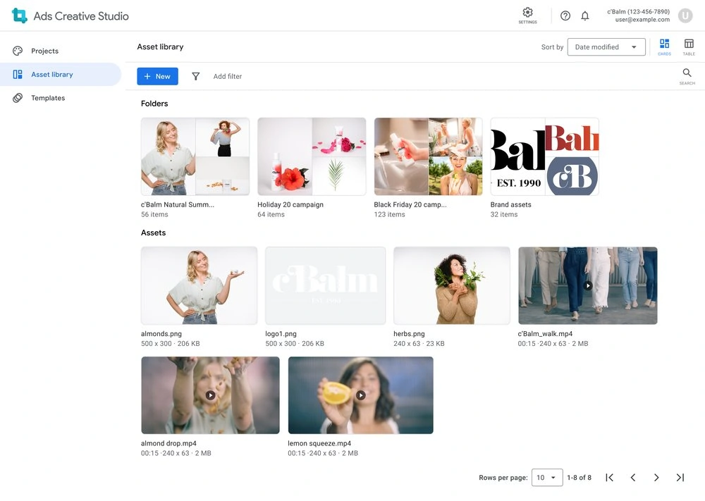

* Ads will also be available to be used across projects, once created.

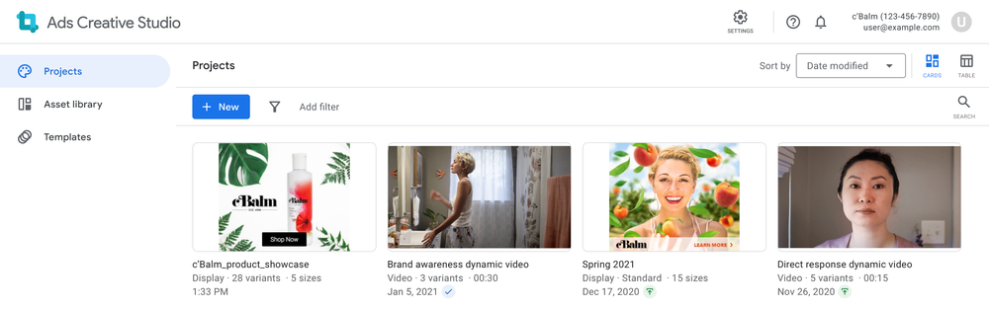

* The Ads Creative Studio is designed to improve collaboration between creative and media teams. Teams can work together to collaborate on templates, implement design rules, and implement QA processes all through the new tool.
* Once ads are created, they are able to be exported to Google Ads, Display & Video 360 and Campaign Manager 360 for use.

<https://www.searchenginejournal.com/google-announces-new-ads-creative-studio/411133/>

## **Spotify Gets Into Social Audio With Greenroom**

Spotify is now competing in the social audio space with the launch of **Greenroom**, which offers the option of **turning live chats into podcast recordings.**

* While this is a new product from Spotify, it’s more a takeover of an existing app rather than the launch of something that was built from the ground up.
* Spotify acquired the company Betty Labs which owns a sports-focused audio app called **Locker Room**. Using Locker Room’s existing code, the app has been given a fresh coat of paint, and many upgrades, to turn it into **Spotify Greenroom.**
* No longer catering to just sports fans, **Greenroom has a broad range of general interest groups about all kinds of topics.**
  + Greenroom allows Spotify users to join and host live audio conversations with groups of people from all over the world.
  + It offers the same key features as other social audio offerings, such as Clubhouse, Twitter Spaces, and Facebook’s Live Audio Rooms.
* **What Makes Spotify Greenroom Different?** 
  + The live audio sessions are recorded by Spotify. This allows users to turn their rooms into podcasts that can be listened to on-demand through Spotify at any time.
  + Another unique feature is a live text chat that users can participate in while listening to others speak.
  + Spotify is incentivizing the use of Greenroom with the launch of a ‘Creator Fund’ that helps live audio creators get paid for their work.

<https://www.searchenginejournal.com/spotify-greenroom/411044/>

## **Apple's advertising platform Apple Search Ads launches in mainland China**

Apple's advertising platform Apple Search Ads is now available in mainland China, but advertisers may have to gain state approval and licenses before using it on the App Store, the media reported.

* Apple has expanded its advertising programme **Apple Search Ads** to China, meaning that **developers and advertisers can now have App Store ads** presented to users in the region.
* Apple Search Ads has been steadily rolling out to more countries, but the Chinese version has extra conditions. As first spotted by AppInChina, advertisers and businesses need to be approved.
* AppInChina claims that most licenses are granted to companies that are 100 percent Chinese-owned.
* There are exceptions for joint ventures where Chinese companies control over 50 per cent, however, and AppInChina does propose using its Chinese licenses and partnering with non-Chinese firms.
* It's also likely that Apple will begin to require these licenses to simply publish an iOS app in China within the next few months.

<https://www.business-standard.com/article/technology/apple-s-advertising-platform-apple-search-ads-launches-in-mainland-china-121062400740_1.html>

## **Amazon Advertising Accelerates for Prime Day 2021**

This year, the 48-hour online shopping event known a**s Amazon Prime Day has driven a 53% increase in advertising spend on Amazon**, according to Jungle Scout’s ecommerce data.

* **The average ad spend** per distinct Amazon ad campaign increased by 284% compared to the Monday and Tuesday a week prior to Prime Day, and rose 53% from 2020:

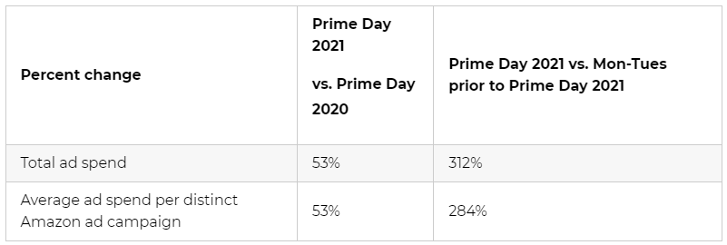

* **Sales revenue** attributed to Amazon ad campaigns during Prime Day 2021 increased by 34% compared to last year. Compared to a normal day, sales for the average Amazon ad campaign measured increased by 395%:

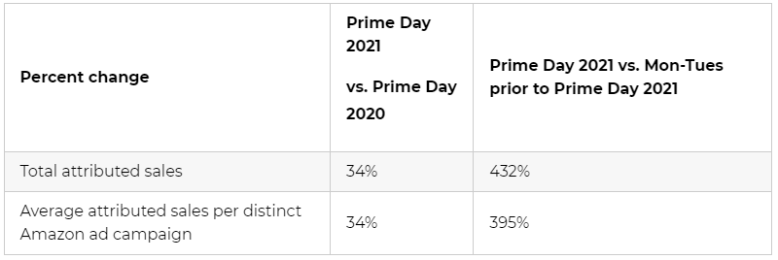

* Total Prime Day **ad sales conversions** increased by 40% from 2020 to 2021:

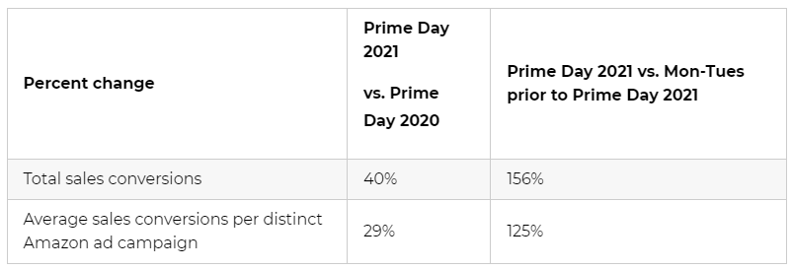

* Jungle Scout data reports a 29% increase in **return on ad spend** from campaigns run during Prime Day compared to the Monday and Tuesday the week prior to the event. However, ROAS has decreased slightly by 12% compared to Prime Day 2020.

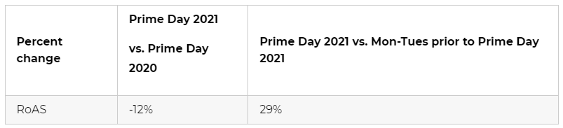

* Overall, online spending during the event surpassed $11 billion and was **6.1% higher compared to last year’s October Prime Day**, according to Adobe Analytics.

<https://www.junglescout.com/blog/prime-day-advertising/>

# Calendar Week 24 (Jun 18)

## **Google Launches Search Console Insights**

Google is introducing a new experience called Search Console Insights which is designed to help site owners better understand their audience.

* This experience joins data from both Search Console and Google Analytics in a joint effort to make it easy to understand content performance.

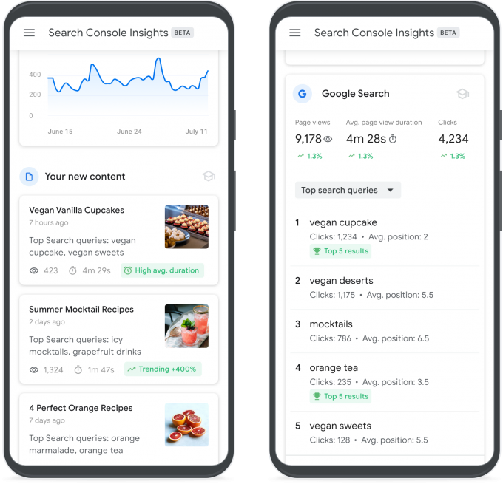

* Data in Search Console Insights will help site owners answer question such as:
  + What are your best performing pieces of content, and which ones are trending?
  + How do people discover your content across the web?
  + What do people search for on Google before they visit your content?
  + Which article refers users to your website and content?
* Site owners can access Search Console Insights via the new link at the top of the Overview page. Soon it will be accessible from Google's iOS app, with support for the Android app being planned as well.

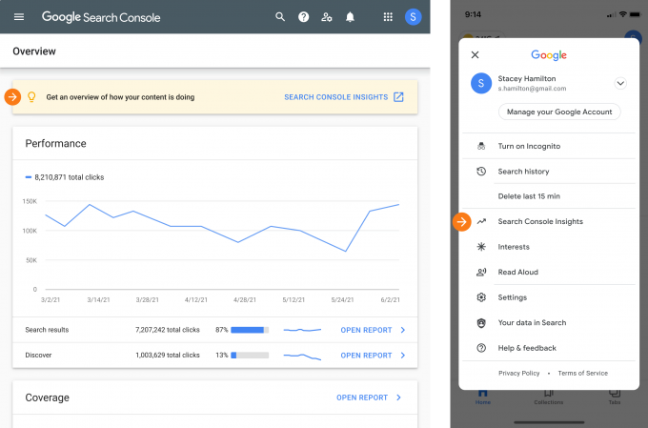

<https://www.searchenginejournal.com/google-introduces-search-console-insights/410570/#close>

## **Microsoft Advertising launches new Tours and Activities ad format in open beta**

Microsoft Advertising is introducing[**Tours and Activities ads,**](https://about.ads.microsoft.com/en-us/blog/post/june-2021/the-rise-of-the-conscious-traveler) **a new ad format that is unique to the platform.**

* **Tours and Activities ads are feed-based ad types** that can display for relevant queries.
* Advertisers in the U.S. and UK can sign up for the open beta.
* This new ad format is created dynamically using unique feed files that include images, price, reviews, videos, ratings, etc. The format leverages Microsoft’s AI, so keywords are not required.
* Tours and Activities ads can appear for relevant queries in Bing search, as shown below. This ad type can also appear in Bing Maps when a user searches for a particular destination or when they search for things to do in a given location.

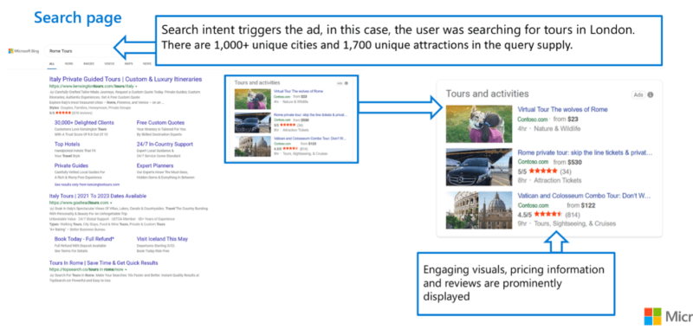

* In addition, these ads can also be seen as a carousel within Bing Travel Guides.

<https://searchengineland.com/microsoft-advertising-launches-new-tours-and-activities-ad-format-in-open-beta-349624>

## **Instagram Reels now has ads**

**Instagram is introducing adverts to its TikTok clone, Reels**, after testing them out on users in a handful of countries like India, Germany and Australia.

* Similar to those slotted in Stories, these too will be vertical, full-screen ad breaks that appear between Reels and can be up to 30 seconds long.
* Also in the same vein, you'll be able to skip or interact with the ads by commenting, liking, saving or sharing them.
* Instagram says that you'll see the ads wherever you view Reels, including in the Reels tab, in Stories, in Explore and in your feed.
* To gain more views, Instagram moved Reels from the Explore tab to their own dedicated section on the main screen in November as part of a redesign that also ushered in a Shop tab.

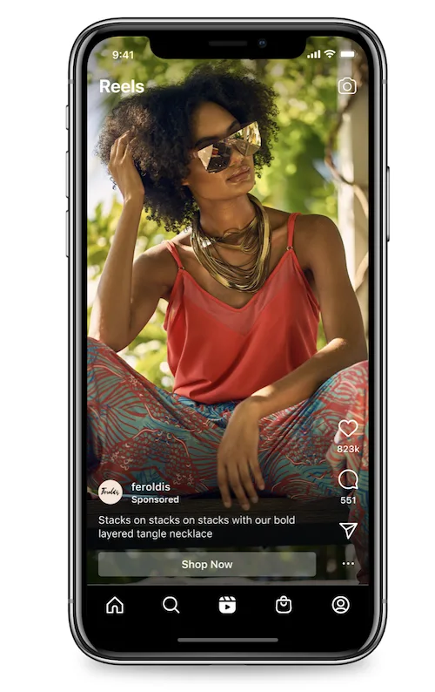

<https://www.engadget.com/instagram-reels-ads-150057886.html>

## **Amazon Ads Are Getting More Expensive**

Advertising on Amazon now costs, on average, $1.20 per click. Up 30% from $0.93 at the start of the year and up over 50% year-over-year. Demand for advertising on Amazon is rising faster than the ad inventory on and off Amazon, thus driving up advertising prices.

* According to Marketplace Pulse research, the average cost-per-click (CPC) was $0.85 in 2020. It reached the lowest point of $0.70 in early May when the pandemic caused supply chain disruptions, resulting in some brands running out of stock and pulling back on advertising.
* It recovered by mid-September and then hit three distinctive peaks: Prime Day in October, Black Friday and Cyber Monday in November, and holiday shopping in December. After that, CPC settled at around $0.90 for most of Q1 2021.
* The average advertising cost of sale (ACoS) was 22% in 2020. It started 2021 at 25% and has now risen to over 30%. Yet, the average conversion rate - the percentage of clicks an ad converts into sales - has remained relatively stable at 12%-13%. Thus the average cost of sale was $6-$7 in 2020 but has risen to $9-$10 - it takes eight clicks at an average price of $1.20 to generate one sale, up from $0.85.
* Advertising prices have changed nearly identically across all Amazon markets, not just the U.S. The same trend of decreasing CPC in May 2020, holiday peaks at the end of the year, and rise over the past few months is visible in other markets like Japan and Europe.

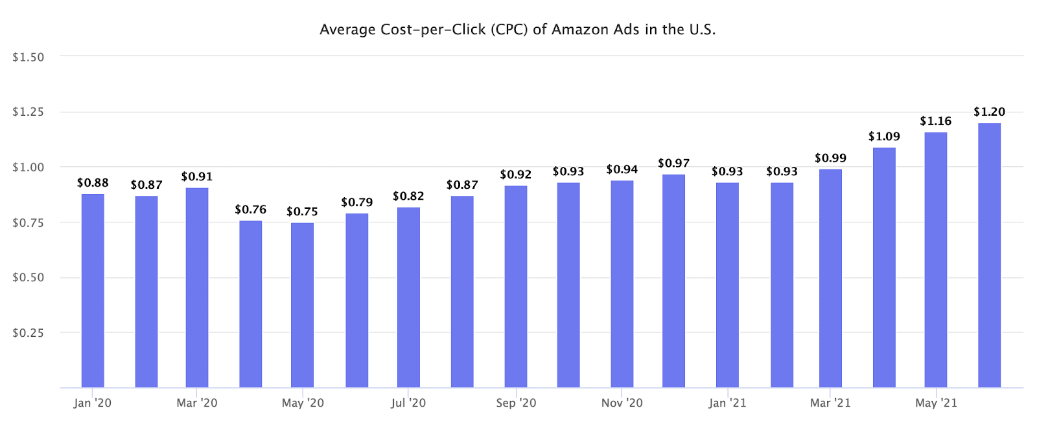

<https://www.marketplacepulse.com/articles/amazon-ads-are-getting-more-expensive>

# Calendar Week 23 (Jun 11)

## **Google Announces New Reporting Features in GA4**

Marketers are receiving new reporting features in Google Analytics 4 to dig deeper into key insights. The platform is also being slightly reorganized for usability.

* Google has announced that **Google Analytics 4 will adopt a new lefthand navigation menu.** 
  + The menu was designed to make it easier for users to quickly and intuitively navigate to different reports for their use case.
  + Each section is designed to support a different use case and these sections will be called “Workspaces”.

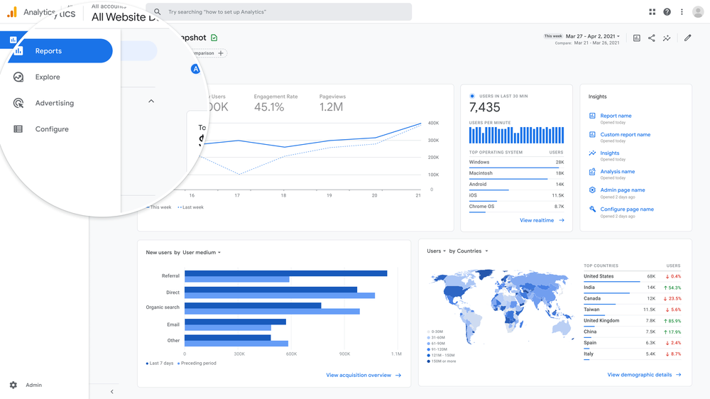

* Later this year, Google Analytics will begin extending the conversion modeling across “certain reports”.
* Google has also announced that **users with admin access will be able to curate the Analytics interface.**
  + It means that folks can expand a panel on the left that would expand key dimensions and metrics, which would allow them to customize what their reports look like – not just for custom reports but for the default reports.
* Soon, all Google Analytics 4 properties will make data-driven attribution available. There will also be two new reports: **the conversion paths report and the model comparison report.**
  + **The conversion paths report** will be similar to the report that Universal Analytics users are familiar with, which will allow you to monitor the full consumer path, across various channels.
  + **The model comparison report** allows marketers to compare various attribution models to see the impact on various channels.

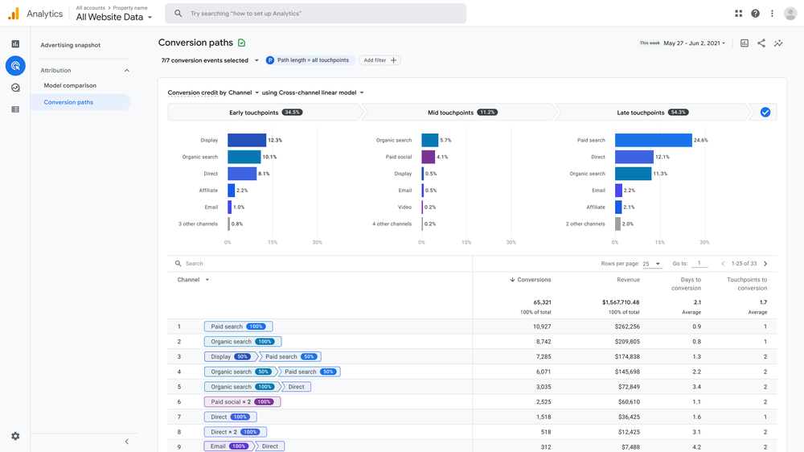

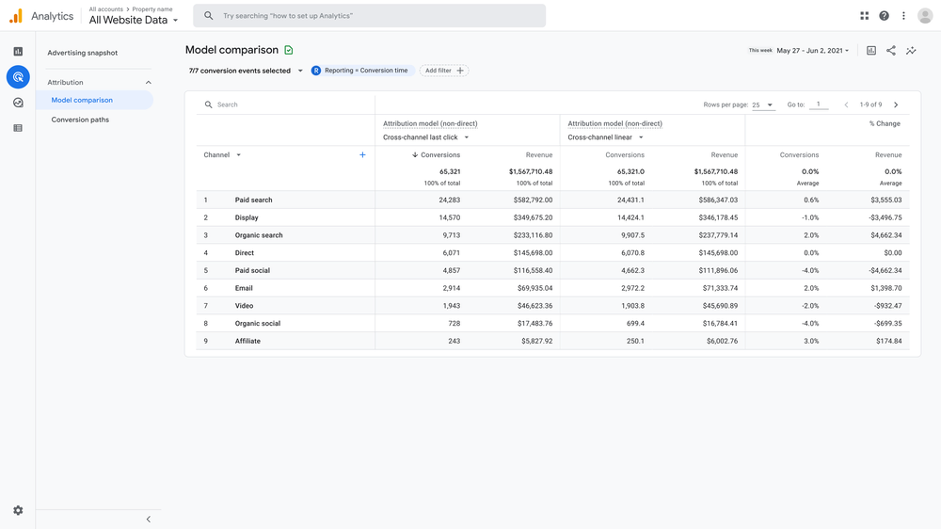

<https://www.searchenginejournal.com/google-announces-new-reporting-features-in-ga4/410195/#close>

## **Rakuten Advertising Brings on Magnite to Further Monetize Rakuten TV Inventory Across Europe**

**Magnite** (NASDAQ: MGNI), the world’s largest independent omnichannel sell-side advertising platform, today announced **Rakuten Advertising will leverage the Magnite CTV platform across Europe to broaden advertiser and agency access to inventory on Rakuten TV AVOD service.**

* Magnite’s CTV platform further expands Rakuten Advertising’s access to technology built to properly handle the nuances of long-form video, resulting in high quality advertising and viewing experiences.
* Rakuten TV sits within Rakuten Advertising’s unified portfolio, where advertisers can buy media across a variety of channels.
* Rakuten TV is the first VOD platform in Europe combining TVOD (Transactional video-on-demand), SVOD (Subscription video-on-demand) and AVOD (Advertising video-on-demand) services.
* The ad-supported offering provides a wide range of content with an extensive line-up of linear channels from global networks, top European media groups and the platform’s own thematic channels that deliver curated content from Hollywood and local studios; as well as more than 10,000 titles available on-demand.
* Ad-supported streaming is on the rise in Europe. Magnite’s recent consumer study “CTV in the EU5: The Future Forward” showed that 63% of TV viewers watched AVOD content weekly.

<https://www.globenewswire.com/news-release/2021/06/02/2240060/0/en/Rakuten-Advertising-Brings-on-Magnite-to-Further-Monetize-Rakuten-TV-Inventory-Across-Europe.html>

## **TikTok Shares New Insights Into the Importance of Sound for Marketing Promotions on the Platform**

According to TikTok's latest research report, audio is also a key component of brand promotions, with TikTok users being more receptive to sound elements within ads than they are on other platforms.

* Among the key findings, the research shows that:
  + **88% of TikTok users said that sound is essential to the TikTok experience**
  + 73% of respondents said they would "stop and look" at ads on TikTok with audio, a significantly higher result than any other platform
  + TikTok is the only platform where ads with audio generate significant lifts in both purchase intent and brand favorability
* As per TikTok: **"[Sound is] the anti-scroll, and it helps your messages not only be heard but be felt by your audiences."**
* **TikTok advises that brands should look to:**
  + License popular audio - Brand usage of sounds is restricted in the app, but **brands are able to organize their own licensing deals for music clips,** which could be helpful if you're looking to tap into trends
  + Amplify branded sounds - **Brands can also turn their owned audio into a promotional tool in the app**, which could even fuel a new trend
  + Create new sounds - **Brands can additionally look to create original sounds for their promotions for use** in their TikTok campaigns
* TikTok also notes that brands can use its free [Commercial Music Library,](https://www.tiktokforbusinesseurope.com/resources/how-to-elevate-your-videos-with-tiktoks-commercial-music-library) which provides access to "hundreds of thousands of pieces of licensed music and sounds to use on TikTok".

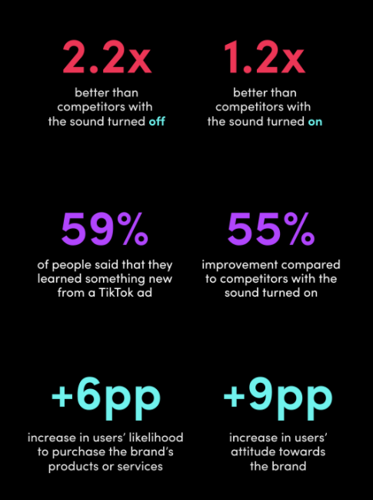

<https://www.socialmediatoday.com/news/tiktok-shares-new-insights-into-the-importance-of-sound-for-marketing-promo/601569/>

# Calendar Week 22 (Jun 04)

## **Google Tightens ‘Limit Ad Tracking’ Policies For Android Ad ID**

Google will zero out the Android Advertising ID – literally – when users have opted out of personalized advertising starting later this year. Currently, users who have opted out of tracking and personalized advertising are still tagged by the Advertising ID when they open an app, since that ID is used for non-advertising use cases such as attribution, analytics and fraud detection. But beginning later this year, the advertising ID field for opted-out users will display only a string of zeroes, instead of the ID.

* In a support page published, Google said that in July it will release an alternative to the Android Advertising ID to support analytics and fraud detection without passing the ID for users who opt out of personalization.
* The big difference is that Apple’s latest iOS proactively alerts every user in every third-party app to decide whether to allow tracking for ads, a program called AppTrackingTransparency.
  + And, when prompted, the vast majority of users reject tracking, according to early data about iOS 14.5.
  + Google is taking the quieter approach of enforcing anonymity when people have opted out of ads personalization, without prompting users to make the decision.
* Unlike Apple, Google’s mobile ad-tracking policy changes will go through months of review and coordination with developers and tech vendors.
  + For one thing, any sudden changes by Google properties like Android or Chrome that disrupt Google’s advertising competition could set off antitrust tripwires. Android is also open-source software, so Google can’t make sudden changes of its own discretion.

<https://www.adexchanger.com/mobile/google-tightens-limit-ad-tracking-policies-for-android-ad-id/>

## **Amid post-cookie confusion, Amazon plans to launch an identifier of its own**

The advertising and e-commerce behemoth has been meeting with different companies to discuss **plans for an identifier that would allow advertisers and publishers to better track and measure activity within its own ads ecosystem**, according to sources at three different companies that have spoken with Amazon about it. Amazon confirmed to Digiday that it plans to release an identifier but did not offer a timeline.

* Amazon is hoping to use the identity vacuum Google has opened with its depreciation of the third-party cookie to suck up more business for its own DSP and publisher services.
* Rather than a universal identifier like the ones being developed by The Trade Desk or LiveRamp, which Google has said it won’t support in its open exchange, **Amazon’s identifier will live solely inside of Amazon’s ecosystem: Available to the buy side via Amazon’s DSP, and available to publishers through its publisher services division APS, those sources said.**
* A spokesperson from Amazon said the identifier will operate in accordance with Amazon’s privacy notice, interest-based ads and opt-out policies.
* Amazon did not make an executive available for comment for this story; a spokesperson said that the identifier would be available only to publishers that meet Amazon’s requirements, without elaborating on what those requirements are.
* The concept of a publisher-provided ID, which has long played a role in private marketplace deals, has recently gotten a fresh look; Google announced in mid-March it would do more to encourage the use of PPIDs in the open programmatic ecosystem, giving publishers the ability to make their respective IDs available in open exchanges to advertisers they designated.

<https://digiday.com/marketing/amid-post-cookie-confusion-amazon-explores-launching-an-identifier-of-its-own/>

## **Google Ads updates cryptocurrency ad policies**

Google has announced an update to its financial products and services policy, which includes its policy on cryptocurrency advertising. **The new rules will take effect in August and all prior crypto exchange certifications will be revoked. Advertisers must request new cryptocurrency exchanges and wallets certification with Google.**

* Google will update its existing financial products and services policy in August *“to clarify the scope and requirements to allow the advertisement of cryptocurrency related business and services.”* The tech giant wrote: *“Beginning August 3, advertisers offering cryptocurrency exchanges and wallets targeting the United States may advertise those products and services when they meet the following requirements and are certified by Google.”*
  + Firstly, they must be duly registered with the Financial Crimes Enforcement Network (FinCEN) *“as a Money Services Business and with at least one state as a money transmitter.”*
  + “Alternatively, the advertisers can be *“a federal or state chartered bank entity.”*
* Google clarified that some ads are not allowed. They include *“Ads for initial coin offerings [ICO], Defi trading protocols, or otherwise promoting the purchase, sale, or trade of cryptocurrencies or related products.”* In addition, *“Ad destinations that aggregate or compare issuers of cryptocurrencies or related products”* are also prohibited.

<https://news.bitcoin.com/google-new-policy-cryptocurrency-ads/>

## **Roku Premieres First Branded-Content Program, With Weekly Streaming Picks**

Roku is debuting an entertainment show designed to give the company a new bucket of ad inventory to sell, as well as a vehicle to promote streaming content on its platform.

* “Roku Recommends” is a 15-minute weekly entertainment program that will feature the Top 5 trending or topical titles.
* The project is a win for consumers, according to Bruss — citing Nielsen research showing it takes viewers an average of 7 minutes to find something to watch on streaming services — as well as marketers who are eager for a way to pitch their products or services to consumers who prefer ad-free, subscription-only environments.
* **Advertisers will not be able to sponsor the weekly titles featured in “Roku Recommends.” But they will be able to purchase timeslots in the show, during which the hosts will discuss a featured promo by a brand (like a “podcast live-read,” according to Bruss).**
  + **Retailing giant Walmart has signed on as the premier sponsor of the weekly program.**

<https://variety.com/2021/digital/news/roku-recommends-branded-content-1234987220/>

## **Similar Audiences and Google Merchant Center store importing are coming to Microsoft Advertising**

Microsoft Advertising will be rolling out Similar Audiences, the ability to import Google Merchant Center stores and an expansion of its Audience Network to include France and Germany, the company announced Tuesday.

* **Similar Audiences:** The feature, which finds new customers by looking for searchers similar to the ones on your remarketing lists, will be rolling out to U.S. advertisers later this month.
  + To use it you need to have at least one remarketing list with 300 or more users. Microsoft Advertising reevaluates your Similar Audience list daily so that there’s no overlap with your original remarketing list.
  + Additionally, advertisers can also import similar audiences and shared remarketing lists from Google Ads.
* **Enhanced Shopping Campaign importing:** Microsoft Advertising is now allowing advertisers to import their Google Merchant Center (GMC) store along with their Shopping campaigns.
  + Importing a GMC store automatically creates a Microsoft Merchant Center store with the same name, settings and domain.
  + This feature is currently only available as a closed beta; to participate, get in contact with your Microsoft Advertising account manager or contact Microsoft Advertising.
* **Microsoft Smart Shopping for Shopify:** Microsoft Advertising’s Shopify app is getting a new feature, called Microsoft Smart Shopping, that simplifies the Shopping campaign creation process.
  + In addition, Shopify merchants using Microsoft Advertising’s app are also automatically opted in to free product listings in Bing Shopping.

<https://searchengineland.com/similar-audiences-and-google-merchant-center-store-importing-are-coming-to-microsoft-advertising-349107>

# Calendar Week 21 (May 28)

## **Google launches new ad formats for local campaigns and pickup later option for local inventory ads**

Google is announcing a number of new local ad-based features at its Google Marketing Livestream event. These include **new ad formats for local campaigns and a new option for “pickup later” in the local inventory ads.**

* **New local campaign ad formats** 
  + **Auto Suggest ads.** Auto Suggest ads show ads based on the searcher’s location. When a searcher is nearby and looks for a related product or service in Google Maps, the ad will auto-suggest the advertiser’s nearby location to that searcher.

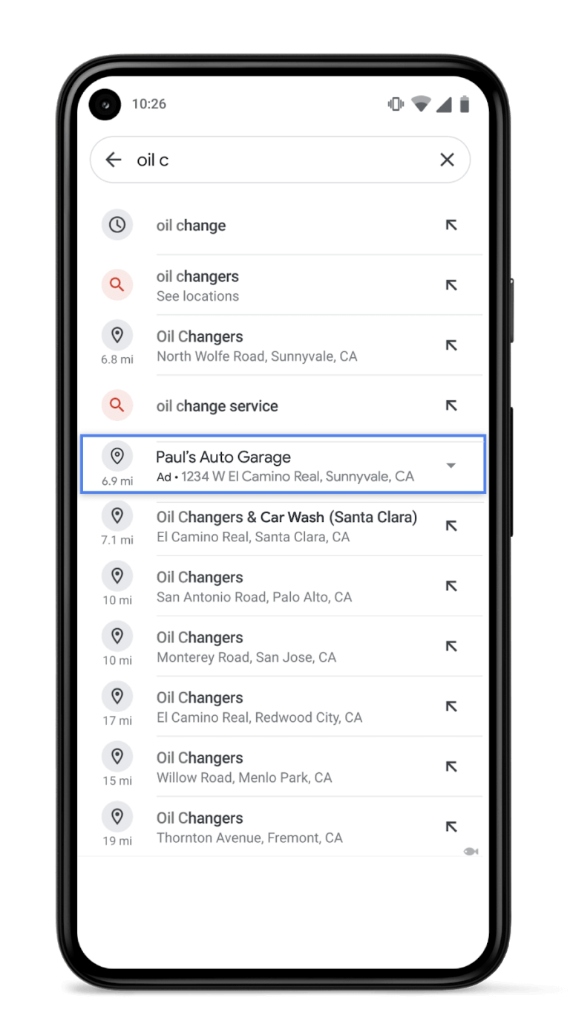

* + **Navigational ads.** Navigational ads are shown while you are using Google Maps driving directions. This allows businesses to show their ads while a user is en route to a destination.
  + **Similar Places ads.** Similar Places ads show up when you search for a specific business location and that business is closed at the time of the search.
* **Local inventory ads now include pickup later option** 
  + **Pickup later.** Google is launching an open beta for US-based advertisers to expand store pickup options by labeling their local inventory ads with a “pickup later” option.

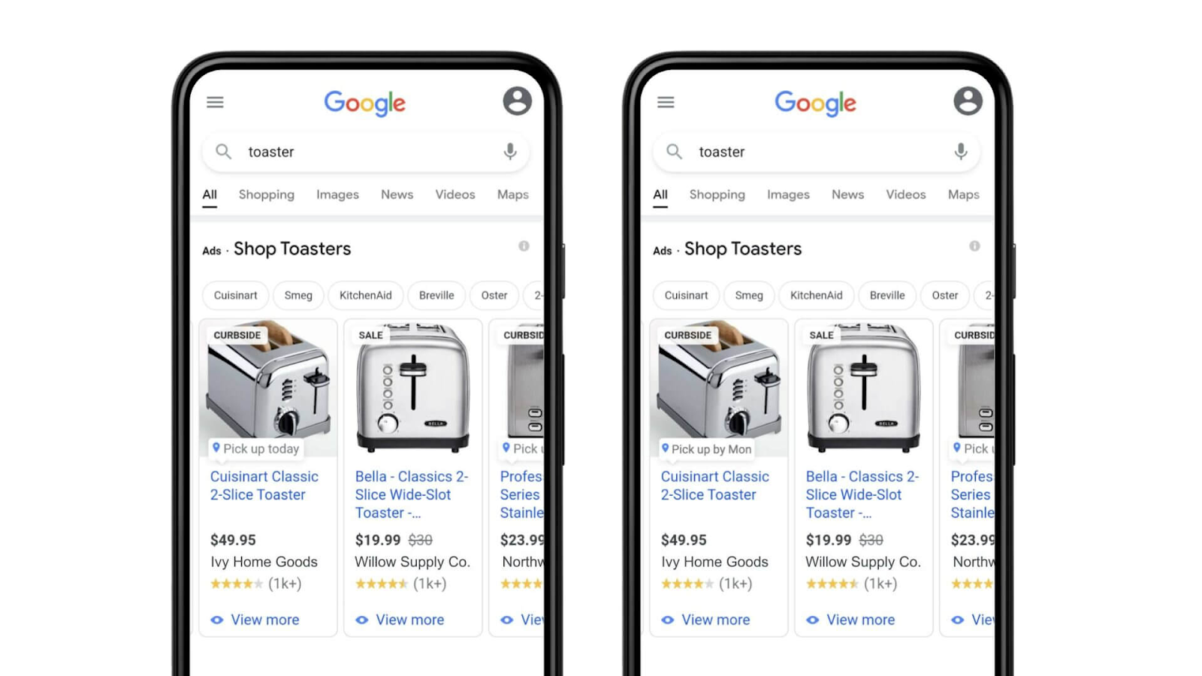

<https://searchengineland.com/google-launches-new-ad-formats-for-local-campaigns-and-pickup-later-for-local-inventory-ads-348959>

## **Microsoft Advertising announces Unified Smart: A single management solution for multi-channel paid advertising and social media**

Microsoft Advertising announced the pilot program for a single streamlined place to manage all of a business’s advertising campaigns. Interested parties can complete the online questionnaire to get early access.

* **For businesses just starting out with advertising**, paid search marketers can enter the business URL and their advertising goals, and Microsoft will automatically create a campaign based on the website content.
* **Manage social media ads in the same platform.** Along with search ads, the single point of management also allows advertisers to create image and video ads for Facebook and Instagram.
* **Reporting in a single place.** Along with being able to manage multiple, cross-channel campaigns in a single platform, small business advertisers can also see their reporting for these search and social media advertising campaigns in one place.

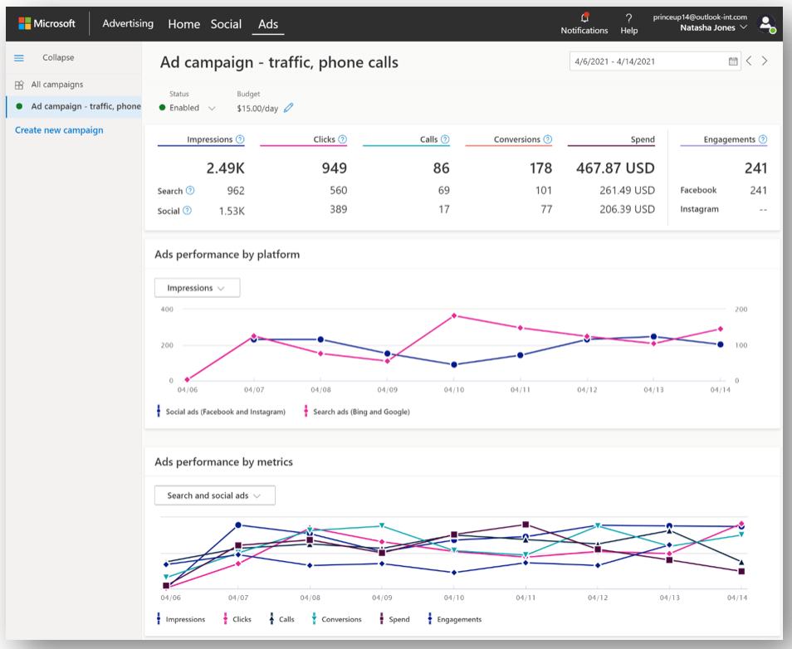

* **Consolidated inbox and post scheduling for Facebook, Instagram, Twitter and LinkedIn.** Businesses can also manage their organic social engagement in the same place with a consolidated inbox through Microsoft.
* **Organic social media reporting.** Along with paid search and social media advertising reports, businesses can also see their social media insights including engagement such as likes, comments, shares, retweets, and more.

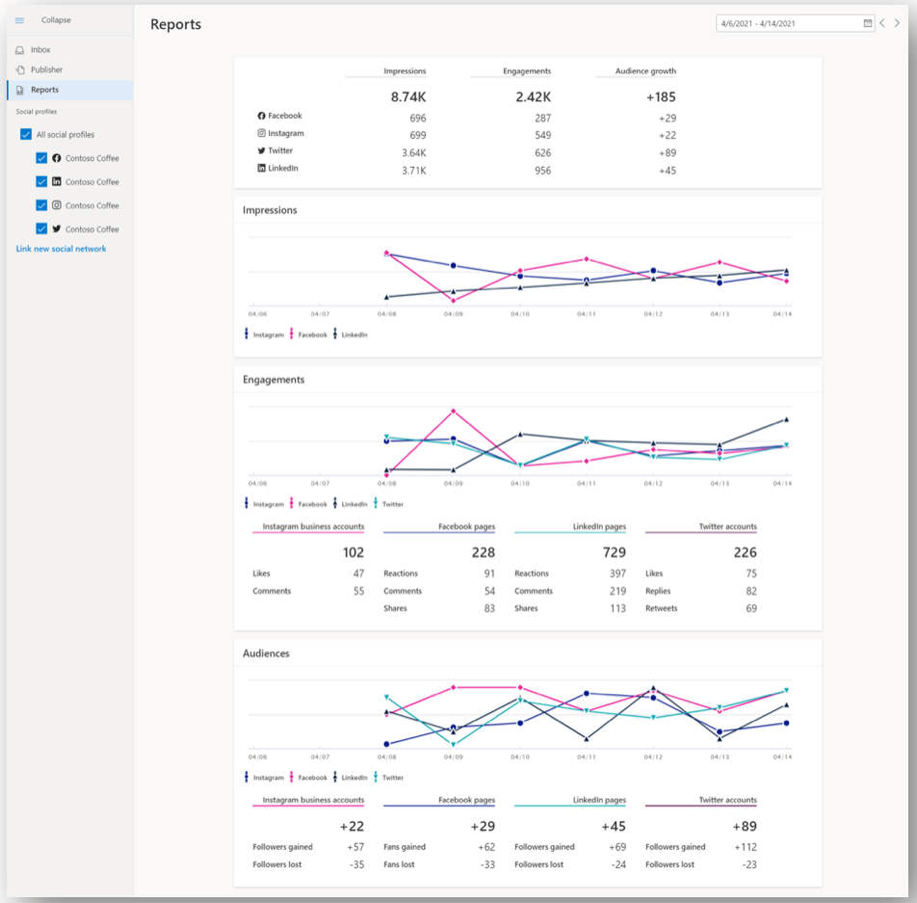

<https://searchengineland.com/microsoft-advertising-announces-unified-smart-a-single-management-solution-for-multi-channel-paid-advertising-and-social-media-348991>

## **LinkedIn introduces Event Ads and “boosted” posts**

LinkedIn has introduced **Event Ads** and the ability to **“Boost” organic posts from within a brand’s page.**

* **“Boosted” posts.** Brands can now increase their post’s reach directly from their LinkedIn page. This feature, known as **“Boost,”** creates a campaign in an ad account associated with your page.

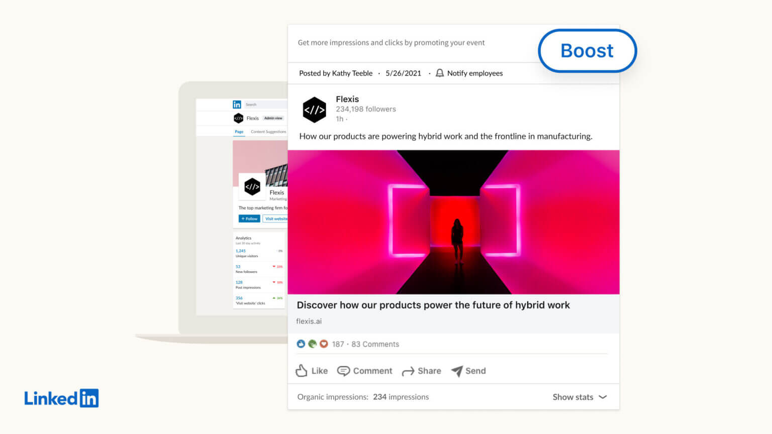

* **Event Ads.** This new ad format appears in the LinkedIn feed and highlights important event details like date, time and how to register. If a user’s mutual connections have expressed interest in attending, that will be shown as well.

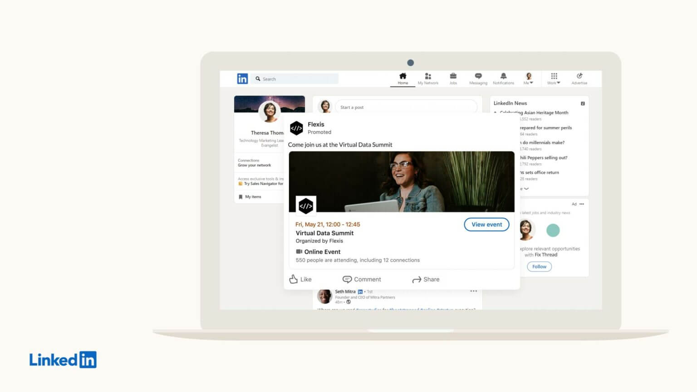

* **LinkedIn is also launching an Event Analytics tool** that provides event organizers with metrics such as attendee/visitor engagement with your Event posts, total number of attendees, unique event visits, attendees’ top job functions and viewer count at the peak of a live stream.

<https://searchengineland.com/linkedin-introduces-event-ads-and-boosted-posts-348880>

## **Amazon Opens Doors to Sellers From Nearly 100 More Countries**

Amazon has expanded the list of countries accepted to register for selling on Amazon to 188 countries. **The company added 85 new countries, mainly in Central Asia, Middle East, South America, and Africa.** Notable countries to be newly included are Pakistan, Kazakhstan, Uruguay, Venezuela, South Africa, United Arab Emirates, and Saudi Arabia. Sellers from practically all countries in the world are now accepted to sell on Amazon. The few missing are heavily sanctioned nations like Cuba, Iran, and North Korea.

* Previously sellers from countries not on the accepted list used middlemen companies or established business entities in neighboring countries to get their products listed on Amazon.
* Despite Amazon’s attempts to foster cross-border e-commerce, international sellers not based in China represent a small share. Only nine countries - Canada, U.K., India, Japan, Australia, Vietnam, Thailand, South Korea, and Ukraine - have more than 10,000 sellers on Amazon.com.
* **In the future, exports through Amazon from some of the newly added countries like Pakistan could grow to be significant.**
  + For example, cotton textile production and apparel manufacturing are Pakistan’s largest industries, accounting for more than half of merchandise exports.
  + Amazon is the direct-to-consumer platform to reach shoppers in the West for many Chinese manufacturers. Some of those manufacturers from Pakistan will now join Amazon. If they succeed, like early merchants from China did, local industry will develop to get more businesses onto the marketplace.

<https://www.marketplacepulse.com/articles/amazon-opens-doors-to-sellers-from-nearly-100-more-countries>

## **Google Outlines Coming eCommerce Advances, Including Improved AR Product Displays**

Google is looking to stay in touch with the next phase of digital product discovery, through the expanded use of AR for item listings and promotions: *"We launched an AR (augmented reality) makeup kit try-on experience for lipstick and eyeshadow, and soon consumers will be able to find that perfectly matching foundation, from brands like L'Oreal and Estee Lauder."*

* The new AR displays will be available in various Google discovery surfaces, while AR Try On tools have been available on YouTube since 2019.
* But Google's also looking to take those tools a step further: **Enabling full virtual try-on experiences, through advanced body mapping, is the next stage of eCommerce discovery, and merging the IRL shopping experience with online tools.**
* Snapchat has made the most significant advances on this front, with its [footwear try on](https://www.socialmediatoday.com/news/snapchat-launches-new-shoppable-ar-try-on-campaign-with-gucci-shoes/580762/) tools and advancing Body Tracking Lenses that will eventually facilitate complete try-on experiences. It seems that Google, too, is now moving in this direction.
* Video is also where Google is looking to advance its general shop listings, with updated, integrated video displays for product demos and listings.

<https://www.socialmediatoday.com/news/google-outlines-coming-ecommerce-advances-including-improved-ar-product-di/600968/>

# Calendar Week 20 (May 21)

## **Google Grows Shopify Partnership, Adds Ways to Shop From Images**

**Google expands its partnership with Shopify** and introduces a simplified process for all 1.7 million merchants to get their products listed with a few clicks.

* This new collaboration with Shopify enables merchants to get discovered by high-intent consumers across Google Search, Shopping, YouTube, Google Images, and more.
* All retailers who sell products through Shopify will be able to take advantage of Google’s free shopping listings, an initiative launched over a year ago at the start of the pandemic.
* With all the data gathered from Google Shopping the company has been able to develop this next highlight from I/O, the **Shopping Graph.**
* **The Shopping Graph** is a real-time dataset about products, inventory, and merchants. It connects users with over 24 billion listings and helps them find products available to buy right now.

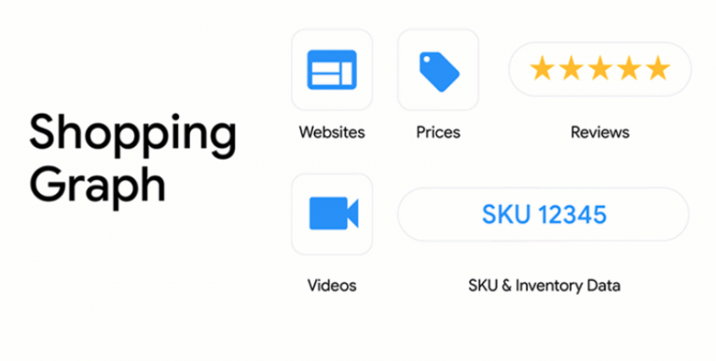

* **Shop From a Screenshot is another new Google’s new shopping feature.** It lets users look up products within any screenshot in Google Photos.
* To use this feature open a screenshot in Google Photos and look for the new option to “search inside screenshot.” That will prompt Google Lens to analyze the photo and return search results for the products it can identify.

<https://www.searchenginejournal.com/google-grows-shopify-partnership-adds-ways-to-shop-from-images/407736/#close>

## **New Smart Bidding features in Google Ads: Top signals for Target ROAS and max conversions, manager account level seasonality adjustments and more**

Google is launching new features for [Smart Bidding](https://searchengineland.com/guide/ppc/setting-up-a-paid-search-campaign/budgeting-and-bidding-strategies#:~:text=AdWords-,smart%20bidding%20strategies,-Within) to help make automation more intuitive to search marketers’ needs and better cater to changes in each advertiser’s individual market.

* **Top signals changes.** Advertisers can now use top signals for search campaigns using Target ROAS and Maximize conversion value.
* **Seasonality adjustments can now be made at the manager account leve**l. Before now, Smart Bidding did take seasonality into account, but there could be events where advertisers expect big changes in conversion rates, such as big sales or product launches. Now, advertisers can set them at the manager account level instead of creating them for each individual account.
* **Recommendations for max conversions.** Google Ads is also now surfacing new opportunities on the **Recommendations** page. These recommendations will show for eligible **Search campaigns** and can help you get more conversion value within your budget.
* **Target Impression Share simulators now available.** Google is now expanding support to Search campaigns using Target Impression Share. Advertisers can now use the simulator tool to get an idea of how changes in target impression share could affect cost, impression share, and clicks.

<https://searchengineland.com/new-smart-bidding-features-in-google-ads-top-signals-for-target-roas-and-max-conversions-manager-account-level-seasonality-adjustments-and-more-348736>

## **Etsy Gives Sellers Access to Ad new Performance Data**

Now in the Etsy Ads dashboard, sellers can see the **click rate** and return on ad spend (**ROAS**) for each of the listings you’re advertising.

* Etsy told sellers the new data can help them better understand which ads bring the most traffic and profit so they can make the most of their ad budget.
* “On the page you can see all these stats for each of the listings you’re advertising, and use the toggle to quickly start or stop advertising a specific listing based on how it’s performing.”

<https://www.ecommercebytes.com/2021/05/12/etsy-gives-sellers-access-to-ad-performance-data/>

## **Advertising: Sellics expands benchmark tool for advertising campaigns (in german)**

Sellics has released **an update to its free advertising benchmarking tool**. This provides advertisers on Amazon with even more detailed comparisons of the performance of their PPC campaigns in direct comparison to competitors.

* The comparison tool now enables even more precise benchmarks and detailed insights thanks to the expansion to 20,000 product categories. Advertisers on Amazon thus receive a tool that is unique on the market and completely free of charge to compare the performance of their PPC campaigns directly with competitors and thus recognise where there is a need for optimisation.
* **With the update of the tool, users receive the following new functions:**

1. Benchmarks for 20,000 product categories and nine Amazon marketplaces.
2. Evaluation at product level for up to 100 top products.
3. Even more precise evaluation of KPIs according to percentiles.
4. Evaluation based on concrete KPIs for all ad formats.

<https://www.e-commerce-magazin.de/advertising-sellics-erweitert-benchmark-tool-fuer-werbekampagnen/>

## **Feedvisor Announces Full-Funnel Advertising Optimization and Intelligence Platform for Amazon and E-Marketplaces**

The AI-driven optimization and intelligence platform for brands and retailers on Amazon, Walmart, and e-marketplaces, today announced the launch of its advanced Advertising Optimization and Intelligence platform. Powered by cutting-edge AI and sophisticated machine-learning technology, the innovative platform solidifies Feedvisor’s full-funnel Amazon Advertising solution, enabling brands and retailers to make data-informed decisions across their entire advertising program.

* Purpose-built to drive sales and return on ad spend (RoAS), Feedvisor’s Advertising Optimization and Intelligence platform improves rankings, conversions and full-funnel performance across all Amazon ad types, including Sponsored Products, Sponsored Brands and Video, Sponsored Display and Amazon DSP.
* Feedvisor’s platform connects brands’ and retailers’ operational data with advertising data. This enables them to gain unique insights into the impact of mid- and bottom-funnel results of various advertising approaches, methods and strategies on the performance of the product catalog down to the ASIN level. Feedvisor’s AI engine instantaneously analyzes the data and implements real-time, autonomous actions to optimize the business performance.

[Feedvisor-Announces-Full-Funnel-Advertising-Optimization-and-Intelligence-Platform-for-Amazon-and-E-Marketplaces](https://www.businesswire.com/news/home/20210518005864/en/Feedvisor-Announces-Full-Funnel-Advertising-Optimization-and-Intelligence-Platform-for-Amazon-and-E-Marketplaces)

# Calendar Week 19 (May 14)

## **Pinterest to test livestreamed events this month with 21 creators**

Pinterest is expanding into live events. The company is planning to host a three-day virtual event that will **feature livestreamed sessions from top creators.**

* Last fall, Pinterest began testing a **“class communities”** feature that allowed users to sign up for Zoom classes through Pinterest, while creators used Pinterest’s boards to organize materials, notes and other resources.
* These class communities also included **a group chat option and shopping features.**
* **Pinterest users will launch the livestreaming experience directly inside Pinterest mobile app** and remain there during the sessions.
* Pinterest users can also comment to interact with the creator during their stream, but there is no longer any shopping functionality.
* Pinterest’s head of Creators notes **Pinterest has integrated with third-party livestreaming technologies** and built its own in-house messaging systems to power live interactions.
* Pinterest’s attraction among competition in livestreaming isn’t clear, but the company will use this experiment to learn more about what works for its own community.

<https://techcrunch.com/2021/05/13/pinterest-to-test-live-streamed-events-this-month-with-21-creators/>

## **Yelp announces Custom Location Targeting, budget recommendations and more features to expand reach for local businesses**

Yelp is now rolling out Custom Location Targeting, machine learning-generated budget recommendations and a number of other new features designed to give business owners more control over their presence and ads on the platform.

* **Custom Location Targeting (CLT).** Businesses on Yelp can now designate specific locations for their ads to appear.

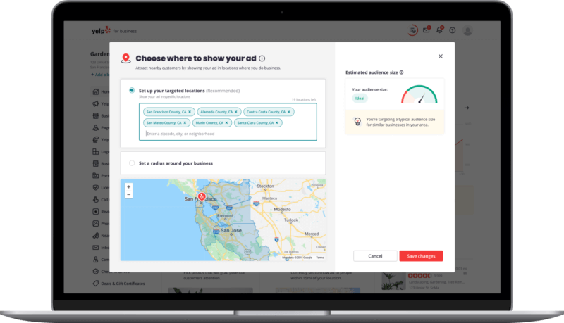

* **New budget recommendations.** The platform has also redesigned its budget editing experience, adding machine learning-generated budget recommendations for advertisers.
  + Yelp’s machine learning model analyzes the business’ profile, historical campaign performance and lookalike audience data to generate budget recommendations.

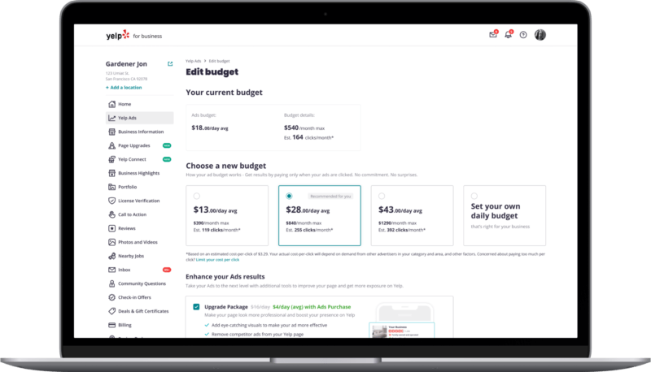

* Connect Audience Model. Businesses that use **Yelp Connect,** a publishing tool not unlike Google Posts, to communicate with their customers are now able to show their posts to people who have interacted with similar businesses or searched for relevant categories.

<https://searchengineland.com/yelp-announces-custom-location-targeting-budget-recommendations-and-more-features-to-expand-reach-for-local-businesses-348455>

## **Google Ads announces privacy-focused changes for Analytics, Tag Manager and enhanced conversions**

In a Google Marketing Livestream [preview announcement of upcoming product launches](https://blog.google/products/ads-commerce/future-proof-measurement-privacy-safe-solutions), Vidhya Srinivasan, Vice President of Engineering at Google Ads, wrote about machine learning in Google Analytics, consent mode for Tag Manager, and enhanced conversions with first-party data.

* **Machine learning extended to behavioral analytics in Google Analytics.** Google said they are extending their advanced machine learning to behavioral analytics reporting in GA.
* **Adjust Consent Mode in Google Tag Manager.** Consent mode helps advertisers in Europe and the UK adjust how Google tags users based on their individual consent status. Google said they’ll soon allow access directly from Tag Manager accounts where they’ll be able to modify and customize tag behavior in response to users’ consent preferences.
* **Enhanced conversions help preserve measurement in lieu of cookies.** When cookies aren’t available, first-party and consented data can help fill in the measurement gaps.

## **YouTube Shorts Launches 4 New Creation Tools**

YouTube is rolling out its **in-app creation tools for Shorts videos** to all US users, and adding four brand new features.

* US creators can use the **Shorts** camera in the YouTube mobile app to record, edit, and publish small clips.
* In addition to the new creation tools, new features are getting added to the Shorts camera that give users more editing options:
  + **60 Second Recordings** When recording videos with the YouTube Shorts camera, users can toggle between a maximum duration of 15 seconds or a maximum duration of 60 seconds.
  + **Shorts Video Filters** YouTube creators will be able to switch to different filters in the recording and editing screens within the Shorts camera.
  + **Shorts Tab on Home Page** In the YouTube mobile app, users can explore more Shorts content via a new tab on the bottom of the screen.

<https://www.searchenginejournal.com/youtube-shorts-launches-4-new-creation-tools/406458/#close>

## **Facebook & Instagram Updated With New Messaging Features**

New features are rolling out to Facebook Messenger and Instagram DMs that allow users to be more expressive in how they communicate.

* **New Facebook Messenger Features**
  + **Chat Archives** Facebook Messenger users can now clean up their inbox without deleting chats and losing their message history.
  + **Tap to Record** Audio messaging enthusiasts can now record messages hands-free in Messenger.
  + **New Themes** Messenger users have more options to personalize their conversations with the addition of new themes.
  + **Celebrating Asian Pacific American Heritage Month** Facebook has added new camera stickers in Messenger and Messenger Kids celebrating the diversity and impact of Asian and Pacific Islanders (API).
* **New Instagram DM Features**
  + **Visual Replies** Instagram has added the ability to send visual replies to direct messages on iOS (coming to Android soon).
  + **Inbox Seen States** A slight update to the Instagram DMs inbox makes it easier for users to see when a recipient has viewed their message.

<https://www.searchenginejournal.com/facebook-instagram-updated-with-new-messaging-features/406002/#close>

Calendar Week 18 (May 07)

## **A Guide to Amazon Sponsored Brands Video Ads**

Amazon’s latest ad innovation is **Sponsored Brands video campaigns.** The new creative **combines product ads with video footage** to capture user attention on the desktop and mobile shopping pages where purchase intent is at its highest.

* **Sponsored Brands video** is a visual ad format that shows on Amazon search results pages and product detail pages to promote your products.

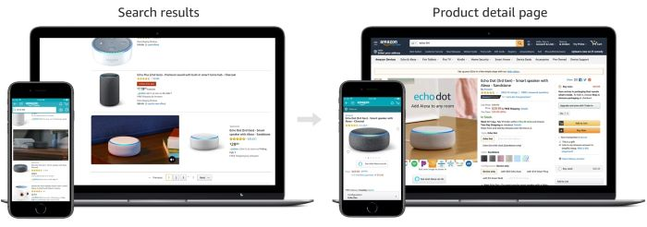

* The ads are **keyword targeted,** allowing you to pinpoint the most relevant audiences and priced on a **cost-per-click model** so you only pay when a user shows enough interest in your ad to click through to the product detail page.
* **The ads include three key components:** product details, an auto-play video and a mute toggle button, as shown below.

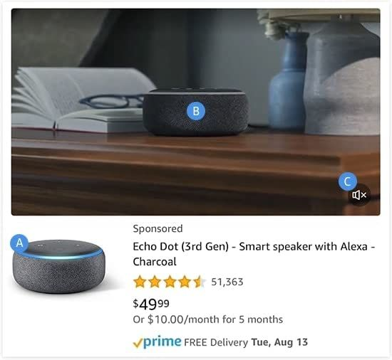

1. **Product details** The primary product image and associated product information (title, star rating, review count, price and Prime eligibility) from the detail page are automatically displayed.
2. **Video** The video will play automatically when 50% of it is on-screen.
3. **Mute toggle button** The mute toggle button is overlaid in the lower right-hand corner of the video and controls audio playback. By default, videos always start without audio.

* In a survey, **95% of video marketers say video has helped increase user understanding of their product or service** and, more importantly, **84% of consumers say they’ve been convinced to buy a product or service by watching a brand’s video.**
* Amazon’s data shows that **Sponsored Brands video campaigns generate +127%-267% higher click-through rates and +28%-43% higher returns on ad spend (ROAS)** than regular Sponsored Brands campaigns.

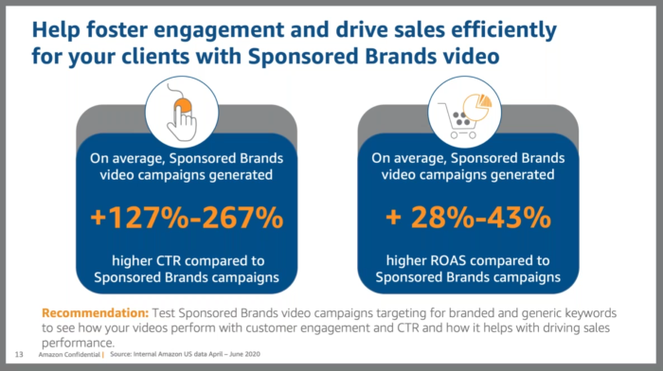

* **Sponsored Brands video ads are integrated into the Sponsored Brands campaign builder**, which allows you to clone existing campaigns, convert them to the video format and add your footage in a matter of minutes.
* Alternatively, you can create campaigns from scratch and create a new Sponsored Brands video campaign by selecting your product and following all of the usual steps.

<https://www.business2community.com/video-marketing/a-guide-to-amazon-sponsored-brands-video-ads-02402450>

## **Microsoft Advertising to treat phrase match the same way Google Ads does**

Microsoft Advertising will e**xpand phrase match to include broad match modifier traffic**, the company announced Tuesday.

* The change, which will start in mid-May, is to “simplify keywords and improve your relevancy when reaching customers.”
* This new treatment for phrase match will bring the platform in line with Google Ads’ updated phrase match, which rolled out in February.
* The updated phrase match treatment means that **your ads will be shown for searches that include the meaning of your keyword.** Microsoft’s example is matching the query “winter vacation in Miami” to the keyword “Miami vacation.”
* Advertisers will no longer have the ability to create new BMM (Broad match modified) keywords beginning in August 2021. Their existing BMM keywords, and any keywords with partial BMMs, will serve under the new phrase match treatment.
* **This change will roll out in the U.S. and Canada** over the next few weeks and in other markets beginning in June.

<https://searchengineland.com/microsoft-advertising-to-treat-phrase-match-the-same-way-google-ads-does-348411>

## **TikTok launches media solutions in the Philippines to help local companies grow their business**

TikTok is now open to advertisers of all sizes in the Philippines. Local SME advertisers will now be able to join their enterprise counterparts in reaching their audience on the app through TikTok’s authorised agencies and partners in the market.

* **TikTok has been the #1 downloaded app in Southeast Asia since February 2020** (Source: App Annie, February 2021), creating a large user base, highly engaged community, and diverse content and audiences.
* Advertisers will now have access to all of TikTok’s present and future marketing solutions designed for brands.
* **TikTok For Business** empowers **small and mid-size enterprises (SMEs)** to be discovered and connect with the community of users on the app, build their brands, and achieve their business goals.
* A business can advertise by creating and posting video ads with a flexible budget, including repurposing their existing creative assets to easily run ad campaigns on TikTok.
* **Advertisers can also track the progress and success of every campaign using TikTok’s vast array of measurement and analytics tools,** including third-party mobile measurement partners for app developers, and TikTok’s own pixel for website tracking.
* A variety of creative tools are also available for advertisers to use on TikTok Ads Manager. including:
  + **Quick Optimisation** – Adds TikTok style visual effects or opening frames to your video with a single click.
  + **Smart Video** – Leverages innovative technology to analyze uploaded videos and images, automatically selecting clips and music to create beautifully edited videos.
  + **Video Templates** – Turns image assets into TikTok ready videos with over 60 customizable video templates for various aspect ratios
  + **TikTok Video Editor** – Edits video creatives down to individual frames, add transitions, and precisely place elements within a video with TikTok’s free web-based video editor
  + **Smart Video Soundtrack** – Incorporates music, which is a vital part of every TikTok video ad. Select from up to 4,000+ copyright free sounds.

<https://business.inquirer.net/322467/tiktok-launches-media-solutions-in-the-philippines-to-help-local-companies-grow-their-business>

## **TikTok pitches brands on 'community-based commerce' while pushing past Gen Z image**

TikTok, often regarded as a video-sharing app most popular among teens, is trying to evolve past that image as it chases more brand dollars and attempts to sustain user growth that has exploded amid the pandemic.

* During its second appearance at the Interactive Advertising Bureau's NewFronts Thursday, the ByteDance-owned company pitched advertisers and media buyers on an audience that extends well beyond Gen Z to encompass more than 100 million monthly active users in the U.S. and one whose interests are more eclectic than lip-syncing and dance videos:
  + *"[Brands] always talk about trying to reach this younger audience. Even if you're trying to reach an older audience, they're all on the platform, they're all engaging and being entertained by the diversity of content and the diversity of creators that we have."*
* **TikTok has invested more heavily in commerce capabilities, recently introducing** [**tie-ups with retailers including Walmart**](https://www.marketingdive.com/news/walmart-enlists-top-tiktok-creators-for-first-of-its-kind-shoppable-livestr/592367/) **that allow consumers to purchase products without leaving the app.** 
  + The retailer has expressed interest in acquiring a stake in TikTok, valuing the app's ability to blend content and commerce.
* TikTok went to great lengths to separate itself from the social-media pack at the NewFronts, **stating its model — a scrolling feed of full-screen, sound-enabled videos — is more closely aligned with Netflix than rivals like Facebook or Twitter**, which executives said users merely "check" in on rather than watch.

<https://www.marketingdive.com/news/tiktok-pitches-brands-on-community-based-commerce-while-pushing-past-gen/599739/>

## **Pinterest Expands Shopify Integration Worldwide**

Shopify’s Pinterest app, which launched last year in the US and Canada, is now available in 27 additional countries.

* **Pinterest’s integration with Shopify is expanding worldwide, giving 1.7 million merchants the ability to turn products from their e-commerce store into shoppable pins.**
* The Pinterest app for Shopify stores lets merchants upload their product catalogues and convert their products into pins. Users can then buy products featured in a merchant’s pins without ever having to leave Pinterest.
* **In addition to expanding its Pinterest app to more countries, Shopify is adding support for multiple product feeds, and the ability to market products via dynamic retargeting ads.**

<https://www.searchenginejournal.com/pinterest-expands-shopify-integration-worldwide/404394/#close>

# Calendar Week 17 (Apr 30)

## **Amazon is loosening its grip on customers and letting some sellers reach out to them**

Amazon began piloting a tool that enables U.S. companies that are part of its **Brand Registry** program to e**mail marketing materials to shoppers who have opted to “follow” their brands.** These companies can then notify those shoppers when they launch a new product or promotion.

* The “follow” button is featured in areas such as a businesses’ store page and videos on [Amazon Live](https://www.amazon.com/live?ref=azlv_dest_header_lg), Amazon’s livestream shopping platform.
* The tool, called **“Manage Your Customer Engagement,”** is designed to drive repeat purchases for vendors and sellers and help them build a more robust following on Amazon’s sprawling marketplace.
* Amazon will give companies aggregate data when they use the tool that shows them how many emails will go out when they decide to share marketing campaigns with their followers. Companies can also view metrics to see how their campaigns were received.
* Amazon has long prohibited businesses that sell on its site from soliciting customers directly, keeping data such as their email addresses private, largely to shield shoppers from spam. Merchants could communicate with shoppers via a messaging feature on Amazon’s site, but only when it concerned things such as the status of their order.
* **More than three-quarters of U.S. brands, or roughly 78%, are currently selling on Amazon’s marketplace,** up from 55% in 2019, according to a February report from Feedvisor.
* For now, the free tool is only available to members of **Brand Registry,** more than 350,000 brands have registered to be part of the program, which has since expanded to include other benefits.

<https://www.cnbc.com/2021/04/23/amazon-tests-tool-that-lets-some-brands-contact-shoppers.html>

## **Amazon’s Sponsored Brands now make up nearly one-quarter of its console ad business**

**Spending on Amazon’s Sponsored Brands ads grew a healthy 25% year over year (YoY) last quarter** and now account for 23% of Amazon’s pay-per-click ad business, per Merkle’s Q1 2021 Digital Marketing Report.

* Companies like Pacvue and Tinuiti also reported higher growth rates for spending on Sponsored Brand ads (89% and 86%, respectively) compared with Sponsored Product ads (41% and 28%).
* This growth is partially because Sponsored Brand ads are newer—plus, Amazon released several new Sponsored Brand formats in 2020, including its popular **Sponsored Brand Video** options.
* Sponsored Brand ads are higher-funnel than Sponsored Product ads—they highlight an entire brand via product carousels or videos at the top of a page rather than individual items.
* Sponsored Brand ads helps Amazon attract marketers from all stages of the customer journey, which helps the platform capture a larger share of the digital ad economy.

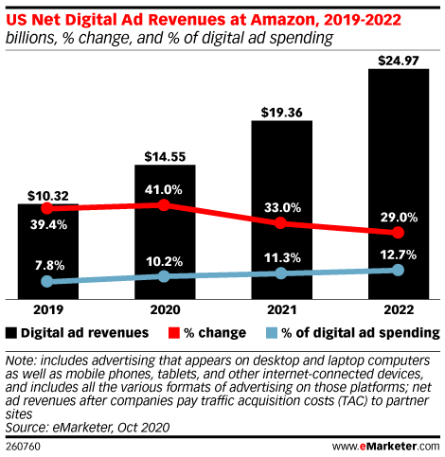

<https://content-na1.emarketer.com/amazons-sponsored-brands-now-make-up-nearly-one-quarter-of-its-console-ad-business>

## **Google released Google Ads API version 7.0**

Google has [released](https://ads-developers.googleblog.com/2021/04/announcing-v7-of-google-ads-api.html) a new version of the Google Ads API. This is version 7.0, which is an upgrade from version 6.1.0 which was released on April 10, 2021.

* There is a full list of changes in the [release notes](https://developers.google.com/google-ads/api/docs/release-notes) if you want to do a deep dive, but here are **some highlights**:
  + New assets for test accounts including callout assets, structured snippet assets, and sitelinks assets
  + Promotion assets are available both in production and test accounts
  + The API now supports reporting for Apple’s AKAdNetwork.
  + Keyword Planning tool supports refining keywords using annotation data, selecting custom date ranges for search volume, requesting aggregated metrics for generating keyword ideas and for keywords in a keyword plan
  + Manage bidding strategy and campaign simulations
* With version 7.0, Google Ads API users can now explore more features within the API to get more done and in a more efficient way.

<https://searchengineland.com/google-released-google-ads-api-version-7-0-348293>

## **ChannelAdvisor Announces New Features Designed to Improve Product Visibility and Connect Brands and Retailers with More Consumers**

Company's global marketplace expansion to include 28 new selling channels, advanced reporting, analytics for 3P sellers, expanded support for Walmart and enhanced video campaign management

* ChannelAdvisor's expanded product offerings enable brands and retailers to diversify and reach new buyers across the most popular selling channels. "Maintaining steady growth is key to multichannel success, which is why ChannelAdvisor's expanded support for Walmart presents an exciting opportunity for brands and retailers to build upon their success in this major marketplace," adds Frechette. "From advertising to fulfillment, sellers on Walmart can take full advantage of ChannelAdvisor's comprehensive, end-to-end support, enabling them to stay competitive."
* **Expanded Support for Walmart Sellers:** Support for Walmart Connect, ChannelAdvisor Support for Walmart Fulfillment Services, ChannelAdvisor Image Checking Tool for Walmart
* **Support for New Marketplace and Dropship Integrations:** New Marketplace Integrations, New First-Party Channel Expansions
* **Enhanced UX, Reporting and Analytics:** 
  + **Third-Party Sellers Analysis:** Third-Party Sellers Analysis is a new ChannelAdvisor Brand Analytics premium feature that can help brands increase visibility of third-party sellers on retail sites and marketplaces such as Amazon and Walmart. With the ability to analyze strategies, track stock levels and identify unauthorized sellers, brands now have a more comprehensive tool for visibility of their retail partners and other third-party sellers.
  + **Enhancements to the Channel Health Console:** Allows brands and retailers to better understand and gauge operational health across all channel integrations, enabling prioritization and focus on the most critical areas of their business. The most recent enhancements to the Channel Health Console save users time and effort by providing a high-level overview of the performance of their product feeds.

<https://finance.yahoo.com/news/channeladvisor-announces-features-designed-improve-121300694.html>

## **Facebook will soon allow more brands to create Facebook ads using WhatsApp’s business tools**

Facebook is working on a new feature for businesses **on WhatsApp to help them to build Facebook ads using their WhatsApp business tools**, which will then connect back to their WhatsApp profile, allowing them to capitalize on the mutual strength of the two platforms.

* Brands have been willing to create Facebook ads that connects then to their WhatsApp for so long, all they have to do is to do so via Facebooks’ Ad Manager. This new method of creating Facebook ads would have the same features within WhatsApp.
* **According to CNN, the procedure would depend on WhatsApp Business collections to gather product details for Facebook advertising. Business owners will be allowed to easily transform a product from their catalog into a Facebook or Instagram ad with a click that directs viewers over to their WhatsApp handle**, says the company. This essentially provides new bi-promotional opportunities for companies on WhatsApp but the value will restricted as it depends on how many viewers among the targeted audience uses both apps. This concern will not create an issue in Western countries as the number of people who uses both of these apps are huge.
* As per Facebook, majority of the business are now accessing click to WhatsApp ads on Facebook that is ultimately boosting the demand and it could be a strong promotional practice to change the digital marketing game.

<https://www.digitalinformationworld.com/2021/04/facebook-will-soon-allow-more-brands-to.html>

# Calendar Week 16 (Apr 23)

## **Amazon Brand Advertising is Booming: Pacvue Report Reveals 41% Increase in Sponsored Product Spend and 89% Increase in Sponsored Brand Spend Year-over-Year**

Pacvue announced the release of their [2021 Q1 CPC Report](https://docs.google.com/document/d/1lRkHEi9Eg9ORaaEhhmsThcojGqTbHr0H-NYiuciJUJk/edit) showcasing insights and growth around Amazon Advertising.

* The report found that **Sponsored Product spending increased by 41% and Sponsored Brand spending increased by 89% year-over-year** -- representing a 59% increase in average daily spend year-over-year in Q1 on Amazon.
* **ROAS saw a modest decline in Q1 2021, w**ith Sponsored Product ROAS down 8% quarter-over-quarter and 6% year-over-year. Sponsored Brand ROAS was down 7% quarter-over-quarter and 12% year-over-year.
* Despite increased brand spend, efficiency costs, including CPC and CPA, were little changed in Q1. Neither moved more than 10% quarter-over-quarter or year-over-year. Advertisers aren't increasing their average daily brand spend in response to higher conversion costs but are instead responding to the increased volume of eCommerce traffic.
* In a sign that consumers are eager for nicer weather after the pandemic winter, **the Sports & Outdoors category saw a dramatic increase in conversion rate throughout Q1,** reaching 12.23% in March. Similarly, the Patio, Lawn & Garden category saw increased competitiveness, with daily spend up 48% month-over-month from February to March and CPCs up 18%.

<https://www.dailyrecordnews.com/news/state/amazon-brand-advertising-is-booming-pacvue-report-reveals-41-increase-in-sponsored-product-spend-and/article_98e932eb-79a8-50e7-aff7-c0af504d2686.html>

## **Microsoft Audience Network Introduces Facebook Import & Video Ads**

The **Microsoft Audience Network** has announced **support for Facebook campaign import functionality and video ads.**

* Much like the Google Ads import feature that many are familiar with, **advertisers will soon be able to import campaigns from Facebook Ads into Microsoft Advertising.**
* This new feature, currently in open beta in select markets, saves advertisers time while also **giving them the flexibility to edit settings such as bids, budgets, targeting, and campaign names.**
* The Facebook import feature will be able to import **campaigns with a single-image format.** Carousels and video ads are not currently supported.
* While locations, demographics, and ad schedules can carry over for Microsoft Audience Network campaigns, campaigns imported into Microsoft Advertising will not be able to use the interest-based or behavioral targeting that they use on Facebook Ads.
* Advertisers should apply in-market targeting, affinity targeting, remarketing, or LinkedIn profile targeting to their campaigns after import to make sure their ads show to the right audience.
* Upon import, all campaigns will be set to **manual bidding.**

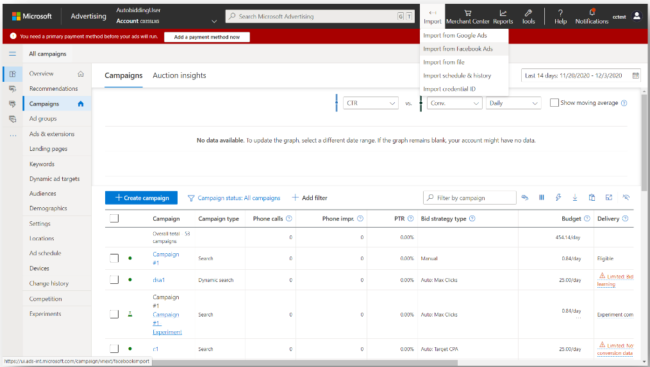

<https://www.searchenginejournal.com/microsoft-audience-network-facebook-import-video-ads/402739/>

## **Pinterest Lets Content Owners Control How Their Images Are Used**

Pinterest is giving content owners greater control over their intellectual property with a tool that lets them claim copyright and decide how images are used.

* The new **Content Claiming Portal** allows creators to remove existing versions of their content and prevent future versions from being used on Pinterest.
* The Content Claiming Portal may prove to be an effective way for rights holders to ensure their photos and videos are not misused on Pinterest.
* **Creators can take control of their content** on Pinterest by filling out an application which asks them to provide **proof of content ownership.**
* If the application is approved, creators will have three options to **enforce how their content is used on Pinterest:**
  + **Mine only:** Remove existing and future versions of the images from Pinterest, except Pins originally saved by the creator.
  + **Website only:** Remove existing and future versions of the images from Pinterest, except Pins that link to the creator’s claimed website(s). (This option will only be available if the creator has a claimed website.)
  + **Block all:** Remove all existing and future versions of these images from Pinterest.
* Once accepted into the Content Claiming Portal, rights holders will be able to claim ownership of additional content without having to submit an application each time.
* Anyone who owns copyright to content can apply for access to the Content Claiming Portal to claim their content and control how it appears on Pinterest.

<https://www.searchenginejournal.com/pinterest-lets-content-owners-control-how-their-images-are-used/403245/>

## **Apple to boost ads business as iPhone changes hurt Facebook**

Apple will expand its advertising business, according to two people familiar with its plans, just as it brings in new privacy rules for iPhones that are likely to cripple the ads offered by its rivals, including Facebook. The iPhone maker already sells search ads for its App Store that allow developers to pay for the top result. In searches for “Twitter”, for example, the first result is currently TikTok.

* **Apple now plans to add a second advertising slot, in the “suggested” apps section in its App Store search page. This new slot will be rolled out by the end of the month**, according to one of the people, and will allow advertisers to promote their apps across the whole network, rather than in response to specific searches.
* **The expansion is the first concrete sign that Apple plans to enhance its own advertising business** at the same time as it shakes up the broader $350bn digital ads industry led by Facebook and Google.
* Apple’s forthcoming software update, iOS 14.5, will ban apps and advertisers from collecting data about iPhone users without their explicit consent. Most users are expected to decline to be tracked, dealing a huge blow to how the mobile advertising industry works.

<https://www.ft.com/content/5527ddd1-77a8-4cd0-82fd-4568be5da80f>

## **Facebook begins testing ads in Instagram Reels**

Facebook on Thursday said it will begin testing ads on its TikTok clone Instagram Reels in India, Brazil, Germany and Australia, as the social media giant aims to make money from its short-form video feature.

* As with other content on Reels, **ads can be up to 30 seconds long and users can choose to skip the ads, Facebook said.**
* Facebook also announced Thursday **it will let advertisers select categories of video content they want to place ads on,** such as videos about children and parenting, animals and pets or fitness and workouts.
* **The effort is Facebook's biggest move yet to let brands advertise alongside content subjects.** Advertisers typically use Facebook to target certain users by their interests.
* Facebook added it will begin testing sticker ads for Facebook Stories in the coming weeks. **Brands can create stickers that creators will place in their Stories**, and influencers will earn a cut of any sales made through the sticker ads.

<https://www.reuters.com/technology/facebook-begins-testing-ads-instagram-reels-2021-04-22/>

# Calendar Week 15 (Apr 16)

## **Google Ads rolling out auto-applied recommendations**

Google announced this morning the official launch of **auto-applied Google Ads recommendations.** This is an opt-in feature, and you can choose from over 17 recommendations to apply automatically within the Google Ads setting.

* Google now allows advertisers to opt-in to apply a certain subset of recommendations automatically to your account.
* Google said the auto-applying recommendations will not increase your budget, “so continue to review the Recommendations page to ensure your budget isn’t limiting your performance.”
* While your budgets are not changed with this feature**, your bids and bid strategies can change with this feature**.
* Here is a screenshot of the settings section where you can opt-in.

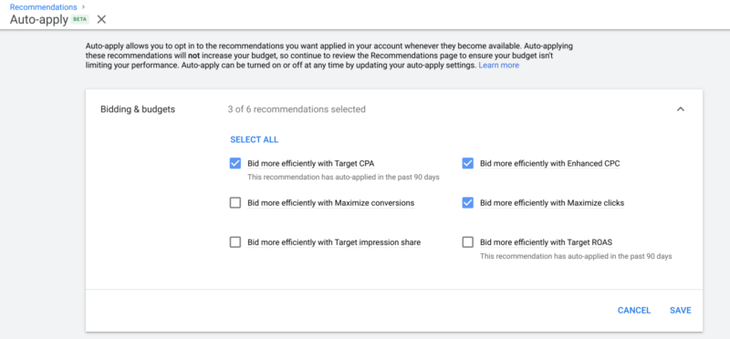

* Google now shows all the changes in the “History” tab, where you can see when and how many times these recommendations have been applied.

<https://searchengineland.com/google-ads-rolling-out-auto-applied-recommendations-347739>

## **Pinterest Has a New Code of Conduct All Users Have to Follow**

Pinterest announces it will soon implement a mandatory code of conduct, called the **Creator Code, aimed at maintaining a positive experience for all users.**

* Before posting story pins, Pinterest will prompt users to sign a mandatory **Creator Code.**
* **The Creator Code** is built around five specific guidelines:
  + Be kind: Ensure content doesn’t insult or put others down
  + Check facts: Make sure information is accurate and factual
  + Be aware of triggers: Practice discretion when it comes to visually sensitive content
  + Practice inclusion: Never intentionally exclude certain groups or communities
  + Do no harm: Make sure any call to action or challenge is safe

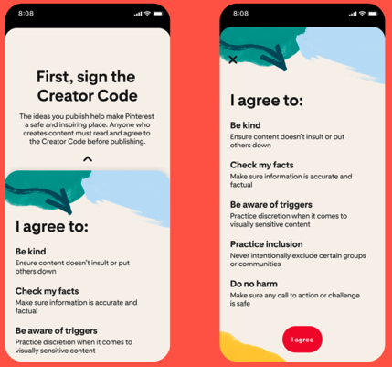

* Pinterest is introducing new tools and features designed to provide a positive experience for both users and content creators, including:
  + **Positivity Reminders** for users to adhere to Pinterest’s guidelines and reconsider potentially offensive comments before posting.
  + **Moderation Tools** for Cceators including comment removal and keyword filtering.
  + **Featured comments** which allow users to pin up to three comments within the comment feed to highlight positive feedback.
  + **New Spam Prevention Signals** using machine learning to detect and remove bad comments.

<https://www.searchenginejournal.com/pinterest-has-a-new-code-of-conduct-all-users-have-to-follow/401951/#close>

## **Smart bidding updates in Google Ads**

Google Ads plans to sunset their Target CPA (tCPA) and Target ROAS (tROAS) smart bidding strategies starting this month and roll their functionality into other bid strategies.

* Starting in April 2021, some advertisers will no longer be able to create tROAS or tCPA bid strategies. Instead, they will see a new field to add a target CPA when using the ‘Maximize Conversions’ strategy and a new field for target ROAS when using the ‘Maximize Conversion Value’ strategy.
* If all goes well, this transition will ultimately lead to the tCPA and tROAS strategies becoming fully absorbed in their new counterparts.

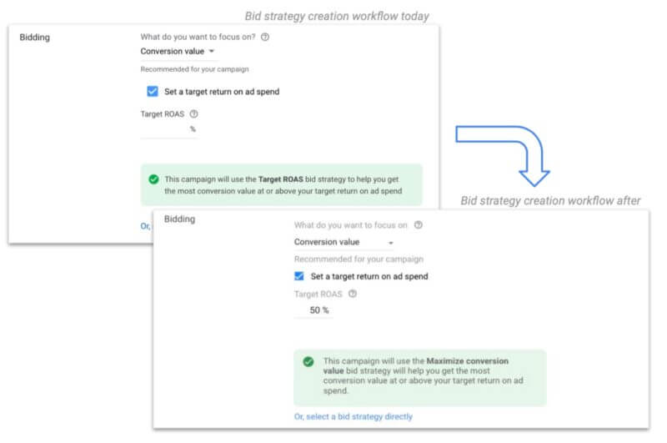

* Smart bidding for search will simply start to resemble smart bidding for shopping a bit more because advertisers with smart shopping campaigns and a target ROAS are effectively already using a Maximize Conversion Value strategy with a tROAS.

<https://searchengineland.com/smart-bidding-updates-in-google-ads-347609>

## **Facebook May Soon Offer Campaign Budget Optimization Across Platforms, Not Just Ad Sets**

Facebook has published a [new research paper](https://arxiv.org/pdf/2103.10246.pdf) that outlines its proposed new approach which would enable it to essentially offer Campaign Budget Optimization across multiple platforms from one ad campaign, as opposed to being confined to a single app.

* The new process seeks to provide more, simplified alternatives to automated ad bidding, thereby optimizing ad spend across various apps from a single budget stream.
  + *"Consider an advertiser who uses the Facebook platform to advertise a product. They have a daily budget that they would like to spend on our platform. Advertisers want to reach users where they spend time, so they spread their budget over multiple platforms, like Facebook, Instagram, and others. They want an algorithm to help bid on their behalf on the different platforms and are increasingly relying on automation products to help them achieve it."*
* The digital ad landscape becomes more crowded, advertisers are increasingly looking to diversify their ad spend, based on where their audience is active. So ideally, they would be able to ensure they're allocating budget to the right platforms to reach their target market
* The concept of [Campaign Budget Optimization](https://www.facebook.com/business/help/153514848493595?id=629338044106215) (CBO) is that it automatically allocates your assigned ad budget across your chosen Facebook ad sets, in order to ensure that the best performers see the most spend, thereby giving you the best bang for your ad buck.
  + But with this new process, you would also be able to ensure the same, across Facebook, Instagram, WhatsApp and Messenger (theoretically), all from a single, streamlined campaign.

<https://www.socialmediatoday.com/news/facebook-may-soon-offer-campaign-budget-optimization-across-platforms-not/598524/>

## **Google Rolls Out New Insights into Rising Consumption Trends Within Google Ads**

Google is adding new [emerging trend insights within Google Ads](https://support.google.com/google-ads/answer/10568762), based on Google search activity, which will alert marketers to relevant shopping and discovery changes in their sector, enabling them to update their ad strategy in line with demand.

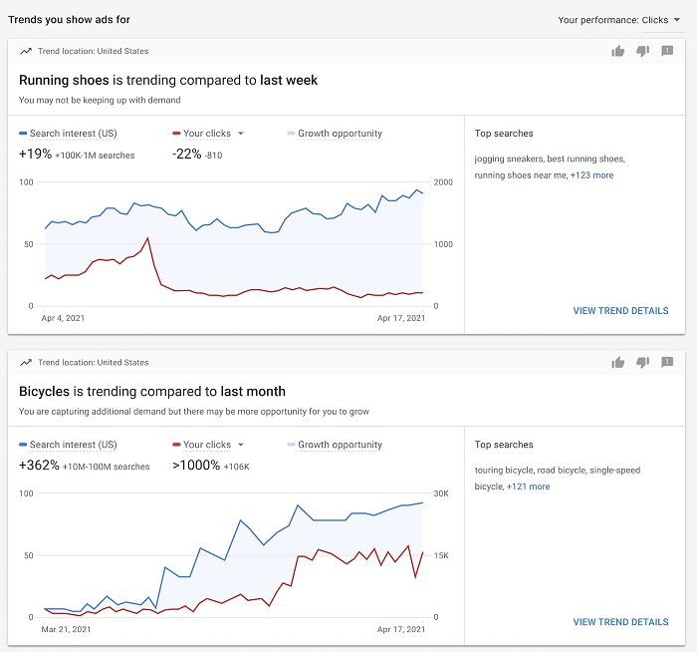

* The new trend charts will highlight rising search interests in your field, along with additional details of more specific elements, which could help you capitalize on the latest opportunities.

<https://www.socialmediatoday.com/news/google-rolls-out-new-insights-into-rising-consumption-trends-within-google/598429/>

# Calendar Week 14 (Apr 09)

## **Google Search Console adds regular expression support and more data filtering to Performance reports**

Google [announced](https://developers.google.com/search/blog/2021/04/performance-report-data-filtering) a couple improvements to the Google Search Console performance reports. The improvements include support for **regular expressions** within the filters of the performance reports and also the **comparison mode** has improved its data filtering.

* **Regular expressions.** 
  + Google introduced a new way to filter your data: regular expressions, or regex. This will help you create more complex query and page based filters and answer more questions that interest them.
  + For instance, let's say your company is called 'cats and dogs' but is sometimes also abbreviated as 'cats & dogs' or even 'c&d'. You can use a regex filter to capture all of your branded queries by defining the regex filter: cats and dogs|cats & dogs|c&d

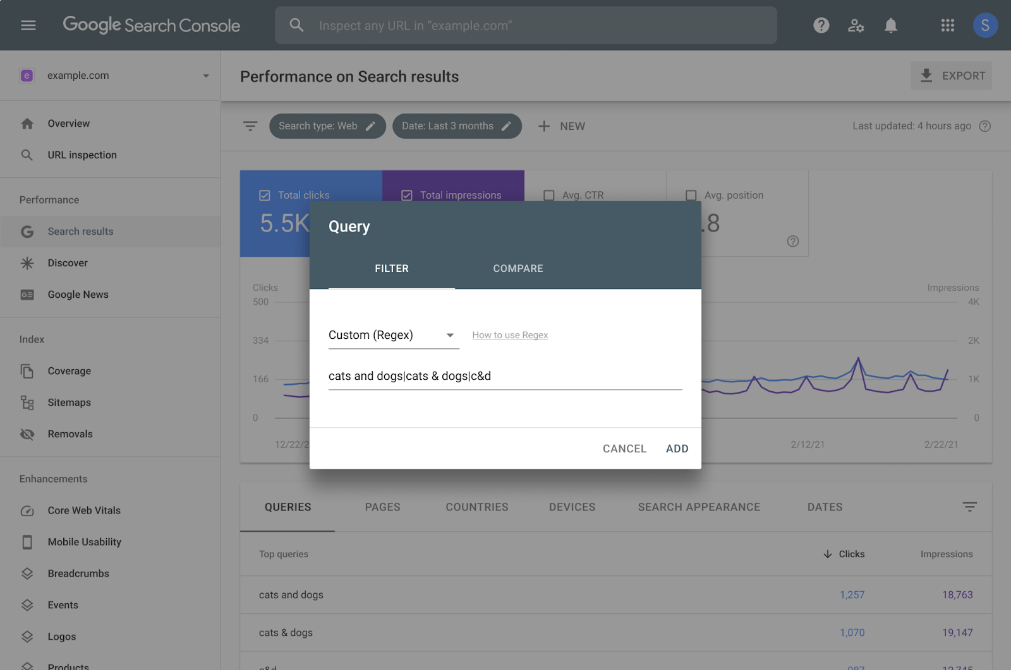

* **Improved data filtering in comparison mode.** 
  + Google also has improved the data filtering within the comparison mode to “fully supports cases where more than a single metric is selected.”
  + Google improved the interface to make it easier to view those results side-by-side, almost doubling the area available for the data table.
  + The comparison mode now supports the new regex filter for queries and pages.

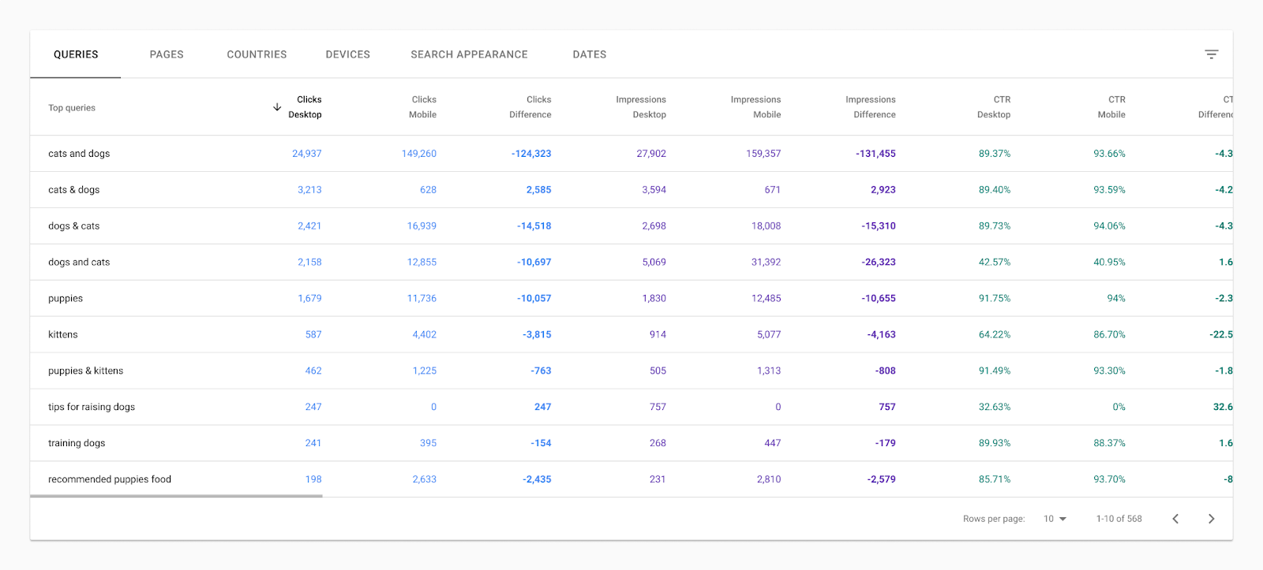

<https://developers.google.com/search/blog/2021/04/performance-report-data-filtering>

## **Amazon’s share of the US digital ad market surpassed 10% in 2020**

As the pandemic drove consumers to move their spending online in 2020, Amazon benefitted in a big way. **Its advertising business grew by 52.5% last year,** pushing Amazon’s share of the US digital ad market past 10% for the first time.

* Amazon’s US ad revenues last year grew to $15.73 billion, increasing its market share from 7.8% in 2019 to 10.3% in 2020.
* Growth was driven by search revenues from Sponsored Products and Sponsored Brands, while video ad revenues on properties including Amazon Fire TV, Twitch, and IMDb TV grew significantly as well.

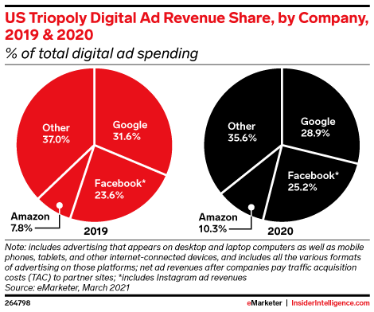

* Amazon continues to slowly chip away at Google’s share of total US digital ad revenues—which will shrink from 28.9% in 2020 to 26.6% by 2023.
* **Amazon’s search ad business will grow to $14.53 billion in 2021,** boosting its share of US search ad spending to 19.0%, up from 13.3% in 2019. By the end of 2022, its share will surpass 20%.

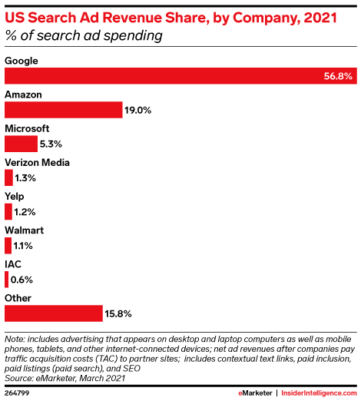

* **Ecommerce channel advertising**, which includes search advertising and display ads on its retail properties, accounts for roughly 89% of Amazon’s ad business.
* This year, **Amazon will control 76.2% of the nearly $24 billion ecommerce channel ad market.** For comparison, **No. 2 Walmart will capture just 6.5% of the market.**

<https://content-na1.emarketer.com/amazon-s-share-of-us-digital-ad-market-surpassed-10-2020>

## **The new TikTok Video Editor makes it easy for advertisers to easily and effortlessly create native TikTok video ads.**

TikTok is introducing a brand new TikTok Video Editor that will give brands a range of “intuitive in-app shooting and editing tools” that help them produce native TikTok video content, easily.

* **The TikTok Video Editor** is an online editor that uses smart tools to help advertisers produce native **TikTok-style content** quickly and accurately. These tools include popular music, fonts, colors, and others.
* You can find TikTok Video Editor under the ‘Create a Video’ menu on the TikTok Ads Manager dashboard – or from the Ad Creation menu when you set up a campaign.
* Steps to create a TikTok video ads:
  + Choose your materials
  + Add your soundtrack by clicking on the music note icon.
  + Add text by clicking on the text icon.
  + Do post-production with transitions, effects, split audio tracks, cropping, editing multiple layers, and more.

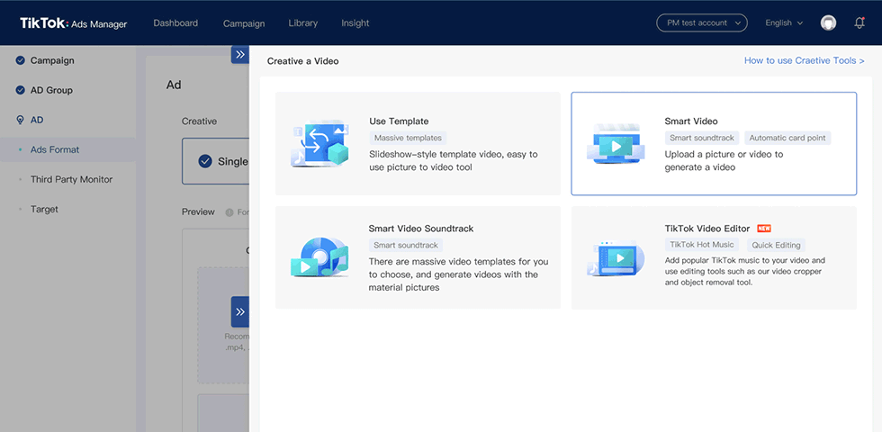

<https://wersm.com/tiktok-introduces-a-new-video-editor-for-native-video-ads/>

## **Shopify Won’t Build a Marketplace**

A year ago, **Shopify launched a consumer shopping app called Shop. Many called it a step towards a marketplace.** However, despite being downloaded tens of millions of times, Shopify **didn’t implement any marketplace features.**

* The app doesn’t allow searching for “coffee” and discovering all Shopify merchants in the category. It doesn’t have rich content like video, nor it has reviews or social features. It won’t let users check out either. It’s a bookmarking app for Shopify merchants with only the most basic functionality.
* Instead, it *“helps merchants strengthen their relationships with buyers with the ultimate goal of increasing customer lifetime value.”* However, the app does little more than delivery tracking (the functionality Shopify’s Arrive app had, the app Shop replaced), and thus it is unclear how it increases LTV for merchants.
* Its most recent updates included expanded functionality around Shop Pay, like managing installment payments. It didn’t add much beyond that over the past twelve months.
* Shopify said that it would continue to develop the app this year into a “must-have shopping companion that fosters buyer loyalty and retention.” It is vague on the specifics. The company has consumer-facing brands like Shop and Shop Pay but ultimately doesn’t want Shop to be where users start their shopping journey.
* **The bigger Shopify gets, the less likely it becomes that it will introduce a marketplace.** It would struggle to compete against discovery leaders like Instagram and TikTok. There is also no gap in the market a Shopify marketplace would fill.
  + Shop app has a confusing value proposition, but Shopify is pretty frank that it won’t become a marketplace.

<https://www.marketplacepulse.com/articles/shopify-wont-build-a-marketplace>

## **Microsoft Ads Rolls Out a Slew of New Features**

Microsoft Ads has announced several new features. Here’s a summary of what they’ve announced:

* **API Support for Google Import:** Microsoft Ads’ announced the global release of API support for Google Import. Microsoft’s Google Import now allows API users to sync Google Ads campaigns to Microsoft Ads. This opens up a variety of automation and customization solutions.
* **Customer Match:** In the coming months, Microsoft Advertising’s Customer Match will allow advertisers to create audiences from email addresses that they have collected through their own first-party audiences, in order to target users on the Microsoft Search Network and Microsoft Audience Network.
* **Flyer Extensions:** Advertisers will be able to attach their flyers to ads in order to drive more engagement and visibility to products and promotions. This feature is unqiue to Microsoft Ads and will only be available in the United States, initially.
* **Countdown customizers now available for Responsive Search Ads (RSA):** Microsoft Ads has announced that countdown customizers will now be available in RSAs. Countdown customizers automatically countdown to the date or time of the event being advertised. Microsoft Ads’ ad customizers will allow advertisers to add countdowns all the way down to the minute in their ads.

<https://www.searchenginejournal.com/microsoft-ads-rolls-out-a-slew-of-new-features/401462/#close>

## **YouTube will recommend products shown in videos**

YouTube will detect items shown in videos and generate a list of related products to buy. **Automated suggestions will appear as viewers scroll on the platform.**

* The technology will allow users to identify products that appear in the video and search for related content on the video site.
* The feature is currently being tested on some users in the US only - but experts say it could bring "huge" change to the advertising industry.
* “We are experimenting with a new feature that displays a list of products detected in some videos, as well as related products, (...). The goal is to help people explore more videos and information about those products on YouTube.”
* The auto-detection will also recommend videos by other creators on the platform that feature the products.

<https://www.bbc.com/news/technology-56499007>

# Calendar Week 13 (Apr 02)

## **YouTube Expands Monetization To More Types of Content**

YouTube is allowing ads to run on more types of content, which will expand the monetization opportunities for **content creators**.

* Creators will now be able to earn revenue on content that previously wasn’t considered suitable for advertisers.
* YouTube is now allowing more types of content to be fully monetized instead of partially monetized.
* Creators that are part of the YouTube Partner Program can immediately tell if a video is eligible for full or partial monetization by looking at **the color-coded icons in YouTube Studio.**
  + **Green icon:** Video is eligible to earn full revenue.
  + **Yellow icon:** Video will display limited or no ads.
  + **Red icon:** Video is ineligible for monetization.
  + **Grey icon:** Monetization has been manually turned off by the creator.
* YouTube says it has met with advertisers to make a case for some responsible policy updates.

<https://www.searchenginejournal.com/youtube-expands-monetization-to-more-types-of-content/401113/>

## **Pacvue Empowers Campaign Management And Optimization For Amazon DSP**

**Pacvue announced support for self-serve advertising via Amazon DSP**. Through Pacvue, marketers can now enhance their Amazon Advertising strategy with a full suite of programmatic media.

* **Amazon DSP** helps programmatically reach audiences both on and off Amazon.com with **display, video, and audio ads**.
* In conjunction with other Amazon Advertising products also supported through Pacvue, such as **Sponsored Products, Sponsored Brands, and Sponsored Display,** Amazon DSP is a meaningful addition to a full-funnel marketing strategy.
* Now, advertisers can manage their Amazon DSP campaigns directly in Pacvue, taking advantage of the intelligent automation features, bid optimization, and robust reporting tools that brands and agencies alike have come to depend on from Pacvue.
* Pacvue is extending the successful approach from its software solution for Amazon sponsored ads to Amazon DSP. **Features include:**
  + **Smart Optimization Tools:** Save time without sacrificing performance with configurable rules, AI algorithms, precise automation functions, and dayparting capabilities, including time-of-day bid multipliers.
  + **Budget Management:** Control monthly and daily spend, budget pacing, and forecasted spend.
  + **Detailed Reporting and Insights:** Gain actionable and unique recommendations, as well as competitive intelligence, customize and schedule reports and notifications, and measure Amazon DSP performance side-by-side with other retail media.

<https://martechseries.com/sales-marketing/programmatic-buying/pacvue-empowers-campaign-management-and-optimization-for-amazon-dsp/>

## **Microsoft Ads Ad Quality Year in Review: Increases in Ad Fraud**

In Microsoft Ads’ ad quality review, they identified an increase in **policy-breaking behavior** in 2020.

* **Increased Fraud**
  + Microsoft suspended almost 300,000 accounts from the Microsoft Advertising platform in 2020, which was a 30% increase from the year prior.
  + Microsoft noted that they have also **removed 1.6 billion bad ads** and an additional 270,000 sites from their system in 2020 alone.
  + Microsoft identified more than a 100% increase in advertising accounts that leveraged phishing and other scams in an effort to scam users.
* **Steps Taken to Improve Ad Safety**
  + Microsoft continues to invest in real-time evaluation systems backed by artificial intelligence, leveraging behavioral signals and fraud analysis tools.
  + In 2020, Microsoft received roughly 50,000 complaints related to non-compliant **ads. They found nearly 65% of the reported ads to be in violation of policy.**
* **Ad Quality Improvements Going forward**
  + Microsoft takes pride in its operations team, which works 24/7 to address concerns relating to ads. In response to complaints, the operations team took down nearly 400,000 ads in the past year.
  + In 2021, Microsoft plans to continue to leverage its two-pronged system of automated reviews powered by machine learning paired with manual reviewers to continue to improve the search experience for businesses and searchers using their platforms.

<https://www.searchenginejournal.com/microsoft-ads-ad-quality-year-in-review-increases-in-ad-fraud/399908/>

## **Global Leader in Marketing Technology Kenshoo Announces Expansion in Retail Media**

Kenshoo, a global leader in marketing technology, **today announces a significant expansion of its retail media reach**, providing access to seven new national retailers including Shipt, Macy’s, Ulta, Meijer, CVS, Staples, and FreshDirect with more to follow later this year. This is a first-to-market expansion that allows brands and agencies to take advantage of the growing ecommerce opportunity with access to insights, advertising, and cross-channel measurement on prime retailer inventory — all within a single platform.

* Through this expanded API integration — which already supports Amazon, Walmart, Target, and Instacart — Kenshoo customers gain the ability to rapidly test and learn the impact of each channel to bottom line sales and achieve rapid program scale and success from a holistic, connected commerce approach across all shoppable media including paid search, social, and retail to drive growth.
* “At Kenshoo, we are laser-focused on helping our clients maximize the tidal wave of ecommerce acceleration,” said Kenshoo GM of Ecommerce Nich Weinheimer. “With this expansion, we are making it even easier and more efficient for brand and agency clients to manage complex cross-retailer advertising campaigns in a single platform. Beyond the breadth of retailers available through this integration, we are also offering a previously unmatched depth of data to help companies stay front-of-mind for consumers.”

<https://martechseries.com/sales-marketing/b2b-commerce/kenshoo-announces-massive-expansion-retail-media-launching-coverage-seven-additional-key-retailers-brands-agencies/>

## **Facebook Lets Users Limit Who Can Comment On Their Posts**

Facebook is giving users more control over their experience on the website with changes to post comments and news feed filters. The updates announced today will allow users to:

* **Control who can comment on their posts**
  + Facebook users can now restrict comments on their public posts. This can either be done at the account level or on individual posts.
  + Users can select who is allowed to comment on their posts from the following options:
    - Public (everyone)
    - Friends
    - People and Pages mentioned in the post
* **Filter their news feed to see more relevant content**
  + A new menu at the top of the news feed, called the **Feed Filter Bar**, gives users quick access to the **‘Favorites’ and the ‘Most Recent’ filter.**
* Learn more about **why a recommended post is getting shown in their news feed**
  + Facebook is expanding its “Why am I seeing this?” feature, which provides more context around suggested content in users’ news feeds.

<https://www.searchenginejournal.com/facebook-lets-users-limit-who-can-comment-on-their-posts/401097/#close>

## **Microsoft Advertising announces Automotive Ads open beta in the US and UK**

This beta opens up the use of **automotive feeds and the API** for advertisers.

* “Automotive Ads are feed-based product ads where automotive marketers can upload all the attributes of their car inventory (make, model, year, trim, image, URLs, etc.) and showcase them on the Microsoft Bing.com SERP right rail, the Bing image results page, and native placements on the Microsoft Audience Network”.
* Microsoft’s Automotive Ads are triggered in both search and Bing image search for purchase intent searches and vehicle research.
* For the pilot program, the ads will show in the right rail of searches on Bing or above the images in vehicle-research-related images searches.
* “The offerings from your feed are matched to queries automatically, and they serve alongside existing text ads with a separate auction, so there’s no bidding up on yourself”.
* Advertisers looking to participate in the pilot program must be in the US or the UK. Applicants can apply through a Microsoft Advertising rep or apply through an online [form](https://microsoft.qualtrics.com/jfe/form/SV_87zhcPBOj5NkMvQ).

<https://searchengineland.com/microsoft-advertising-announces-automotive-ads-open-beta-in-the-us-and-uk-347367>

# Calendar Week 12 (Mar 26)

## **Microsoft Advertising introduces more automation via ad suggestions with auto-apply**

Microsoft Advertising users may see **ad suggestions with auto-apply** on their Recommendations page this month.

* **Ad suggestions** are variations of existing ads, based on their keywords, landing page, targeting, ad extensions and other relevant content.
* Microsoft Advertising will generate **ad suggestions** **when it detects an ad group that may be better served with more quality ads.**
* Ad suggestions will continue to be created as long as Microsoft Advertising’s systems **detect that an ad group performance can improve.**
* Advertisers should be aware that **ad suggestions marked as auto-apply will start serving after 14 days if no action is taken.**
* If an ad suggestion is applied, the go-live date will appear in the **Recommendations page** and the advertiser is **notified via email.**
* Auto-applied suggestions can be viewed in the Ad & extensions page, with the tag “Auto applied ad suggestion,” where advertisers can pause, delete or edit them.

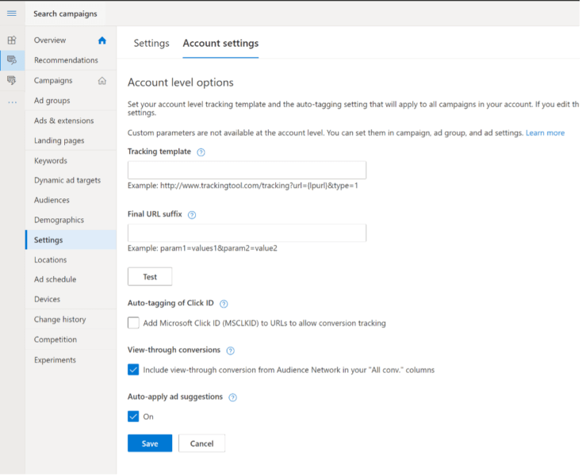

<https://searchengineland.com/microsoft-advertising-introduces-more-automation-via-ad-suggestions-with-auto-apply-347238>

## **Instagram Will Let Users Draft Stories to Save For Later**

Instagram users will soon be able to create stories and save them as drafts to publish later, the company confirms in an announcement.

* Instagram has long offered the ability to save regular posts as drafts, while stories have always had to be created at the time of publishing.
* **The ability to schedule stories will give businesses the flexibility to craft Instagram stories in advance and publish at a later time.**
  + This could either be done ahead of a big announcement, or simply to save for posting at a time when a business’s audience is more active.
  + Businesses can create the content when they have time, save it, and hit the send button when their audience is most likely to see it.
* Saving Instagram story drafts can be a useful addition to the workflow of teams that manage a single account.
  + Teams can collaborate on content by adding to and editing story drafts before they go live. Similar to how teams would collaborate on a WordPress post or a Google Doc.
* Some content is better left in the drafts, but we often do not start second guessing our own content until after it’s been created.

<https://www.searchenginejournal.com/instagram-will-let-users-draft-stories-to-save-for-later/400060/>

## **Japan’s Advertising Spending Drops for First Time Since 2011**

Dentsū, Japan’s leading advertising company, announced that the nation’s total 2020 advertising expenditures fell 11.2% from 2019 to ¥6.16 trillion. This was the first decline since 2011, the year of the Great East Japan Earthquake.

* Total advertising expenditures were divided into three categories: **the four mass media outlets of TV, radio, magazines, and newspapers**; **Internet advertising**; and **promotional media for events.**
* **Mass media expenditures** fell for the sixth consecutive year, declining 13.6% year on year to ¥2.25 trillion.
* **Internet advertising expenditure**s grew 5.9% year on year to a strong ¥2.23 trillion.
* **The majority of Internet advertising is targeted, based on users’ browsing and search history.** This rose by 9.7% to ¥1.46 trillion, driven by the increased usage of social media and video streaming services by homebound consumers.

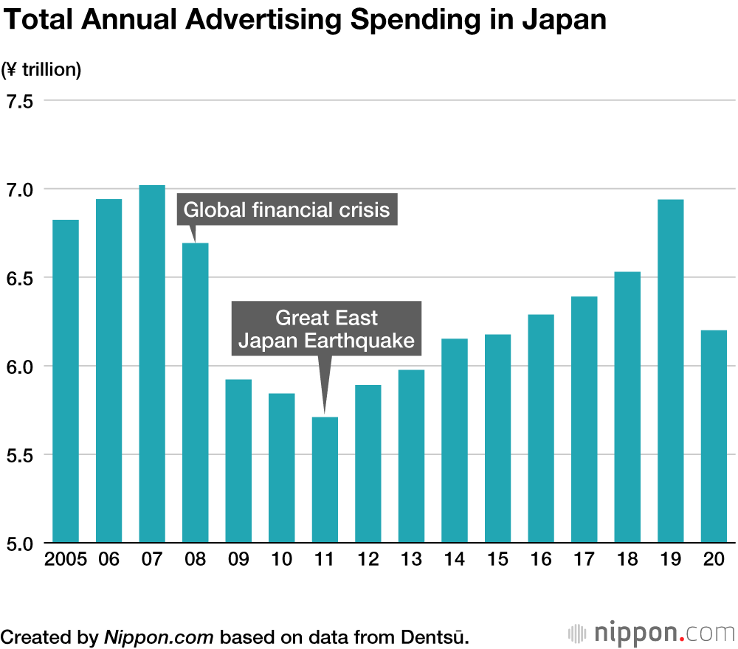

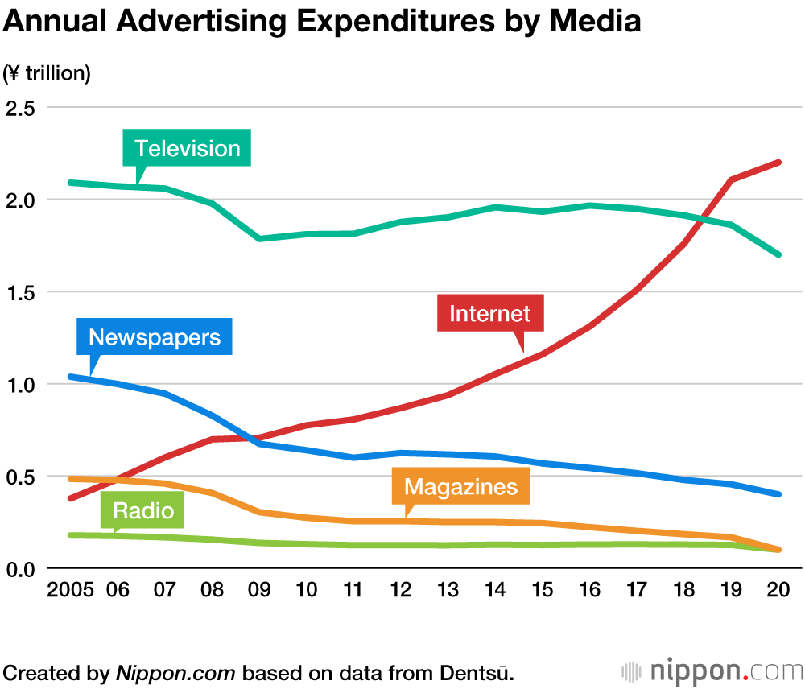

<https://www.nippon.com/en/japan-data/h00959/>

## **Chinese Sellers on Walmart Marketplace**

Nearly a hundred China-based sellers have joined the previously US-only Walmart Marketplace over the past few weeks as the company quietly expanded it to allow foreign sellers. **Walmart officially announced the expansion at a conference hosted in Shenzhen on March 25th.** Jeff Clementz, Senior Vice President at Walmart, leading the company’s U.S. marketplace business, opened the event.

* **Sellers must have a valid Chinese business license, more than a year of operating experience selling on North American marketplaces, and good store ratings.** To solve the weeks-long delivery times, Walmart will be onboarding those sellers to the Walmart Fulfillment Services (WFS), a service that so far has seen [little adoption](https://www.marketplacepulse.com/articles/walmarts-fulfillment-service-for-sellers-not-seeing-adoption).
* The sellers that joined so far are not using WFS and thus show delivery estimates as long as three weeks. Furthermore, most consumers won’t be aware of where they are buying from since the Walmart marketplace doesn’t make sellers’ business details or their warehouse location public.
* There are risks to opening the doors, too. Walmart’s verification of sellers outside the U.S. is unlikely to be as effective as domestically.
* Selling on Walmart still requires approval, so the [82,000 sellers](https://www.marketplacepulse.com/walmart/number-of-sellers) figure will not increase quickly. However, [75% of new sellers](https://www.marketplacepulse.com/articles/75-of-new-sellers-on-amazon-are-from-china) on Amazon are from China, and many meet the requirements Walmart set for foreign sellers.

<https://www.marketplacepulse.com/articles/chinese-sellers-on-walmart-marketplace>

# Calendar Week 11 (Mar 19)

## **TikTok makes it mandatory for users to see personalised ads**

TikTok has announced to **make it mandatory for users to see personalised ads from April 15.** Based on users' content preferences, the company will show ads in the app.

* The app currently has a setting that allows users to choose whether they'll be served ads based on their activity within the app.
* Starting April 15, user settings will change and the ads users will see may start to be based on what the user does on TikTok.
* The change is related to Apple's upcoming rollout of iOS 14, which will require developers to get users' permission to track their data across apps for targeted advertising.

<https://www.indiatvnews.com/technology/news-tiktok-makes-it-mandatory-for-users-to-see-personalised-ads-691888>

## **TikTok Launches New Ads Library, Enabling You to Find the Best Performing Ads in a Range of Categories**

TikTok has launched a new Ad Library tool, currently called **'Top Ads',** which enables you to **search for the best performing TikTok ad campaigns, by vertical and region,** in order to get inspiration from their approach.

* TikTok provides a range of search filters to navigate through the ad listings, including **'Ad Type', 'Region' and 'Industry'.**

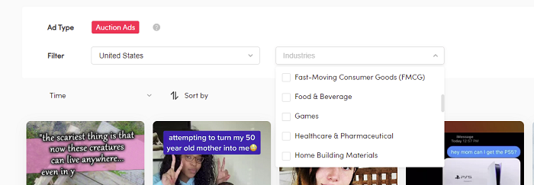

* Advertisers can then further filter the displayed results **by time (last 7 days or last 30 days) and by performance (CTR, Impressions, 6 second video view rate)**, honing in on the most relevant examples for their business.

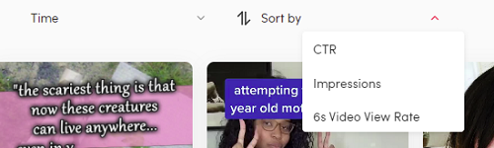

* From there, advertisers can tap into any of the listed ad examples to get more info on that specific promotion.

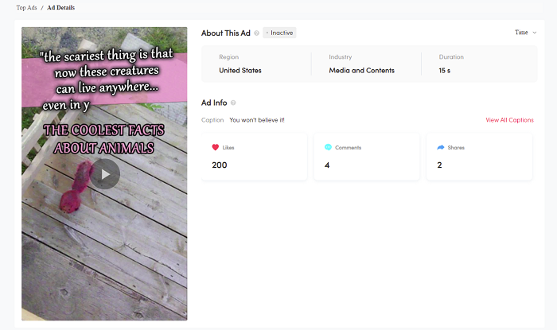

* TikTok additionally notes that the ads displayed in the library are limited to those which have been authorized by advertisers "and may not reflect all the actual top-performing ads".

<https://www.socialmediatoday.com/news/tiktok-launches-new-ads-library-enabling-you-to-find-the-best-performing-a/596927/>

## **Rakuten Advertising Helps Advertisers Tackle Wasted Advertising Spend**

Rakuten Advertising launched a new **guide** titled, “Connecting in the Moment: **A Guide to key media ‘Moments’ and how advertisers can use them**”, which **explores the concept of connecting advertisers to consumer ‘Moments’ to improve advertising performance**.

* Highlighting the importance of treating consumers as more than data points, the **guide showcases how brands can connect with audiences on a deeper level based on the mindset or Moment that they’re in.**
* In the guide, Rakuten Advertising is urging advertisers to **think more strategically and look beyond audience data to maximise the impact of adverts and reduce wasted budget.**
* A **‘Moment’** is defined as what people do throughout their days and evenings, such as watching TV with family, messaging friends, contributing to discussions on the latest entertainment content or browsing the internet for gifts for loved ones.
* Instead of viewing an audience in terms of demographics, advertisers should consider reframing their behaviour as a series of ‘Moments’, allowing them to understand the mindset their audience will be in at any given time while engaging with media and content.
* “Connecting ads with the audience while they’re in the right frame of mind – in the right Moment – will ensure the advert lands with impact, increasing the likelihood of direct action being taken.”
* The **guide** showcases **how advertisers can harness Moments** across Rakuten Advertising’s different platforms for brands, covering a messaging app and streaming services.

<https://aithority.com/technology/native-and-programmatic-advertising/rakuten-advertising-helps-advertisers-tackle-wasted-advertising-spend/>

## **Google tests displaying cost estimates in local search results**

A Google spokesperson confirmed the company is testing displaying cost estimated directly in the local panel in the search results.

* Google displays an estimated range of the cost to have certain jobs done in your local area for your home.
* The example below shows the estimated cost to repair a roof in Hackensack, New Jersey. Anubhav posted a screenshot of this on Twitter for us to use:

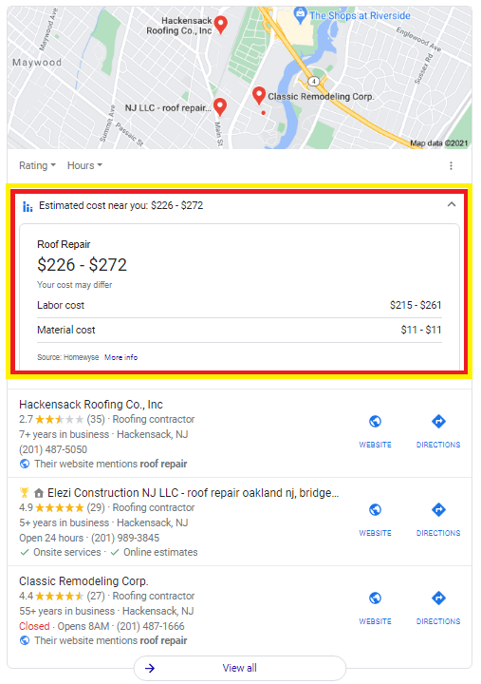

* These are **not through any form of Google Ads service** or form of Google Guaranteed or Google Local Service Ads. These are organic listings and not paid search answers.

<https://searchengineland.com/google-tests-displaying-cost-estimates-in-local-search-results-346885>

## **YouTube Adds More Analytics Data, Updates Studio Mobile App**

YouTube is giving creators access to more data on video views and rolling out updates to the Studio Mobile app.

* YouTube creators now have access to **new metrics about video views**, and the Studio Mobile app is getting refreshed with efficient ways to view data.
* New analytics data includes granular information about the sources of video views which wasn’t available before.
* **Impressions derived from sources like TV and video game consoles** will be available in channels’ analytics count.
* YouTube launched **new and returning viewers metrics** that can be seen in the **Audience tab** within YouTube studio.

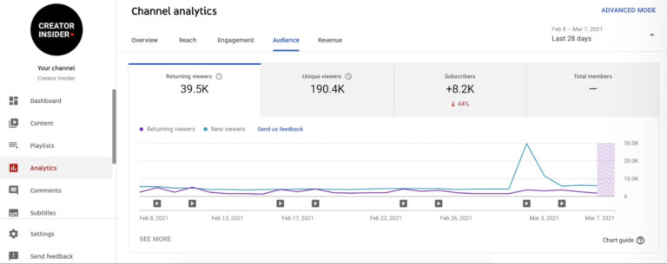

* YouTube has overhauled the tabs in the Studio Mobile app to focus on alignment. **The most used tabs are now aligned, which include: audience, reach, engagement, overview, and revenue.**

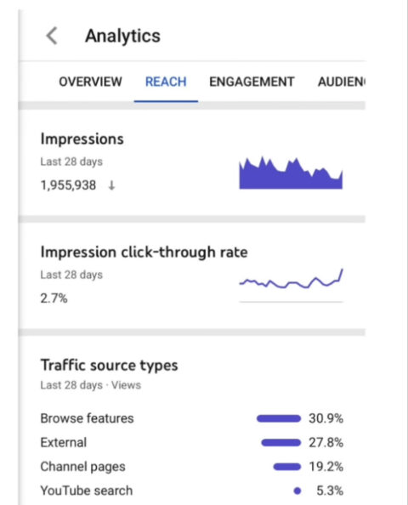

<https://www.searchenginejournal.com/youtube-adds-more-analytics-data-updates-studio-mobile-app/399083/#close>

# Calendar Week 10 (Mar 12)

## **Marketplaces Year in Review 2020**

2020 was the best year for e-commerce marketplaces in over a decade. E-commerce growth had a step change, and marketplaces captured most of it. In aggregate, it was the most successful year for sellers and brands that transact through them, too.

* **Amazon Gross Merchandise Volume (GMV)**
  + In 2020, sellers on the Amazon marketplace sold $295 billion worth of products, and as a retailer, Amazon’s sales were $180 billion. For a total Amazon gross merchandise volume of $475 billion, according to early and rough estimates based on Amazon disclosures.

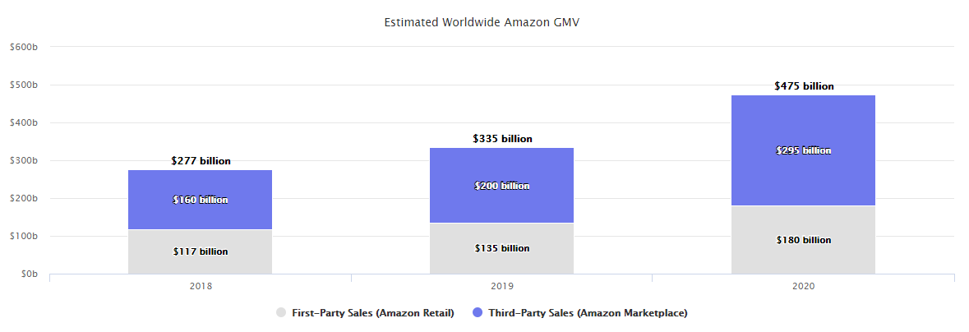

* + Third-party sellers increased their sales by $95 billion in a year, up from $200 billion in 2019. Amazon’s sales grew by $45 billion, from $135 billion. Gross merchandise volume (GMV), the total amount of sales on Amazon websites, including those by the company itself and by the marketplace, grew from $335 in 2019 to $475 billion in 2020.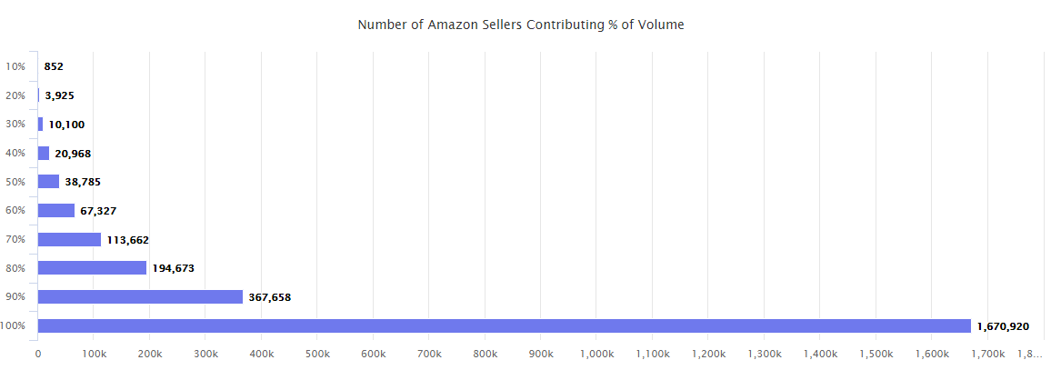
  + Just 850 sellers were responsible for 10% of Amazon’s worldwide volume. But more than 38,000 sellers were responsible for 50%. Finally, more than 360,000 sellers were responsible for 90% of the volume.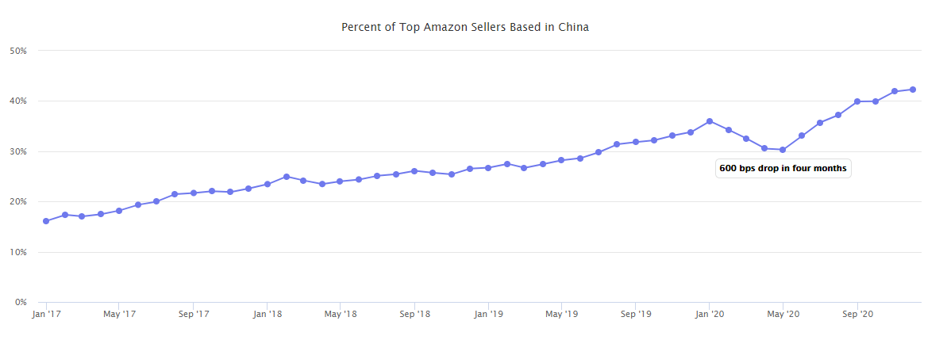
  + By the end of 2020, the share of top Amazon sellers from China reached an all-time high of 42%.
* **Amazon Advertising**
  + The average cost-per-click (CPC) on Amazon ads is $0.85, according to Quartile Digital data. Despite more brands flocking to advertise on Amazon and the net ad spend increasing (nearly $13 billion was spent on Amazon ads in the U.S. this year), Amazon has also increased the ad inventory on and off Amazon and introduced new ad types.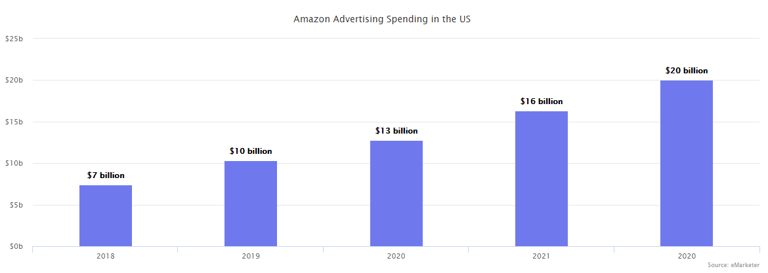
  + In 2015, advertising revenue represented only 32% of marketing expenses. It grew to 41% in 2016, 46% in 2017, 73% in 2018, 75% in 2019, and 93% in 2020.

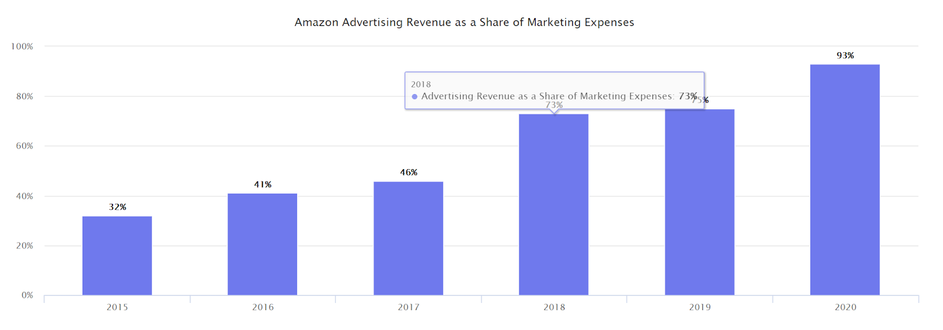

* **Etsy**
  + Etsy has used surging demand for face masks to accelerate growth for all handmade and vintage goods. After growing 20% for the last five years, it nearly doubled GMV in 2020.
  + The company reported selling $346 million worth of face masks in the second quarter and $264 million in the third quarter.
  + Etsy added 1.9 million new sellers in 2020, up from one million last year.

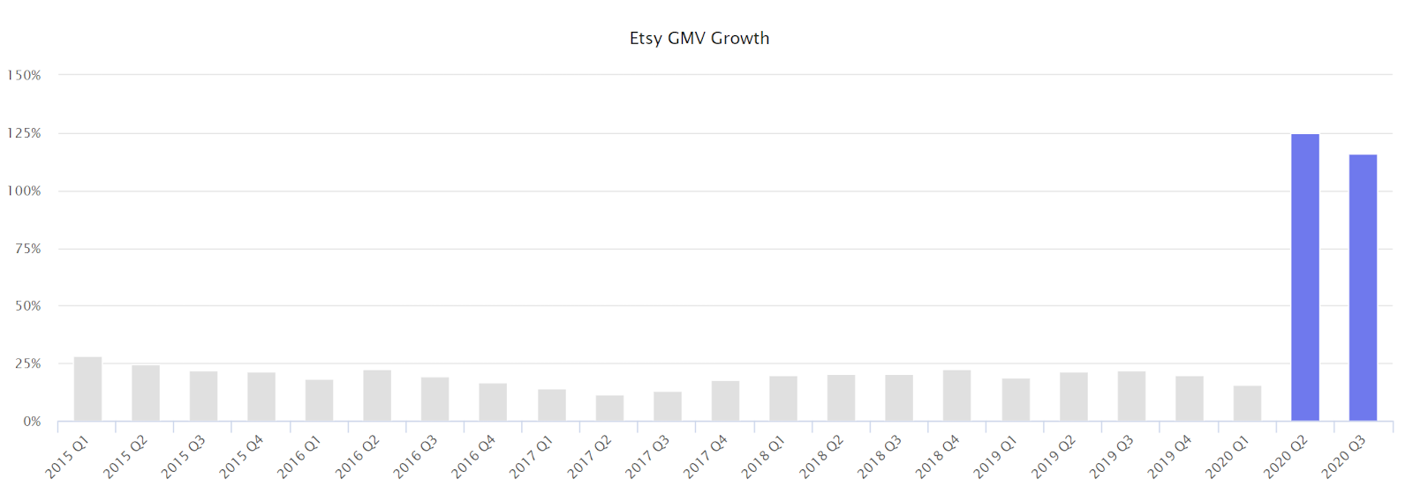

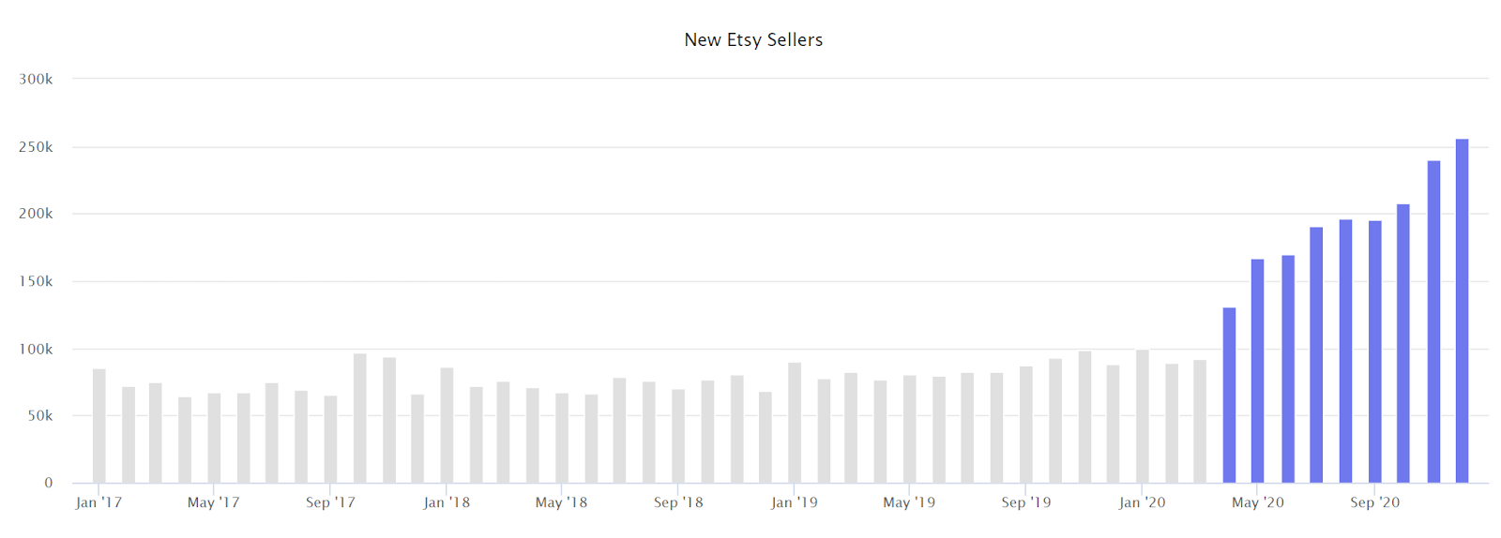

* **Walmart**
  + Walmart’s marketplace GMV more than doubled in 2020. In the third quarter, marketplace sales grew “triple-digits” (over 100%) while overall e-commerce sales were up 79%. The marketplace sales also grew at least 100% in the second quarter, according to the company.

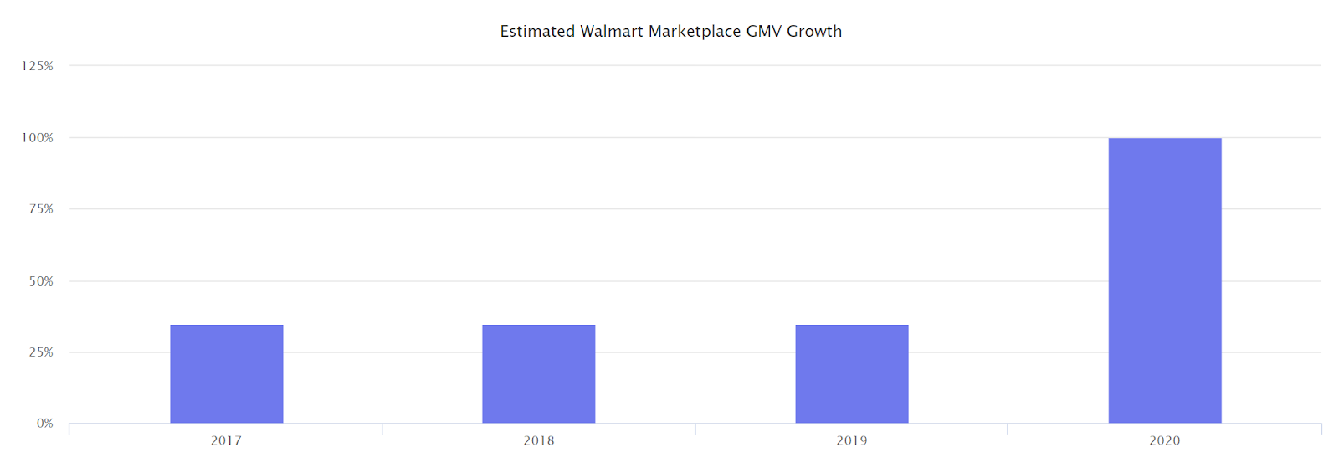

* **Target**
  + On February 25th, 2019, the company launched a marketplace called **Target+,** or Target Plus. It started with 30 merchants and 60,000 products. The most significant difference is that **Target’s marketplace is invite-only,** meaning merchants and brands on it are selected by the company instead of more open marketplaces of other retailers.

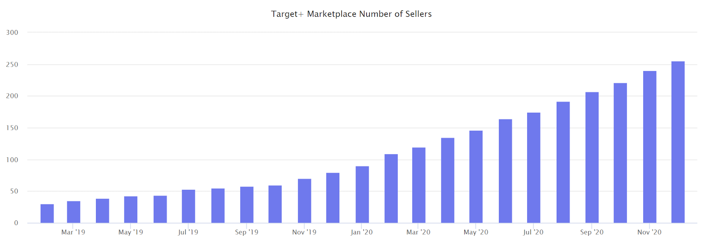

* **eBay**
  + eBay’s GMV grew 26% in the second quarter and 22% in the third quarter, a remarkable acceleration from the 2% average over the past thirteen quarters.

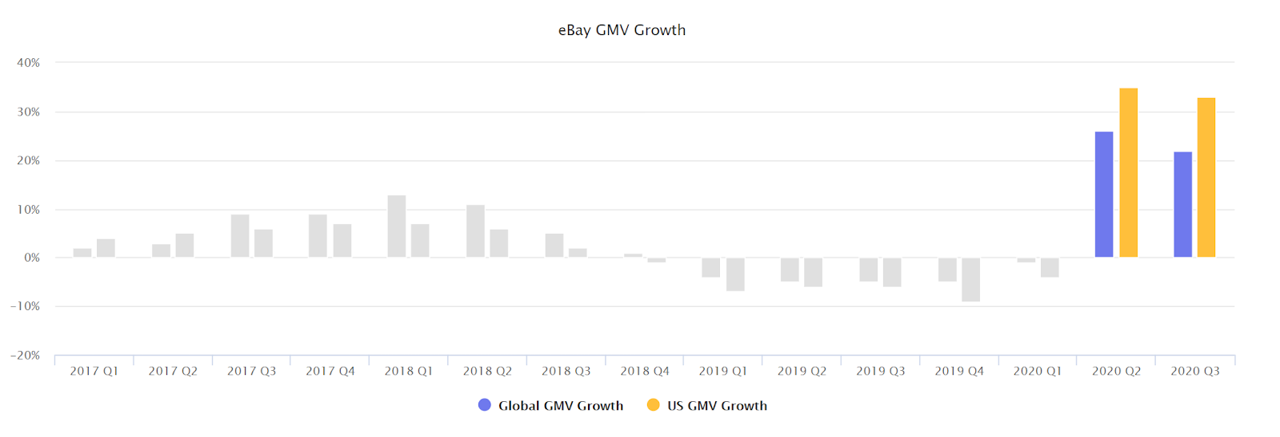

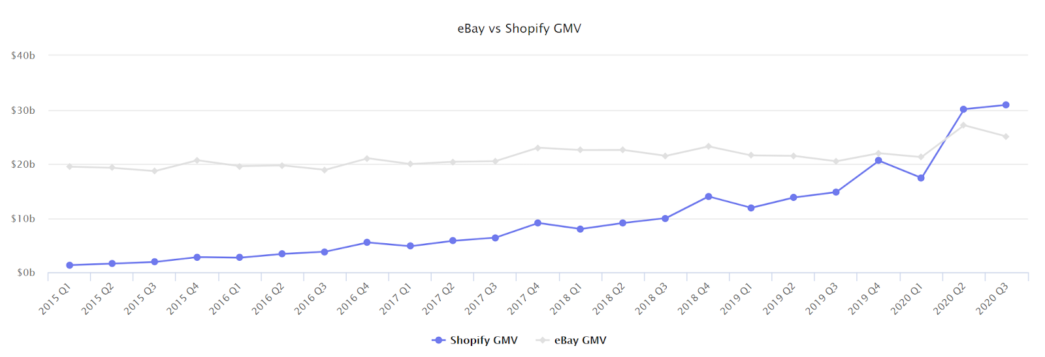

<https://www.marketplacepulse.com/marketplaces-year-in-review-2020>

## **Amazon Advertising Demand Side Platform Clear Ads Launches Podcast**

**The Amazon advertising demand-side platform DSP business, Clear Ads, is bringing its expertise to its podcast show "Highway to Sell."** With new episodes every two weeks, the show is focused on helping sellers and e-commerce businesses navigate Amazon advertising.

* The show has already covered topics of interest, including recommending a strategy for bidding and keyword research, how to decide on an appropriate budget for campaigns, and the main benefits of Amazon PPC.
* New episodes will be available to listeners every two weeks on the audio streaming services Spotify, Anchor, Breaker, Google Podcasts, Pocket Casts, and RadioPublic.
* To expand its ability to share its wealth of experience, the new podcast is centered around helping sellers and [e-commerce](https://www.martechcube.com/ecommerce/) businesses navigate the Amazon advertising platform and provide insight into Amazon PPC and Amazon’s Demand Side Platform.
* Each episode will:
  + **Share industry insights and tips**
  + **Provide strategic advice**
  + **Share real stories, interviews and recommendations for seller campaigns**
  + **Answer seller questions.**

<https://www.martechcube.com/amazon-advertising-demand-side-platform-clear-ads-launches-podcast/>

[9](https://searchengineland.com/static-headlines-now-available-for-dsas-in-microsoft-advertising-346809)

## **Google says it won’t use new ways of tracking you as it phases out browser cookies for ads**

Google recently clarified its plans for targeted advertising, promising not to use other ways to “track” users around the internet after it ends support for cookies in Chrome by early 2022.

* The company said in a blog post **it will only use “privacy-preserving technologies” that rely on methods like anonymization or aggregation of data.** Google announced plans in January 2020 to end support for third-party cookies, which fuel much of the digital advertising ecosystem, in its Chrome browser within two years.
* The blog post from David Temkin, director of product management for ads privacy and trust, said the search giant had received questions about whether it will “join others in the ad tech industry who plan to replace third-party cookies with alternative user-level identifiers.”
* ***“Today, we’re making explicit that once third-party cookies are phased out, we will not build alternate identifiers to track individuals as they browse across the web, nor will we use them in our products,”*** the Google post said.

<https://blog.google/products/ads-commerce/a-more-privacy-first-web/>

## **Put a Pin in it: Pinterest Premiere invests in video advertising**

With so many active users on the platform, the company is introducing new marketing tools to attract advertisers. **At Pinterest’s first-ever global advertiser summit,** [**Pinterest Presents**](https://www.pinterestpresents.com/us)**, the company introduced a new video ad solution and measurement tools.**

* **Pinterest Premiere is the company’s video ad unit that advertisers can purchase to target consumers based on a user’s behavior.** The video ads appear during specific time frames on people’s feeds and target a consumer’s interests.
* *“Pinterest Premiere gives you the option to align video ad targeting with either a specific demographic, or a specific category (combining demographics and interests). These packages are set up to help you drive broader reach and scale for moments like launches, brand events or even ongoing campaigns,”*
* At the summit, **Pinterest also revealed Pinterest Trends and Conversion Insights.** [According to the company](https://newsroom.pinterest.com/en/post/draft-pinterest-presents), this planning and measurement tool “will show actionable insights to help advertisers optimize their performances and opportunities to reach consumers.”

<https://theamericangenius.com/business-marketing/pinterest-premiere-highlights-video-advertising/>

# Calendar Week 09 (Mar 05)

## **Microsoft Bing updates search results interface to make it more visually immersive**

Microsoft announced several updates to **Microsoft Bing Search** that make the search experience more “visually immersive”. This update goes across many different search features including **recipe results, image search’s similar looking items, expandable search result carousels, infographic knowledge panels and the local answers design.**

* Microsoft launched these **new knowledge panel designs that are very visually appealing.** Here is a screenshot of what it looks like, notice how the right panel, as well as other parts of the page, are very visually immersive.

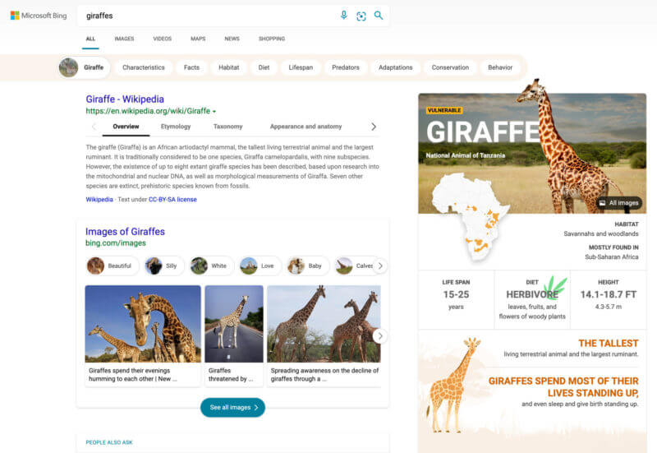

* Now when you search in Microsoft Bing for a local answer you will get more information from Bing Maps, **top images, visitor reviews, and more**.

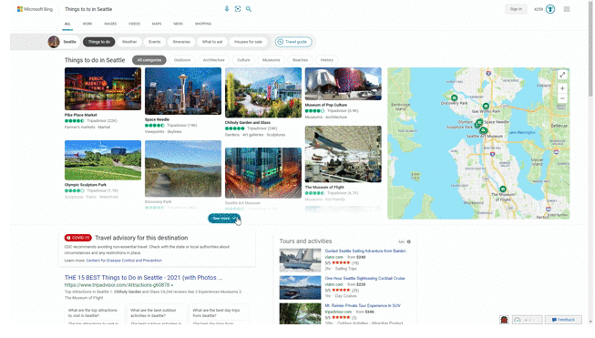

* **Microsoft also added these expandable carousels** where you will have a carousel of answers that showcases just the results’ high-level information to avoid crowding the page.

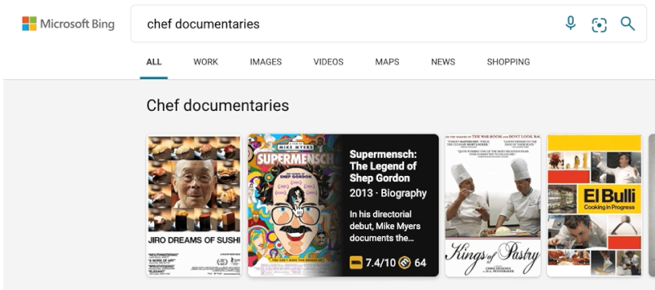

* Within Microsoft Bing Image Search you can now click on an image and **use the similar looking item feature to highlight a part of that image to see more images that look similar to that portion of the image.**
* When you search for recipes, Microsoft will show you a list of recipes and let you expand to see more.

<https://searchengineland.com/microsoft-bing-updates-search-results-interface-to-make-it-more-visually-immersive-346665>

## **Google Ads mobile app adds custom and performance insights notifications**

**Custom and performance insights notifications** have been added to the Google Ads mobile app, Google announced Thursday.

* **Custom notifications.** You can now set up custom notifications to help you keep tabs on the metrics that matter most to your business.
  + “Let’s say you’re planning a Spring Sale campaign, and you want to stay on top of how conversion volume changes week-over-week,” Google provided as an example, “With this new feature, you can create a custom notification to alert you when weekly conversions increase by more than 10%.”

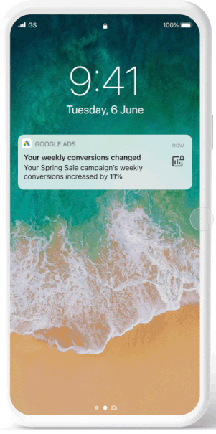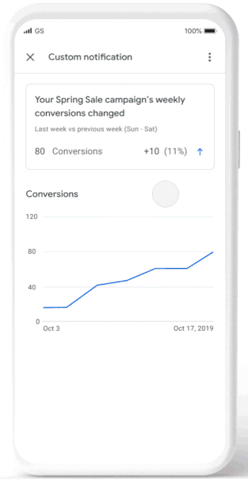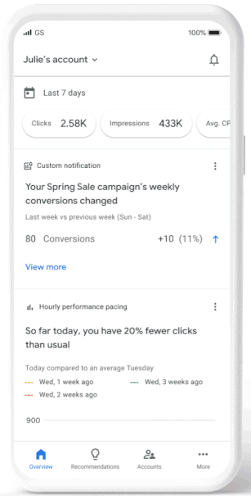

* **Performance insights notifications.** These notifications can alert you when there’s a significant performance change and provide you with an explanation of why the change may have happened.
* **Google may also provide recommendations**, which can be applied directly from the performance insights notification (shown above).

<https://searchengineland.com/google-ads-mobile-app-adds-custom-and-performance-insights-notifications-346661>

## **Google My Business report shows how people found your business**

Google My Business has upgraded [**the new performance report**](https://searchengineland.com/google-my-business-launches-new-performance-reporting-345252), which was an upgrade from the Insights report, to add a section for people who viewed your business profile. This new section shows you **how people found your local listing**, either on desktop or mobile and either through Google Search or Google Maps.

* You can access the report by logging into Google My Business. There is a section that shows “**how people discovered you.**”

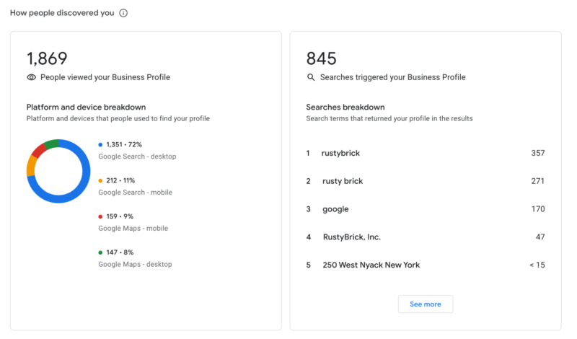

* “**People who viewed your business profile**” section on the left gives you a breakdown of who viewed your profile on **Google Search** vs **Google Maps** and then by desktop device or mobile device.
* Google has updated the help document to add a section for the **“users who viewed your profile”** section. The section explains it is the “number of unique visitors to your profile”, “Per breakdown device and platform, a user can only be counted once a day”.

<https://searchengineland.com/google-my-business-people-who-viewed-your-business-report-346632>

## **Jungle Scout Adds Support for Amazon Advertising With $110 Million in Growth Capital**

[Jungle Scout](https://www.builtinaustin.com/company/jungle-scout), an Austin startup that helps businesses sell their products on Amazon, [announced](https://www.prnewswire.com/news-releases/jungle-scout-announces-110-million-in-growth-capital-to-empower-ecommerce-brands-301240437.html) Thursday it raised $110 million in fresh growth capital. **The money will be used to acquire Amazon adtech company** [**Downstream Impact**](https://www.builtinseattle.com/company/downstream?page=0,6), as well as to grow the business and [team](https://www.junglescout.com/jobs/).

* Though it may not be a household name like Amazon, [Jungle Scout](https://www.junglescout.com/) has a massive impact on the e-commerce giant, claiming to support more than $8 billion in Amazon revenue for more than 500,000 businesses on the site.
* **Here’s how it works:** 
  + Jungle Scout’s data search engine ingests keyword, sales and trend information from some 500 million Amazon products, which can then be used to help businesses sell their own products better.
  + Last year the company also rolled out Cobalt, **a tool that is capable of processing more than one billion data points daily, providing powerful intelligence on things like market share, trend analysis, content optimization and competitive insights.**
* This model is a departure from other companies in this space. Startups like [Thrasio](https://www.builtinboston.com/2021/01/11/thrasio-raises-500m-new-financing), [Perch](https://www.builtinboston.com/2020/10/20/perch-raises-123m-hiring) and [Heyday](https://www.builtinsf.com/2020/11/23/san-francisco-tech-funding-news-112320) have raked in massive amounts of funding to buy up promising third-party sellers on Amazon, then use its resources to make them more profitable.
* *“Today, Jungle Scout serves a global customer base of entrepreneurs and brands focused on building a business on Amazon and beyond,” Mercer said in a statement. “We’ve grown profitability since day one, and we believe the opportunity only continues to grow.”*
* **A key part of Jungle Scout’s success going forward is its acquisition of Downstream Impact, which manages more than $250 million a year in Amazon advertising spend for major brands like HP and Bic.**

<https://www.builtinaustin.com/2021/03/04/jungle-scout-raises-110m-hiring>

## **Walmart beefs up ad network with 3 new providers of marketing services**

Walmart Connect, the retailer's recently rebranded advertising network, **this week expanded its approved partners program to include HarvestGroup, Stackline and Tinuit.** The addition of the three companies to the Walmart Advertising Partners Program is part of the company's effort to help advertisers run their campaigns more efficiently, per an announcement emailed to Marketing Dive.

* **Harvest Group is an omnichannel retail growth agency, Tinuiti is a performance marketing agency that specializes in online marketing and Stackline is a retail intelligence and software company focused on e-commerce**, according to their respective websites.
* **Third-party service providers Flywheel, Kenshoo, Pacvue and Teikametrics already belong to the Walmart Advertising Partners Program**, which was launched as a self-serve platform in January 2020.
* The number of advertisers that use services from Walmart's partners has grown 10 times from a year earlier, amid a 56% gain in search inquires and 185% growth of Walmart sponsored products ads that appear on the first page of search results, category pages and item pages on its site, per its announcement.
* **Walmart also** [**partnered with ad-tech firm The Trade Desk**](https://www.marketingdive.com/news/walmart-links-with-the-trade-desk-in-extensive-overhaul-to-ad-business/594118/) **to create a new demand-side platform (DSP) for marketers that buy media in automated auctions.** The platform, which has a target launch date ahead of the 2021 holiday season, will give marketers a way to harness Walmart's shopper data to improve their ad targeting on other websites aside from its e-commerce platform.
* **The company this month announced plans to buy the technology and IP** [**behind Thunder**](https://www.marketingdive.com/news/walmart-acquires-thunder-ad-tech-as-it-preps-self-serve-display-portal/594538/)**, an ad-tech solution focused on creative automation, in an effort to grow its self-serve display platform.** Thunder's automation capabilities aim to make campaign management more seamless and accessible to a wider range of advertisers including smaller suppliers.

<https://www.marketingdive.com/news/walmart-beefs-up-ad-network-with-3-new-providers-of-marketing-services/595930/>

## **Pinterest Announces New Marketing Tools, Including 'Pinterest Premiere' Video Ads**

As part of its first-ever '[Pinterest Presents](https://www.socialmediatoday.com/news/pinterest-announces-pinterest-presents-virtual-summit-for-marketers/594753/)' marketing and advertising summit, Pinterest has today announced several new ad tools to provide more insight into campaign performance, and enhanced opportunity to reach the right audience.

* First off, Pinterest is adding a new video ad option called 'Pinterest Premiere', which will enable advertisers to purchase exclusive video placement in the home feed for a specific demographic, interest or category for a designated time frame.
* And finally, Pinterest is rolling out its Conversion Insights more broadly, which enables advertisers to view both promoted and organic Pin metrics in a single report.

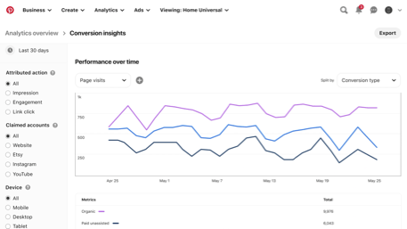

* Pinterest launched a version of Conversion Insights for advertisers in the US and UK last September, but the updated format will go deeper into downstream conversions and better highlight cross-channel impact.

<https://www.socialmediatoday.com/news/pinterest-announces-new-marketing-tools-including-pinterest-premiere-vid/596027/>

# Calendar Week 08 (Feb 26)

## **Google Search Console Updated With New Associations Page**

**Google Search Console** has a new and enhanced **Associations page** which will carry over all existing associations.

* **An association** refers to the connection between a **Search console property and a property in another Google service**, such as Analytics.
* **The updated Associations page**, which is found within the settings menu of **Search Console**, supports the following association types:
  + **Google Analytics:** View your Search Console data, such as organic search queries, in your Google Analytics property.
  + **Google Ads:** View the paid and organic report in Google Ads.
  + YouTube channel: Link your videos to your associated website.
  + **Play Console app:** Use App Indexing.
  + **Actions Console project:** Verify your brand and enable cross-platform functionality.
  + **Chrome Web Store account:** Publish apps and extensions to the Chrome Web Store on behalf of your site.
* Now it’s possible to link **Search Console domain properties to Google Analytics,** which will provide better coverage of organic search results.

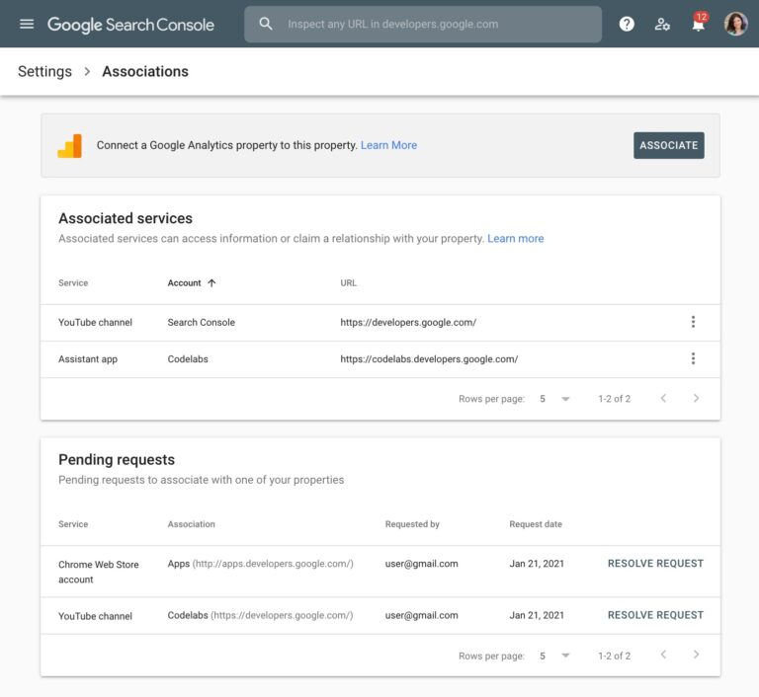

<https://www.searchenginejournal.com/google-search-console-updated-with-new-associations-page/396715/>

## **Facebook, Microsoft & Google Ads Compared: CTR, CPM & CPC Benchmarks**

Cambridge University conducted a study about how **imagery, sentiment, landing page quality and language** impacted click-through rates (CTRs) on Facebook, Microsoft & Google Ads.

* Researchers found that each of the major online ads platforms has its strengths:
  + **Facebook Ad**s was **the most cost-effective channel** on average.
  + **Microsoft Ads** was **most responsive to increasing ad spend.**
  + **Google Ads** had **the greatest reach for the lowest cost.**
* In the evaluation of **how factors impacted CPM and CPC,** they found that an advertiser’s choice of channel has a significant impact on both metrics:

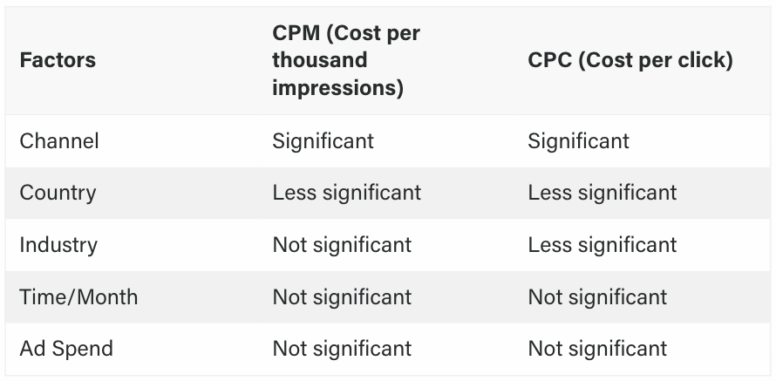

* Microsoft Advertising had the highest median CPM and CPC, but researchers advise it is best for targeting affluent customers:

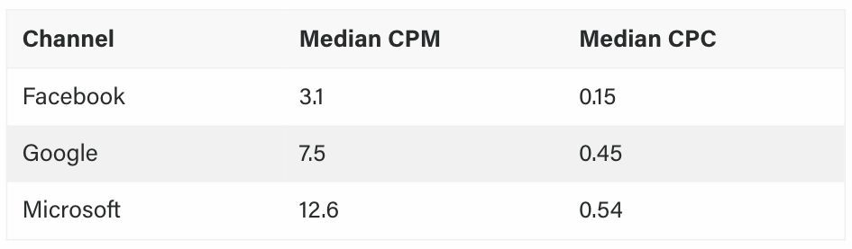

* Researchers used regression analysis to determine whether **increasing ad spend also increases the number of impressions and clicks**.

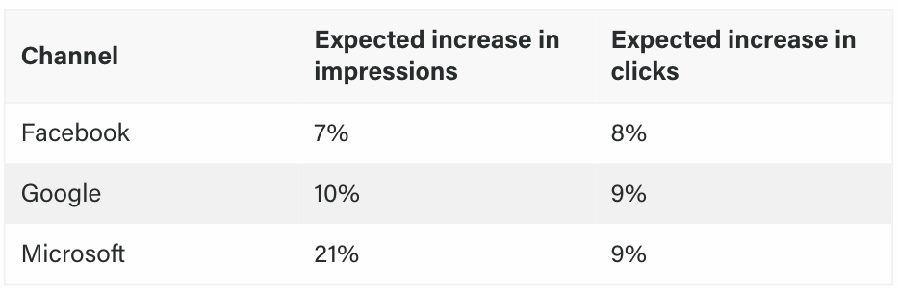

* Key Takeaways from Facebook Ads v. Microsoft Advertising v. Google Ads Comparison:
  + **Facebook** is, on average, the **most cost-effective channel for SMBs.**
  + Ads with positive sentiment perform better on Microsoft, and negative sentiment performs better on Google Ads.
  + Best practices were the most important conversion element for landing pages, followed by SEO (titles and meta descriptions, valid robots.txt, ensuring links are crawlable, etc.).
  + Very few advertisers are maximizing their conversion opportunities, leaving plenty of opportunity to **improve ROAS through landing page optimization**.

<https://www.searchenginejournal.com/facebook-microsoft-google-ads-comparison/397091/#close>

## **Facebook Ad Campaign Promotes Personalized Advertising**

Facebook Inc. will promote **the value of targeted ads to businesses and consumers in a new ad campaign in digital media, radio and TV programming** including National Collegiate Athletic Association basketball games and Sunday’s Golden Globe Awards.

* The effort comes as Apple Inc. nears implementation of a policy requiring many apps to ask users whether they want their behavior on the web to be tracked for the purposes of personalized ads.
* Facebook relies on the data from that sort of tracking to inform the targeted advertising it sells, and said in January that it expects the policy to weigh on the performance of its ad business.
* Facebook plans to [accompany Apple’s new prompts](https://www.wsj.com/articles/facebook-to-counter-apple-privacy-update-with-its-own-prompt-11612191604?mod=article_inline) with a screen describing how certain data is used to personalize a user’s experience and asking permission to use data collected from third-party websites and apps.

<https://www.wsj.com/articles/facebook-ad-campaign-promotes-personalized-advertising-11614261617>

## **Etsy Offsite Ads: Etsy to Begin Billing Sellers for Its Content Marketing Costs**

Etsy began charging sellers for paid-search campaigns last year through a new Offsite Ads program, and **now it will charge sellers for content marketing expenses using the same program.** So if an affiliate publisher drives traffic that results in a sale on the marketplace, Etsy will charge that seller a fee.

* The marketplace announced Tuesday it was expanding the Offisite Ads program to include its Publishing Partners: *“Offsite Ads can bring shoppers to your listings through ads on high-traffic sites like Google, Instagram, and Pinterest. And now, it could also* ***get your items featured on publishing sites like Buzzfeed, Martha Stewart, and Real Simple****. In addition to these big-name publishers,* ***we’ll also share your Etsy listings with social media influencers and bloggers.****”*
* Other publishers participating in Etsy’s content marketing program include MyWedding, Better Homes and Gardens, Lyst, and Shape.
* With Offsite Ads, in addition to paying a commission fee on all sales, sellers pay an additional “advertising fee” of between 12% – 15% for sales resulting from Offsite Ads. That makes the program tricky for sellers when setting prices for their products
* Etsy also announced on Tuesday, ***“In addition to adding publishers to Offsite Ads, we’re also expanding from Google Shopping to the full Google Display Network.*** *That means your ads can appear on thousands of sites that partner with Google, helping you reach more potential customers, even when they’re not actively searching for something to buy.”* Last year, Google Shopping went from pay-to-play to a mostly free platform.

<https://www.ecommercebytes.com/2021/02/23/etsy-to-begin-billing-sellers-for-its-content-marketing-costs/>

## **Shopify and TikTok Take Social Commerce Global**

**Shopify is expanding its social commerce partnership with video-sharing platform TikTok to an additional 14 countries in North America, Europe, the Middle East and Asia.** The goal is to help sellers create in-feed shoppable ads targeting TikTok users around the world.

* This marks the extension of a relationship established in the U.S. in October through which Shopify merchants were able to generate video ads and drive TikTok users to their online stores.
* The expansion of TikTok’s Shopify channel to a global audience—which now includes Australia, Canada, the U.K, France, Germany, Italy, Spain, Israel, Indonesia, Japan, Malaysia, South Korea, Thailand and Vietnam—gives even more merchants access to these self-service tools to be discovered by TikTok users and to optimize their marketing campaigns.
* Advertisers from Shopify will be able to access “core functions” of the TikTok for Business Ads Manager from within the Shopify dashboard, including:
  + adding the TikTok pixel to their websites to find new customers
  + creating shareable ads with tools that “help turn merchants’ products into high quality TikToks in minutes”
  + targeting, retargeting and performance tracking

<https://www.adweek.com/commerce/shopify-tiktok-social-commerce-global/>

# Calendar Week 07 (Feb 19)

## **Google brings Display ads to attribution reports as an open beta**

Google has added **Display ads to its Google Ads attribution reporting** as an open beta, the company announced Thursday.

* Last year, Google streamlined its attribution reporting and included YouTube ads to it, also in beta.
* Eligible advertisers can opt-in to **Display ads in attribution reports** by going to the Measurement > Attribution section of Google Ads.
* After opting in, **Display ads** will be shown in all attribution reports, along with **search ads (including Shopping)**, and, if they have opted into it, **YouTube ads.**
* **Attribution reports** include Top Paths, Model Comparison, Assisted Conversions and Path Metrics reports.
  + The **Top Paths report,** shown above, can help you identify the most common paths customers take to complete a conversion, based on the ads they’ve interacted with.

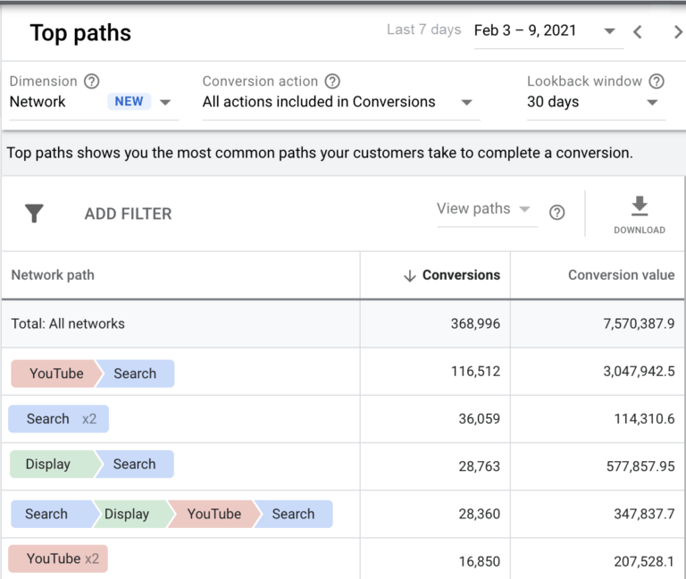

* + **Model Comparison report** shows how your Display ads are affecting conversions and to ensure that you’ve selected the most appropriate attribution model.
* Display ads within attribution reporting help advertisers see how campaigns across different channels complement each other and move customers along their journey.

<https://searchengineland.com/google-brings-display-ads-to-attribution-reports-as-an-open-beta-346242>

## **Responsive Search Ads Are Now Default Type for Google Ads**

**Responsive Text Ads** will now be the default ad type created in Google Ads. Advertisers can still create new Expanded Text Ads and edit existing ones.

* Expanded text ads are still supported, and advertisers can still create them. The difference is the platform won’t default to expanded text ads when an advertiser goes to create a new ad.
* **What Are Responsive Search Ads?** 
  + Traditionally, **text ads** in Google were comprised of headlines and body copy. The advertiser would write them in the intended order.
  + For **Responsive Search Ads**, each piece of the ad is viewed as an “asset.” These assets are then mixed and matched by Google to find the best combination of headlines and body copy for a campaign’s goal.

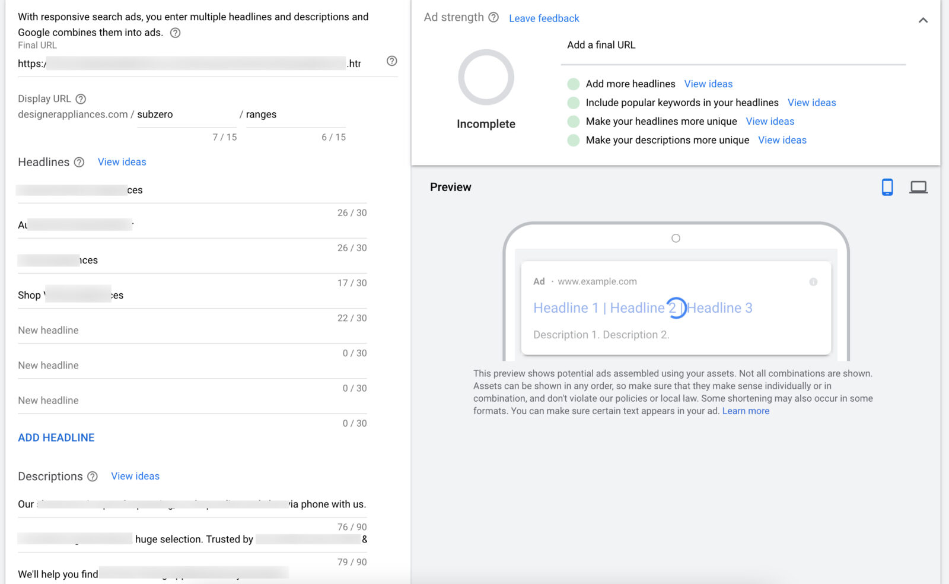

* **What are the Challenges with Responsive Search Ads?**
  + They require a little more thought in setup. Since the advertiser isn’t mandating the order like in a normal text ad, each headline and body copy asset has to make sense on its own, no matter what combination it’s used in.
* **Responsive search ads** have also been a focus in the **Recommendations** section, with frequent prompts to add more headlines or body copy. Google also started making suggestions for them, which can be approved or denied.

<https://www.searchenginejournal.com/responsive-search-ads-are-now-default-type-for-google-ads/396398/#close>

## **Facebook & Instagram Shops Integrate With Shopify**

**Facebook and Instagram Shops** are adding **Shopify as a payment option** which is estimated to **increase conversion rates by 1.72x.**

* All Shopify merchants selling on Facebook and Instagram can now offer **Shop Pay** as a checkout option for customers.
* Checking out with Shop Pay is said to be 70% faster than a typical checkout, which is due in large part to how it pre-populates customer details such as billing and shipping information.
* When a customer uses Shop Pay for the first time their information is stored for future purchases. Next time they checkout with Shop Pay they can speed through the process with a simple tap.
* This marks the first time Shop Pay has been available outside of Shopify.
* In a study of 10,000 of the largest Shopify merchants with Shop Pay enabled it was found that checkouts going through Shop Pay have **an average conversion rate of 1.72x** higher than those going through regular checkouts.

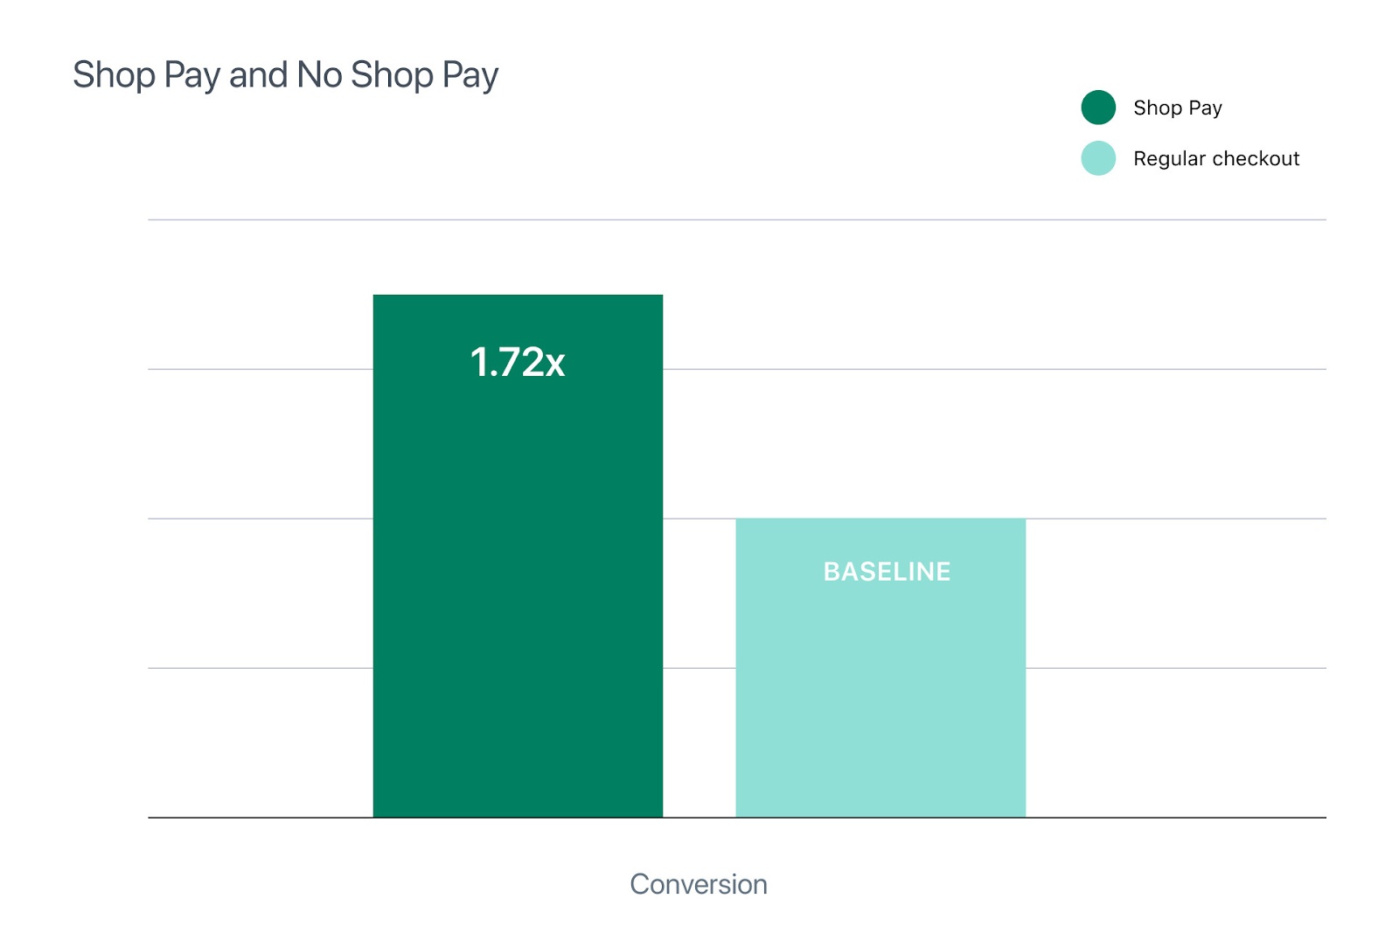

* That number is even higher on mobile, where Shop Pay increases conversion rate by 1.91x.

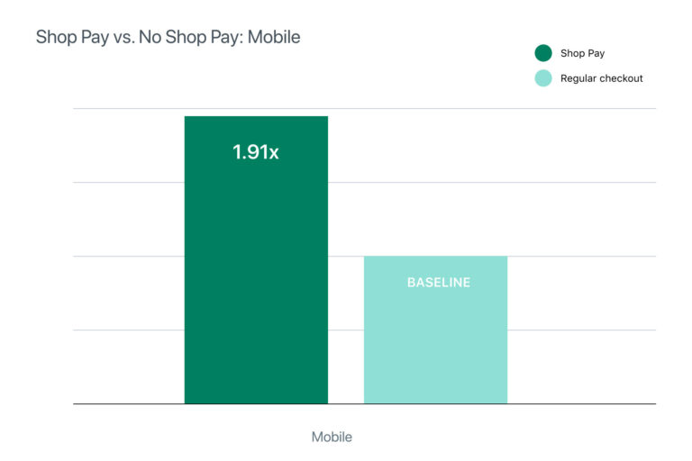

<https://www.searchenginejournal.com/facebook-instagram-shops-integrate-with-shopify/395950/>

## **Shopify Is 40% As Big as Amazon Marketplace**

Shopify is now the size of 40% of Amazon Marketplace after nearly doubling in 2020. It was just 25% two years ago. The important thing is not whether Amazon and Shopify are comparable - they are not - but the readiness of brands to sell directly to consumers.

* Shopify GMV was 25% as big as Amazon Marketplace in 2018. It reached 30% in 2019 and finally 40% in 2020. Said differently, Amazon marketplace was 3.9 times larger than Shopify in 2018. By 2019 Amazon’s dominance shrank to 3.3 times, and by 2020 it was bigger only 2.5 times.
* **Amazon is reportedly working on a Shopify competitor under the codename “Project Santos.”** But “Amazon’s attention to Shopify is not about Shopify, the tool, but the trends Shopify represents.”
* The growth of Shopify GMV is not comparable to Amazon because Shopify doesn’t carry the assortment Amazon has. Sellers that make up the Amazon marketplace are not migrating en masse to Shopify either. Finally, Shopify is not a marketplace and doesn’t connect shop owners to shoppers. No consumer goes shopping on Shopify.
* **Shopify is not competing with Amazon, but it challenges its market share by doing e-commerce differently.** The growth of Shopify signifies the viability of direct-to-consumer retail.
* Five years ago, Shopify was ten times smaller than eBay. In 2020 it overtook eBay. If Amazon’s marketplace grows 25% while Shopify grows 50% for the next five years, Shopify will become bigger than it too.

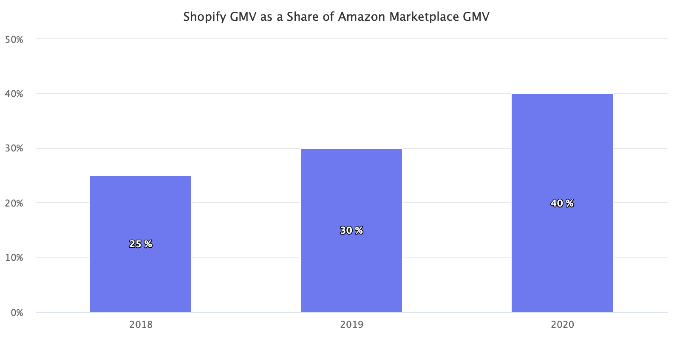

<https://www.marketplacepulse.com/articles/shopify-is-40-as-big-as-amazon-marketplace>

## **Ideoclick Extends Strategic Ecommerce Expertise Beyond Amazon to Include Leading Advertising Platforms Instacart, Walmart and Target**

Single vendor solution Ideoclick, Inc., the provider of the industry’s leading e-commerce optimization platform, announced its strategic e-commerce expertise now extends beyond Amazon to include leading advertising platforms Instacart, Walmart and Target.

* The move will provide Ideoclick’s customers with a single vendor advertising management solution and comprehensive, API-driven-view of digital performance across all platforms. The solution will help brands maximize efficient advertising return on investment and strategically manage their surging e-commerce retailer platforms.
* By maximizing cross-platform coordination with Ideoclick, brands will realize greater efficiencies and optimal sales. They will also experience time savings with one point of contact dedicated to syncing execution across retailers.
* Brands will benefit from Ideoclick’s industry-leading Amazon marketing service expertise in integrating paid search management services across Amazon, Walmart, Instacart, and Target platforms.
* **Key benefits include:**
  + **Ability to measure Share of Search on Amazon**: Ideoclick’s flagship Share of Search methodology helps brands measure the digital shelf. It allows them to compare peers on percentage of estimated traffic, star ratings, review counts, price points, and more for chosen search terms.
  + **Holistic “one-stop-shop” management:** Ideoclick strategists will help brands build a highly strategic, integrated e-commerce advertising platform go-to-market plan. Ideoclick manages overall strategy and execution across leading e-commerce retailer platforms.
  + **Strategic guidance:** Ideoclick provides recommendations on budget allocation, optimal assortments, cross-retailer pricing strategy, profitability, and inventory management.

<https://martechseries.com/mobile/mobile-marketing/e-commerce-and-mobile-commerce/ideoclick-extends-strategic-ecommerce-expertise-beyond-amazon/>

# Calendar Week 06 (Feb 12)

## **Shopify Expands Its Checkout System to Facebook and Instagram**

Shopify Inc., a commerce platform for businesses, **is bringing its checkout and payment processing system, Shop Pay, to some Facebook Inc. platforms.**

* The Shop Pay option will first be available to Instagram users on Tuesday and will roll out on Facebook Shops, the social-media company’s platform for small businesses, in the next few weeks.
* Consumers will be able to use Shop Pay to complete purchases, expanding on existing options to use PayPal Holdings Inc.’s PayPal or manually enter credit or debit card information. All these methods are offered via the Facebook Pay payment system.
* Shop Pay, which stores credit card and shipping information to speed online checkout, hasn’t previously been available outside the e-commerce stores of Shopify clients.
* Registered users would select Shop Pay at checkout, enter the email address and phone number associated with the account, and receive a code to verify it is them the first time they use it on Facebook Shops or Instagram.

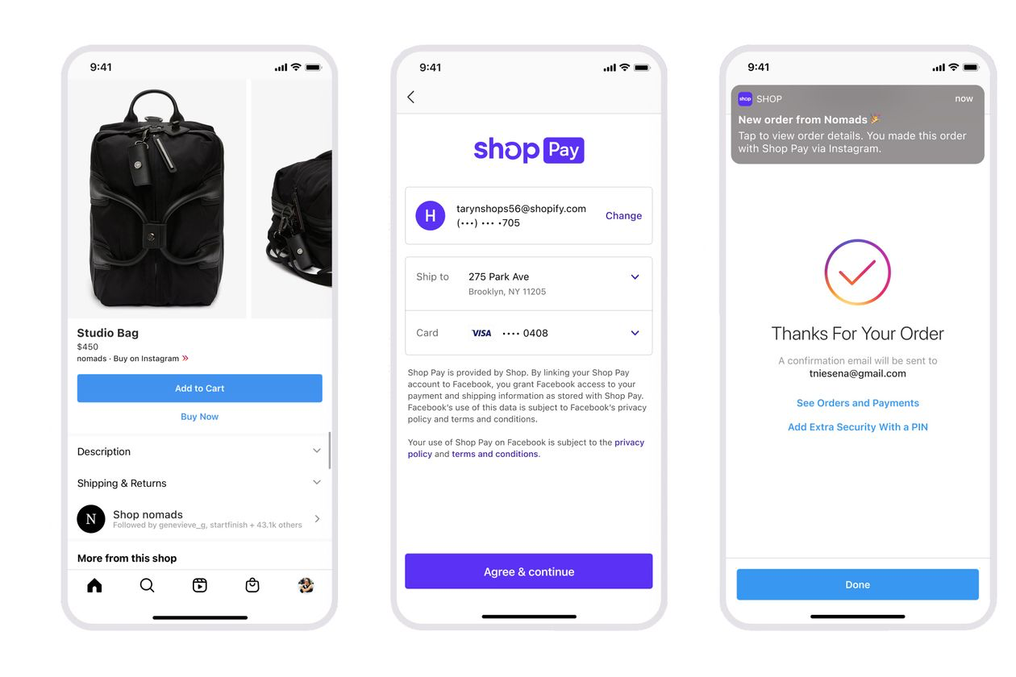

<https://www.searchenginejournal.com/breaking-google-ads-to-phase-out-modified-broad-match/395129/#close>

## **Microsoft Ads to replace Manual CPC with Enhanced CPC by end of April**

Microsoft will transition all search, shopping, and Dynamic Search Ads campaigns that do not have automated bidding strategies to Enhanced CPC (eCPC) beginning in March.

* *“Starting in March 2021 and continuing through April 2021, all existing search, shopping, and Dynamic Search Ads campaigns without any automated bidding strategies in place will be automatically migrated to Enhanced CPC. All ad groups and keywords will also be set to inherit bidding from their parent Campaign,”* says the [announcement](https://about.ads.microsoft.com/en-us/blog/post/february-2021/up-level-your-bidding-practice-with-enhanced-manual-bidding).
* **Walmart Connect will focus on three areas:**
* March: Manual CPC to eCPC migration begins
* April 5: New campaigns will no longer have the option of Manual CPC
* April 30: Any campaigns not yet using eCPC will be automatically migrated
* **The details.** If advertisers’ campaigns do not have an automated strategy currently set up, they will lose access to manual bidding this spring. If you’re using one of the following existing automated strategies, they will remain:

<https://searchengineland.com/microsoft-ads-to-replace-manual-cpc-with-enhanced-cpc-by-end-of-april-345917>

## **YouTube earns accreditation for protecting advertisers from unsuitable videos**

Alphabet Inc’s YouTube said on Tuesday it has become the first digital platform to receive an accreditation from the Media Rating Council, signifying the streaming video service effectively **protects its advertisers from appearing on content deemed inappropriate for paid ads.**

* The company said in a blog post it was committed **to remaining at least 99% effective at making sure ad placements on YouTube are brand-safe.**
* YouTube had high-profile incidents dating back to 2017 of ads appearing on videos with hate speech or other disturbing content, which led several major advertisers to turn off their YouTube ads.
* YouTube said it had made investments in technology that analyzes videos, beefed up its staff of human moderators and expanded policies to address brand safety.
* The MRC, which was formed by the U.S. Congress in the 1960s to measure audiences on media content, said it conducted an extensive audit of YouTube, including how its internal standards for determining which videos are suitable to receive advertising compared with industry-body standards.

<https://www.reuters.com/article/us-alphabet-youtube-advertising/youtube-earns-accreditation-for-protecting-advertisers-from-unsuitable-videos-idINKBN2A9227>

## **In-SERP lead forms convert Google Ads users without a click-through**

Google Ads announced its updated lead form extension which pops up a form directly from a click on an ad. Lead form extensions are available for Google advertisers in Search, Video, and Discovery.

* If opted into, it means that when a user clicks a headline from an ad, the lead form appears in the SERP instead of requiring users click through to an advertiser’s landing page to complete a form.
* After the form completion, the lead can choose to go to the advertiser’s site or continue searching on Google.
* **Benefits:** The related help article states that the benefits includes generating more leads, increasing conversions, and improved ad engagement. “After a potential customer submits a lead form, they can choose to visit your site or return to the search results page,” says the updated support doc.
* **Pulling the data:** Google states that advertisers can manually download the last 30 days of lead data directly from Google Ads or create a webhook to have leads moved directly into a CRM. Beta testers told Search Engine Land that it’s critical to create a cadence to pull the leads and hand them off to sales if there isn’t a webhook setup.

<https://searchengineland.com/in-serp-lead-forms-convert-google-ads-users-without-a-click-through-346000>

# Calendar Week 05 (Feb 05)

## **Google expands phrase match to include broad match modifier traffic**

Google announced phrase match will expand to include **additional broad match modifier traffic and support for broad match modifier will end.** The changes will start rolling out in two weeks.

* Google announced today what is potentially a large change for certain paid search managers: **the broad match modified version of keywords will be going away.**
* Phrase match will now expand to cover broad match modified instances. Google notes it will “continue to respect word order when it’s important to meaning.”
* Broad match modified keywords can continue to be added until July. At that point, it’s anticipated the full roll-out will be completed and no new ones will be added. Existing broad match modified keywords will continue to serve, but will be matched based on this update.
* **How Does this New Matching Mechanism Work?**
  + Currently, broad match modifier tells Google “these terms must all be present in the search query.” It’s expressed by putting **a plus sign** in front of the keywords required in the search.
  + Here’s how the keywords for “moving services nyc to Boston” (phrase match) or +moving +services +NYC +to +Boston (modified broad match) would be treated in this new era:

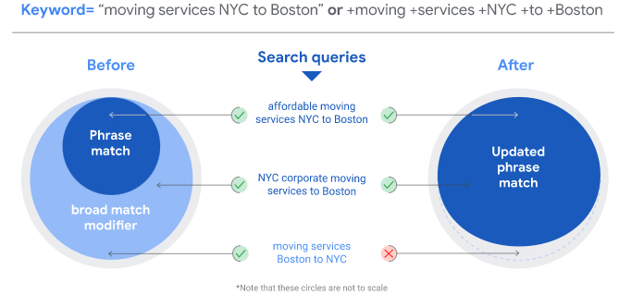

<https://www.searchenginejournal.com/breaking-google-ads-to-phase-out-modified-broad-match/395129/#close>

## **Google Search launches about this result feature**

Google announced it is rolling out a new feature that will communicate to searchers, before they click on the result, more information about that search result snippet they are looking at.

* This is a **“about this result”** box that can be triggered if the searcher taps on the three dots on the right top corner of the search result snippet.
* The about this result feature helps searchers learn more about the search result or search feature they are interested in clicking on.
* It tells the searcher where the information is coming from, helping searchers understand if they can trust this site to give them the information they are seeking.
* Google will show if the site is secure, if Wikipedia has information on that site and if the search listing is paid for or not.
* Google said this can help a searcher “if it’s a site you haven’t heard of before, that additional information can give you context or peace of mind, especially if you’re looking for something important, like health or financial information.”

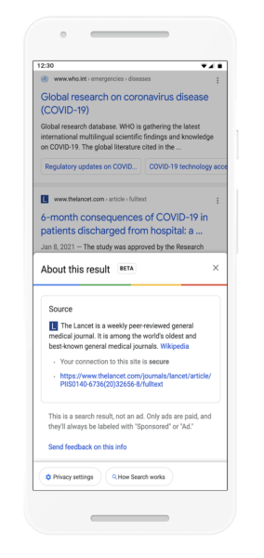

<https://searchengineland.com/google-search-launches-about-this-result-feature-345649>

## **Walmart Buys Ad Tech Platform As Rivalry With Amazon Intensifies**

Walmart is buying up the technology and assets behind Thunder, which uses **automation** to create digital ads. **One key goal for the retailer is to bring in more advertising business from small to medium-size businesses (SMBs).** The behemoth retailer’s latest move is part of its campaign to take on Amazon’s advertising division, in part by broadcasting what Walmart can do for online sellers.

* *“Thunder’s technology and team will reduce the time between the idea for an ad and the ad going live for suppliers,*” said Janey Whiteside, chief customer officer for Walmart, in a press release. *“While we expect our largest suppliers to adopt automation technology fastest, we are building this new platform to scale for Marketplace sellers and suppliers of all sizes.”*
* Last week (Jan. 28), Walmart renamed its media operations from Walmart Media Group to Walmart Connect. The retailer said the new name reflects its capacity to connect its 150 million weekly shoppers and advertisers, according to an announcement.
* Walmart said that in 2020, its media group increased “net new advertisers by more than 40 percent” while demonstrating to companies their return on advertising spend.
* **The acquisition arrives closely on the tails of an overhaul to Walmart's media network. The revamp includes a name change from Walmart Media Group to Walmart Connect and a partnership with The Trade Desk on developing a demand-side platform (DSP).**

<https://www.pymnts.com/news/ecommerce/2021/walmart-buys-ad-technology-as-rivalry-with-amazon-intensifies/>

## **Walmart links with The Trade Desk in extensive overhaul to ad business**

**Walmart rebranded its media network from Walmart Media Group to Walmart Connect**, part of a larger overhaul the retailer is enacting as it looks to scale the offering into a top-10 advertising platform, [according to a company announcement](https://www.businesswire.com/news/home/20210128005616/en).

* **Walmart Connect will focus on three areas:**
* Leveraging owned properties like Walmart.com, Walmart+ and the Walmart app to create holistic campaigns for advertisers
* Building out in-store experiences through assets like TV walls and self-checkout screens
* And applying first-party data to improve media performance for sellers operating outside of Walmart's proprietary sites.
* **Walmart has partnered with ad-tech firm The Trade Desk to create a new demand-side platform (DSP) that is aiming to launch in time for the 2021 holiday season.** The changes serve as another indication that Walmart is ramping up efforts to create a meaningful advertising competitor to platforms like Amazon and Google, with a spotlight on its capabilities in omnichannel retail.

<https://www.marketingdive.com/news/walmart-links-with-the-trade-desk-in-extensive-overhaul-to-ad-business/594118/>

## **Instagram Launches New 'Professional Dashboard' Platform to Provide Quick Guidance for Creators**

Instagram has announced the launch of a new 'Professional Dashboard', which is essentially a management overview platform that provides basic performance insight, as well as access to relevant tools to help Instagram creators maximize and monetize their platform presence.

* *"As part of our ongoing effort to give creators and businesses the tools they need, we are launching Professional Dashboard, a central destination to track performance, access and discover professional tools, and explore educational information curated by Instagram."*
* **The new Professional Dashboard offers insights on three key elements:**
  + **Track Your Performance** highlights key trends and data notes based on your account performance, including comparative prompts based on past performance stats.
  + **Grow Your Business** provides quick access to various tools to help you manage your account more efficiently, including Badges, Branded Content and IGTV promotions.
  + **Stay Informed** provides links to Instagram's latest educational resources, "including tips, tricks, guidance, and inspiration".
* All of these features have been available in different form previously - the Professional Dashboard just brings them all together into a more cohesive, and accessible listing.

<https://www.socialmediatoday.com/news/instagram-launches-new-professional-dashboard-platform-to-provide-quick-g/593839/>

# Calendar Week 04 (Jan 29)

## **Microsoft Advertising now offers Filter Link Extensions**

Microsoft Advertising announced an addition to their ad extension offerings today: **Filter Link Extensions.**

* **Filter link extensions** mean “Advertisers can present many different features under categorized headers so that users can quickly navigate to their key products and offerings.
* With **Filter Link Extensions,** your ads will include **one header with between 3 and 10 clickable text values.**
* There are 36 pre-defined headers for Filter Link Extensions such as amenities like WiFi, pools, and fitness centers for hotels.
* They can also be shown with other ad extensions, like sitelinks, and the cost for clicking a filter link is the same cost-per-click (CPC) as clicks on the ad headline.
* Here’s what it looks like in the SERPs:

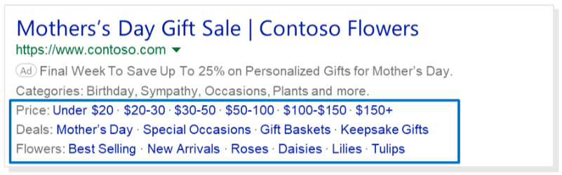

<https://searchengineland.com/microsoft-advertising-now-offers-filter-link-extensions-345578>

## **Google adds price drop appearance rich results to search results**

Google has updated the product structured data help documentation to **add a section for price drop appearance.**

* Google said it now supports displaying price drop rich results on snippets within English in the US, on both desktop and mobile search.
* Google said “to be eligible for the price drop appearance, add an Offer to your Product structured data. The price must be a specific price, not a range (for example, it can’t be $50.99 to $99.99).”
* Here is a screenshot of **price drop appearance**:

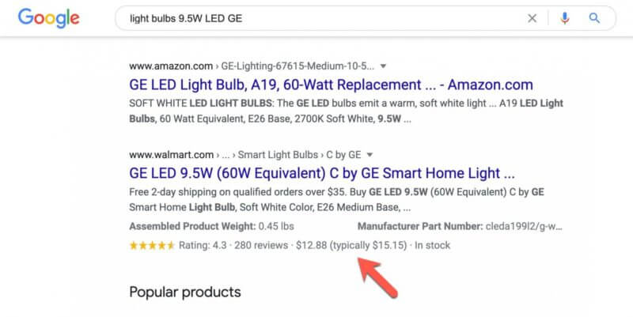

* Google does this all automatically based on the pricing you send the search engine via product schema over time.

<https://searchengineland.com/google-adds-price-drop-appearance-rich-results-to-search-results-345606>

## **Walmart Plans Big Push to Challenge Amazon on Advertising, Shares Shopper Data With Brands**

Walmart plans to expand its advertising business, **adding space for advertisements at its US stores and sharing its vast trove of shopper data with brands**, looking to challenge rival Amazon as a media powerhouse.

* The efforts are key to Walmart's aggressive plan to **grow its advertising business by more than 10 times within the next five years,** according to a source familiar with the matter.
* Reuters previously reported Walmart's annual advertising revenues were expected to be nearly $1 billion (roughly Rs. 7,300 crores) in 2020.
* Walmart has expanded its advertising business after years of stuttering progress, even as a deal to buy a 7.5 percent stake in video-sharing app TikTok remains in limbo.
* Walmart said it will build a new advertising platform in partnership with advertisement technology company Trade Desk. It will allow brands to use Walmart's ample shopper data to make advertisements more effective, even on websites and apps Walmart does not own.

<https://gadgets.ndtv.com/internet/news/walmart-amazon-flipkart-challenge-advertising-shopper-data-share-brands-tiktok-deal-2359842>

## **The Disappearing Amazon Resellers**

Amazon conceived the marketplace to bring brands it couldn’t convince to sell onto the site. Thus, for years most of the sellers were large resellers with tens of thousands of products. However, increased competition and brands going direct has eroded this opportunity.

* **Only 10% of the top third-party sellers on Amazon have more than 1,000 products for sale. Five years ago, in 2016, that number was nearly 40%.** According to Marketplace Pulse analysis of the top Amazon sellers, the share has steadily decreased since then.
* The number of products was chosen as an arbitrary point to differentiate large resellers from other types of sellers. Half of the top sellers currently have 70 or fewer products.
* **Selling on Amazon has become synonymous with building private label brands because the reseller business model stopped working.** Sourcing products from established brands was a repeatable and successful business model. However, dozens of sellers were soon competing for the sale.
* Successful resellers are now often positioned much more like agencies than retailers. They present a third option to brands for selling on Amazon. Rather than selling wholesale to Amazon or selling directly as a seller on Amazon, the agency-reseller acts as the intermediary. Most brands are unwilling or unprepared to be sellers, and plenty is trying to move away from the wholesale relationship with Amazon.

<https://www.marketplacepulse.com/articles/the-disappearing-amazon-resellers>

## **Pinterest Introduces Story Pins Follower Streams**

Pinterest has been exploring and testing its own take on Stories for a while. As Pinterest continues to develop its content discovery offerings, the team has just announced their latest update: **Story Pins following streams.**

* When we hear "Stories" related to social networks, we associate that content with a 24-hour life span. On Pinterest, Stories mean something entirely different. Story Pins are saveable, actionable, and long-lasting, so content can be discovered and revisited over time.
* Available on iOS and Android, Story Pins following streams allow users to see more personalized content from the accounts they choose to follow.
* **The format is unique given its extended life-span**, but there's more. When interacted with, stories appear the same as a pin. Creators can add plenty of context to their stories in the caption, as well as interact with their community in the comments section.

<https://www.socialmediatoday.com/news/pinterest-introduces-story-pins-follower-streams/594224/>

# Calendar Week 03 (Jan 22)

## **LinkedIn Launches 6 Free Advertising Courses**

LinkedIn is launching an **all-new on-demand learning center for advertising** which is full of free resources.

* **LinkedIn Marketing Labs** is a new on-demand learning center where marketers can access free resources about how to advertise on LinkedIn.
* LinkedIn is launching with 6 courses curated by in-house experts who have studied **LinkedIn advertising best practices** across a variety of industries.
* This is a prime opportunity for marketers to learn more about **generating leads through advertising on a platform** which generates **5x more conversions than regular landing pages.**
* **LinkedIn Marketing Labs** is a solution created for marketing professionals who want to learn the best practices of LinkedIn ads, refine their ad strategies, and stay informed about the marketing tools on LinkedIn.
* The complete list of initial course offerings is as follows:
  + Introduction to LinkedIn Ads
  + Using LinkedIn’s Ad Targeting
  + Reporting and Analytics for LinkedIn Ads
  + Building a Full-Funnel Content Marketing Strategy on LinkedIn
  + Using LinkedIn for Brand Awareness
  + Using LinkedIn for Lead Generation
* All courses can be accessed from the **LinkedIn Marketing Labs hub.**

<https://www.searchenginejournal.com/linkedin-launches-6-free-advertising-courses/392652/#close>

## **What Are Amazon Sponsored Display Ads & Are They Worth It?**

Amazon vendors or a Brand-Registered seller can access a number of powerful advertising tools to help scale your business on Amazon. One of those tools is **Sponsored Display Ads**.

* **Sponsored Display Ads allow you to reach relevant audiences on and off Amazon.** So not only will your ads be displayed across various Amazon pages, they’ll also be visible to customers on third-party websites and apps.
* **Sponsored Display Ad** program doesn’t target keywords. Instead, it **targets customers based on audience interests and shopping behaviors**, as well as whether they’ve viewed your product’s detail page.
* **Sponsored Display** is a self-service display advertising solution.
* **With Sponsored Display, brand-registered sellers can:**
  + Retarget customers who have previously viewed their listing(s) within the past 30 days
  + Target similar products or categories
  + Target customers based on their interests and previous shopping behaviors (Vendors only)
* There are three types of targeting options available with Sponsored Display Ads: **product targeting, views remarketing, and audience interests.**

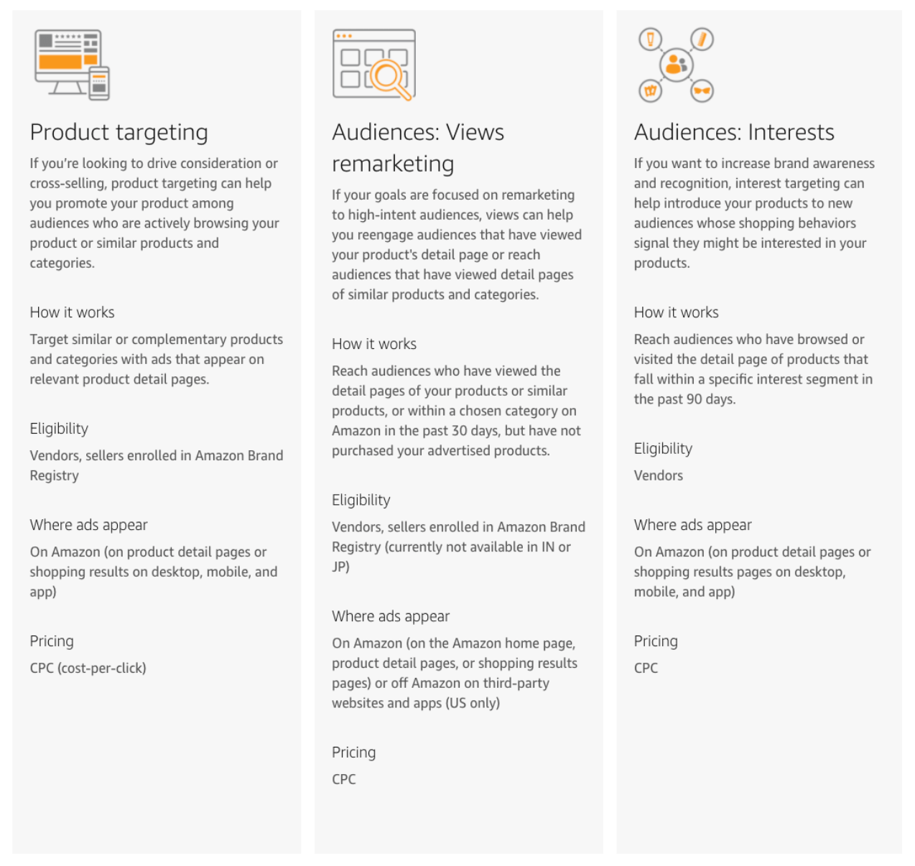

* **Sponsored Display ads** may appear on Amazon (on product detail pages or shopping results on desktop, mobile, and app) or on third-party websites and apps (in the U.S. only), depending on the targeting option you choose.

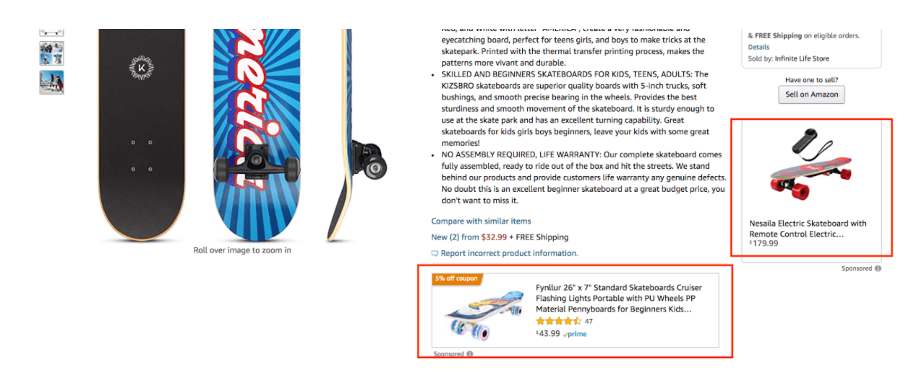

<https://www.junglescout.com/blog/amazon-sponsored-display-ads/>

## **Pinterest's new ad format automates personalized messaging**

Pinterest this week introduced **a customizable advertising format that lets marketers automate the process of building personalized creative** to target specific audiences.

* Advertisers can make multiple versions of Pins from digital assets or a product feed, **automatically importing product data such as price, location and availability** for target audiences.
* Pinterest named RevJet, StitcherAds and Smartly.io as approved partners to provide software tools and templates to design **dynamic creative ads, helping advertisers reduce the time and effort that would otherwise be required to create hundreds of customized ads for specific audiences to** drive sales. Marketers also can run tests of the creative to compare which ads drive the best performance.
* The new performance-driven format comes as Pinterest looks to support shopping-related behaviors on its platform, which saw an 85% jump in the number of Pinners engaging with shopping surfaces in the six months ended Sept. 30.
* With its new format, Pinterest is catching up to platforms like Facebook and Snapchat, which already offer dynamic creative, underscoring how the automation media buyers have come to expect with programmatic ads is increasingly extending into creative.

<https://www.marketingdive.com/news/pinterests-new-ad-format-automates-personalized-messaging/593626/>

## **SPOTIFY WILL FORCE AD-FREE PREMIUM USERS TO LISTEN TO ADVERTS**

**Spotify users who have paid for the ad-free Premium subscription will still have to listen to adverts if they use the platform for podcasts** – Users of the music streaming service are split into two tiers: Free and Premium.

* The music streaming service announced on 21 January that it would be bringing Spotify Podcast Ads to the UK for all users – meaning Premium subscribers who paid to avoid adverts will still have to listen to promotional content.
* When asked why paying users would experience the same service as free users, Spotify said that advertising is *“an integral part of the podcast industry.”*
* “All Spotify users receive an on-demand podcast listening experience that may include ads or sponsorships. Spotify Premium offers users an ad-free music listening experience. However, Spotify offers all listeners the ability to pause, rewind and fast forward through any part of a podcast episode, including advertisements,” the company told *The Independent*.
* The ads are only available on podcasts that Spotify produces itself, so it will receive money both from subscription fees and company ads.

<https://www.independent.co.uk/life-style/gadgets-and-tech/spotify-premium-podcast-adverts-b1791160.html>

## **75% of New Sellers on Amazon Are From China**

China-based sellers represented 75% of new sellers on Amazon in January. A significant increase from 47% in the previous year. While this hasn’t yet impacted the GMV market share - domestic sellers are responsible for most of the total sales - it is a trend that has been accelerating for years.

* 75% of new sellers in the top four core Amazon markets - U.S., U.K., Germany, and Japan - are based in China.
* The percent is the average of the four marketplaces, according to Marketplace Pulse analysis of more than forty thousand sellers that joined those Amazon marketplaces so far in 2021.
* Each of those four marketplaces and the other three European marketplaces (France, Italy, Spain), and Amazon’s other international platforms, exhibit an identical pattern.
* Sellers based in China represented 47% of new sellers in January 2020 and 41% of new sellers in January 2019. The share has more than doubled on Amazon in the U.S. from 28% in 2019 to 63% in 2021.

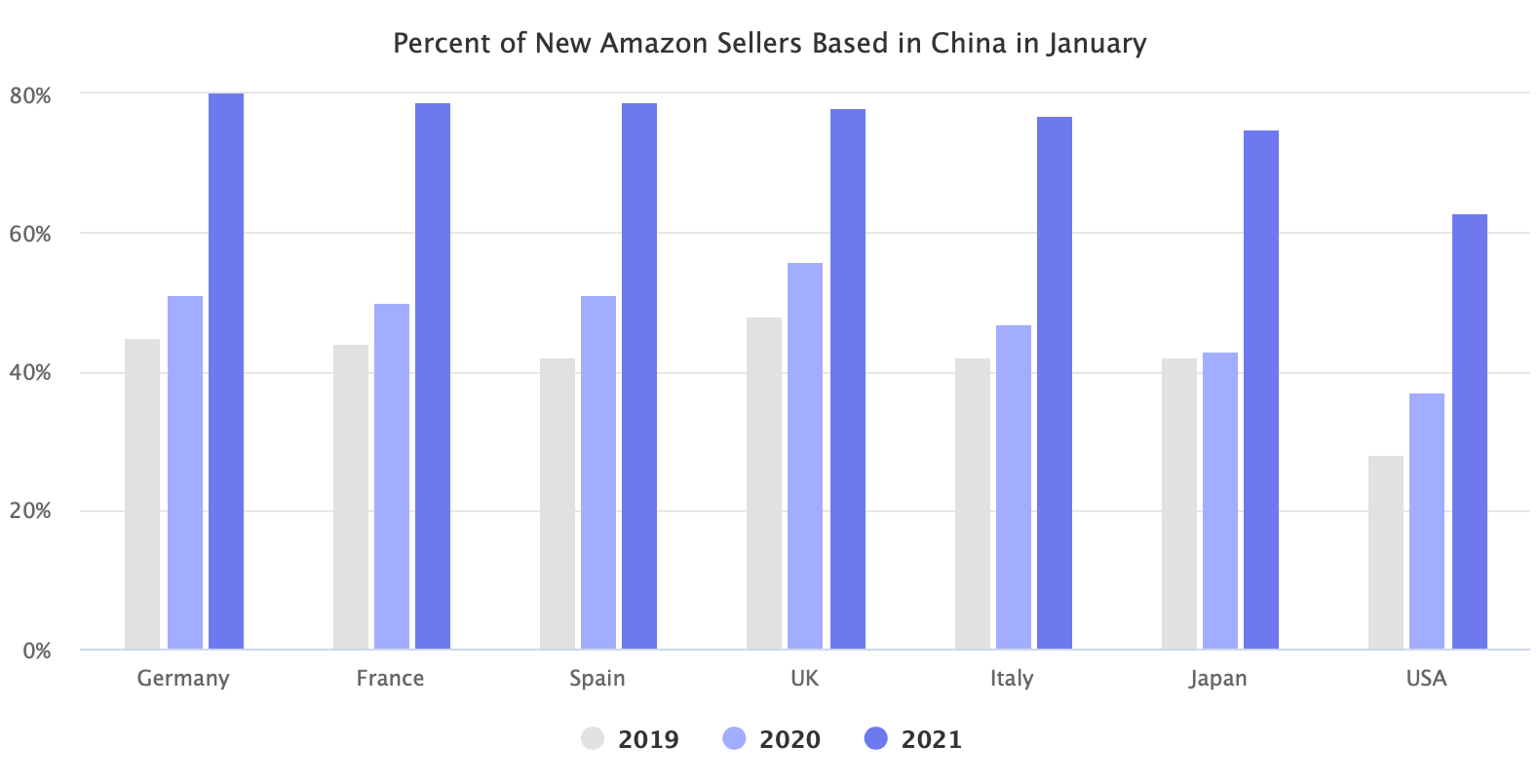

<https://www.marketplacepulse.com/articles/75-of-new-sellers-on-amazon-are-from-china>

# Calendar Week 02 (Jan 15)

## **More than two-thirds of US marketers will use influencer marketing**

eMarketer estimates that **67.9% of US marketers with 100 or more employees will use influencers for paid or unpaid brand partnerships in 2021.**

* Although some marketers cut spending on influencer marketing during the pandemic (such as travel marketers), the interest in working with influencers actually increased; between 2019 and 2020 the percentage of US marketers using influencers grew from 55.4% to 62.3%.
* Budgets for influencer marketing look ready to rise. In July 2020 research by Kantar Media, senior marketers worldwide said they expected to **increase budget allocation for branded content shared by influencers by 48% in 2021.**
* Influencer marketing has its pitfalls, but an increasing percentage of marketers are working with influencers.

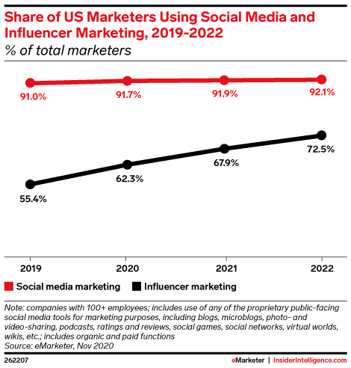

<https://www.emarketer.com/content/more-than-two-thirds-of-marketers-will-use-influencer-marketing>

## **(More) digital trends for 2021: Influencer- and user-generated content**

In the year ahead, there will be **a big pivot to more user-generated content in marketing.**

* Consumers are less trusting of the mainstream media and slick corporate marketing, **turning instead to user-generated content and influencers** to find their own truth.
* AI-based services are now helping brands create ads from these assets in a frictionless manner and target them to the right audiences as well.
* Admittedly, this shift was already underway before 2020, but the pandemic put it into high gear. Influencer- and user-generated content is cheap, easy, and quick to create—and consumers (so far) have been receptive to it.
* Brands are increasingly aware that they can deploy this type of creative more effectively and at less expense. This shift will continue because consumers have been responding to such repurposing of influencer- and user-generated content.
* With user-generated and influencer-driven content on the rise, and tied ever closer to performance marketing, there will be pressure on marketers to get better at measuring influencer impact.

<https://www.emarketer.com/content/more-digital-trends-2021-influencer-user-generated-content>

## **YouTube Analytics Adds ‘First 24 Hours’ Metric**

YouTube is adding a new metric that allows creators to analyze the performance of a video within the first 24 hours after publishing.

* It can be accessed in the video analytics section of the YouTube creator studio. To retrieve this data, select “First 24 hours” from the date picker in the top right-hand corner.

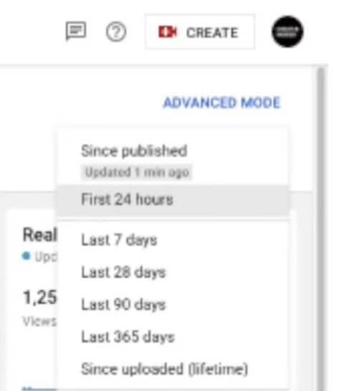

* After selecting **first 24 hours** from the date picker as shown in the photo above, you’ll see a full set of data collected from the first 24 hours after the video was published. Upon opening the first 24 hours view you’re greeted with a summary at the top of the screen.

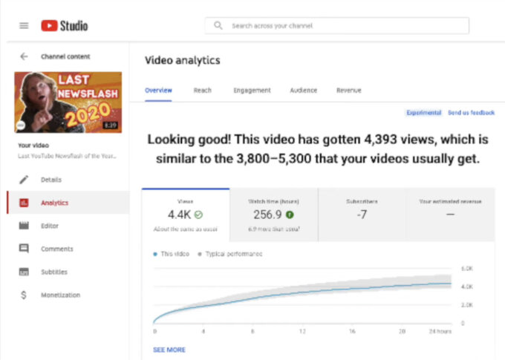

* As you go down the screen you’ll find the total watch time accumulated by the video in its first 24 hours. The report shows how many subscribers you gained or lost during that time, and how much revenue you earned if the video is monetized.
* While the summary at the top is helpful in figuring out **how the data compares to other videos**, you can dig deeper than that.
* On top of launching first 24 hours data for each video, YouTube is giving creators the ability to **compare 2 videos side-by-side.**

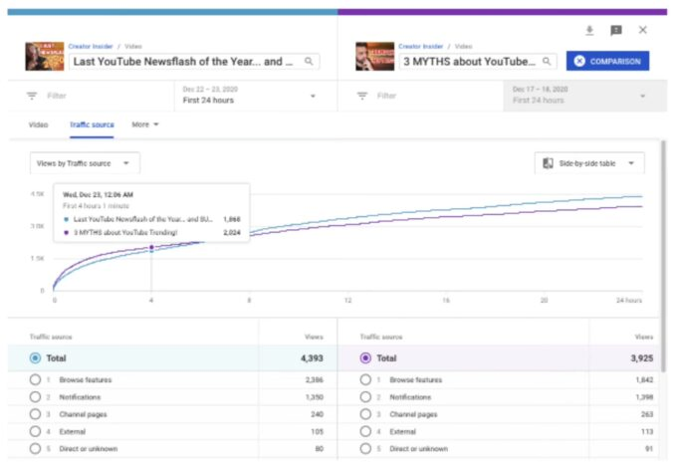

<https://www.searchenginejournal.com/youtube-first-24-hours/392392/#close>

## **Amazon Marketing Cloud Enters Advanced Beta Testing**

Amazon Marketing Cloud has entered a new phase in an effort **to boost its appeal with advertisers from household brand names.** The ecommerce giant’s nascent platform, dubbed AMC, is now available to even more brands, buying agencies and relevant tech vendors across North America, Europe and parts of Asia. **AMC aims to better help marketers accurately measure how their ads perform across different channels, including how they impact awareness, lift, preference and, ultimately, whether or not they lead to sales.**

* The AMC offering allows marketers to perform such analysis by uploading their own first-party datasets to the marketing cloud via what is popularly known as a data cleanroom that anonymizes all customer information.
* From there, **advertisers can gain further insights into customer behavior and subsequently refine their campaign activity**, such as redirecting spend to better-performing channels.
* “*Advertisers often ask us how OTT video and display advertising work together to improve customer engagement across the purchase funnel in Amazon’s store,*” reads a blog post attributed to Emmeline Toyama and Alan Lewis from the Amazon Advertising team.
* Amazon declined to detail the number and profile of brands that participated in testing AMC since it was first unveiled in mid-2019, but noted that the marketing cloud is now integrated with other parts of the ecommerce giant’s ad stack such as its demand-side platform and Sponsored Products offering.

<https://www.adweek.com/programmatic/amazon-marketing-cloud-advanced-beta-testing/>

## **ChannelAdvisor Announces Platform Enhancements Designed to Optimize Retail Product Content and Improve Operational Efficiency**

Channeladvisor announced new platform capabilities and an expansion of services to help brands efficiently manage product data for retailers, monitor fulfillment performance, expand to new channels, and leverage Amazon's demand side platform (DSP) for advertising.

ChannelAdvisor's newest enhancements include for example:

* **Managed Services for Amazon DSP:** Brands selling on both Seller Central and Vendor Central can target audiences on and off Amazon with support from ChannelAdvisor Managed Services for Amazon's demand-side platform (DSP). Brands seeking to amplify their brand presence can rely on ChannelAdvisor's retail media experts to help drive effective advertising with Amazon DSP.
* **New Marketplace Connections:** Adding to its more than 100 global marketplace integrations, ChannelAdvisor continues to help connect brands and retailers with more consumers through the support of Amazon Sweden (SE), Back Market (AT, BE, NL, FI and PL), Darty (FR), Paysfer (US), and Spartoo (FR).
* **Channel Health Console:** ChannelAdvisor's newest enhancements to the Channel Health Console provide sellers with a simplified dashboard, enabling them to monitor the health and performance of their fulfillment channels closely

<https://www.prnewswire.com/news-releases/channeladvisor-announces-platform-enhancements-designed-to-optimize-retail-product-content-and-improve-operational-efficiency-301206258.html>

## **TikTok Launches New Small Business Resource Center for Marketers**

As it continues to expand its business offerings and ad options, TikTok has launched a new [Small Business Resource Center](https://www.tiktok.com/business/en-US/smbcenter), which includes a range of case studies, creative tools and explainers to help SMBs tap into the fast-growing app: *"From success stories to creative tools and free webinars, it has everything you need to grow your small business on our platform."*

* **The platform includes a range of helpful tools, including case studies:**

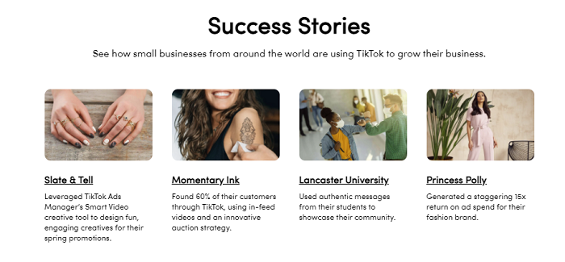

* **And creative tools for your campaigns:**

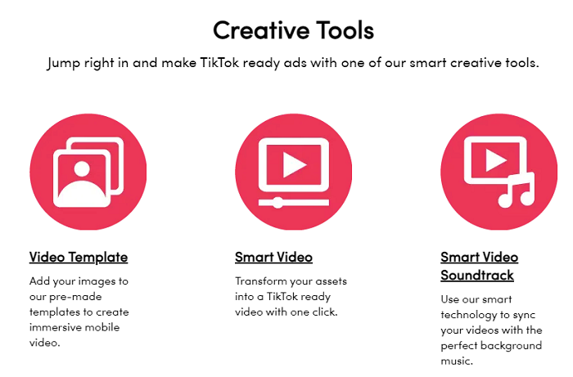

* There are also webinars, details on TikTok ad and performance metrics, and links to a range of other business resources.

<https://www.socialmediatoday.com/news/tiktok-launches-new-small-business-resource-center-for-marketers/592570/>

# Calendar Week 01 (Jan 08)

## **3 Myths About YouTube Trending Debunked**

YouTube debunks 3 myths about how it features content and explains what it takes for a video to appear in the coveted ‘Trending’ section.

* **Youtube Trending** is a separate section of the YouTube website which is accessible from the main navigation menu.
* The goal of YouTube trending is to provide a set of videos that a wide range of viewers would find appealing.
* YouTube Trending is one of the few areas where users can discover new videos which **aren’t personalized based on viewing history.**
* **The 3 myths to get featured in Trending include:** 
  + YouTube Trending gives preferential treatment to specific creators.
  + YouTube Trending is exclusive to high profile creators.
  + There’s an ideal time to publish to get featured in Trending.

<https://www.searchenginejournal.com/3-myths-about-youtube-trending-debunked/391333/>

## **Amazon’s advertising business booms in pandemic**

The surge in online shopping triggered by the Covid-19 pandemic has put Amazon on course for its first-ever $100bn quarter, but it has also boosted an overlooked part of the company’s business**: advertising.**

* According to FactSet, a financial data company, Amazon’s “other” unit will make $21bn in revenue in 2020, a 47 per cent jump on last year. Its rapid growth is helping Amazon to chip away at online advertising’s dominant player, Google.
* Several studies had shown that people were increasingly searching for things to buy directly on Amazon, rather than on Google.
* **Sponsored posts** are a source of continual friction between Amazon and major brands because it allows competitors to pay to appear above rivals, even if a customer has searched for a specific brand name.
* A survey of 1,000 major brands conducted by Feedvisor suggested **the number advertising on Amazon has risen to 73 per cent this year, up from 57 per cent in 2019.**
* Amazon is also attracting advertising from **brands that do not sell their products on its website,** such as carmakers and insurance companies, which are keen to use Amazon’s purchasing data to target the right people.

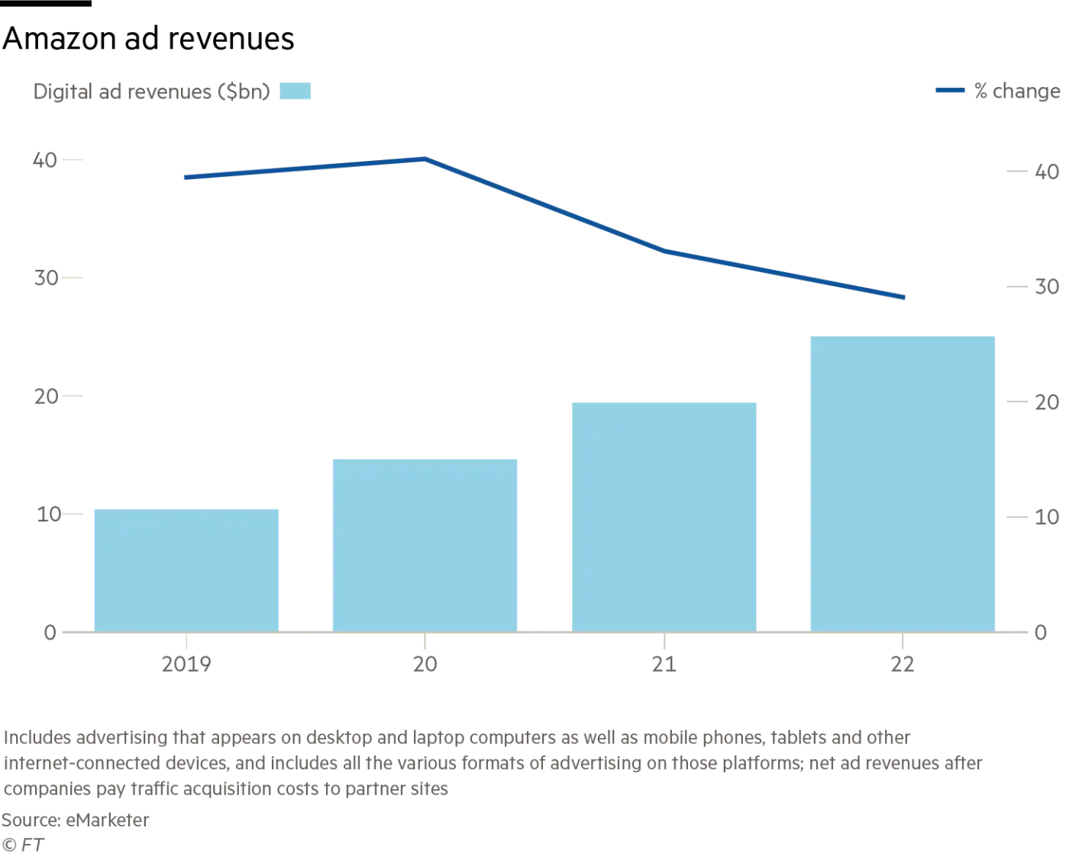

<https://www.ft.com/content/095d73d5-a7a6-4acc-9dcc-9ee3e3d1fff4>

## **Shopify... for livestreaming e-commerce: The Drum editorial team’s best of 2020**

One of the trends from this year that’ll grow further in 2021 is e-commerce **livestreaming** – or shoppertainment as it’s called in Asia Pacific. Started in China by the e-commerce giants, shoppable video live-streams have become a high energy and sociable way to sell goods in a year that saw many of us confined to our homes.

* This is a trend that is inextricably linked to the pandemic. Alibaba’s Taobao shopping platform said in February 2020 that the number of brands that adopted livestreaming grew 719% month-on-month as they sought new ways to reach consumers at home.
* **Fastforward six months and global e-commerce platform Shopify** announced a number of partnerships and new services to its platform... including livestreaming. This is significant because with 820,000 businesses using the Shopify platform to sell goods, this launch took e-commerce livestreaming as a predominantly Asian trend out into the west.
* Shopify also announced a commerce partnership with the short-form video platform. From Shopify, brands can create shoppable in-feed video ads for **TikTok**.
* Finally, in a showing of e-commerce’s resilience in a year of challenging economic circumstances, Shopify merchants broke records in selling over $5.1bn in worldwide sales, according to the brand.

<https://www.thedrum.com/news/2020/12/31/shopify-livestreaming-e-commerce-the-drum-editorial-team-s-best-2020>

## **Advertising predictions for 2021**

Despite there being many unknowns, there are several trends impacting the current state of consumer behaviour and the advertising industry that help us predict what we’ll see next year and allow advertisers to adjust accordingly. **Here are six predictions for what advertisers can expect in 2021:**

* **Exponential e-commerce growth will continue** In 2021 with the changing trends, advertisers are banking on the shifting trends of traditional shopping experiences towards a more online and connected environment.
* **Advertisers will increase investments in digital advertising** Advertisers will not only encourage purchases, but also **build customer loyalty for years to come.** To do this, advertisers will increase their spend across digital marketing channels such as virtual events, paid display, and content marketing.
* **Connected TV will become a marketing mainstay**
* **Brand safety will stay front and center** Advertisers will leverage solutions that help them better control their ad placements to safeguard their brand’s image and stay true to their brand values.
* **Industry collaboration towards new identity solutions will kick into overdrive** We’ll likely see various advertising players come together, to stand behind unified solutions, which advertisers and publishers can begin testing in the coming year.
* **In-store shopping experiences will become even more seamless** What will change about the in-store shopping experience, beyond increased sanitation, is that it will be optimised for consumers to spend less time inside with features such as digital transactions, “buy online, pick up in store”, and cashier-less checkouts.

<https://www.financialexpress.com/brandwagon/advertising-predictions-for-2021/2162358/lite/>